Simulation of Variable Displacement Pump

Altaf A. Pinjari

*Department of Mechanical Engineering*

*(MITADT University Loni Pune)*

*MIT School of Engineering*

*(MITADT University Loni Pune)*Pune, India  
altafpinjari2001@gmail.com

Anurag Nema  
*Department of Mechanical Engineering*

*(MITADT University Loni Pune)*

*MIT School of Engineering*

*(MITADT University Loni Pune)*Pune, India  
anurag.nema@mituniversity.edu.in

Abdullatif Navarange  
*Department of Mechanical Engineering*

*(MITADT University Loni Pune)*

*MIT School of Engineering*

*(MITADT University Loni Pune)*

Pune, India  
abdullatifnavrange1@gmail.com

Dr. Mathew K.  
*Department of Mechanical Engineering*

*(MITADT University Loni Pune)*

*MIT School of Engineering*

*(MITADT University Loni Pune)*Pune, India

mathew.karvinkoppa@mitunivesity.edu.in

*Abstract*— *The variable displacement pump is used to maintain the unequal volume flow. This is considered to be an effective method. All of these important parts are merged in a simulation environment and create the framework of a design tool that results to performance evaluations, important problems, and other results in a well-known influence and feasible solutions.*

Keywords—VDP, Simulation on variable displacement pump, RPM, Stroke Length, flow rate

# Introduction

Types of Variable Displacement Pump: -

1. Axial Piston Pump

2. Radial Piston Pump

3. Swash Plate Pump

Fulbright, Nathaniel, and James Ven created a dynamic model to analyse the behaviour of the pressure compensated pump by the use of poppet-style control valves [1]. “Modelling a Variable Speed Drive for Positive Displacement Pump”, this model enables for the analysis of the loading generated by pressure gradient in a PD pump. It's important to examine how pressure variations impact the crank shaft mechanism [2]. It was observed that the flow stabilisation error can be compensated for the negative impact of the reduced control pressure drop [3]. Displacement control steering can be classified under election-hydrostatic power steering, where the torque / angular torque is sent to the controller to re-adjust the VDP [4]. The low-efficiency portion of the pump is inversely proportional to the speed when reduced from rated to 48 percent of rated speed [6].

# Simulation

1. We analysed various research papers about various mechanisms, linkage, types and simulation of Variable Displacement Pump (VDP).

2. We have selected an efficient formula for displacement of fluid (flow rate).

Piston pump displacement = pi/4 * (bore)^2 * stroke length

Piston pump flow rate = [(Piston pump displacement) * rpm]/231

* Piston pump flow rate is in ga/min

* Bore and stroke length are in inches

We have made and simulated a model using the above formula. Using this model, we have calculated the piston pump displacement using the bore length (x) as 12 mm designations.

With the help of piston pump displacement, we got the

*Fig. 1*

*(Fig.1 shows the Simulink model of VDP)*

pump flow rate. We took minimum range of stroke length i.e., 2 - 6 mm and the rpm as 200 – 400 rpm

# Conclusion

A successful model of a Variable Displacement Pump (VDP) system in Simulink (MATLAB) is developed. Observation and Results of the developed Variable Displacement Pump are shown below:

Output of piston pump displacement (flow rate) varies from 0 – 50 gal/min for the chosen values of rpm and stroke length. (Fig.2a)

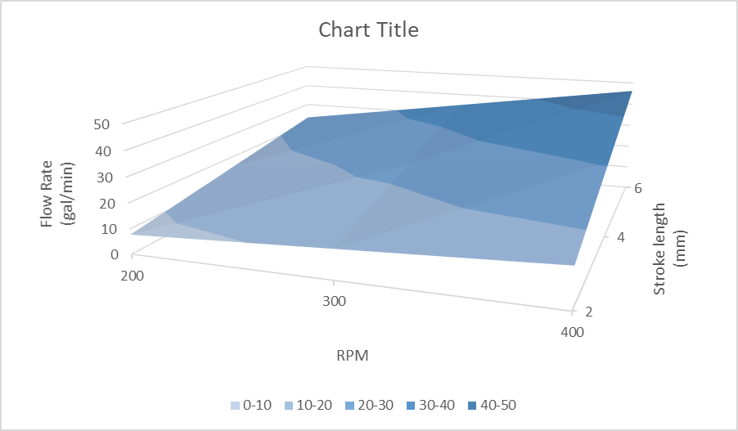According to the graph we can see a straight-line graph where flow rate increases when there is an increase in rpm and stroke length. (Fig. 2b)

##### References

1. Fulbright, Nathaniel, and James Ven. “DYNAMIC RESPONSE OF PRESSURE COMPENSATED VARIABLE DISPLACEMENT LINKAGE PUMP.” Sept. 2018. *(references)*
2. Josifovic, Aleksandar, et al. “Modeling a Variable Speed Drive for Positive Displacement Pump.” July 2014.
3. Burennikov, Y., et al. “ABOUT THE POSSIBILITY TO REDUCE HYDRAULIC LOSSES IN THE CONTROL SYSTEM OF HYDRAULIC DRIVE WITH VARIABLE– DISPLACEMENT PUMP.” 2007.
4. Daher, N., and M. Ivantysynova. “SYSTEM SYNTHESIS AND CONTROLLER DESIGN OF A NOVEL PUMP CONTROLLED STEER-BY-WIRE SYSTEM EMPLOYING MODERN CONTROL TECHNIQUES.” Oct. 2013.
5. Park, Sung, et al. “Modeling and Performance Improvement of the Constant Power Regulator Systems in Variable Displacement Axial Piston Pump.” 6 Aug. 2013.
6. XU†, Bing, et al. “Characteristics of Volumetric Losses and Efficiency of Axial Piston Pump with Respect to Displacement Conditions.” 3 July 2015.

