Design and Fabrication of rocker-bogie mechanism

Sanskar Sanjeev Dhore   
Department of Mechanical Engineering  
MIT-ADT UniversityPune, India  
sanskar900@gmail.com

Ronak Patel  
Department of Mechanical Engineering  
MIT-ADT UniversityPune, India  
0000-0003-4013-839X

Vaishnavi Dhumal  
Department of Mechanical Engineering  
MIT-ADT UniversityPune, India  
Rahul Kulkarni  
Department of Mechanical Engineering  
MIT-ADT UniversityPune, India  
rahul21pune@gmail.com

*Abstract*— Mars exploration includes a long history, however, there have been solely four roving vehicles that with success operated on its surface. Robotic rovers became necessary tools in planetary exploration. Future rovers need improved rover performance as the uneven Martian parcel of land is tough to traverse. so as to confirm that the task is successfully achieved, it's a key issue to style and optimize the mechanical system of all-terrain mobile robots. This project presents the design and fabrication, of the rocker-bogie mechanism to understand this mechanical system capable of operation in multi-terrains of Martian surfaces and has higher mobile performance.

Keywords— Design, Prototype, Rocker-Bogie, Space Exploration

# Introduction

Mars exploration programs over the years have tried to explore the possibility of life on Mars. Such explorations have been mostly done using rovers. Considerable research has been done in recent years to improve planetary exploration vehicles. Robotic rovers have become important tools in planetary exploration, and future rovers require improved rover performance. These rovers are to be specially designed to operate effectively on natural terrains of Mars that may be sloped, rough, or elevated. So, the key change to be made in a rover by which it can tackle the problem of traversing on uneven Mars surface lies in its suspension system. To ensure that the task is successfully achieved, it is a key issue to design and optimize the suspension system of all-terrain mobile robots(rover).

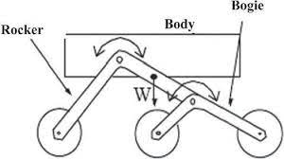

Figure 1.1. Line Diagram of Rocker-Bogie system

Rocker Bogie Mechanism is a type of suspension system that was developed by NASA in the year 1988 with a view of overcoming the traversing problems of the rover and which has since become NASA’s favored design for rovers. NASA used the Rocker-Bogie mechanism

for the first time in the Mars rover, Sojourner. NASA used the same mechanism in 2003 and 2013 Mars exploration mission rovers: Spirit, Opportunity, Curiosity, and also in the latest rover Perseverance which is set to land on the Martian surface on Feb 18, 2021. The scientists at NASA states that this rocker-bogie system reduces the motion of the main vehicle body by half compared to other suspension systems. This type of suspension design has no springs or stub axles for each wheel, allowing the rover to climb over various obstacles (such as rocks, debris, etc.) that can be up to two times the wheel's diameter in size also while keeping all the six wheels of the rover on the ground. Rocker is the linkage which is mounted on body on each side of the rover. The rockers are connected through a differential bar. Relative to the body, both rockers will rotate in opposite directions in order to maintain equal wheel contact. One side of the rocker is directly connected to a wheel, and another side is pivoted

to bogie which consists of two bars that are again connected to two wheels. So, in total, the rover has six wheels with individual motors that drive the rover, and there are four steering motors connected at the end of the rockers, which makes zero-radius turning of the rover possible. This type of mechanism makes it possible for the rover to have all-time ground contact.

# Calculations for creating a prototype

The Rocker-Bogie suspension design has no springs and stub axles for each wheel, which allows the rover to climb over obstacles, such as rocks, that are upto two times the wheel’s diameter in size while keeping all six wheels on the ground. In any suspension system, the tilt stability is limited by the height of the centre of gravity. The centre of gravity must be as low as possible. Systems using springs tend to tip more easily as the loaded side yields. The system is designed to be used at slow speeds of around 0.3141m/s, so as to minimize dynamic shocks and consequential damage to the vehicle when surmounting sizable obstacles The key factor in the manufacturing of rocker-bogie mechanism is to determine the dimensions of rocker and bogie linkages and angles between them. The lengths and angles of this mechanism can be changed as per requirement. It has angles of linkages are 90˚& 135˚

## Calculation of rocker-bogie mechanism

## 

## Figure 2.1 Dimensions of Rocker-Bogie mechanism

## To find the dimension of bogie linkages, first pair of wheels should be placed at horizontal position means at the end of the rising as shown in Fig.2. And the second pair should be the same manner.

## Using Pythagoras theorem, find the dimensions of the model.

## AC² = AB² + BC²

## (320) ² = x² + x²

## (102400) = 2x²

## x = 226.0 mm

## Hence, AB = BC = 226 mm

## Similarly, to find dimensions for rocker linkages first two-wheel pairs should be placed at horizontal position. The third wheel pair should also be in a similar way as the first pair of wheels. By placing the wheel in such a manner, we obtained the dimension of link DF

## Now consider ∆DEF (Fig.2),

## Which is Scalene Triangle, by using the Law of Cosine Rule

## DF² = DE² + EF² - (2 x DE x EF) Cos DEF

## DF² = (200) ² + (276) ² - (2 x 200 x 276) Cos 135˚

## DF² = 194240.5886

## DF = 440.727 (mm)

## Design & Selection of Wheel

Design of wheel is required at a velocity up to 0.3141 m/s. Assume speed is 60 rpm motor. Using velocity relation linear velocity is calculated for assumed rpm.

Calculating angular velocity:

ꞷ = 2πN / 60

ꞷ = 2π x 60 / 60

ꞷ = 6.2832 (rad/s)

Converting angular velocity to linear velocity:

v = r x ꞷ

v = 0.05 x 6.2832

v = 0.3141 (m/s)

Using the calculated velocity value need to find out the diameter of the wheel is 100 mm. Selection of rubber thread bonded to the wheel makes it lightweight and durable, provides excellent traction, and friction. These plastic wheels (as shown in Fig.2 offer a low-cost solution that is durable enough for a rover yet still light enough to be practical. For rover that uses six wheels.

Wheel Diameter: 100 mm

Wheel Width: 40 mm

Shaft Diameter: 6 mm

# Designing of the rover mechanism

## 2-D Model Development

A two-dimensional sketch was created on the AUTODESK Fusion-360 platform by taking the dimension considerations obtained from the calculations performed and also referring to NASA's Curiosity and Perseverance rovers.

## 3-D Model creation

From the two-dimensional sketch created on the Fusion-360 platform, a 3-D rendered model was developed consisting of the calculated dimensions.

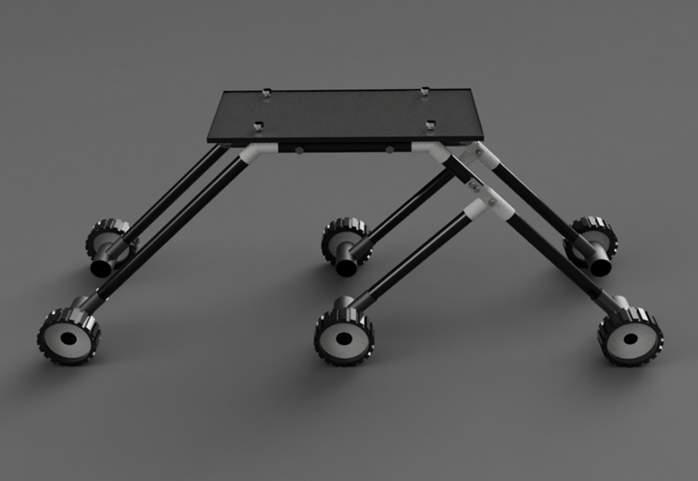Figure 3.1 Rendered 3-D model

# Fabrication of prototype

By creating a prototype, we can actually hold a version of our proposed model and thus determine in what aspects does it perform well and in what aspects it needs refining.

## Materials for the rover

The considerations of the materials for any prototype are important because:

* It minimizes the overall cost of the prototype
* It optimizes the weight of the prototype
* It increases the reliability of the prototype
* It must sustain the load of the electronic components placed on it

These are the materials used for the fabrication:

1. Body: Acrylic sheet
2. Rocker-Bogie: Poly-Vinyl Chloride pipes
3. Wheels: Plastic wheel covered by rubber cleats

## Electronic Components:

The electronic component that will be used are:

1. Battery: 12V lead acid
2. Motors: 12V 60 rpm dc geared
3. Relay board: 4-Channel
4. Bluetooth module: HC-05
5. Controller: Arduino Uno

## Program Development:

The controller programming is done on the Arduino IDE

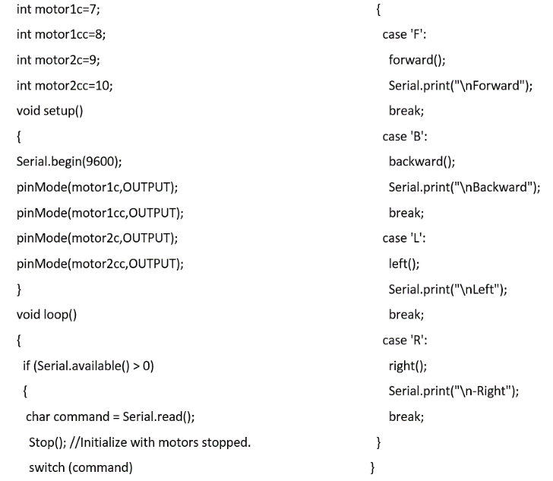

Figure 4.1 Program Part 1

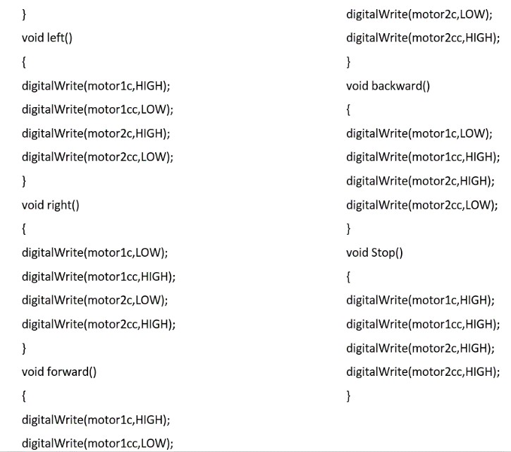

Figure 4.2. Program Part 2

## Fabricated prototype:

The final fabricated prototype is shown in figure 4.3 and 4.4 respectively

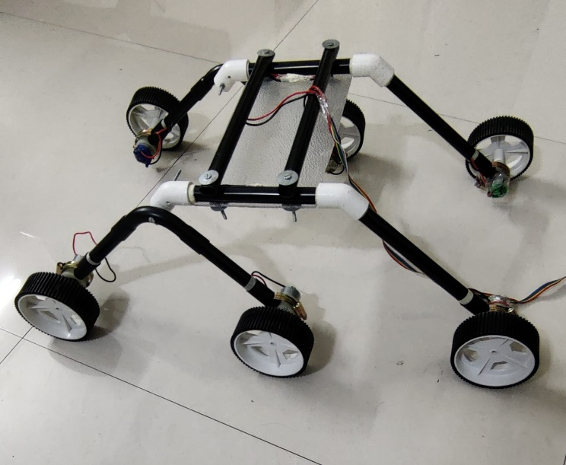

Figure 4.3. Prototype without electronics

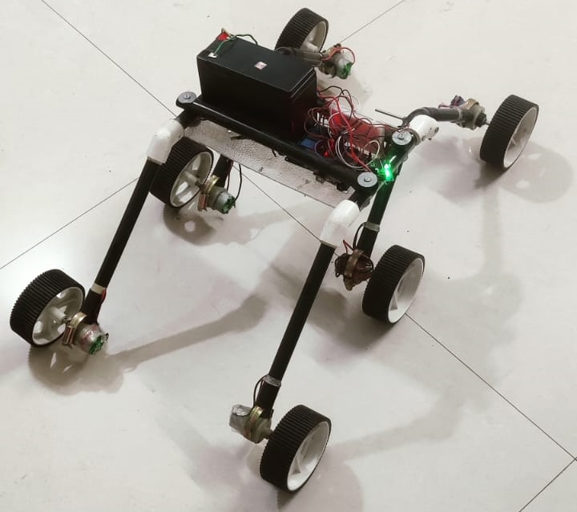

Figure 4.4 Prototype with electronics

# Navigation and Control:

The 6 motors of the rover are controlled using 4-channel relay module, which receives the signals from the controller (Arduino). The rover is can be controlled using mobile application which sends the data through Bluetooth module to the Arduino and Arduino accordingly sends the signals further to the relay board to control the 6 motors. In this manner the rover can move forward, backward, right, left or stop using the commands given by the mobile application.

#### 

# Testing of prototype:

#### The testing of prototype was done on uneven terrains and obstacles to check if any refinement in the structure was needed

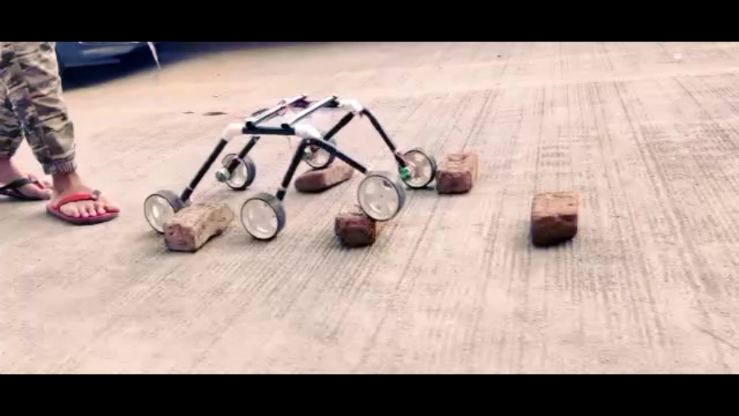

Figure 6.1 Testing of prototype over obstacles

# Conclusions:

A low-weight and highly reliable rocker-bogie suspension system is shown in this paper.

After the Bluetooth connection is established between the rover and the mobile application, we were able to control the rover from a distance. The rover was able to traverse smoothly on the uneven terrains. As it can be seen in the figure 6.1 the rover overcomes the obstacles easily without any considerable shocks to the main body of the rover.

The rover can be equipped with additional sensors and electronics in order to make it fully autonomous and useful for exploration projects.

##### Acknowledgment

We take great pleasure to express our deep sense of gratitude to our guide Prof. Siddharth Salve for their useful comments and suggestions, which lead to the improvement of this paper.

##### References

1. N. Yadav, B. Bhardwaj, S. Bhardwaj, “Design analysis of Rocker Bogie Suspension System and Access the possibility to implement in Front Loading Vehicles”, IOSR Journal of Mechanical and Civil Engineering, e-ISSN: 2278-1684,p-ISSN: 2320-334X, Volume 12, Issue 3 Ver. III, PP 64-67, May - Jun. 2015.
2. Schenker, P., et. al., “Lightweight Rovers for Mars Science Exploration and Sample Return,” Intelligent Robots and Computer Vision XVI, SPIE Proc. 3208, Pittsburg, PA, October, 1997.
3. Lindemann RA and Voorhees CJ. Mars exploration rover mobility assembly design, test and performance. In: IEEE international conference on systems, man and cybernetics, Vol. 1, Waikoloa, HI, 2005, pp. 450–455. IEEE

[4] C.R.Weisbin, D.Lavery, G.Rodriguez; “Robotics Technology for Planetary Missions Into the 21st Century,” Proc. i-SAIRAS’97, Tokyo, Japan, July, 1997, pp.5–10.

[5] J. A., Neck, K. T., Jones, J. A., Rodriguez, and J.Balaram, “Planetary Exploration by Robotic Aerovehicles” Journal of Autonmous Robots, January 1999