Role of Artificial Potential Field Approach in Navigation of Robot

Prof. Dr. Bhumeshwar Patle   
*Department of Mechanical Engineering*  
MIT-ADT University, MIT-School of EngineeringPune, India  
bhumeshwar.patle@mituniversity.edu.in

Aniriddha Khati  
*Department of Mechanical Engineering*  
MIT-ADT University, MIT-School of EngineeringPune, India  
khatianiruddha@gmail.com

*Abstract*— This review article discusses the research of robot navigation. The approach developed is based on the Artificial Potential field. Despite being the most well-known navigation strategy, Artificial Potential Field (APF) still has flaws such as easy fall into local minima, poor success rate, and inefficient path planning. The navigation of robots is still one of the most complex and hard functions to do. This paper examines the usage of the Artificial Potential field technique for numerous applications in various sectors, as well as the navigation across static and dynamic situations. The report finishes with tabular data and graphs comparing the simulation results for each robot application.

Keywords—Navigation, Obstacle avoidance, Artificial Potential Field

# Introduction

Obstacle avoidance by the manipulator Path planning is the process of determining a viable path from the starting point to the end point of the manipulator. Throughout the process, the manipulator must avoid colliding with any obstacle. This is an advanced three-dimensional obstacle path planning issue in environment. The path planning problem, [1] static as well as dynamic depends upon the information available in the space. Path planning in a partially or completely unknown environment seems to be more realistic, but also more difficult.

In the navigation of robot to solve the problems of path planning there are various approaches such as [2] Vonoroi Diagram (VD), Visibility Graph (VG), Virtual Force Field, Virtual Force Histogram, Neural Network based approach, Fuzzy logic, Cell Decomposition, Roadmap approach, Artificial Potential Field Approach etc.

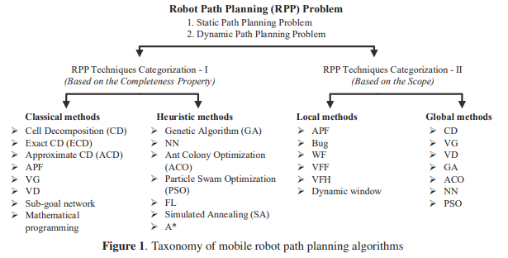

1. Taxonomy of mobile robot path planning algorithms

Robot path planning is mainly devided in to two catagories, Firstly, based on the completeness of the property, and secondly based on the scope. The completeness of property is been catagoried into two sub parts, classical and Hueristic. The main aim of the classical algorithms is to find out the optimal path to travel if there any otherwise proving that there is no soltion for it. While in hueristic algorithms, they tries to find the better path in no time but they does not take full responsibilty to find the soltion. Also, RPP based on the scope also derived in 2 subcatagories, Local method and Global method. Local method, uses the sensor information as they does not know the enviornmet or any othe partial information and about Global approach they vreates a hazard free path based on the previously known path.

Tharinder Veerakon [2] have proposed a tabular data of basic fundamental comparison of some of the approaches as shown below in table 1.

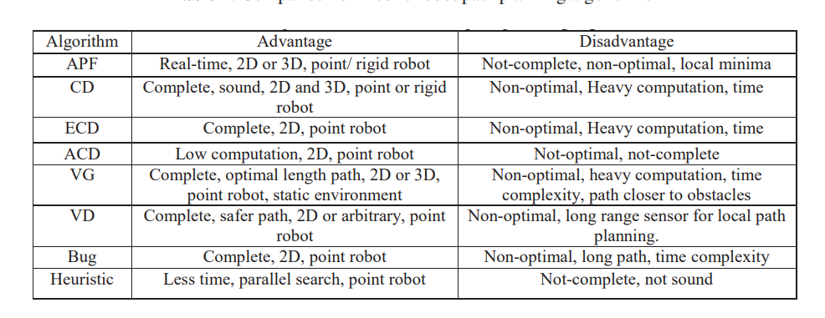Table 1: Taxonomy of mobile robot path planning algorithms

As we know the current trend in robotics having shifting from industrial to more challenging parts, such as in Healthcare industry to perform surgeries, underwater robots to explore the sea in deep etc. In such cases it makes so much hard to make the right path and cannot be able to identify fully the obstackle present in it’s route. To tackle this problem khatib [3] proposed an approach in 1985 namely Artificial Potential Field. This method is commonly used for mobile robot path planning. It is also know for it’s elegant mathematical analysis and simplicity.

# Artificial Potential Field

## 3.1 Introduction

The traditional Artificial Potential Field (APF) approach entails creating an appealing artificial potential field around the target site attracts the robot and repels it using an artificial potential field the robot is being repelled by barriers. Having been influenced by the robot advances to its destination based on these two combined potentials. While avoiding the impediments in its path, it arrives at its target. The manner in which the way this algorithm works is that, despite the fact that the potentials are only a few, They can create an artificial force field that, in turn, can generate an artificial force field. In turn, when paired with the condition of the robot and artificial dynamics can generate a synthetic velocity and acceleration for use in simulations a reference that may be used to regulate the robot's posture in real time.

The Artificial Potential Field (APF) approach, gives a virtual potential to the target location that draws the robot as it moves away to the stumbling blocks, a virtual potential that repels the as it draws closer to them, the robot becomes more obnoxious. The robot is moving around the world while avoiding the obstacles along the way to the destination it's on its way.

Potential field techniques, which are widely used for real-time collision-free path planning. Before using this strategy, the robot becomes trapped at local minima achieving the desired setup and colleagues have designed a real-time mobile obstacle avoidance strategy robot. The navigation algorithm considers a variety of factors a mobile robot's dynamic behavior and solves the local minimum a difficulty with traps The repulsive force is substantially stronger than the attractive force. They are considering the appealing force. To put it another way, the goal location is not the absolute lowest point in the overall potential field. As a result, the robot is unable to achieve its objective to the neighboring stumbling block [6].

## 3.2 Application of APF in Robots

## Wheeled Mobile Robot Navigation

Wheeled Mobile Robots (WMR) are the most important choice for to be utilized in the place where peoples need to work in hazardous situations like explosive industries, exploration industries, radioactive chemical factories. WMR eliminates this situation as it can work in any conditions and are autonomous.

To work in this type of environment a mobile robot has to decide the exact direction or carry out a process exactly as it has to be done due to not fixation of robot. To carry out this process and to reach the required target from its original position and this approach is called as Maneuvering Planning. Priyanka Sudhakaraa proposed [4] a route planning strategy based on the features of water current stream flow utilizing a grid-potential approach. The flow of the stream, like the water current stream, goes from the high potential field to the low potential field, and the headstream assumes the robot's original location. When the water current stream runs, the trajectory of the stream generates a reasonable obstacle-avoiding path from the starting point to the desired location.

A scenario based map has been created depending on the environment. The physical workspace of the robot is represented by a two-dimensional array cell. Each cell on the map contains the potential function value as well as the grid coordinate values. Local sensors mounted on the robot collect information about the local environment. This will also update the information in the cells. In this case, the heuristic searching function makes use of the potential function to trace the route during processing [4].

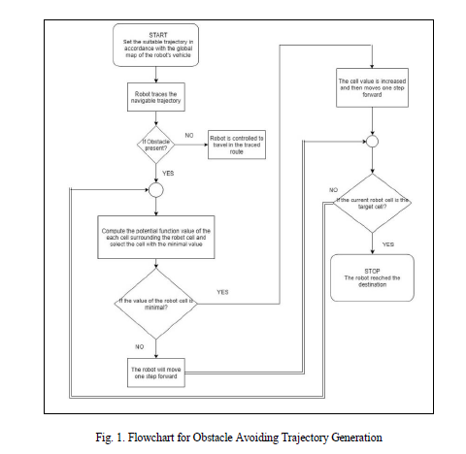

1. Flowchart for trajectory generation for WMR

## Industrial Robot

## Station changeover is a crucial part of multi-station industrial robot welding systems. A fixed instruction track is used in traditional station conversion, however in today's complex industrial output environment, a constant track usually can't keep up with demand.

Based on the obstacle data conveyed by the system's external sensor, the deadlock path can be fully planned and conveyed back to the control cabinet via the local area network, enabling the industrial robot's implementation trajectory to be controlled and the station transfer to be realised. The general adaptability of the multi-station welding system is improved, and the situation where the station changeover trajectory needs to be changed in response to changing work environment is avoided, resulting in a significant boost in work efficiency.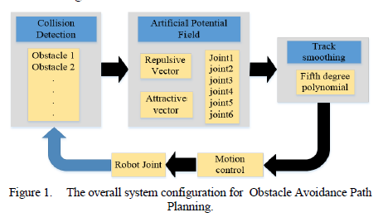

1. Overall system config. For ostackle avoidance and path planning in Industrial Robot

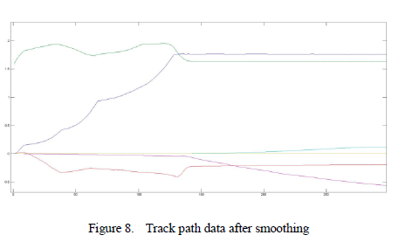

1. Track pack data after simulation

The number of barriers is shown to be 6 in this scenario. The welding station change, in general, poses less obstacles than the preceding scenario. In the tough case, the detection technique can also resolve the collision-free path smoothly, demonstrating that the methodology may be applied. With fewer barriers in real-world scenarios [5].

## Unmanned Aerial Robot

# Unmanned aerial systems (UASs) are becoming more popular in the field of its diverse surveying and military applications. Automatic UASs require a collision-avoidance optimization method, also known as sense and avoid, to monitor the flight and alert the aircraft to critical avoidance moves. The artificial potential fields (APFs) method is a well-known collision-avoidance approach based on electric fields. Impediments (other planes) are portrayed as repellent charges, whereas objectives (waypoints) are depicted as attractive charges. These expenses are then added together to determine which route is the safest to move towards. Whereas the basic procedure is clear and simple, it can malfunction in a variety of conditions, including becoming caught in a local minimum.

# The utilisation of dynamic force fields that are based on the vehicle's position and velocity. The distance the aeroplane can fly in a second was used to build an elliptical force field in this analysis. The force field uses scalar changes to create a bigger and stronger field in front of the aircraft. As a consequence, the difference in bearing between the aircraft exerting the force and the aircraft feeling the force may be utilised to calculate the force exerted on another aircraft. A supplementary calculation is also carried out, which translates the applied force into a felt force. [8].

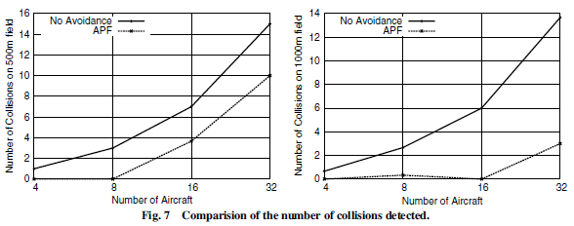

1. Comparison of no. of collison detected

## Humanoid Robot

# Humans have designed their settings in proportion to their ergonomics, thus robots with the same physical physique as humans are more helpful than others. Humanoid robots that are completely adaptable to industrial contexts are yet not possible to create. Some research needs include stability, mapping, interfacing, computation, and grasping, and path planning makes humanoid robot navigation an unresolved challenge. The ultimate objective for a humanoid robot is for it to be able to work in any situation. Because the actual world is changeable, it is hard to save all surroundings in robot memory. This means that humanoid robots will have to work in unfamiliar situations. For mobile robots, the placement of barriers, restricted zones, and free areas must be established throughout the path design process. This information might be obtained via an imaging system in humanoid robots [9].

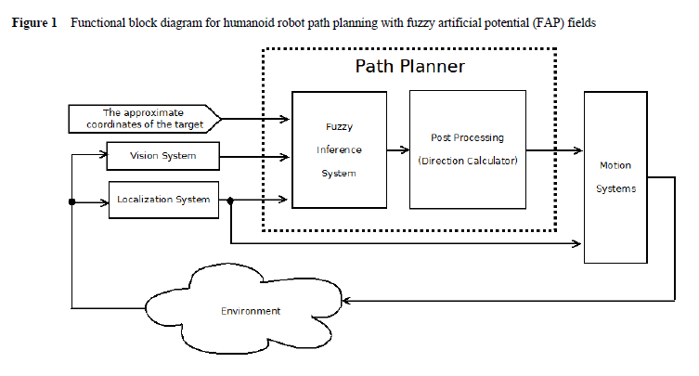

1. Path Planning for humanoid

## Underwater Robot

Because there is no direct relationship between the remotely operated underwater vehicle (AUV) and its mothership, because the AUV's power and energy are constrained, and the ocean environment is complicated and unpredictable, underwater path planning and navigation technology development is essential for avoiding obstacles and effectively completing underwater activities. Many scholars have concentrated their efforts on combining established ground mobile robot path technology and implement into underwater vehicle route planning, notably the artificial potential field path planning technique, which is widely used in the field of ground mobile robots.

The unique path planning method combines the artificial potential field technique and the velocity synthesis algorithm. After the combination of ocean current velocity and AUV velocity, the artificial potential field exactly defines the velocity direction.

The non - periodic flow of saltwater that is typically constant but changes with the seasons, climate, topography, and depth of the sea. Ocean current is a complex time-space variable that is challenging to mathematically express. In a constrained marine region and for a certain time period, the flow rate and direction, on the other hand, remain relatively constant. The AUV's energy is also limited, and it can only move inside a specific sea zone. As a result, the ocean current is a static vector in the simulation. To put it another way, the value and direction remain the same [9].

# Conclusion

The Study of Application of APF in various categories of robot have been studied. From this study it is clearly state that robot no matter which category it is from path planning is the utmost problem in the navigation system to carry out the given task. It is also observed that for different conditions or different environment require some modification of APF approach. APF has used successfully for path planning of drone, underwater robot, industrial robot, humanoid robot. It is a very fast and accurate technique due to its real time path planning ability. Due to its ability of making suitable route in real time it gives response in proper time and a widely adopted technique in the industry.

1. Ming Zhao 1 And Xiaoqing Lv, Improved Manipulator Obstacle Avoidance Path Planning Based On Potential Field Method, Hindawi, Journal Of Robotics, 2020.
2. Tharindu Weerakoon, Kazuo Ishii And Amir Ali Forough Nassiraei, An Artificial Potential Field Based Mobile Robot Navigation Method To Prevent From Deadlock, Jaiscr, 2015
3. Khatib O; Real-Time Obstacle Avoidance For M.Anipulators And Mquiee Robots, Ieee, 1985
4. Priyanka Sudhakaraa, Velappa Ganapathya, B.Priyadharshinia, Karthika Sundarana, Obstacle Avoidance And Navigation Planning Of A Wheeled Mobile Robot Using Amended Artificial Potential Field Method, International Conference On Robotics And Smart Manufacturing (Rosma2018), 2018.
5. Shengnan Gai , Rui Sun,Shunjun Chen ,Shuting Ji, 6-Dof Robotic Obstacle Avoidance Path Planning Based On Artificial Potential Field Method, International Conference On Ubiquitous Robots (Ur), 2019
6. B.K. Patle A, Ganesh Babu L B, Anish Pandey C, D.R.K. Parhi D, A. Jagadeesh E, A Review: On Path Planning Strategies For Navigation Of Mobile Robot, Defence Technology 15, Elsevier, 2019.
7. Jason Ruchti,∗ Robert Senkbeil,∗ James Carroll,∗ Jared Dickinson,∗ James Holt,† And Saad Biaz, Unmanned Aerial System Collision Avoidance Using Artificial Potential Fields, Journal Ofaerospace Information Systems, 2014
8. Mahdi Fakoor, Amirreza Kosari And Mohsen Jafarzadeh, "Revision On Fuzzy Artificial Potential Field For Humanoid Robot Path Planning In Unknown, Int. J. Advanced Mechatronic Systems, 2015.
9. Chunlei Cheng, Daqi Zhu, Bing Sun, Zhenzhong Chu, Jianduo Nie And Sheng Zhang, Path Planning For Autonomous Underwater Vehicle Based On Artificial Potential Field And Velocity Synthesis, Ieee, 2015

**IEEE conference templates contain guidance text for composing and formatting conference papers. Please ensure that all template text is removed from your conference paper prior to submission to the conference. Failure to remove template text from your paper may result in your paper not being published.**