**Development of External Pipe Inspection Robot to Determine the Surface Leaks**

|  |  |  |  |
| --- | --- | --- | --- |
| Enrique Queiroz MIT ADT University Pune,India enriquequeiroz@gmail.com | Shreeyash Sarwade  MIT ADT University  Pune, India  shreeyash46@gmail.com | Harshit Desai  MIT ADT University  Pune, India  Harshitdesai08@gmail.com | Dr. Nitin Pagar  MIT ADT University  Pune, India  pagarnd@gmail.com |

***Abstract—*** ***This project aims at the design and development of an external pipe inspection robot for industrial purposes. The mechanism of this robot is expected to be applied for the inspection of industrial piping structures which carry gases and liquids. Precise applications include piping structures in industrial heat exchangers. Leakages, variations and cracks in long industrial pipes are generally inaccessible to humans and inspection of such pipes involves high amount of risk. Such piping structures are generally at height and carry gases which makes the structure inaccessible and potentially hazardous if it comes in contact with humans. As these structures undergo rigorous wear and tear, inspection at uniform intervals is necessary for smooth operational efficiency. Therefore, to perform this task, a robot is required which helps solve this problem by automating this process. After study of various concepts and feasibility, a hexagonal frame based external pipe inspection robot has been developed. Hexagonal frame is selected because it provides better payload capacity, better contacting force and equidistant shafts. Latching mechanism is used to enhance the adaptability of the robot to different diameters. The robot consists of 4 wheels all driven with the help of a DC motor. Inspection will be done with the help of gas and leakage sensors and a microcontroller (AT mega 328P). IOT system will allow the user to receive the output from the microcontroller on graphical basis. Conceptual design has been developed on solid works with dimensions selected such that area occupied by the robot is minimal. Aluminum frame is selected because of its light weight and extensive applications. A compact robot which provides visual as well as technical inspection with a feasible mechanism is expected to be developed which provides automated inspection at regular intervals.***

***Keywords—******External pipe surface robot, Inspection, Mechanism, Hexagonal frame, Leak determination***

Introduction

Nowadays, in the revolutionized industry, Power plants and chemical plants require steady maintenance since, corrosion and abrasion are caused due to fluid on or within the pipe. In thermal power plants, there is high temperature and pressure inside or on the surface of the boilers and hence, humans cannot be allowed to perform such operations. Manual inspection is very time consuming, hence to reduce the time of inspection and cost, there is a need for a pipe climbing robot for pipe inspection.Long pipes carrying water and stream also need inspection for leakage. There are different types of robots based on different principles used to climb poles, walls, vertical magnetic surfaces, ropes and pipes. Different types of systems are used in these robots such as electrical system, mechanical systems, control systems and Internet of things (IOT).

Types of mechanical systems include, vacuum mechanism, magnetic mechanism, clamping mechanism, caterpillar mechanism

# **Methodology**

The Methodology of the project was based on Research papers

•Problem Statement

•Identification of Gaps

•Objectives

These points helped us to find various things such as right feasible mechanism, design, calculations of motor, torque, spring and other components to use.

Step1: - Choosing a feasible mechanism through various research paper references. Examples of different mechanisms include: -

* Vacuum principle-based mechanism: To run the vacuum-based robot smoothly on wall it should be lightweight, compact, controlled remotely and should balance its weight. The attachment of robot to wall or pipe and its locomotion is the major objective of this mechanism. Force is directed straight to wall so that gravity and torque cancel out each other. To produce large vacuum pressure for sticking on the wall ducted fan motor was used.[1]
* Clamping mechanism: In this combination of design poles with locomotion wheels with wheels is used. The newest way to hold on to a pole with a robot is to use several of the same modules and use them against other poles using springs or other elastic objects. This design has advantages in holding poles with a wider range of angles compared to the size of a robot, but requires a larger number of motors.[2-3]
* Magnetic mechanism: This mechanism inherits the use of magnets for inspection of pipes with huge diameter which are generally used for marine purposes. The constituent material of the pipe to be inspected is generally stainless steel or carbon steel. The only drawback of this mechanism is that the inspection pipe should be made of materials that conduct magnetic properties.[3]
* Caterpillar mechanism: A pole-climbing robot mechanism is designed a strategy of climbing pole is proposed, which has high precision in each stride. To enable the robot to sample the angle relative to the ground in real time, micro electro mechanical systems three-axis accelerometers are equipped on micro pole-climbing robot.[4]
* Frame and wheel-based pipe climbing mechanism: The law of construction is that the center of gravity has a degree of adjustment of the pipe, which represents the body of the ascending human being, which results in the normal force between the wheel and the pipe high enough to drive upwards.[7]

Step 2: - Based on feasibility, payload capacity and vision function, frame and wheel-based mechanism was selected for optimal inspection output.

Step 3: - Various frame shapes were studied based on application, and hexagon was preferred over circle, square and triangle for the following reasons: -

* Proper contacting force was not enhanced on the pole through circular shape.
* Equidistance of shafts was not maintained and flexible pole diameters could not be handled.
* Payload capacity of square was lesser than compared to hexagon.

With reference to the information mentioned above, preference for a specific shape in accordance to the frame-based mechanism was given. More emphasis and further studies were conducted on hexagonal structure because of its enhanced grip, optimum contacting force, shaft equidistance, suitable payload capacity and higher moment of inertia. [10-18]

Components of IOT system include: -

1. AT mega 328 P microcontroller
2. LCD display
3. Gas and leakage sensor
4. Buzzer
5. WIFI based IOT module (ESP8266)

AT mega 328 P microcontroller: - 8bit microcontroller with embedded system connected to an IOT module. Is used to receive, interpret output information based on dumped code.

LCD: - It is a device used to display output on a screen from the operation that is being processed. It uses the light emitting properties of liquid crystals for the usage of display. It is structured like a flat panel and is a very important component for tracking the status of the operation.

Gas sensors: - LPG gas detection sensor MQ2 can detect concentration of gas between 200ppm to 10000ppm. It functions on the principle of change in resistance when gas is contacted with specimen material.

IOT module: - ESP 8266 WIFI module is connected to microcontroller. It can communicate the output of the microcontroller to the user on graphical bases that can interpreted. They are durable enough to work for more than a decade which proves to be one of the most important advantages of this component

Working with the help of a block diagram: -

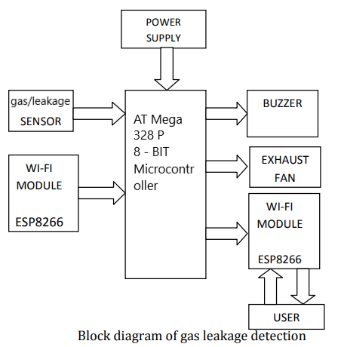

Block diagram: - In figure 3.6, a block diagram is specified highlighting the components of the IOT module in the project it consists of a gas and leakage sensor, a WIFI module, buzzer, exhaust fan and a power supply. The whole process takes place in the AT mega 328 P 8 Bit microcontroller. LPG gas detection sensor MQ2 can detect concentration of gas between 200ppm to 10000ppm. MQ2 is a metal oxide semiconductor type sensor. When a gas is detected, by gas/leakage sensors, the WIFI module at the same time gives an output signal to the buzzer, LCD, and exhaust fan. The intensity of the leakage is further specified on graphical basis to the user for further analysis. This whole process helps in detection of any anomalies through a remote place.

Thus, in the detailed methodology reason and validation for hexagonal structure has been explained along with components of the inspection robot. Components have been selected such that they satisfy market conditions and availability and ensure proper feasibility of the project.

# **Design and calculations**

Mathematical Reason to not select circular frame: More efficient against bending usually means the particular cross-section will develop lower bending stress under the action of the same bending moment (M).

The formula which determines bending stress in a structure or beam under simple bending:

|  |  |
| --- | --- |
| $$σ=\frac{M×Y}{I}$$ | (1) |

I = moment of inertia of defined cross-section  
Y= distance from surface to center of mass of object. To get higher moment of inertia for the same mass (M) and distance from surface to center of mass of object (Y), less bending stress is required

A square of side (h) and area (A) is A = h2 and moment of inertia is: -

|  |  |
| --- | --- |
| $$I=\frac{h⁴}{12}$$ | (2) |

A circle of radius r and area (A) and moment of inertia is

|  |  |
| --- | --- |
| $A=\frac{ πr^{2}}{1}$ and its $I=\frac{ πr⁴}{4}$ | (3) |

When area of both circle and square is equal

|  |  |
| --- | --- |
| h²=πr² or, r $=\frac{h}{\sqrt{π}}$ | (4) |

Substituting the value of r in moment of inertia of circle

|  |  |
| --- | --- |
| $I=\frac{ πr⁴}{4}$........ r $=\frac{h⁴}{\sqrt{π}}$ | (5) |
| $$I=\frac{ h⁴}{4π}$$ | (6) |

Moment of inertia of a circular frame is smaller than moment of inertia of a square frame.

Therefore, the bending stress will be low at every point on the square cross-section if it is compared with circular cross-section, because the value of moment of inertia (I) of square cross-section is higher than circular cross-section.

Motor calculation: - components like motor, joints, electronics component etc. = 1kg

|  |  |
| --- | --- |
| $$Total weight=6.66kg$$ $Taking into account FOS$ = 1.5…... (factor of safety) $Total weight$ = 10 kg $Weight enforced by 1 motor$ = 2.5 kg $Diameter of wheel$ = 50 mm  Torque enforced by 1 motor:  Torque = Force $×$ perpendicular distance from length of link to centre axis | (7) |

= 2.5 $×$ 9.81 $×$ 50

= 1226.25 NM

= 1.23 Nm

= 12.3 kgcm

Then, torque required for 1 motor to Carry the robot =12.3 kgcm

Therefore, we have selected a motor of 25 kgcm torque which is greater than 12.3kgcm to lift the robot upwards.

Output power of a DC motor is = voltage ×current

= 12x0.8

= 9.6 watt

$$Power=\frac{ 2 x π x n x torque}{60}$$

n = 36.67 rpm

We require motor of less power for our design.

So, we are selecting motor with 10 rpm.

Force Analysis:

Normal force (Fn)

Tension force (Ft)

Gravitational Force (Fg)

frictional force (Ff) ...... which is the force between the rubber wheels and the pole

Assuming there’s no sleep condition between wheel and pole

The resultant force in y- direction under equilibrium state

∑Fy = 0

∑Fy = µ cos θ (Fn1 + Fn2 + Fn3 + Fn4) = Fg = mg

In x- direction

∑Fx = 0

Fn1 = Fn2

Fr is the rolling resistance force, Fn normal force, b coefficient of rolling friction between pipe and wheels, r is the radius of the robot wheel

$$Fr=\frac{ Fnb}{r}$$

Two DC motors need to overcome the inertia force Fi caused by the robot mass during the accelerated movement

During the accelerated movement two DC motor needs to overcome the inertia force Fi. In general, due to inertia force it creates the lift force that is in opposite in direction to an accelerating force acting on a body.

$$Fi=m\frac{dv}{dt}$$

Acceleration resistance which creates inertia torque: The wheel rotational inertia I, the angular acceleration of wheel is α, and rolling radius of wheel is rr

τi = I × α

τi = Fi × rr

Fm = Fr + Fg + Fi

τm = τr + τg + τi

Force and torque required for DC motor is Fm and τm . Rolling resistance torque is τr ; torque due to robot gravity is τg .

The stress (σ) on the rubber tire deformation obtained by tension force to grip on The tower surface that equates normal force acting perpendicular to the (A) area can be Determined to be as

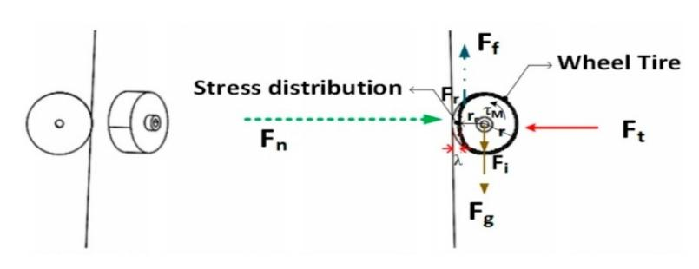σ = $\frac{Fn}{A}$

Forces and moments exerted by the climbing robot all around the tower can cause stress that also depends on the modulus of elasticity (E) of the rubber. Thus, the strain (ε) can be calculated as:

E = $\frac{σ}{E}$

Conceptual design and its dimensions are demonstrated below: -

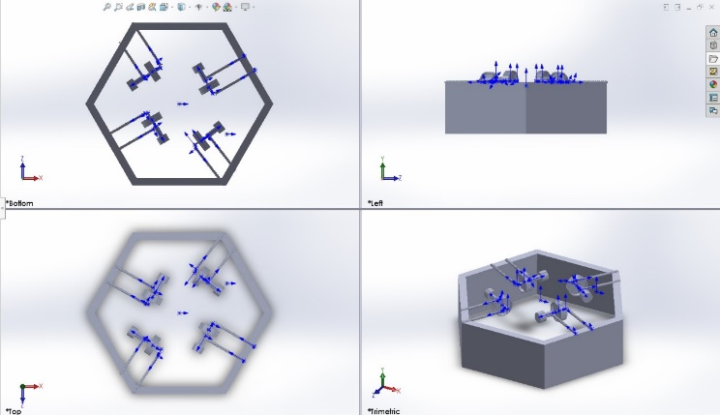

* Center Distance: 314mm. (Horizontal plate.)
* Center Distance: 285mm (Inner Horizontal plate.)
* Center Distance: 175 mm- (Vertical plate.)
* Casing thickness: -28mm.
* Wheel ID: - 60 mm
* Wheel OD: - 80 mm (According to appropriate wheel offered in market.)
* Input shaft diameter: - 37mm.
* Distance between casing and wheel: - 150 mm.
* Distance between input shaft and wheel: - 83mm.
* Distance between two extruded wheels in shaft: -37mm.
* L shaped part latching: - 17mm (vertical distance) & 13mm (horizontal distance with 2.8mm filet.)
* Screw diameter: - 14mm.
* Screw length: -24mm.

Area calculations of hexagon are as follows: - $$Area of hexagon:=\frac{3\sqrt{3}}{2 x 314.54² }$$

S=257041.7

$$S1=\frac{3\sqrt{3}}{2 x 285.5² }$$

S=211209.1

Sh=S-S1

Sh=45832.574

Area of whole structure= 0.42m $²$

# **Results and discussions**

We have designed a robot which can function in both upward and downward direction on pipes. Also, it can carry itself, remain stationary at a desired height sententiously carry its own weight and inspect the pipe by a sports camera and IOT module attached on it. Mechanism of this robot is quite feasible. Output is provided to the user on vision as well as graphical basis. This makes the outcome more dependable and anomalies in the mechanical industry can be avoided. Main features of this robot are, it has good payload capacity, the vision system can collect more information and send it to user via Bluetooth or Wi-Fi. Through the help of two types of sensors leakage and gas can be detected and other problems such as surface irregularities, material defect and crack detection can be covered with the help of the attached camera. Calculations based on area required for hexagonal structure, calculations of frictional force, gravitational force, tension and normal forces have been carried out to support the validation of the project.

Thus, from the above observations and calculations, we can conclude that this are the expected results from fundamental studies and the market research for the design.

##### **References**

1. M Tavakoli and A Marjovi “A climbing robot for inspection of 3D human made structures” *.International Conference on Intelligent Robots and Systems, IROS (2008)*

DOI: [10.1109/IROS.2008.4651024](https://dx.doi.org/10.1109/IROS.2008.4651024)

1. H Kawasaki , S Murakami , H Kachi , and S Ueki “Novel Climbing Method of Pruning Robot” *Proceedings of the SICE Annual Conference (2008)* DOI: [10.1109/SICE.2008.4654641](https://dx.doi.org/10.1109/SICE.2008.4654641)
2. D Qiaoling , L Xinpo, W Yankai and L Sinan “The obstacle-surmounting analysis of a pole-climbing robot” *International Journal of Advanced Robotic Systems (2020)*

DOI: [10.1177/1729881420979146](https://dx.doi.org/10.1177/1729881420979146)

1. K Fondahl, M Eich, J Wollenberg, F Kirchner “A Magnetic Climbing Robot for Marine Inspection Services” Proceedings of the 11th International Conference on Computer and IT Applications in Maritime Industries (COMPIT) (2012)
2. A Anuar, K Salleh and M Sahari “Development of In-pipe Inspection Robot” *IOSR Journal of Mechanical and Civil Engineering (2016)*

DOI: [10.9790/1684-1304076472](https://dx.doi.org/10.9790/1684-1304076472)

1. H Li , R Li , J Zhang and P Zhang “Development of a Pipeline Inspection Robot” *IOSR Journal of Mechanical and Civil Engineering (2016)*

DOI: [10.9790/1684-1304076472](https://dx.doi.org/10.9790/1684-1304076472)

1. A Baghani ,M Nilia and A Harati “Kinematics Modeling of a Wheel-Based Pole Climbing Robot” *IOSR Journal of Mechanical and Civil Engineering (2016)* DOI: [10.9790/1684-1304076472](https://dx.doi.org/10.9790/1684-1304076472)
2. K H Cho, F Liu and H Choi “Cable Climbing Robotic System ” Proceedings of the 28th International Symposium on Automation and Robotics in Construction, ISARC (2011)

DOI: [10.22260/isarc2011/0269](https://dx.doi.org/10.22260/isarc2011/0269)

1. D Schmidt , K Berns “Climbing robots for maintenance and inspections of vertical structures” *Robotics and Autonomous Systems (2013)*

DOI: [10.1016/j.robot.2013.09.002](https://dx.doi.org/10.1016/j.robot.2013.09.002)

1. J Christophe and J Morillon“Design of a climbing robot based on self locking” *Industrial Robot (2010)*

DOI: [10.1108/01439911011037695](https://dx.doi.org/10.1108/01439911011037695)

1. H Kawasaki , S Murakami , H Kachi and Satoshi Ueki “Novel Climbing Method of Pruning Robot” *Proceedings of the SICE Annual Conference (2008)*

DOI: [10.1109/SICE.2008.4654641](https://dx.doi.org/10.1109/SICE.2008.4654641)

1. D Qiaoling , L Xinpo, W Yankai and L Sinan “The obstacle-surmounting analysis of a pole-climbing robot” *International Journal of Advanced Robotic Systems (2020)*

DOI: [10.1177/1729881420979146](https://dx.doi.org/10.1177/1729881420979146)

1. K Fondahl, M Eich, J Wollenberg amd F Kirchner “A Magnetic Climbing Robot for Marine Inspection Service” Proceedings of the 11th International Conference on Computer and IT Applications in Maritime Industries (COMPIT) (2012)
2. I N Ismail, A Anuar, K Mohemad “Development of In-pipe Inspection Robot” *IOSR Journal of Mechanical and Civil Engineering (2016)*

DOI: [10.9790/1684-1304076472](https://dx.doi.org/10.9790/1684-1304076472)

1. S S Hajjai and I B Khalid “Design and Development of an Inspection Robot for Oil and Gas Applications” *International Journal of Engineering and Technology(UAE) (2018)*

DOI: [10.14419/ijet.v7i4.35.22310](https://dx.doi.org/10.14419/ijet.v7i4.35.22310)

1. D Tandon, K Patil and M Dasgupta “Designing a Modular Rope Climbing Bot” 12th IEEE International Conference Electronics, Energy, Environment, Communication, Computer, Control: (E3-C3), INDICON 2015 (2016)

DOI: [10.1109/INDICON.2015.7443716](https://dx.doi.org/10.1109/INDICON.2015.7443716)

1. J Kim , J C Lee ,Y R Choi and S Lee “Automatic Grasping of a Pole Climbing Robot using a Visual Camera with Laser Line Beams” *MATEC Web of Conferences (2016)*

DOI: [10.1051/matecconf/20164203005](https://dx.doi.org/10.1051/matecconf/20164203005)

1. M Tavakoli, L Marques and A T Almeida “A low ­cost approach for self­ calibration of climbing robots” *Robotica (2011)*

DOI: 10.1017/S0263574710000676

1. S Khan and S Prabhu “Design and fabrication of wheeled pole climbing” *IOP Conference Series: Materials Science and Engineering (2018)*

DOI: [10.1088/1757-899X/402/1/012021](https://dx.doi.org/10.1088/1757-899X/402/1/012021)

1. S E Zahab and T Zayed “Leak detection in water distribution networks: an introductory overview” *Smart Water (2019)*

DOI: [10.1186/s40713-019-0017-x](https://dx.doi.org/10.1186/s40713-019-0017-x)

1. S Burn , D DeSilva , M Eiswirth , O Hunaidi , A Speers and J Thornton “[Pipe Leakage – Future Challenges and Solutions](https://www.mendeley.com/catalogue/93e32f9a-4857-3c91-a59a-12901c6a2a7a)” *Pipes Wagga Wagga (1999)*
2. M B Khan, T Chuthong “[ICrawl: An Inchworm-Inspired Crawling Robot](https://www.mendeley.com/catalogue/8660a1c1-591b-3de7-89bd-43f86a90760c)” *IEEE Access (2020)* DOI: [10.1109/ACCESS.2020.3035871](https://dx.doi.org/10.1109/ACCESS.2020.3035871)
3. A Baghani, M N Ahmadabadi and A Harati “Kinematics Modeling of a Wheel-Based Pole Climbing Robot *Proceedings” IEEE International Conference on Robotics and Automation (2005)*

DOI: [10.1109/ROBOT.2005.1570423](https://dx.doi.org/10.1109/ROBOT.2005.1570423)

1. S Belose1, S Sangame, R Shete, B Patil and S Shinde “Design and Development of Automatic Pipe Climbing Robot” *Intelligent Systems, Control and Automation: Science and Engineering (2018)*
2. T Dewi, P Risma “[Motion Control Analysis of a Spherical Robot as a Surveillance Robot](https://www.mendeley.com/catalogue/cf7f5364-2574-38d8-83e4-7e89006ff240)” *Journal of Physics: Conference Series (2019)*

DOI: [10.1088/1742-6596/1167/1/012004](https://dx.doi.org/10.1088/1742-6596/1167/1/012004)

1. H Kawasaki , S Murakami , H Kachi, and S Ueki “Novel Climbing Method of Pruning Robot” *Proceedings of the SICE Annual Conference (2008)* DOI: [10.1109/SICE.2008.4654641](https://dx.doi.org/10.1109/SICE.2008.4654641)
2. H Khairam, Y M Choong, N S N Ismadi, W A F W Othman, A A Wahab and S N Alhady “Design and development of a low-cost pole climbing robot using Arduino Mega” *Journal of Physics: Conference Series (2021)*

DOI: [10.1088/1742-6596/1969/1/012008](https://dx.doi.org/10.1088/1742-6596/1969/1/012008)

1. M Tavakoli , C Viegas, L Marques1 , J Pires and T Almeida1 *“*OmniClimber-II: An omnidirectional climbing robot with high maneuverability and flexibility to adapt to non-flat surfaces” *Proceedings - IEEE International Conference on Robotics and Automation (2013)*

DOI: [10.1109/ICRA.2013.6630746](https://dx.doi.org/10.1109/ICRA.2013.6630746)

1. G Haynes and A Khripiny “[Rapid pole climbing with a quadrupedal robot](https://www.mendeley.com/catalogue/1212d7b1-3133-3e24-9b85-593c042c90b7)” *Proceedings - IEEE International Conference on Robotics and Automation (2009)*

DOI: [10.1109/ROBOT.2009.5152830](https://dx.doi.org/10.1109/ROBOT.2009.5152830)

1. V T Nguyen and N Nguyen “A Study of Wall-Climbing Robot for Cleaning Silo Using Vacuum Principle*” International Journal of Mechanical Engineering and Robotics Research (2021)*

DOI: [10.18178/ijmerr.10.7.368-373](https://dx.doi.org/10.18178/ijmerr.10.7.368-373)