A Review On Electric Vehicle Powertrain

Harshkumar Tiwari R, Amit Aundhakar, Sateesh Patil*
MIT-ADT UNIVERSITY, MIT School of Engineering, Mechanical Engineering Department, Pune

ABSTRACT :-
Electric vehicles (EV) are becoming more common mobility in the transportation sector in recent times. The major objective is to provide an overall view of the current pure electric vehicle powertrain technology and possibilities of future green vehicle development to assist in future research in this sector. An analytical model of an electric vehicle (EV) powertrain has been developed in this work to study the vehicle dynamics, based on a Nissan Leaf EV and Tesla Roadster. The electrical components which is use in the powertrain include a battery pack, a battery charger, a battery management system (BMS), power electronic component (a DC/DC converter, a DC/AC inverter), Motor (a permanent magnet synchronous motor (PMSM)), and a control system (Energy management unit, Energy refueling unit, Temperature control Unit), while the mechanical system consists of power transmissions, axial shaft and vehicle wheels. Help of the real world driving tests and simulation tests in MATLAB/ Simulink the performance of the electric vehicle can be studied, And the estimation of the vehicular dynamics against changes in the vehicle velocity and acceleration, state of charge (SOC) of the battery, and the motor output power. Finally, a number of EVs are introduced in the system to optimize the power dispatch.
1). Introduction
CONCERNS over global warming and depleting fossil fuels have led to the rapid development of electric vehicles (EVs) to replace internal combustion engine (ICE) vehicles. Presently, major industrial countries have published their energy policies and developed economic incentives to encourage the uptake of EVs. The electrical components of the EV powertrain include a battery pack, a DC/DC converter, a DC/AC converter, an electrical machine and a control system The pure battery EVs utilize batteries as the power source to drive the vehicle .fuel cell hybrid electric vehicles (FCHEVs) have a controllable input power from fuel cells and a supercapacitor to respond to the demand. But they are complex in control and costly in the marketplace. For instance, only 200 units of Toyota Mirai (FCHEV) are sold in Europe. In the UK, there are 6008 charging stations for PEVs while there are only 11 hydrogen stations for FCHEVs. In terms of EV motor system, four types of electrical machines are commonly used in EVs. Compared with brushed DC motors, induction motors (IMs) and switched reluctance motors (SRMs), permanent magnet synchronous motors (PMSMs) have their advantages, such as better controllability, lighter weight, higher power density and efficiency. In this work, the EV is Nissan Leaf which utilizes a PMSM. It is a pure EV and is one of the best-sellers in Europe. More than 300,000 cars are sold since its introduction in 2010, including 68,000 in the European market. The Nissan Leaf powertrain includes electrical and mechanical systems. In the literature, EV powertrains are generally modeled by mechanical systems while electrical systems are overlooked.
An electric vehicle (EV) is a road vehicle which involves motion with electric propulsion. The electric vehicle utilized the features of traction provided by an electric motor consuming the portable and electro chemical energy source. The electrochemical energy conversion linkage system between the vehicle energy source and the wheels is the powertrain of the vehicle. The powertrain of an electric vehicle has electrical as well as mechanical linkage. Passenger vehicles constitute an integral part of our daily life, but due to tail pipe emission of conventional internal combustion vehicles (ICEVs), these vehicles generate urban air pollution causing greenhouse gas effect which leads to global warming. Air quality around the globe has been found to be deteriorating and the emissions from the vehicles have been one of the main sources. The increase in vehicular emissions is because of growing population, urbanization, and socio-economic development and the resulting usage of vehicles.

* corresponding guide

2) EV powertrain topology
An electric motor with the simplified gearbox can make up an extremely compact power plant for propelling. According to the distributions and configurations of the power plants, numerous feasible schemes of powertrain topology (i.e., EV powertrain topology) can be achieved. Fig. 1 depicts the four typical types of EV powertrain topology. The central drive powertrain, as shown in Fig. 1(a), is the most common topology for both EVs and conventional vehicles. The differences lie in that the internal combustion engine (ICE) is substituted by an electric motor, and the sophisticated multi-speed gearbox is simplified to a single-stage reducer. The mechanical differential and essential drive shafts are still reserved. Therefore, the chassis layout and configuration do not need to be modified excessively. Some existing EVs such as Nissan Leaf and Tesla Model S adopted this topology. However, the central drive powertrain topology is relatively cumbersome. The tight arrangement of the mechanical components makes it difficult to hold large capacity battery packs. In addition, the energy dissipation is relatively large. Recently, many researches have been conducted on EVs adopting the distributed electric motor configurations. The distributed configuration allows the independent control of each
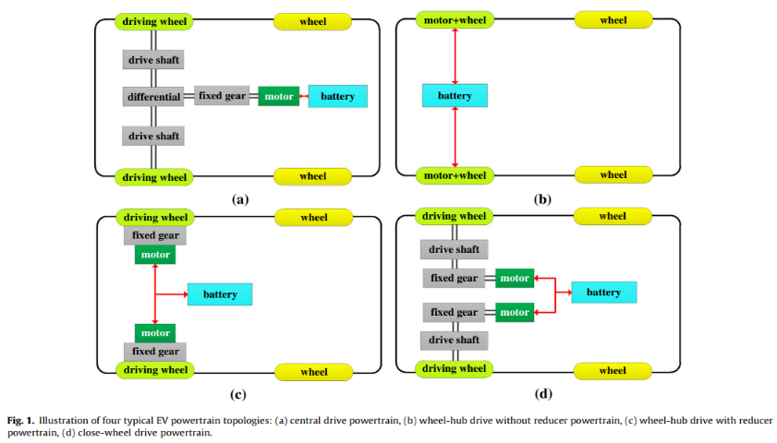
Fig. 1 Powertrain for EVs
diving wheel and the traction torque distribution can be determined intelligently and precisely. Thus, the vehicle dynamics, steering performance and driving safety can be optimized and improved without additional hardware implementation. Additionally, eliminating mechanical transmission such as the gearbox, mechanical differential, and redundant drive shafts, may provide significant improvements on weight reduction, and cost saving. The simplest EV powertrain, called the wheel-hub drive without reducer, is shown in Fig. 1(b). This type of EV powertrain topology has been widely adopted in the electric bicycles and electric scooters which have gained great successes in Chinese market. Although the mechanical transmission loss is eliminated, the electric motor works mainly within the non-efficiency region of the low speed and high torque due to the lack of reducer. For solving this problem, the wheel-hub drive with reducer powertrain is proposed, as depicted in Fig. 1(c). The electric motor and the reducer with constant gear ratio are integrated into a single assembly. The driving wheel connects the drive shaft to the reducer. The major shortcoming of those two wheel-hub drive powertrain topologies is that the unsprang mass of the suspension will be increased, which adversely affects the handling and ride, especially during fast oscillating motions over bumps. The wheels will transmit instead of absorbing the oscillations to the chassis. Fig. 1(d) depicts the schematic of close-wheel drive powertrain. The electric motor and the reducer are also integrated into a single assembly. However, different from the wheel-hub drive powertrain, the close-wheel drive powertrain uses an output shaft of the reducer to drive the wheel through the drive shaft assembly containing universal joints. For instance, Mercedes-Benz applies this type of powertrain topology to their SLS AMG E-CELL vehicle.
3) NISSAN LEAF
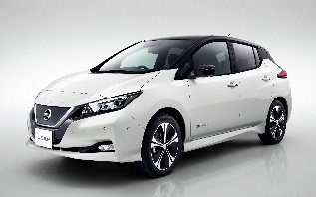
In this section, a model of the Nissan Leaf is created and compared with test results from on-going road tests. The test route daily taken by the driver is approximately 60 km roundtrip on roads with some steep slopes and a mix of urban and suburban driving. Google Maps and Google Earth were found to be very useful tools in estimating the vehicle power consumption. A GPS-based mobile app, View Ranger, is also used to track the location, elevation, and speed.
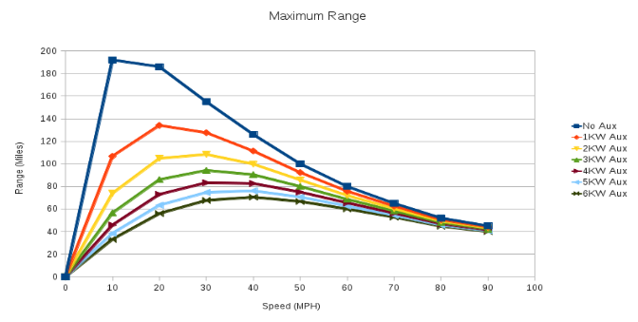
Fig.2 Range vs Speed
Nissan leaf powertrain
The Leaf is powered by an electric synchronous motor with 80 kW (107 hp) and 280 N⋅m (207 ft⋅lb) driving the front wheels. The Leaf was initially equipped with a 24 kWh lithium ion battery, later increased to 30 kWh. The battery is manufactured by Automotive Energy Supply Corporation. It's guaranteed for eight years or 100,000 miles in the USA, and 100,000 km or 5 years in Europe.
There is no active cooling of the battery pack, only passive cooling by radiation. There is a battery refurbishment program in Japan, but not in the US.
Nissan reports the 2011 Leaf has a drag coefficient of Cd=0.29 and the 2013 model Cd=0.28. The Leaf is generally cheaper to operate than gasoline and hybrid cars. However, since the Leaf costs significantly more than similar gasoline-powered vehicles, it may take a long time for the fuel savings to cancel out the increased initial cost, even after government incentives for plug-in electric vehicles.
Nissan Motor Co. Ltd., today introduced its new drive system called e-POWER to customers. It marks the first time that e-POWER technology is available for consumers, marking a significant milestone in the electrification strategy under Nissan Intelligent Mobility.
e-POWER borrows from the EV technology perfected in the Nissan LEAF, the best-selling pure electric car in history, with more than 250,000 units sold. Unlike the LEAF, e-POWER adds a small gasoline engine to charge the high-output battery when necessary, eliminating the need for an external charger while offering the same high-output.
The results presented in Table III shown an excellent correlation with the published data. For 30 % regeneration of braking energy, the model predicts a range of 101 miles correlating well to the Nissan prediction of 100 miles. A range of 74 miles is the model prediction for the EPA 5-cycle range. Allowing for a battery degradation to 80%, this correlates well to the EPA sticker range of 73 miles. The SC03 test under full HVAC indicates that a range less than 40 miles is likely with a degraded or long-life-mode battery and full HVAC at extreme temperatures.
Based on the model developed above, graphs of range versus speed are generated for the Nissan Leaf as shown in Fig. 2.
The curves show the ideal vehicle range for a fixed speed as the upper curve, the middle curve assumes a significant HVAC load of 6 kW for the Leaf for extreme temperature conditions. There is a significant reduction in vehicle range as has been suggested in the Nissan Leaf literature. The lower curve reduces the extreme temperature range to 80 % to allow for battery degradation with time or long-life mode. As can be seen, the HVAC can have a very significant impact on the achievable range. Overall range will reduce with time due to battery degradation.
On-going tests with a Nissan Leaf have resulted in a range of 97 miles. This data point correlates well with the nominal 100 mile range. This point is shown on the graph of Fig. 2 and Table I as VUT for vehicle under test.
The Technology of e-POWER
The e-POWER system features full electric-motor drive, meaning that the wheels are completely driven by the electric motor. The power from a high-output battery is delivered to the e-POWER's compact powertrain comprised of a gasoline engine, power generator, inverter, and a motor. In conventional hybrid systems, a low-output electric motor is mated to a gasoline engine to drive the wheels when the battery is low (or when traveling at high speeds). However, in the e-POWER system, the gasoline engine is not connected to the wheels; it simply charges the battery. And unlike a full EV, the power source originates from the engine and not just the battery.
This system structure generally requires a bigger motor and battery because the motor is the only direct source to drive wheels. This has made it hard for the automotive industry to mount the system in compact cars. However, Nissan has cracked the code and learned how to minimize and reduce weight, develop more responsive motor control methods and optimize energy management. As a result, e-POWER uses a smaller battery than the LEAF, but delivers the same driving experience as a full EV.
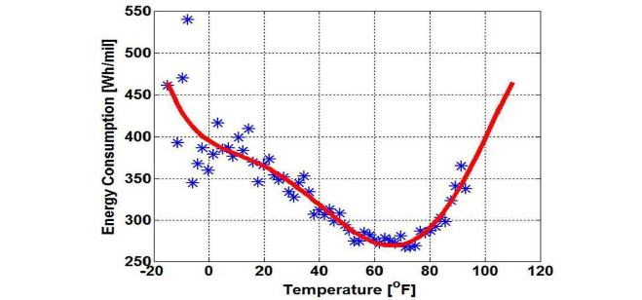
Fig.3 Energy consumption vs Temperature
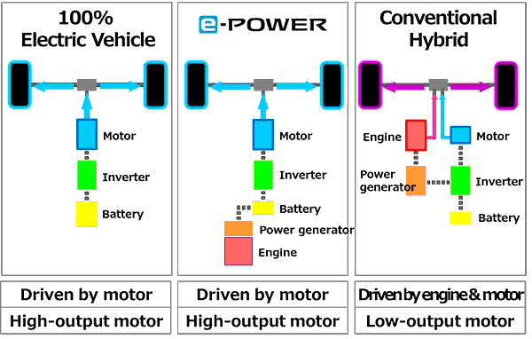
Fig.4 differences between powertrains

Table I 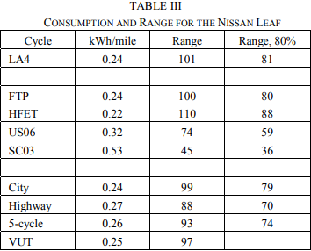4)TESLA ROADSTER
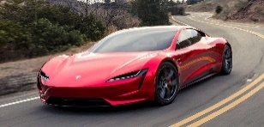
The Tesla Roadster's drivetrain is different from almost any car that's come before. It consists of only three major parts: a motor, a controller and a battery pack. The base motor makes 185 kW, which is equivalent to 248 hp in a gasoline-powered engine. The Sport model makes 215 kW, or 288 hp.
The Roadster uses lithium-ion batteries similar to the ones that power a cell phone, only there's 7,000 of them. The pack can be fully charged at a 220-volt outlet in under four hours, and can run a maximum of 200 miles on one charge. The range of an electric car however, depends on how it's driven. Tooling around town at 40 mph will put maximum range near the upper end of that 200 miles. But slamming the throttle to test the Tesla's acceleration, or attempt to reach the Tesla's maximum speed of 125 mph is going to shorten the range considerably.
The Roadster was built with performance in mind, though. The company realized that if a car was going to cost just over $100,000, it was going to have to have more going for it than stellar green credentials. It can do 0-60 in under 5 seconds, thanks to the electric drive that generates nearly all its torque available all the time. The base Roadster is capable of a strong 275 lb-ft of torque, while the Roadster Sport can make 295 lb-ft
Tesla Motor Company has published various data and information on the range of their vehicles. The following fuel consumption and range curves are presented in Fig 6
A Tesla model is generated to correlate to the above graphs and the parameters are input to the drive cycles similar to the Nissan Leaf above. The predictions for fuel consumption and range are shown in Table III. A higher regeneration level of 50 % is assumed for the Tesla with 4 kW HVAC for the SC03 test. Plots of range versus speed are shown in Fig. 5. The vehicle under test has similar range to the US06 drive cycle, as shown in the bottom row of Table III.
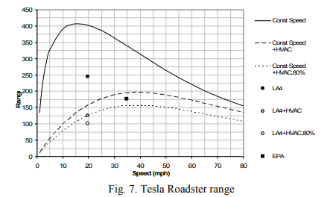
Fig.5 Tesla Roadster Range

Table II
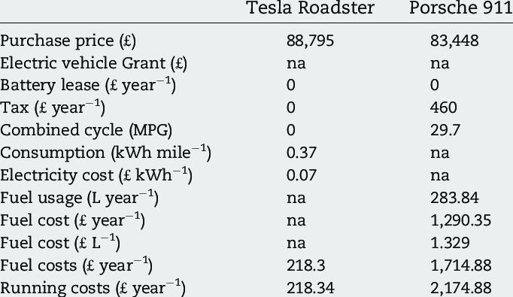

Fig. 6 Tesla Roadster Fuel economy
Fig.7. Tesla Roadster Range

Table III
5) CONCLUSIONS
In this work, simplified EV power train models are analyzed for Nissan Leaf and Tesla Roadster. The models are developed based on published vehicle parameters and range information for the Nissan Leaf and Tesla Roadster. The models are compared with published manufacturer specifications for range under various route and driving conditions, and for various drive cycles. The test route topography is modeled using Google Earth and a GPS based mobile app. Excellent correlations are demonstrated between the experimental results, manufacturer data and the model predictions. Impacts of battery degradation with time and vehicle HVAC loads are considered in the study.
6) REFERENCES
[1] Nissan Motor Corporation website, www.nissanusa.com
[2] Environmental Protection Agency website, www.epa.gov
[3] US EPA, “Fuel Economy of Motor vehicle Revisions to Improve Calculation of Fuel Economy Estimates,” December 2006.
[4]http://www.fueleconomy.gov/feg/fe_test_schedules.shtml
[5] C. Park, A.K. Jaura, “Dynamic Thermal Model of Li-Ion Battery for Predictive Behavior in Hybrid and Fuel Cell Vehicles,” SAE 2003-01- 2286.
[6] C. Mi, L. Ben, D. Buck, N. Ota, “Advanced Electro-Thermal Modeling of Lithium-Ion Battery System for Hybrid Electric Vehicle Applications,” IEEE VPPC 2007.
[7] M. Ehsani, Y. Gao, A. Emadi, Modern Electric, Hybrid Electric and Fuel Cell Vehicles: Fundamentals, Theory, and Design, 2nd Edition, CRC Press, 2009.
[8] AVL, www.avl.com
[9] B. Randall, “Blowing hot and cold,” www.teslamotors.com/blog/blowing-hot-and-cold. Dec. 2006.
[10] J.B. Staubel, CTO, “Roadster efficiency and range,” www.teslamotors.com/blog/roadster-efficiency-and-range, Dec. 2008.
[11] E.D Tate, M.O. Harpster, P.J. Savagian, “The electrification of the automobile: from conventional hybrid to plug-in hybrids, and extended_range electric vehicles,” SAE 2008-01-0458.
[12] 2011 Nissan Leaf Owner’s Manual.

