Review on Mechanisms for Inflate and Deflate Systems
Nikhil Joshi, UG student, MIT WPU, Pune, India. Email: inboxofjoshinikhil@gmail.com
V. S. Kanthale, Associate Professor, MIT WPU, Pune, India. Email: vilas.kanthale@mitwpu.edu.in
N. T. Dhokane, Assistant Professor, MIT WPU, Pune, India. Email: nilesh.dhokane@mitwpu.edu.in
S. B. Barve, Professor, MIT WPU, Pune, India. Email: shivprakash.barve@mitwpu.edu.in

Abstract
An automatic inflation and deflation system is a mechanical/system or mechanism that automatically inflates and deflates tires according to the need of climate and driving conditions. The tire looses on an average of 1 to 2 psi of pressure every month hampering the performance and life of tires .This paper is concerned about review of automatic inflate and deflate systems and focuses on the mechanisms and their applications. The paper has focused on the mechanisms like mechanism using solenoid valve , rotary joint , wind driven compressor . This paper covers the fundamental concepts of various prototypes that have been designed and developed over the years These system can be used in military trucks , tractors , off road vehicles , passenger cars etc . The system keeps the tyres inflated if pressure is low and deflate if pressure is high . Implementation of these systems will help in reducing wear of tires, increasing vehicle performance. The basic components generally used in mechanisms are pressure switch , sensors , housing , compressor , power supply .
Keywords — Automatic inflate and deflate system , mechanisms , reciprocating compressor , solenoid valve , pneumatics , CTIS

Introduction
According to one study, about 80 per cent of vehicles on The road is driven with one and multiple inflated tires. Pneumatic tyre loses air during normal operation. The vehicle may also lose 1 or 2 psi per month in winter and especially in summer.[1]. Research conducted by NACFE in 2013 also demonstrates that a poorly inflated tire will affect vehicle performance and due to heat caused by friction the underinflated tires gets heated up easily[2] .
The ability to inflate and deflate tyres is extremely useful for matching tyre grip to terrain and achieving the best tyre wear and vehicle riding experience. When more traction is needed (such as in snow or sand), the tyres may be partially deflated to increase the amount of surface contact with the terrain.[4]. Maintaining adequate tyre pressure is an important part of vehicle maintenance. Stopping distance, ride and handling, fuel economy, tread wear, and load bearing are all compromised while driving on underinflated or overinflated tyres. For several years, the idea of a tyre inflation mechanism has been used on commercial and military vehicles. Many military vehicles are fitted with a central tyre inflation system (CTIS), which includes both inflation and deflation features and allows the tyre pressure to be manually adjusted in response to the vehicle's road conditions.[9] .
Installation of tire inflate and deflate system will keep tires inflated thus reducing the wear of tire, increasing fuel efficiency and passengers safety.
Goals of the tire inflate and deflate system are
- Detect and monitor the air pressure of tires
- Inflate the tire to proper level if pressure is low
- Deflate the tire to proper level if pressure is high
The basic components generally used in mechanisms are pressure switch , sensors , housing , compressor , power supply . [11]

Mechanism

Mechanism Using Solenoid Valve
Components used in this mechanisms include –
- Flexible hose
- Quick release coupling
- Pressure switch
- Solenoid valve
- Power supply
- Flexible air hose – Used to travel air from compressor to tires
- Quick release coupling – Used to connect or disconnect flow through lines
- Pressure switch – Used for sensing the pressure and transmitting on/off signal to solenoid valve
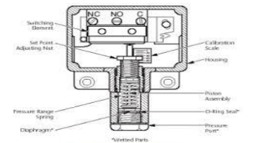
FIG.1 cross section of pressure switch [1]

- Solenoid valve – It is a electrochemical device used to allow or restrict flow of air from compressor
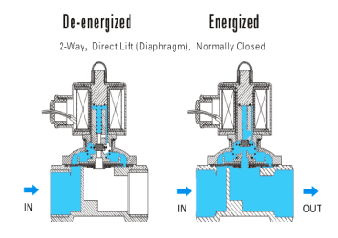

FIG 1.1 working of solenoid valve [1]

Working And Mechanism
Working and mechanism –
In this one finish of the Solenoid valve is appended to the compressor and another to the air hose. This hose is associated with the haggle switch, solenoid valve and switch additionally associated with one another to send the signals. The haggle parts are amassed to the frame .Whenever there is a pressure drop in the tire this pressure is a feeling of the pressure sensor which is pre-aligned, this switch gives the sign to the valve and the solenoid will invigorate and valve open. The packed air will begin streaming and expanding the tire and when the adjusted pressure is acquired the sensor will give the sign and the solenoid will de-empowered and valve close. With this we gotten the adjusted pressing factor and vehicle will run smoothly[1]
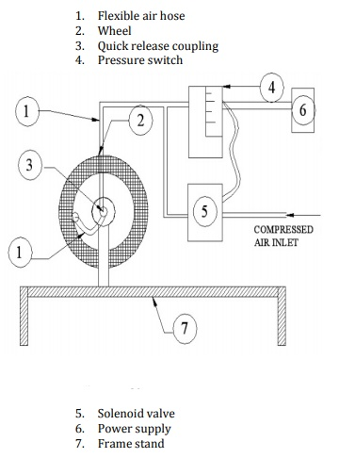
^{FIG. 1.3 Mechanism setup[1]}
- Mechanism using Rotary Joint
In solenoid valve the compressor and air house are connected on either ends of valve the switch and wheels are connected by the hose . the solenoid valve and switch are in contact such that they can transmit signals .
Whenever the pressure in the tires drop below a certain limit . The pressure sensor sense the change in pressure then the solenoid gets signal from switch . due to this solenoid valve energizes and opens . The tire gets inflated as compressed air from compressor starts filling air into tires. And when the tire gets inflated the pressure sensor again sense the temperature and sends signals to de energize the solenoid valve
Components used in mechanism –
- Rotary union –
The rotating association comprises of an air chamber through which the section of air happens along the shaft rotation
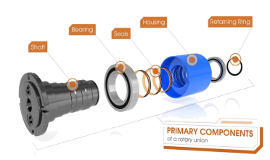
FIG 2.1 Components of rotary union [2]
- Housing –
The wide range of various parts of the rotary union are held together by the lodging. It comprises of a bay port which is strung and lodging providing medium is joined to it. The lodging stays fixed. It is comprised of a shaft, bearing furthermore, mechanical seal from inside
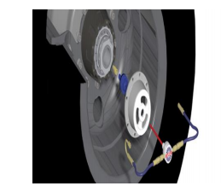
FIG 2.2 Housing [2]
- Compressor –
Compressor is used to increase the pressure and reduce the volume of air in tire
- Pressure gauge and sensor –
- The most significant undertaking in this framework is to identify the genuine tire pressure and measure what amount is by and large should have been provided so the tires are re inflated, so the pressure gauge check and sensors are the most significant gadgets. The sensors recognizes the least and greatest pressing factor level. It will be in ON position at whatever point the pressing factor level goes underneath the limit level of P optimum-min. (least ideal pressing factor) and thus will be turned OFF when the pressing factor level goes above P optimummax.(maximum ideal pressing factor). The pressing factor check lodging is loaded up with a gooey oil. The oil filling has different benefits like it hoses the pointer vibrations and it likewise doesn't leaves any space for encompassing air to enter the framework thusly water doesn't gathers. Perusing appeared by gauge is completely computerized subsequently it is exact and simple to peruse for the client. The pressing factor checks are grouped as indicated by the precession (least exact is grade D – 5% mistake and most exact is grade 4A - 0.1% mistake). A chart outlines the opening of seals because of pressing factor and it stays open until pressure is calmed [2]
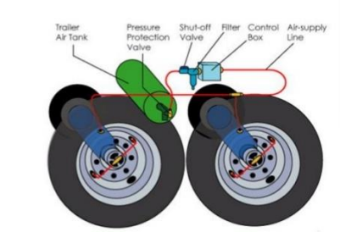
FIG 2.3 - Components of an Air delivery system [2]
- Wind driven compressor mechanism –
When the compressor is active and supplying compressed air to the tyre, the system has a switch that drives the turbine vent gathering outward. This is done so that the sharp edge device is exposed to the drag on all sides and therefore increases the force in the relative wind . As a result, the large circle cover in the graph below serves as a protective cover, ensuring that air currents do not disrupt the wheel's plunge.
Components required in Wind driven compressor mechanism are –
- Compressor Unit
- Pipe network
- Delivery systems and valves
- Sensor mechanism
Definition of the wind-driven compressor system – The framework includes a small wind turbine with 8 rotor edges of outspread length R83mm (due to the limited space on the wheel) that is powered by drag (wind) close to the body of a rapidly moving vehicle. A fast-moving vehicle would be cutting through a cloud of wind, which is moving in the opposite direction. The motor energy in this mass of air is used in this plan because it has the capacity to transform the turbine by turning a small wrench circle R40mm that is rigidly fixed to the back of the turbine hub. The wrench - turn would drive the cylinder pole all the way around in one upheaval, allowing for simple pressure strokes. Because of the limited space on the wheel section, the cylinder - chamber blower is of special size: bore 30mm X stroke L80mm. The compressed air will then be easily delivered to the tyres through the power source check valve (one route calve) to the sensor measure, which will then deliver compressed air to the tyre.[3]
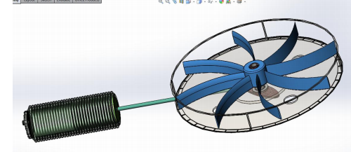
FIG 3 Wind driven compressor [3]
- Centrally controlled tire inflation / deflation system –
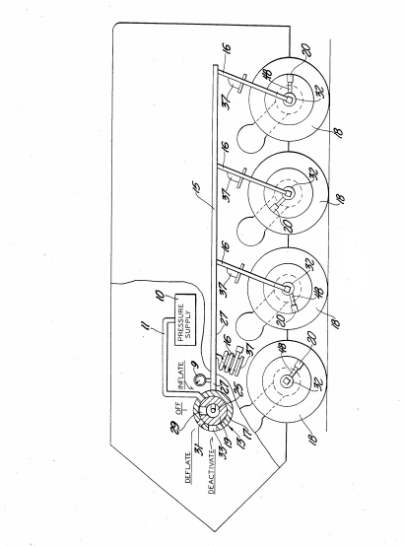
The operation of a halfway regulated tyre swelling/deflation framework is schematically depicted in FIG. A central atmospheric pressure supply (10) with a carrier (11) prompting a physically operated selector valve is included in the system. 13. Ten of the supplies are at a pressure level that is slightly higher than the maximum tyre pressure that can be achieved. Valve (13) is depicted schematically. The valve has a barrel-shaped lodging (17) and a Rotary valve component, as it appears (19). A handle or turn, which has yet to be seen, can be accommodated by pivoting part (19) to one of four distinct positions, like "off," "expand," "deflate," or "deactivate." The rotor component (19) designates a focal cavity or chamber 25 that is in constant communication with an air passage 27 that prompts the vehicle tires. From the hole (25) to the barrel shaped mass of lodging, an expanded port (29) leads (17). Air entry (27) is installed from pressure bid (10) and at mo circle in the delineated scenario of part (19). Port (29) registers with line 11 when part (19) is rotated clockwise for 45 degrees; this is known as the "expand" position. Compressed air from supply (10) travels via line (11) to port (29) and, more importantly, cavity 25, which leads to air entry (27) for swollen vehicle tires. . A 45-degree counterclockwise rotation of part nineteen causes port (29) to register with the small vent port (31). During this method, the air entry (27) is depressurized to a normally low pressing problem, such as 15 p.s.i.g. This position was created to fill a "empty" position. Port (29) registers with huge vent port 33 when part (19) is rotated counterclockwise an additional (45) degrees (a ninety-degree addition); this can be designated as the "deactivate" place. The air entry (27) is depressurized to a low pressure, and the selector valve (13) is preferably located near the driver's station in the taxi region of the vehicle. For the first half of the year, the pressing issue supply (10) will be an air blower and associated flood tank located outside the taxi field. Each flat line (15) is preferably an inflexible course that can be set up within or outside the vehicle, depending on the available space; inside aras are preferred. Any spur (16) on the connected wheel-tire get along is preferably AN flexible path stretching out from line fifteen to an error ring gathering (32) on the connected wheel-tire get together[4].

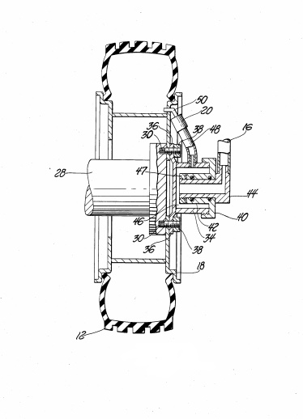
Since road wheel 18 pivots relative to the casing, a form of liquid slip-ring part must be provided at each road wheel to transfer compressed air from each branch entry 16 to the corresponding road wheel. FIG. 2 depicts a revolving hub 28 with different studs 30 for subsequently mounting the wheel 18. The slip-ring assembly 32 has a tube-shaped lodging 34 with at least three tabs 36 that can be inserted into one of the studs 30. Nuts 38 hold the gathering in place on the hub's exposed end board. Screwed onto lodging 34 is a cap 40 with an inner cylindrical expansion 42. For moving compressed air between hose (entry) 16 and inner space 46 inside lodging 34, an air fitting 44 has a turn fit inside cylindrical expansion 42. The hose 48 transports air between the lodging space 46 and the pressure control part 20. Component 20 is connected to a standard tyre valve 50 by a screw.
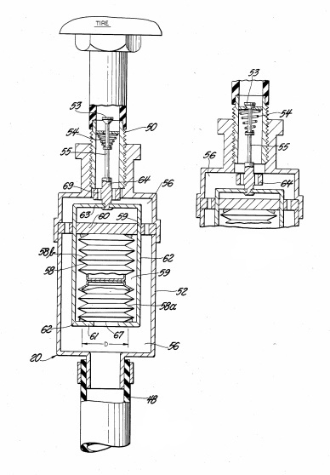
The underlying highlights of pressing factor control feature 20 are shown schematically in FIG. multi-piece lodging structure 52 with a screw-on connection to the tyre valve 50 is included in the component. Valve 50 is a standard design for controlling the compression and depressurization of vehicle tyres; it includes a depressible check valve component 53 with a light pressure spring 54 that moves the valve component to a closed position when the working power from stem 55 is removed. The spring and the tyre pressure keep the valve closed in its closed position. The lodging structure 52 designates a chamber 56 that is located between the hose (air section) 48 and check valve part 53. A fixed pressing factor sensitive case 58, consisting of two fixed howls 58a and 58b, is arranged inside chamber 56. Only one howl is needed for the framework's operation; however, using two roars allows parts to maintain a proportion of operability in the event that one of the howls breaks during administration. When chamber 56 is depressurized, the howls grow to the point where end divider 67 of the cries moves from parcel 60, and each howl 58a and 58b is accused of a gas to a predetermined "very still" inside pressure slightly above air. When chamber 56 is depressurized, the howls grow to the point where end divider 67 of the cries moves from parcel 60. As a result, valve depressor 64 is drawn in by connector lash 62.
Working –
If the tyre pressure is to be reduced from a high to a low level, selector valve 13 is enabled to compress the various carriers 15, 16, and 48; this is accomplished by turning component 19 to the INFLATE position, where port 29 registers with carrier 11. Line 48 delivers compressed air to chamber 56 where depressor 64 is coercively moved toward valve stem 55 by roars 58a and 58b. As a result, the tyre valve is opened. Rotor part 19 is only kept in the INFLATE role for a short period of time. From there, rotor part 19 is moved to the Flatten location, where port 29 connects to small vent port 31. The compressed lines 15, 16, and 48 are vented to the atmosphere in the DEFLATE position. Since valve 53 is open, the associated air will be vented as well. The size of vent port 31 is chosen so that each chamber 56 has a higher pressure than the pressure within the associated roars 58a and 58b during tyre depressurization. Wind current out of the relevant tyre is limited by each valve 53. As a result, the tyre pressing factor will appear to be higher than the pressing factor in chamber 56, particularly near the beginning of the tyre emptying test. The tyre pressing factor will gradually be reduced due to the fact that a nonstop wind stream is produced from the tyre via valve 53 into chamber 56, as well as toward vent port 31 through the various lines 48, 16, and 15. During the tyre emptying phase, rotor component 19 can be switched to the OFF position. Gauge 9 will then be able to reveal the pressing element trapped within the system. Component 19 is switched between DEFLATE and OFF until the desired tyre pressure is achieved. [4]
- Supplying air from axles to rotating tires –
This application is primarily concerned with a vehicle tyre swelling framework for supplying air from the vehicle's axles to the pivoting tyres on a consistent basis. It associates with a System of this kind having an improved rotational unit that sends compressed air from a pivot end to the Surrounding pivoting centre cap through a cylinder positioned toward one side close to the pivot end's focal point and at the other end close to the pivot end's focal point.
One part of a typical rotary union for such a system is fixed to the pivot's farthest limit, while the other is fixed to the centre point cap Some will combine a smooth graphite face seal with an elastomer seal to serve as a strong wear seal while others will use elastomer seals.
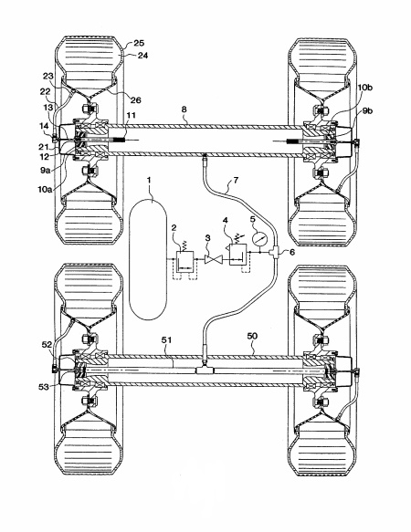
appears to show a vehicle with an air supply 1 attached to the vehicle's side. The repository is supplied with air through a pressure security valve 2. When the supply 1 reaches a base level of pressing factor, the pressing factor assurance valve 2 opens, allowing air to flow through to the shut-off valve 3. The Shut-off Valve 3 will be physically opened until the framework is operational. Air should be sent to the pressing factor controller number four. The pressing factor controller 4 reduces the supply pressure in the vehicle's tyres to the optimal pressing factor. A pressing factor measure 5 takes into account the pressing factor controller 4's valid update. At that point, a complex 6 makes it conceivable to convey air to a majority of axles The attachments 9A and 9B, as well as their individual seals 10A and 10B, transport air to the pivot 8, which is empty and fixed at the two ends by the attachments 9A and 9B and their individual seals 10A and 10B. The air from the joined channel 7 is compressed in the hub 8. The compressed air in the pivot at that point passes through a channel 11 and into the opening of the principal rotational patron 12, which is Seal ably connected with the hub plug 9A and kept in place by pipe strings at the pivot's hub.
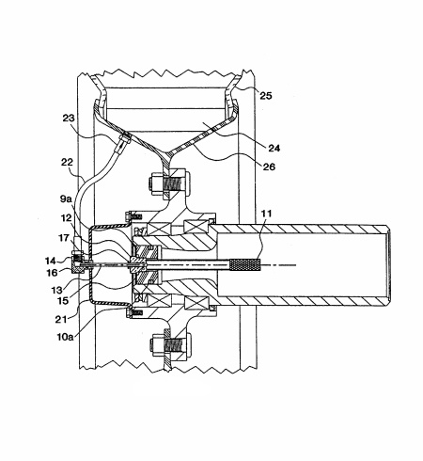
shows a closer view of the rotational relationship, showing how compressed air is transferred from the primary turning patron 12 to the adaptable cylinder 13 and fixed by the static Seal 15 positioned over the part's opening. The adaptable cylinder setup is held in place by a pressure fitting 17, in this case a collect. The adaptable cylinder 13 then directs compressed air into the opening in the Second Part 14 of the turning connection, which is attached to the hub of the centre point cap 21. . To form a rotatable seal between the adaptable cylinder 13 and the second part 14, a powerful Seal ring 16 is conveyed around the opening in the subsequent part. The compressed air is sent through a course 22 and a single direction register valve 23 with the compressed territory 24 formed by the tyre 25 and the wheel 26 until it is in the rotatable Second part 14. Every second hub 50, which is empty but does not go around as a compressed channel like the main pivot 8, is shown in FIG. If all else is equal, a channel 51 is housed inside the hub 50, and the settling plug 52 establishes a link between the channel 51 and the first person from the turning association 53.
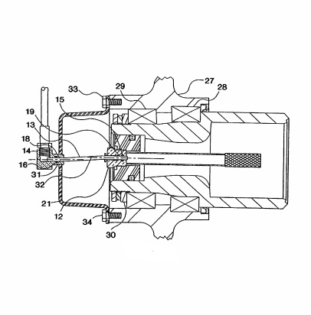
FIG. depicts a modified version of the invention in which the adaptable cylinder 13's finish passes coaxially through the special Seal ring 16 and an additional Seal a day and a half, the first 18 internally of ring 16. The third seal ring is not a traditional compressed Seal; rather, it prevents compressed air from spilling past the wear Seal ring 16 from entering the bearing oil compartment 38 by redirecting it through a vent 41. Although the bearing oil compartment 38 is normally vented through an opening 39, without the Seal ring a day and a half location, added gaseous stress from a spill at the wear Seal ring 16 could introduce contaminants into the oil compartment 38, and an additional pressing factor could cause the wheel seal 40 to fail prematurely.
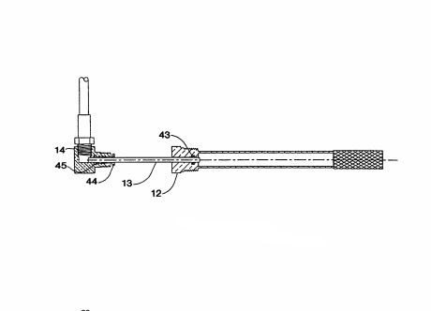
The powerful wear ring 43 is housed in the part 12, and the collet 44 and the static seal ring 45 are housed in the turning association's Second part 14. FIG. is an altered version of the revolving association where the powerful wear ring 43 is housed in the part 12, and the collet 44 and the static seal ring 45 are housed in the turning association's Second part 14. The adaptable cylinder 13 compensates for bearing wobble and other misalignments. A chime mouth 68 on the main part 12 allows the flexible cylinder 13 to be strung into the extend opening 19 during installation. [5]
Application in Logging Truck –
CTI was implemented on 11 axle logging truck . The 2 structured tests drawbar pull and rolling resistance were performed . The used data system was self contained , programmable , battery operated and portable . Drawbar pull tests were performed on ice and snow with hard and soft tires. When truck was not loaded drawbar pull increased by 31% on snow and 37% on icy road by using lower tire inflation pressure
When truck was loaded the traction was observed to be increased by 6% where as no change observed in performance on snow roads. On sugar sand roadways rolling test was performed that reduced the average load by 45% when the tire inflation was lowered . The peak value observed got reduced by 39% from 3100 lbs to 2200 lbs
When the tires are lower inflated it reduces damage to forest roads that improves the ride of truck. When CTI are implemented it needs less gravel to stabilize sand roads. The road costs were decreased by 62% as observed in this study. Improved traction, rolling resistance . Truck drivers also supported the concept of CTI [6]

Conclusion
The paper is concerned about the different mechanisms used in automatic tire inflate and deflate system .The paper explains the mechanisms and their working and also the applications of system in logging trucks and the advantages of using the system in logging trucks . Using of automatic inflate and deflate system in vehicles will help in increasing efficiency and reducing wear of tyres . In generally we can conclude the mechanisms have compressor , housing , sensor and pressure valve in common. The use of system in forest logging truck will reduce the need of gravel , improve traction and rolling resistance

References
- AUTOMATIC TYRE PRESSURE INFLATION SYSTEM Shivam Dangi1, Jitesh Singh2, Kshitij Bachhania3, Colonel P.K. Prasad4
- AUTOMATIC TIRE INFLATION SYSTEM SHREYANSH KUMAR PURWAR
- Design of an automatic tyre pressure inflation system for small vehicles Tawanda Mushiri
- TIRE INFLATION/DEFLATION SYSTEM Lawrence A. Gant, 1027 Harvard, Gross Pointe Park, Mich. 48230
- VEHICLE TIRE INFLAION SYSTEM Mark H Nadler
- Performance Of A Logging Truck With A Central Tire Inflation System John A . Sturos, Douglas B . Brumm , and Andrew Lehtos
- TRENFLATION SYSTEM : Anthony L. Ingram, Guthrie, OK (US); Calvin Burgess, Guthrie, OK (US); Michael H. Penwell, Oklahoma City, OK (US); Patrick E. Roberts, Owasso, OK (US)v
- INTELLIGENT TIRE INFLATION AND DEFLATION SYSTEMAPPARATUS (71) Applicants: Joe Huayue Zhou, Hacienda Heights, CA (US); Steven Hiuman Wong, Cerritos, CA (US)
- TIRE PRESSURE MANAGEMENT SYSTEM Airgo IP , LLC , Oklahoma City
- Auto How Stuff Works/CTIS
- ProLee lns of the TnLernaton.l Con erence on the Percormvce

