CFD Analysis of spiral, helical and conical tubes.

1st Satyavan P. Digole  
*Department of Mechanical Engineering,*  
*MIT SOE MIT ADT University*Pune, India  
satyavan.digole@mituniversity.edu.in

4th Tejas D. Dagade  
*Department of Mechanical Engineering,*  
*MIT SOE MIT ADT University*Pune, India  
dada22.4883@gmail.com2nd Rushikesh H. Pisal  
*Department of Mechanical Engineering,*  
*MIT SOE MIT ADT University*Pune, India  
rushikeshpisal909@gmail.com

5th Omkar A. Pardhi  
*Department of Mechanical Engineering,*  
*MIT SOE MIT ADT University*Pune, India  
pardhi.onkar88@gmail.com 3rd Prasad B. Gilbile  
*Department of Mechanical Engineering,*  
*MIT SOE MIT ADT University*Pune, India  
prasadgilbile9722@gmail.com

***Abstract*—The coiled tube due to it’s high heat exchange property and compact structure it is generally used in many industrial applications. As these pipes have a curved structure there is a formation of turbulence which forms dean vortices, and this increases the heat transfer coefficient. By Using ANSYS Fluent we have studied the heat transfer coefficient and heat rate for spiral, helical and conical tubes. For all three coils additional pressure drop, temperature distribution and velocity distribution are also shown, by using Fluent steady-state simulation is carried for the prediction of the temperature of outlet fluid flowing through tubes. And for CFD trials similar tube diameter and length are considered, for all shapes of tubes the outlet temperature is varied with mass flow rate. Maximum outlet temperature 338.9l is seen for the spiral tube for 0.04 kg/s mass flow rate. The heat transfer coefficient for the spiral tube is 0.44% greater than the helical tube and 2.57% greater than the conical tube for a 0.04 kg/s mass flow rate. Additionally, pressure drop through the spiral coil is 2% greater than a helical and conical coil.**

Keywords—Spiral tube; Conical tube; Helical tube; Computational fluid dynamics; Heat Exchanger

# Introduction (*Heading 1*)

Heat transfer is a mechanism in which energy and entropy are transferred from one place to another and it’s been used in many industrial applications like heating, cooling, condensers in power plants and steam generators, etc. [1-3] In thermal efficiency, heat transfer play’s an important role in increasing efficiency as wastage is reduced. The process of increasing the effectiveness of heat exchangers is known as heat transfer enhancement, there are main two types active and passive, this process is mainly used to improve the efficiency of heat exchangers or any other system which uses coils for heat transfer. [4-6]

For the active heat transfer enhancement, it needs additional energy at the input, for example, it is used in jet impingement, surface vibrations, and electrostatic fields, whereas in passive it doesn’t require any external energy, and that is why it’s been used more than active as there is less power consumption, but as compare to passive, active cooling systems are much better, the examples of passive heat transfer are wire coils, twisted tapes, ribs, dimples, and dimples. [7-10] These two techniques do enhance heat transfer rate, as compared to straight tubes, it is also been proved by many researchers worldwide. [11-15]

The kubair and kuloor studied two spiral coils for the ‘Greatz problem’ which tells about curvature ratios term, they studied combinations of straight tubes, helical and spiral coils, and thermal efficiency of curved coils was proven superior compared to straight tubes,[16] and within coils, spiral coil was more efficient. Dr. Madhukar and Dr. Joshi came up with a new design for a process industry where steam was generated with the help of waste heat [17]. Paisarn Naphon studied to influence curvature ratio on both the transfer of heat and flow formation throughout the spirally horizontally tubing, their studies show that centrifugal force has greater impact on improving heat transfer and drop of pressure [18], Yang and Lau their approach was to improve convective heat transfer by analyzing the temperature field, pressure field and path lines for demonstration of their new heat exchanger.[19]

The Yakut and Sachin utilized vibration behavior of the conical ring, for increased thermal performance and they concluded that heat transfer occurs at the smallest pitch ratio, [20-21] Digvijay.D did a comparison between cone-shaped helical coil and helical coil and it was found that cone-shaped helical coil is 1.18 to 1.38 times better than the simple helical coil. [22-24]

G.D Gosavi studied that fins can be used to dissipate about 50% to 60% of heat and stated that due to perforation heat transfer becomes more uniform and perforated fin has greater efficiency then solid fin[25], Alberto Garcia investigated the three wire coils and made conclusion that heat transfer enhancement with wire coils is quite higher than one obtained with twisted tapes[26], mostly materials used for heat transfer exchangers are aluminum and copper because of their optimum property of their optimum property and corrosion resistance, in here we are using copper as it has high conductivity and low resistivity, and because of that setup becomes more compact, so in passive heat transfer enhancement[27-30] , coils play important role so different types of coils are considered like helical, spiral and conical their comparison is done to come up with efficient coil, here we’ve used computational fluid dynamics(CFD) methodology using ANSYS Fluent is used for carrying analytical to find analytical simulations to find out parameter changes, all these variations were taken into account as mass flow rate changes (0.4kg/sec-1.2kg/sec), all simulations were considered to find their heat transfer behaviour for each coil and for results graphs were used for each coil.

After getting the results we are going to compare it with the reference paper, and going to check the variation if we get results close enough, we will compare all three coils to come up with an efficient coil.

.

.

# Materials and Methods

## Numerical Computation

The modeling of the spiral tube heat exchanger is done and then conversion is done by using solid edge by step file for further CFD analysis. The process of discretization involves the transformation of a partial differential equation into a set of an algebraic equations for discrete points. ANSYS workbench 20.2 with grid system is used to do discretization. Boundary condition specify the flow variation and it allows the governing equation to differentiate between different flows fields and produce a unique solution for a given geometry. The governing equation can be written as:

$\frac{∂}{∂x_{i}}\left(ρu_{j}\right)=0$ (1)

$\frac{∂}{∂x_{j}}\left(ρu_{i}u_{j}\right)=\frac{∂}{∂x_{j}}[ -ρδ_{ij}+ μ\left(\frac{∂u_{i}}{∂x_{j}}+\frac{∂u_{j}}{∂x_{i}}\right)$ (2)

$\frac{∂}{∂x_{i}}\left(ρu_{j}C_{p}T\right)-\frac{∂}{∂x_{j}}\left(λ\frac{∂T}{∂x_{j}}\right)=S_{T}$ (3)

To calculate acceptable solution grid convergence index carried out. In this study object having different grid distributions are considered such as:

• Spiral tube - 134044, 100305, 237820,3125770 and 3034980

• Helical tube - 113025, 100120, 234675,2545395 and 2475925

• Conical tube - 205024, 180245, 302624,3987210 and 3894750

From this grid distribution it is observed that 5 grid distributions give acceptable solution. Outlet temperature of water is calculated at different grid distribution, it is found that grid finer than 237820, 234675 and 302624 for spiral, helical and conical tube gives acceptable solution at outlet temperature and its variation within 1%.

The Pre-Processor:

The Pre-processing is the first step of CFD analysis in which the model objective definition, identification of computational domain is carried out first. This is followed by generation of mesh structure. More than 50% time is spent on the mesh generation. In order to reduce difficulties, the geometries are done on the Solid edge software. The 3-Dimensional geometrical model is imported on the Ansys workbench. The mesh model is shown in fig 1. The domain is meshed with Quadratic mesh.

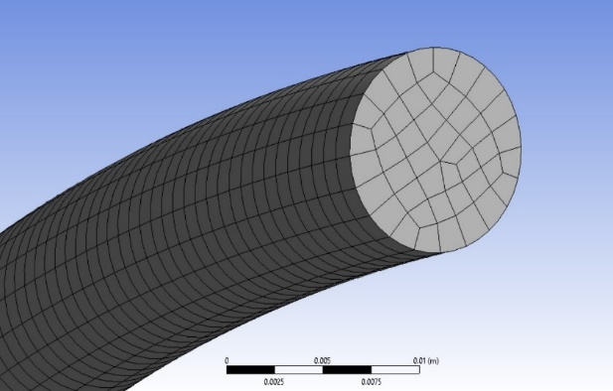

1. Meshing

The nodes and elements for the tubes are:

1. Geometry elements and notes details

|  | Nodes | Elements |
| --- | --- | --- |
| Spiral tube | 1124393 | 237820 |
| **Helical tube** | 1090089 | 234675 |
| **Conical tube** | 1367399 | 302624 |

The Main Solver:

The solver is generally the heart of the CFD. Fluent Solver is used for the setup and solution. The he meshed model is selected with double precision. The solver type is pressure-based, velocity formation is absolute and time is steady. Then material properties are defined. The water-liquid as a working fluid which is flowing through tube.

The fluid properties for water being constant throughout the computational domain are:

• Density – 998.2 kg/m³

• Specific heat – 4182 J/ (kg K)

• Thermal conductivity - 0.6 W/ (m K)

• Viscosity - 0.001003 kg/ (m s)

The Solid material used is copper with constant properties are:

• Density – 8978 kg/m³

• Specific heat – 381 J/ (kg K)

• Thermal conductivity - 387.6 W/ (m K)

The Energy equation is used in the solver. The convergence criteria all mass, momentum and energy equation are 10-3 . The boundary condition in the fluent are given as follows:

• Inlet boundary condition: The inlet is mass flow inlet having mass flow rate varying from 0.04 to 0.12 kg/sec with constant inlet temp of 300K.

• Outlet boundary condition: The outlet is outlet vent having the pressure at atmospheric pressure.

• Wall boundary condition: The wall is stationary wall which is at 353K temperature.

In Solution the Simplic method with Hybrid initialization is done. The second order scheme was used for solving momentum and energy equations. Relaxation factor have been kept to different values.

1. Relaxation factor detail

|  |  |  |  |  |
| --- | --- | --- | --- | --- |
| Pressure | Momentum | Energy | Density | Body Force |
| 0.3 | 0.7 | 1 | 1 | 1 |

Specific Iterations are given for run calculation.

The Post-Processor:

The post processor is last part of CFD. In this the result are displayed with the help of contours, vector, streamline and volume rendering. The calculations are done from the above experimental values.

## Calculation

The surface area (0.26 m2 ) and the length of the tube (8.48 m) are constant in helical, spiral and conical tube.

𝐴 = 2 𝜋 𝑟 𝑙 (4)

The calculations are done from the results that obtained through numerical computation. The value of Cp is taken as 4182 J/kg K. The outer wall temperature is 353K. The inlet temperature of the fluid is 300K. The mass flow rate of the water varied from 0.4 to 0.12 kg/sec.

The heat rate can be expressed as:

𝑄 = 𝑚 𝐶𝑝 ∆𝑇 (5)

The Heat transfer coefficient can be expressed as:

𝑄 = ℎ 𝐴 ∆𝑇 (6)

# results and discussion

## Effect of Mass flow rate on Average Outlet temperature for spiral, helical and conical tube

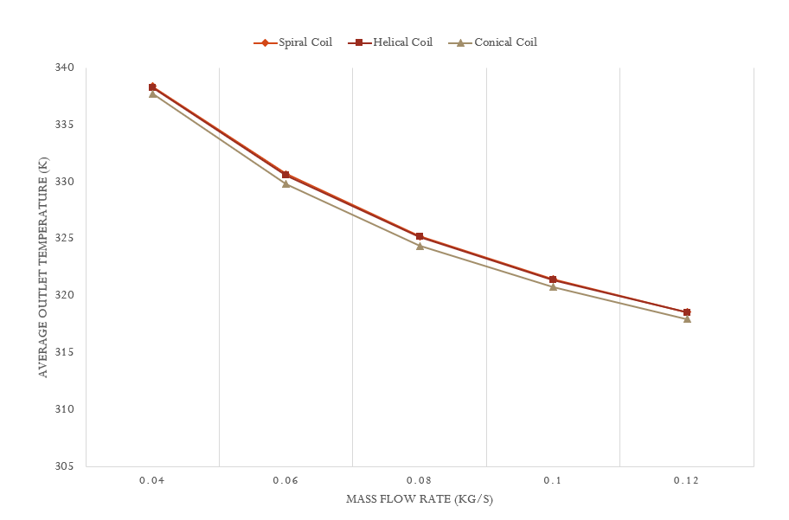

1. Mass flow rate vs average outlet temperature

The effect of mass flow rate on average outlet temperature is observed in the graph, as mass flow rate increases average outlet temperature decreases gradually, it is seen that at 0.04 mass flow rate average outlet temperature is maximum (i.e., between 335 to 340) and at mass flow rate 0.12 average outlet temperature minimum (i.e. between 315 to 320). The mass flow rates for all the three tubes are 0.4, 0.6, 0.8, 0.10 and 0.12 according to this the average outlet temperature of the spiral tube is 338.39, 330.71, 325.23, 321.46, 318.57. For helical tube it is 338.28, 330.60, 325.20, 321.40, 318.56 and for conical tube 337.77, 329.83, 324.41, 320.80, 317.96. It is seen that the change outlet temperature in the spiral tube is maximum as compared to other and in the case of conical and helical the change is similar.

## Effect of Mass flow rate on Pressure drop for spiral, helical and conical tube

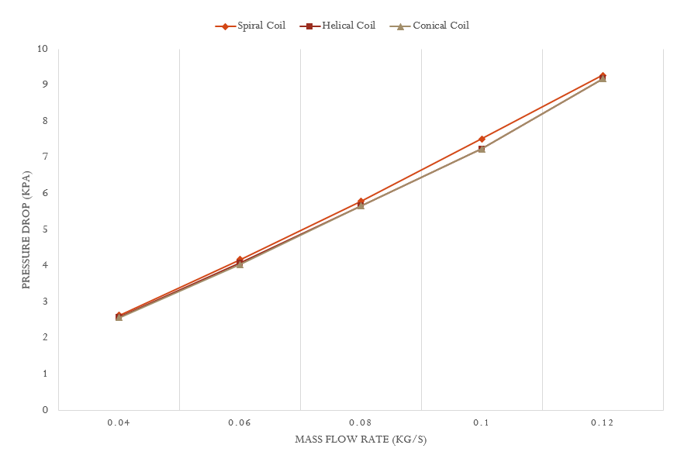

1. Mass flow rate vs Pressure drop

The effect of mass flow rate on pressure drop is seen in the graph it is seen that there is the effect of mass flow on pressure, as the mass flow rate increases pressure drop increases, in this case, mass flow is also considered from 0.04 to 0.12 and the behavior change in pressure drop is similar in all tubes it is increasing gradually, for the spiral tube it is 2.6, 4.18, 5.8, 7.5, 9.2 and for helical tube 2.5, 4.0, 5.6, 7.2, 9.1. The values of pressure drop for conical tube is 2.5, 4.0, 5.7, 7.2, 9.0. The max value of pressure drop is at 0.12 (i.e., 9.2 Kpa) in spiral tube and min value is at 0.04 (i.e., 2.57 Kpa) in conical tube, the change in pressure drop in spiral is seen high as compared to all other tubes, whereas in conical and helical the pressure drop change is quite similar throughout.

## Effect of Mass flow rate on Heat rate for spiral, helical and conical tube

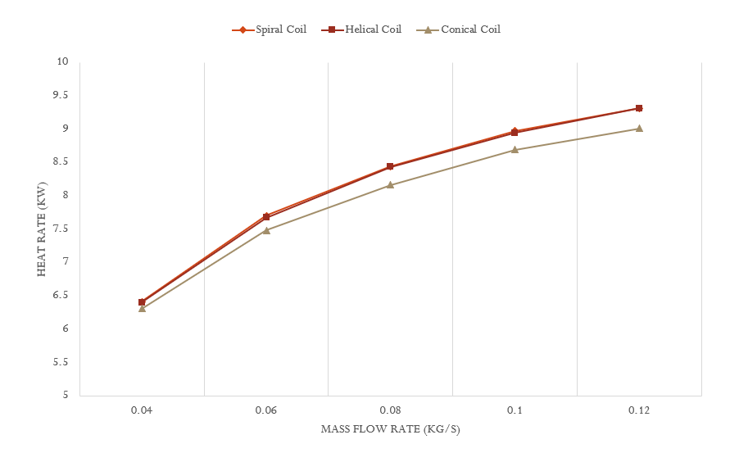

1. Mass flow rate vs Heat rate

The effect of mass flow on heat rate is seen in the graph, it is seen as mass flow increases heat rate increases, there is gradual increment of heat rate, the mass flow is considered from 0.04 to 0.12 according to this for spiral tube heat rate is 6.4, 7.7, 8.4, 9.0, 9.3. For helical tube heat rate is 6.3, 7.6, 8.4, 8.9, 9.3 and for conical tube is 6.3, 7.4, 8.1, 8.6, 9.0. The change of heat rate in conical is minimum as compared to other and in case of helical and spiral the change is quit the same, here minimum heat rate is seen at 0.04 (i.e., 6.3 Kw) in conical tube and maximum at 0.12 (i.e., 9.3 Kw) at spiral tube.

## Effect of Mass flow rate on Heat transfer coefficient for spiral helical and conical tube

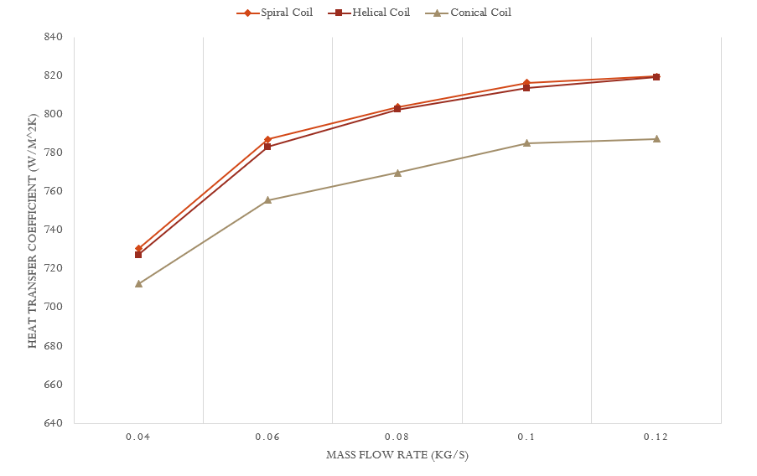

1. Mass flow rate vs Heat transfer coefficient

It is seen that there is effect of mass flow rate on heat transfer coefficient in all three tubes, and as mass flow rate increases heat transfer increases, the behaviour change in heat transfer coefficient is similar in all three tubes, the change of mass flow is considered from 0.04 to 0.12 and. In the spiral tube as per the mass flow rates heat transfer coefficient are 730.6, 787.3, 803.9, 816.6, 818.9 also for helical tube 727.3, 783.3, 802.6, 813.7, 819.4 and for conical tube heat transfer coefficient are 712.3, 755.9, 769.9, 785.3, 787.4. It is also seen that there is maximum change of heat transfer in the start (i.e.,0.04 to 0.06) and after that there is gradual change, and in conical tube coefficient of heat transfer is low as compared to other two, whereas the change of heat transfer in spiral and helical are quite the same.

## Pressure Contour

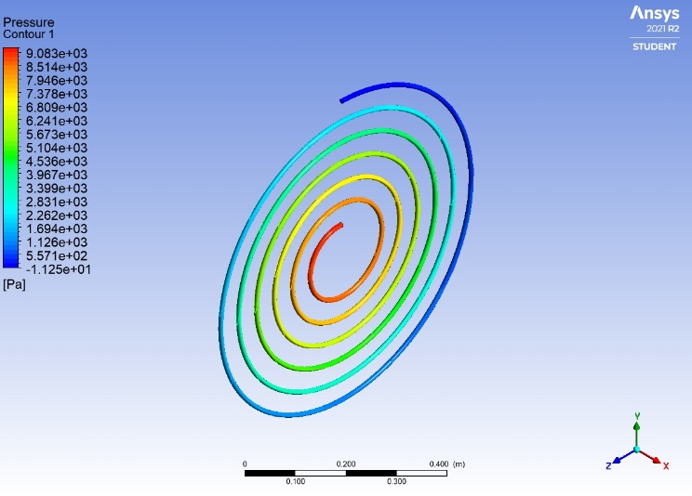

1. Pressure contour of spiral coil

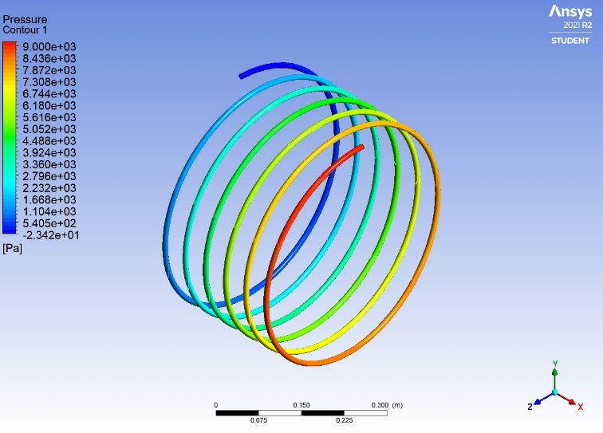

1. Pressure contour of helical coil

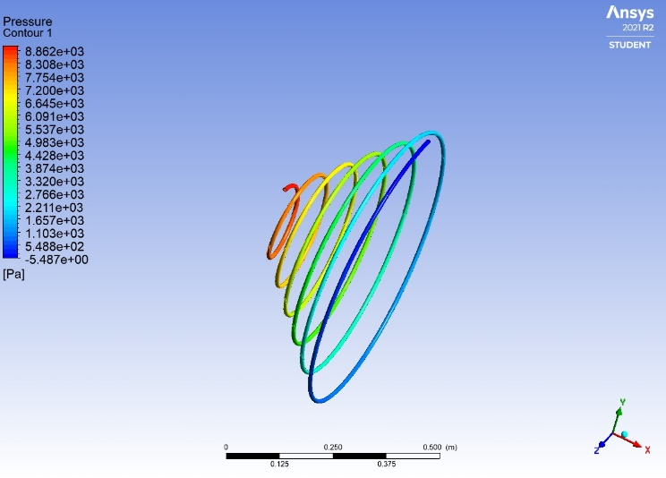

1. Pressure contour of conical coil

Fig. 6,7 and 8 shows the pressure contour of the spiral, helical and conical tubes at a 0.12 (kg/sec) mass flow rate. The pressure is maximum at the inlet of the tube shown by the red color and then decreases at the outlet end shown by blue color. The pressure shown is in the local range by default legend view.

## Temperature Contour at the outlet of the tube

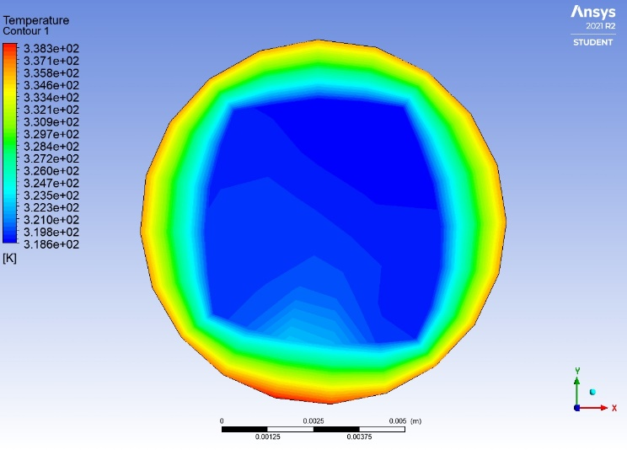

1. Temperature contour of spiral coil

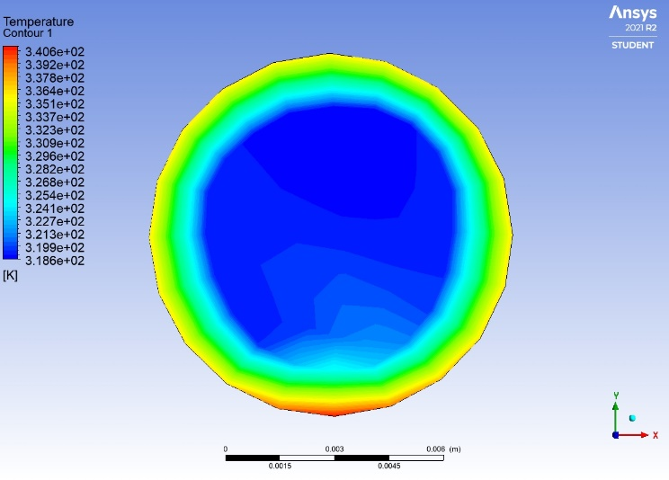

1. Temperature contour of helical coil

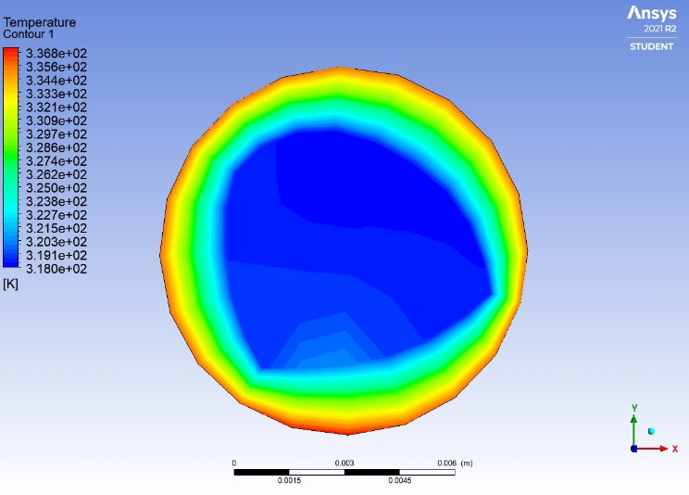

1. Temperature contour of helical coil

In the temperature contour, the temperature is maximum at the outermost side of the tube. It is reducing towards the innermost end. Fig 9,10 and 11 shows the temperature contour of spiral, helical and conical coil respectively.The temperature shown is in the local range by default legend view.

## Dean Vortices

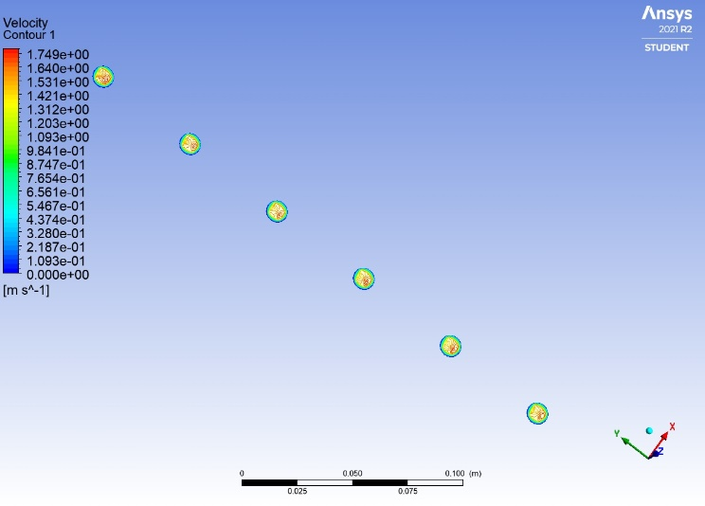

1. Dean vortices

During the motion of the fluid in the curved pipe centripetal forces caused particles of fluid to change their motion from the main direction of the particle. This motion appears as a pair of counter-rotating cells. The velocity contour shows the formation of Dean vortices in fig 8.

##### conclusion

This study presents the numerical study on the helical, conical and spiral tube, where the thermal and flow characteristics are resolved using ANSYS Fluent. After the experimental investigation following conclusions are found from the present numerical analysis work:

* The average outlet temperature of the spiral tube is greater than 0.032% of the helical and 0.18% of the conical tube. The conical tube is smaller than 0.15% of that of the helical tube.
* It is seen from the result that the pressure drop in the spiral tube is greater than 2% of the helical tube and conical tube.
* As predicted heat transfer coefficient of the spiral tube is greater than the helical and conical tube. The spiral tube heat transfer coefficient is 0.44% greater than the helical tube and 2.57% greater than the conical tube.

##### Nomenclature

h - Heat Transfer Coefficient (W/m2 K)

A - Area (m2)

M - Mass Flow Rate (kg/sec)

Cp - Specific heat (kJ/kg K)

T1 - Inlet Temperature (K)

T2 - Outlet Temperature (K)

Q - Heat transfer rate (kW)

l - length (m)

##### Acknowledgment

I would like to acknowledge and give my warmest thanks to my supervisor Satyavan Digole who made this work possible.

##### References

1. Pooja Jhunjhunwala, CFD ANALYSIS OF HELICALLY TUBEED TUBE FOR COMPACT HEAT EXCHANGERS, Master of Technology in Mechanical Engineering with Specialization in Thermal Engineering.
2. Yamini Pawar1, Ashish Sarode2, An Experimentation of Helical Tube Tube Heat Exchanger with Different Curvature Ratio and Geometry, 2017 IJCRT | International Conference Proceeding ICGTETM Dec 2017 | ISSN: 2320-2882.
3. Srinivas Valmiki, Heat Transfer Enhancement In Pipe With Passive Enhancement Technique, 2017 IJEDR | Volume 5, Issue 3 | ISSN: 2321-9939.
4. 1Ramnaresh R. Prajapati, 2Pravin A. Mane, 3Mrs. Seema Mane, 4Dattatray Gaikwad, Review of Recent Techniques of Heat Transfer Enhancement and Validation of Heat Exchanger, Journal of Emerging Technologies and Innovative Research (JETIR) (ISSN-2349-5162)
5. 1Mangesh Shashikant Bidkar, 2Dr. Rashed Ali, CFD Investigation of Convective Heat Transfer in Spiral Tube tubes, Journal of Emerging Technologies and Innovative Research (JETIR) (ISSN-2349 5162).
6. Srinivas Valmiki, Heat Transfer Enhancement In Pipe With Passive Enhancement Technique, 2017 IJEDR | Volume 5, Issue 3 | ISSN: 2321-9939
7. Mr. Tejas Sonawane1, Mr. Prafulla Patil1, Mr. Abhay Chavhan1, Prof. B.M.Dusane2, “A REVIEW ON HEAT TRANSFER ENHANCEMENT BY PASSIVE METHODS”, International Research Journal of Engineering and Technology (IRJET) e-ISSN: 2395 -0056 p-ISSN: 2395-0072
8. Leon Liebenberg, Josua P. Meyer, In-tube passive heat transfer enhancement in the process industry, 2007 Published by Elsevier Ltd.ScienceDirect, Applied Thermal Engineering 27 (2007) 2713–2726
9. Umang K Patel1, Prof. Krunal Patel2, CFD ANALYSIS HELICAL TUBE HEAT EXCHANGER, IJARIIEISSN(O)-2395-4396 4126 www.
10. Parag S. Desale* Nilesh C. Ghuege, Heat Transfer Enhancement in Tube-in-Tube Heat Exchanger using Passive Techniques, International Journal of Innovative Research in Advanced Engineering (IJIRAE) ISSN: 2349-2163 Volume 1 Issue 10 (November 2014)
11. Leon Liebenberg, Josua P. Meyer, In-tube passive heat transfer enhancement in the process industry, ScienceDirect 2007 Published by Elsevier Ltd., Applied Thermal Engineering 27 (2007) 2713–2726
12. Seyed Soheil Mousavi Ajarostaghi 1, Mohammad Zaboli 2, Hossein Javadi 3, Borja Badenes 3, and Javier F. Urchueguia 3, A Review of Recent Passive Heat Transfer Enhancement Methods, Methods. Energies 2022, 15, 986. <https://doi.org/10.3390/en15030986>
13. A Dewan1_, P Mahanta1, K Sumithra Raju1, and P Suresh Kumar2, Review of passive heat transfer augmentation technique, A04804, IMechE 2004
14. 1Mangesh Shashikant Bidkar, 2Dr. Rashed Ali, CFD Investigation of Convective Heat Transfer in Spiral Tubeeds tubes, 2021 JETIR August 2021, Volume 8, Issue 8, (ISSN-2349-5162) JETIR2108350 Journal
15. Piyush Gupta*, Avdhesh Kr. Sharma, and Raj Kumar, Shell Side CFD Analysis of a Small Shell-and-Tube Heat Exchanger with Elliptical Tubes, 2019 Totem Publisher, Inc. All rights reserved.
16. M. H. SABER, H. MAZAHER ASHTIANI, Simulation and CFD Analysis of heat pipe heat exchanger using Fluent to increase the thermal efficiency, ISSN: 1790-5095 ISBN: 978-960-474-158-8
17. Mr. M.D.Rajkamal 1, M. Mani Bharathi2, Shams Hari Prasad M3, Santhosh Sivan.M4, Karthikeyan.S5 r.H.Bahruteen Ali Ahamadu6 S.KALIAPPAN 7 Dr.T.Mothilal 8, THERMAL ANALYSIS OF SHELL AND TUBE HEAT EXCHANGER, THERMAL ANALYSIS OF SHELL AND TUBE HEAT EXCHANGER
18. S. Aziz, N.A.M. Amin, M.S. Abdul Majid, M. Belusko, F. Bruno, CFD simulation of a TES tank comprising a PCM encapsulated in a sphere with heat transfer enhancement, S1359-4311(17)37318-0 https://doi.org/10.1016/j.applthermaleng.2018.08.013 Reference: ATE 12516
19. Yamini Pawar1, Ashish Sarode2, An Experimentation of Helical Tube Tube Heat Exchanger with Different Curvature Ratio and Geometry, 2017 IJCRT | International Conference Proceeding ICGTETM Dec 2017 | ISSN: 2320-2882
20. Vimal Kumar, Supreet Saini, Manish Sharma, K.D.P. Nigam, Pressure drop and heat transfer study in tube-in-tube helical heat exchanger, 2006 Elsevier Ltd., Chemical Engineering Science 61 (2006) 4403 – 4416
21. Pooja Jhunjhunwala, CFD ANALYSIS OF HELICALLY TUBE TUBE FOR COMPACT HEAT EXCHANGERS, A THESIS SUBMITTED IN PARTIAL FULFILLMENT OF THE REQUIREMENTS FOR THE DEGREE
22. Surendra Vishvakarma*, Sanjay Kumbhare, K. K. Thakur, A REVIEW ON HEAT TRANSFER THROUGH HELICAL TUBE HEAT EXCHANGERS, IJESRT INTERNATIONAL JOURNAL OF ENGINEERING SCIENCES & RESEARCH TECHNOLOGY ISSN: 2277-9655
23. Ali Ali Abdul-Sahib* and Ayser Muneer, Experimental Steam Condensation Enhancement on Metal Foam Filled Heat Exchanger, Journal of Mechanical Engineering Research and Developments ISSN: 1024-1752 CODEN: JERDFO Vol. 44, No. 4, pp. 145-167 the Published the Year 2021
24. Areej Sami Mahdi1, Ameer Resan Kalash1, Kadhim H. Suffer2, Laith Jaafer Habeeb1, Experimental And Numerical Investigation Of Heat Transfer Enhancement By Using Different Geometry Tubeed Tubes, Journal of Mechanical Engineering Research and Developments ISSN: 1024-1752 CODEN: JERDFO Vol. 43, No. 4, pp. 92-104 the Published the Year 2020
25. Nazar Baker, Ger Kelly & Paul D. O'Sullivan, A grid convergence index study of mesh style effect on the accuracy of the numerical results foran indoor airflow profile, International Journal of Ventilation ISSN: 1473-331
26. F Mohd Sakri*, M S Mat Ali and S A Z Sheikh Salim, Computational investigations and grid refinement study of 3D transient flow in a cylindrical tank using OpenFOAM, AEROTECH VI - Innovation in Aerospace Engineering and Technology IOP Publishing, IOP Conf. Series: Materials Science and Engineering 152 (2016) 012058 doi:10.1088/1757-899X/152/1/012058
27. Monisha Mridha Mandal and K. D. P. Nigam, Experimental Study on Pressure Drop and Heat Transfer of Turbulent Flow in Tube in Tube Helical Heat Exchanger, 2009 American Chemical Society Published on Web 09/10/2009
28. 1Mr. Arun Barla, 2Dr. J.N. Mahto, Experimental Study Of Heat Transfer In Helical Tube Heat Exchanger With Nano Fluid, International Journal for Research in Engineering Application & Management (IJREAM) ISSN: 2454-9150 Vol-04, Issue-09, Dec 2018
29. N. Jamshidi, M. Farhadi*, D.D. Ganji, K. Sedighi, Experimental analysis of heat transfer enhancement in shell and helical tube heat Exchangers, 2012 Elsevier Ltd. All rights reserved.
30. Mateusz Korpy´s, Grzegorz Dzido, Mohsen H. Al-Rashed, Janusz W´ ojcik, Experimental and numerical study on heat transfer intensification in turbulent flow of CuO–water nanofluids in a horizontal tube, PII: S0255this(20)304402DOI:https://doi.org/10.1016/j.cep.2020.107983 Reference: CEP 107983 To appear in Chemical Engineering and Processing - Process Intensification, 2020 Published by Elsevier.