REVIEW PAPER ON NOISE VIBRATION AND HARSHNESS ANALYSIS FOR FOUR WHEEL AUTOMOBILES

Aaryan Bhatnagar   
Design Engineering  
MIT –Art, Design and Technology   
University  
Pune, India  
aaryan040998@gmail.com

Prof. Dr. Sudarshan B. Sanap Mechanical department MIT – Art, Design and Technology Univrsity Pune, India sudarshan.sanap@mituniversity.edu.in

Prof. Siddharth Salve

Mechanical department

MIT – Art, Design and Technology Univrsity Pune, India siddharth.salve@mituniversity.edu.in

*Abstract*— Noise Vibration & Harshness (NVH) of a vehicle (Light or Heavy) refers to an engine performance attribute represented by noise, vibration, and harshness. Engine noise is quite common and is originated by a source of energy (e.g., combustion of fuel), generated by the vibratory motion of the solid surfaces of various engine components with high oscillatory accelerations, radiated to the surrounding air and perceived by the human ear. Harshness usually refers to a short duration of noise spikes and the after-shake oscillatory vibrations. We will see in this article an outlook on noise, vibration and harmonics in automobiles, their influences on energy conservation, configuration of various components and the structural features that can minimize the adverse effects. Noise and vibration are unwanted phenomena in most systems and result in a loss of energy, and reduction in the fatigue life of the body. When it comes to automobiles, noise is highly unwanted as it also has a negative effect on the ambience and user experience. Vibration can also lead to friction and erosion on the surface of parts in contact. Thus, companies invest heavily in mitigating these NVH effects. The structural changes, assessment methods and the upcoming trends related to NVH research and its overall contribution to improving the efficiency and comfort of automobiles.

Keywords— *Noise, Vibration Harshness, unwanted phenomenon, Automobiles*.

# Introduction

The category of automobile vibration and sound is the various most important attributes of the automobile. Other attributes include dynamics, styling, overall performance, fee, safety, reliability, sturdiness, and gas financial system. These characteristics should be considered intently in the design manner. Vehicle NVH can also be classified into two classes, interior and outside. The interior NVH issues deal with the noise sound stage, sound fine, and vibration experienced via the occupants within the vehicle cabin. The outdoors noise radiated through the vehicle has an instantaneous impact on the fine of life for those who listen the noise. The outside noise is difficulty to the skip-via noise regulation. The diesel engine contributes to a massive quantity to each the interior and outside noises in sound strain stage and sound pleasant.

Moreover, automobile NVH problems can be classified in line with the dynamic excitation resources. The outside excitation assets include street floor, wind and different environmental outcomes. The inner excitation sources encompass powertrain (engine and transmission) and drivetrain forces, along with engine combustion, engine reciprocating imbalance, engine vibration and torque cyclicity, engine-driven accent disturbances, engine mount vibration, consumption and exhaust noises, gear meshing variant, torque converter imbalance, driveshaft and half-shaft imbalances, tire and wheel imbalance, and brake precipitated forces.

Automotive sound and vibrations have acquired plenty attention with the aid of researchers over the last couple of decades. In the automotive community, the term NVH (noise, vibration, and harshness) has been broadly used to explain undesirable vibration and sound in a car/automobile. NVH is a generic time period/acronym that covers the department of engineering associated with car refinement in terms of vibration and sound skilled through the occupants whilst the vehicle is in service.

The structure-borne noise transmits via the engine mountings, drive shafts and other connecting elements into the vehicle body. The airborne noise transmits directly from the engine compartment to pass through the body shell wall to enter into the vehicle to contribute to the total interior noise. Automotive structure-borne noise is usually below 500–1000 Hz in a low frequency range. The airborne noise is usually in a wide range of 300 Hz to 7 kHz, generally in a high frequency range.

# Vehicle NVh

## Basic Conceps of NVH

NVH refers to an engine performance attribute represented by noise, vibration, and harshness. Sound is generated by a travelling wave of the fluctuation in the ambient air pressure. The speed of a sound wave is given by

Vsound = √𝑘. 𝑅𝑔𝑎𝑠. 𝑇

Where k is the ratio of specific heat capacities (k = 1.41 for air), Rgas is the gas constant of air (Rgas = 287 J/kg.K), and T is the ambient air temperature in K. The speed of sound is approximately 340 m/s at normal ambient temperatures. A sound pressure is generated when the sound wave propagates.

## Buzz-Squeak and Rattle (BSR)

The sound waves emanating from the vibrating structure alone effects in buzz. Squeak is the noise originating from frictional motion among components. Squeak arises due to the elastic deformation of the contact surfaces storing power that is launched as sound. Finally, “rattle” is the noise due to lose or very bendy elements under forced excitation. The BSR noise arises as a result of the relative movement of structural components exceeding a threshold fee.

## Source-Path-Receiver Model

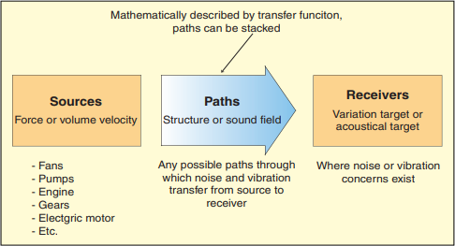The most sincere and widely acceptable method to cop The most sincere and widely acceptable method to cope with a noise and vibration situation is to break it into separate parts to the use of the source-path-receiver model shown in Figure 1.1.

Fig 1.1 Source-Path-Receiver Model

If you are a vehicle-level engineer and your responsibility is full-vehicle NV overall performance, then the engine may be taken into consideration a black container source that produces 2d-order pulsations which might be enter to the exhaust. It may be that the power from the source desires to be reduced, however a person else is liable for that, and you are simply considering it a black container. On the opposite hand, in case you are the engine manufacturer, then the engine desires to be damaged into a source-path-receiver model to lessen the quantity of energy it produces. The supply would be the engine combustion, the trails will be the engine layout and structure, and the receiver will be the engine 2d-order pulsations output to the exhaust. An instance of the source-route-receiver version for a vehicle-stage engineer working on an engine-related boom problem is shown in Figure 1.2.

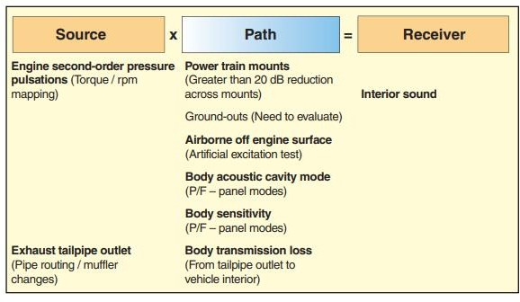

Fig 1.2 Source-path-Receiver model for engine related boom

# OBJECTIVES

• To study the types of automobile noise identification.

• To Study characteristics of diesel and gasoline engine noises that will provide us the difference in those noises for different types of vehicles.

• To study recent research done on Noise vibration analysis of automobiles.

# LITERATURE REVIEW

Noise Vibration and Harshness has been major research area in vehicles since last couple of decades. In this seminar, we review research and development of automotive noise identification and how to solve these problem related to the acoustics of any vehicle. Structures and models of various automotive problem solving methods and eliminate the NVH issue are described. Based on the reported studies and development, the comparisons between diesel and gasoline engines and their respective issues are also expressed in this report. After comprehensive studies, it is deduced that acoustics problem can be solved with the practical methods deduced by Gabriella Cerrato and Paul Goodes which are noise maturity model, source-path-receiver model etc. Also, a person can take some ideas about the active and passive measures and how to measure the primary and secondary measurement issues. AVC, ASAC and ANC are explained by T. Bein, J. Bös, D. Mayer and T. Melz. FEM and BEM were explained by Mohanty below which gives us a brief introduction in how FE methods are helpful.

**Gabriella Cerrato and Paul Goodes** [1] stated the noise and vibration maturity model which emphasized on the approach to show the steps a company should take to evolve from a reactive reaction on NV troubles in the direction of a proactive role where they are designing products with the NV overall performance in thoughts and are capable of are expecting problems and to resolve them before they occur. The final intention regularly will become the efficient layout of low noise and vibration products.

Since the cost of a product increases significantly, it is a well understood truth that the fee of layout changes will increase extensively at some stage in the design cycle. A layout change for sound treatment can fee little to nothing at the early layout levels of a product, before tough tooling is in region. As the design envelope closes all through the product layout cycle, the value to make the ones identical changes can be considerable and are regularly executed with compromises due to other design constraints. Therefore, it is in a company’s best interest to restrict the range of design adjustments required late within the software. In a reactive mode those past due software issues occur due to a diffusion of motives such as loss of layout consideration, poor target setting, no warnings and lack of reaction to warnings. To lessen the number of overdue application adjustments, an organization wishes to transport its efforts forward in the improvement cycle the use of SVQ/jury, target cascading and expertise key members. Beyond design recommendations, these key individuals are the output of a troubleshooting research and may be leveraged to encompass or enhance NVH performance in the layout cycle.

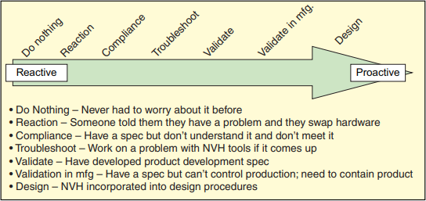

Fig.1.3 the Noise and Vibration Maturity Model

Active and Passive measures for NVH optimization were presented by **T. Bein, J. Bös, D. Mayer and T. Melz** [2]. They also explained structure borne sound function and how to reduce it.

For Passive measuring Ribbings, stiffeners, damping, isolation, and vibration absorber are used for enhancing the driving point impedance. They are the primary measures taken whereas the secondary measures for NVH optimization are enclosures, acoustic insulation, sound attenuation, acoustic ceilings, sound barriers, vibration absorbers.

For active measuring, active vibration control (AVC), active structural acoustic control (ASAC) are the primary measures used whereas the secondary measures for the same is Active noise control (ANC).

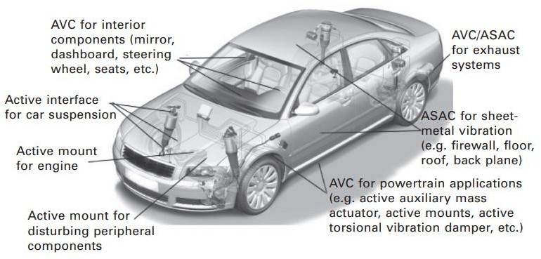

Fig 1.4 Typical application for AVC/ASAC in cars

Measures reducing the structure-borne sound function impact each noise and vibrations. However, reducing the shape-borne sound feature often leads to a better radiation performance (see under) for which cause both parameters ought to be considered concurrently whilst aiming to lower the extent of the acoustic transfer function. Nevertheless, the discount of the structure borne sound characteristic is in many instances lots higher than the increase of the radiation performance in order that an impartial remedy of the shape-borne sound feature is a valid approach. Furthermore, the structure-borne sound feature is extra without difficulty managed via structural layout than the radiation efficiency. Since flexural modes on the surface are the dominant supply for radiated noise, large amplitudes of the structure-borne sound function by a given excitation have to be averted or reduced. The design must be made in one of these way that the pressure flux is not directed towards surfaces without difficulty radiating noise however alternatively kept in small, massive, and stiff designed components of the shape. It is plain that decreasing the amplitude of the shape-borne sound feature additionally leads to lesser vibrations.

Some of the rules to reduce the structure borne sound function are as follows:

* Forces should first act on compact, straight-walled structures.
* Impedance at the driving point of excitation increased.
* Surface area preferably small
* Use of materials with high intensity

**A.R. Mohanty and S. Fatima** [3].

There were enough research accomplished by the researchers that show the primary noise sources in a vehicle are the Powertrain noise, tyre interaction noise and wind noise. Computer aided engineering techniques which include Finite Element Method, Boundary Element Method, Statistical energy analysis, rigid body dynamics and computational fluid dynamics were also explained by them.

Finite element method (FEM) has evolved as a numerical device for elastic analysis of systems to determine the pressure brought on in an issue due to each static and dynamic load, among others. Durability and fatigue evaluation of car additives are carried out by means of FEM. Dynamic analysis, related to free and pressured response of vehicle components and systems is accomplished by means of the techniques of FEM. It is also used to determine the natural frequencies of the components. An FEM/BEM analysis become finished to expect the indoors noise stage on the motive force’s proper ear vicinity because of structural vibrational excitations on the 4 cab mount locations as shown in fig 1.5. BEM has been used to expect the indoors noise tiers within the passenger cavity of an automobile, the radiated noise from a powertrain and the layout of exhaust mufflers.

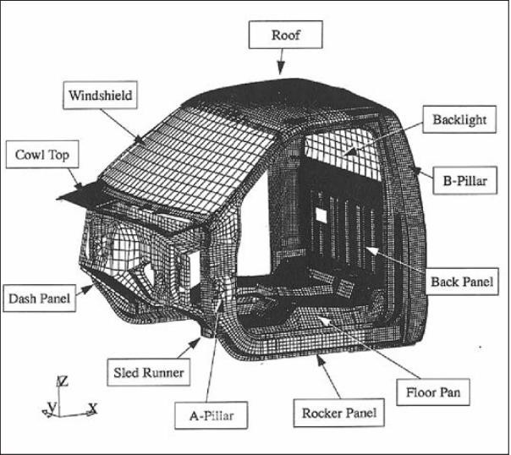

Fig 1.5 FE model of a truck cab

Sound quality is the notion of noise as heard through a human being only. Earlier in noise control, a discount in the sound pressure stage changed into taken into consideration appropriate when you consider that a noise discount has been completed. However, for the same level of noise, one noise can also sound first-class than the opposite to the human ear. So there has been a want for setting up other capabilities of the noise through which a measured noise may be characterized. Some of these parameters are known as the sound pleasant metrics like the loudness, speech interference level, tonality, articulation index, and many others. Many commercial sound exceptional software are to be had using which those sound best metrics may be anticipated. Sound stress degree measured is typically supplied in the dBA scale, but if one computes the other sound satisfactory metrics, a higher correlation with the human perception and the measured sound first-class parameters can be acquired. In order to appropriately reflect the notion of sound as is heard by means of a man or women using ears with a three dimensional spatial sound discipline, measurements the use of a human torso with microphones placed on the ear places on the torso are used rather than a single microphone as is finished for pass by noise measurements of a vehicle.

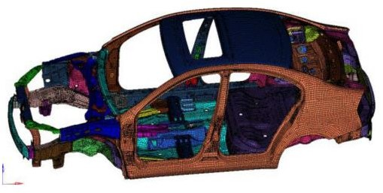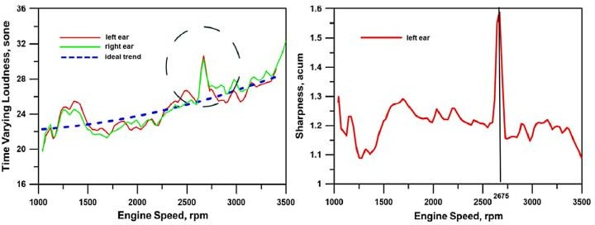

Fig 1.6 (a) Time varying loudness vs RPM (b) Sharpness vs RPM during vehicle acceleration

Also Sharpness plot in Fig. 1.7(b), which refers to the same take a look at, suggests a low automobile interior sound first-class at a specific working condition (round 2675 rpm), as it reaches a substantially excessive stage. The measure of the stated psychoacoustic parameters enables to perceive the excellent answers to improve NVH performance in terms of excellent indoors sound satisfactory in place of best reduced noisiness. Solutions can regard using suitable substances which make certain adequate acoustic insulation and absorption of the vehicle cabin, in addition to structural damping.

**Kailash Chandra Panda[5]** explained the power train NVH using FEA and Multi-Body dynamics analysis (MBD) model for NVH analysis. Power-train bending analysis is very useful mainly due to the fact that it gives accurate information on bending frequencies so that measures can be taken to avoid getting these modes excited by engine or other subsystem operations. Flow chart for FEA in power train systems and MBD analysis are depicted in the figures 1.8 and 1.9 respectively:

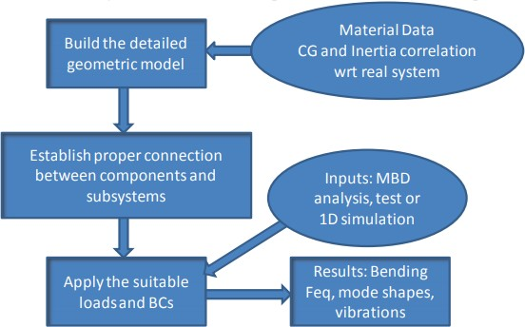

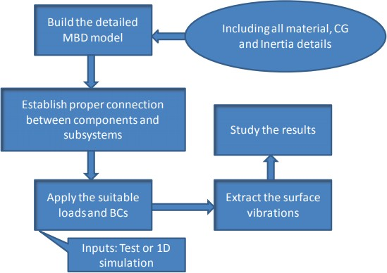Fig 1.7 Steps used for FEA analysis

Fig 1.8 Steps used for MBD analysis

Jun Lu, Zhenfei Zhan, Haozhan Song, Xu Liu, Xin Yang, and Junqi Yang [6] established the fact that NVH design optimization problems have become major concerns in the vehicle product development problems. Body-In-White (BIW) plays an important position in figuring out the dynamic traits of vehicle machine at some stage in the concept layout section.

The Body in White of a car is used as an example to illustrate the optimization method in this paper .The complete scale NVH finite element version is shown in figure 1.10.

Fig 1.9 Finite Element model of Body in white of a car

Optimization problem can be formulated in multiple ways depending on different optimization purposes. In preliminary phase of product development, the purpose of optimization is to enhance the performance and reduce the body mass. There are various types of optimization algorithm presented in the existing researches. Even though adaptive simulated annealing needs much less calculating time compared with the universal one, it remain time-consuming and inefficient requiring multiple computations. Obviously, it is not appropriate for complex systems like finite element model of vehicle body. Therefore, in the present study, the genetic algorithm is considered to be combined with response surface model. The benefit is not only improving the optimization efficiency but also ensuring the global optimization solution. The complete process of design optimization is shown in Figure 1.11. It mainly contains the following four steps: (1) finite element analysis of initial complex model, (2) construction of surrogate mode, i.e., response surface model,(3) optimization algorithm based on surrogate mode, and (4) the application of optimization results to enhance the structure performance.

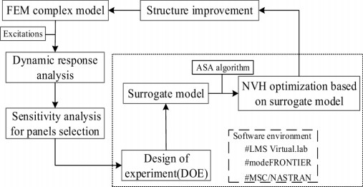

Fig 1.9 Flow chart for optimization method with approximation models

Souri V S Sreeramagiri [7] explained the NVH and MATLAB partnership for adaptations done in the automobile sector. He also explained some basics like BSR (Buzz, Squeak and Rattle) and how they are the result of the relative motion of structural components exceeding a threshold value.

# CASE STUDY

**Volvo Car Corporation Noise vibration Testing**

In the arena of automobiles, the name Volvo is synonymous with protection, first-class and reliability. Sound and vibration evaluation is a vitally essential component of vehicle engineering. New model improvement time has been notably decreased even as the quantity of to be had NVH data has substantially extended, for that reason ensuring regular product excellent. Brüel & Kjær is proud to have labored with Volvo Car Corporation for many years. It is testimony to this courting that a Volvo S60 is one of the crucial functions in Brüel & Kjær’s exhibition region.

The Volvo Car Corporation is one hundred% owned by way of the Ford Motor Company and is one of the corporations in Ford’s Premier Automotive Group, collectively with such marques as Jaguar, Aston Martin, Lincoln, etc. Volvo is Scandinavia’s biggest car producer generating about 400000 cars a year. The name is shared with the Volvo Group which manufactures vehicles, buses, articulated haulers, marine and commercial power pants, and aero engines.

1. Shorter Development Time

In the past, it is able to take a few years from the conception of a new model till it become released for delivery. New layout and improvement era has had a major effect in this location and, for example, within the first nine months of 2000, Volvo added no much less than four new models. But, despite the fact that the time needed for improvement has been decreased, the amount of check and analysis statistics has improved. The result is that Volvo guarantees steady will increase within the basic high-quality of its automobiles.

In 1997, rapidly after the multi-analysis solution was first delivered, Volvo determined to upgrade considered one of its chassis-dyno equipped NVH check cells and ordered its first PULSE™ gadget from Brüel & Kjær. Volvo selected PULSE for numerous reasons. They needed an "open" system that would be effortlessly customised. Another requirement turned into rapid measurement cycle instances to lessen the general test time. PULSE provided real-time processing with as much as 32 channels. With multi-analysis capability, Volvo ought to run numerous unique forms of evaluation together with Order, 1/3-octave, FFT and Zwicker Loudness, simultaneously, on a single run-up.

Today, Volvo has many PULSE structures with a huge channel count number. PULSE is used for a wide form of NVH evaluation duties which includes engine, wind tunnel, transmission and in-car testing. Of course, the engine produces a high proportion of noise in any vehicle.

Therefore, it is not sudden that Volvo makes use of PULSE structures extensively for engine sound and vibration evaluation. Hans Håkansson, NVH Test Manager, has ordinary responsibility for sound and vibration analysis. He says, "We presently have engine sound take a look at rooms and every uses a 24-channel PULSE system". He continues, "We additionally use PULSE in our chassis-dyno (rolling road) take a look at regions"

1. Pulse Workflow Manager

Volvo wanted a program to assist their group of workers with repetitive checking out. Working together with Brüel & Kjær, the PULSE WorkFlow Manager changed into evolved.

This guides the engineer from the check planning stage right via to computerized generation and archiving of stories.

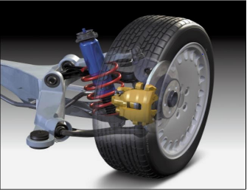

Fig 1.10.The suspension and braking systems are subject to thorough NVH testing

1. Structure

The time taken to outline after which communicate the test plan to the engineers became reduce by means of 70% whilst in comparison to the preceding device. The Test Plan in WorkFlow Manager most effective desires to be set up once and can then be used repetitively for every comparable set of measurements.

1. How to measure

The better channel-be counted and the capability to perform multi-analysis with PULSE makesit viable to take all the vital measurements for a check run concurrently with all of the required analyzers running in parallel.

1. How much time will be saved by this?

The Test Plan facility inside the PULSE Workflow Manager honestly turns the PULSE device into an efficient testing tool. The Test Plan shall take a look at mobile engineer plan the take a look at in advance, accordingly saving him pricey take a look at cellular time. Also it courses him through the check, making sure the proper records is saved with the facts. The Test Plan may be added to the final document, presenting an overview of the entire check. The usual result become a forty five% time saving the usage of the PULSE machine whilst as compared to the previously installed 8-channel gadget.

# Summary & Conclusion

According to Case study, Volvo now has many PULSE systems and an excessive common channel be counted. "What used to take every week now takes a day" Workflow Manager guides the engineer from the check planning stage through to file era Test setup time has, in some instances, been reduced by 70% .Printed reviews are to be had as quickly as the checks had been completed Using Workflow Manager has given an typical time-saving of 45%.

The literature cited gives a broader view of the studies that has been done inside the past decade and directs one in the direction of the modern-day NVH studies within the subject of delivery, especially automobiles. The growing call for for sustainable technologies, emission-free vehicles, extended protection concerns, and advanced gas-financial system and efficiency, are the important thing factors which are going to influence all principal studies efforts in the automobile quarter. NVH study and characterization play an essential role in this regard. Multiple studies on vibration traits of systems had been able to efficiently version and mitigate unwanted excitations through structural adjustments, and decrease the power loss bobbing up from it. By characterizing the herbal harmonics of a machine, layout changes may be carried out such that the opportunity of resonance in the course of operation is mitigated. This now not only reduces the risk of huge deformations however the cost of maintenance too. Such efforts substantially reduce the maintenance cost, boom sturdiness of structures and also make sure extended structural balance. In addition to this, the automobile area being closely reliant on patron- stories, will simply appearance in the direction of NVH modifications with the intention to provide expanded passenger comfort and reduce ambient noise.

REFERENCES

1. Maria Antonietta Panza,, A review of experimental techniques for NVH analysis on a commercial vehicle, ATI 2015 - 70th Conference of the ATI Engineering Association, Energy Procedia 82 ( 2015 ) 1017 – 1023.

2. International Organization for Standardization, Method for Calculating Loudness Level, ISO-532-1975 (E)

3. G. Cerrato, Automotive Sound Quality – Powertrain, Road and Wind Noise, Sound &Vibration, April 2009

4. G. Cerrato and P. Goodes, Practical approaches to solving noise and vibration problems, Sound & Vibration, April 2011.

5. Li, M., van Keulen, W., Tijs, E., van de Ven, M., & Molenaar, A. (2015). Sound absorption measurement of road surface with in situ technology. Applied Acoustics, 88, 12-21.

6. John Wiley & Sons, Vehicle Noise and Vibration, 2016 Scrivener Publishing LLC. Published 2016.

7. Harriaon, M., Vehicle Refinement: controlling noise and vibration in road vehicle, Elsevier Butterworth Heinemann, Oxford, UK, 2004.

8. Govindswamy K, Wellmann T and Eisele G (2009), Aspects of NVH integration in hybrid vehicles’, SAE paper 2009-01-2085.

9. Juang T B, Harvey K E, Burzlaff M W and Rockett P J (2006), Analytical and experimental development to improve powertrain system induced vehicle NVH issues’, SAE paper 2006-01-1533.

10. Siano D and Bozza F (2009), ‘Combustion noise prediction in a small diesel engine finalized to the optimization of the fuel injection strategy’, SAE paper 2009-01-2077.

11. Kailash Chandra Panda,” Dealing with Noise and Vibration in Automotive Industry”, 12th International Conference on Vibration Problems, ICOVP 2015.

12. Beloiu, D.: Modelling and Analysis of Power-train NVH, SAE paper no 2012-01-0888(2012).

13. S. J. Kim, G Kim, K.S. Oh, S.K. Lee: Excitation Force Analysis Of A Power-train Based On CAE Technology, International Journal of Automotive Technology, V 9, Issue 6, pp 703-711 (2008).

14. Dirk Mayer, Jonathan Militzer, Thilo Bein: Integrated Solutions for Noise and Vibration Control in Vehicles, SAE paper no 2014-01- 2048 (2014).

15. Shouwei Lu etal: NVH Optimization of Vehicle Power-train, Proceedings of the FISITA 2012 World Automotive Congress, Lecture Notes in Electrical Engineering Volume 201, 2013, pp 141-149 (2013).

16. Souri V S Sreeramagiri,” NVH And Structural Adaptations in Automobiles: A Perspective”, International Journal of Engineering Research & Technology (IJERT), Vol. 10 Issue 01, January-2021.

17. A. R. Mohanty and S. Fatima,” An overview of automobile noise and vibration control”,noise notes volume 13 number 1.

18.T. Bein, J. Bös, D. Mayer and T. Melz, “Advanced materials and technologies for reducing noise, vibration and harshness (NVH) in automobiles”, Woodhead Publishing Limited, 2012.

19. Bein Th et al. (2008), ‘Smart interfaces and semi-active vibration absorber for noise reduction in vehicle structures’, Aerospace Science and Technology, 12, 62–73.

20. Elliott S (2008), ‘A review of active noise and vibration control in road vehicles’, ISVR Technical Memorandum No 981, Southampton, UK.

21. Kumar N (2009), ‘Vibration and damping characteristics of beams with active constrained layer treatments under parametric variations’, Materials and Design, 30, 4162–4174.

22. Thilo Bein , Joachim Bös, Sven Herold, Dirk Mayer, Tobias Melz, Martin Thomaier,” Smart interfaces and semi-active vibration absorber for noise reduction in vehicle structures”, Elsevier Masson 2007.

23. Mingliang Li, Wim van Keulen, Emiel Tijs , Martin van de Ven , André Molenaar,” Sound absorption measurement of road surface with in situ technology”,Elsevier ,2014.