“A Study of Winning Marketing Strategies Post Pandemic with reference to Out of Home (OOH) Media.” : A literature Review
Prof. Rupa Rawal
Research Scholar
Abstract:
Marketing is not just related to sales but it is a strategy which tries to modify and improve their performances in times of crisis. The economic world today in Covid 19 is not just affected by financial crisis, but also affected in terms of sales, market share and profitability. During such period of time marketing managers are striving hard to play a pivotal role in the post –pandemic era since it would be a different world were the outdoor advertising especially Out of Home (OOH) Media will lay emphasis on placing trust and reliability on connecting with people when they are on move. The purpose of this paper is to examine how Out of Home (OOH) Media will adopt winning marketing strategies in the new normal in post pandemic a winning strategy which will boost human care, sustainability of environment and really win the modern age.
Keywords: Marketing strategies, Post pandemic, Out of Home (OOH) Media.
Introduction:
Marketing strategy is a tool and technique which is used by the organization to have long term impact and approach in a business to achieve a sustainable growth and advantage with relation to customers’ needs and wants. Strategic planning involves an analysis and evaluation of how one can cover up cost and meets companies profitability. To target all the factors with effect to the companies goals and objectives marketing uses the elements of 7Ps amongst its as promotional strategy plays a vital role in reaching targeted customers.
In the changing business scenario new winning market strategies along with outdoor advertising has become a need of the day. The role of Out of Home (OOH) Media is playing empathetic role in advertising especially when people are on move with media components like digital billboards, hoardings, canopies, and lollypops etc. which have started providing viewership measurements to the industry users and advertising agencies to gauge their profitability. Though now the world is under crisis and movers are less still there is a way to look at new normal again
Objectives of Study:
- To study marketing strategies of post pandemic
- To define and learn effects of Out of home (OOH) Media
RESEARCH METHODOLOGY:
It is a descriptive study in which secondary data is collected from various forms like journals, magazines, blogs, references which helped to understand the concept of marketing strategies used for winning in post pandemic situations with reference of Out of home(OOH) Media advertising. The researcher conducted review of literature to identify the factors impacting mind of consumers while on go through new tools and techniques applied in new normal again.
Definition:
“Out of Home media encompasses a broad and diverse array of communication platforms that can reach consumers at almost any point in their daily lives. It is the oldest form of branded communication that humans have, and has stood the test of time with the ever-changing media landscapes because of the simple truth, that it continues to be effective at reaching an audience”.
Similarly, Out of Home (OOH) definition is identified by various agencies or universities based on their implications and applied characteristics these are summarized in the following

REVIEW OF LITERATURE:

- (How OOH media advertising might play out Post-Pandemic May 22.2020 Hub Spot Co-Founder, Dharmesh Shah,) The research study reveals that after the possibility scene faced after Covid 19 in post –pandemic stages the world would see an age of “revenge shopping “ similarly compared to other countries which have experienced after lockdown and restrictions were normalized. The new strategies will move towards adopting new traffic zone patterns. The community who have shifted would return back in original areas and geographical places.OOH Media will have to mark up new campaigns and research how strategies been developed shall cope up in changing mindset

- (E.consultancy blog, effective-ooh-advertising- Nikki Gilliland 20.10.2020) The research study reveals in UK in late summer (Acc.to new Covid rules) company Skoda felt a need to launch a digital out of home media (DOOH) campaign for promoting its SUVs. The campaign was run by clear channel which was touch less the consumers could interact with the screen display by gesturing hands on it, they could discover vehicles and have the privilege of test drive too. Digital communication screens could not only attract the commuters but will be enhancing safety measures too.

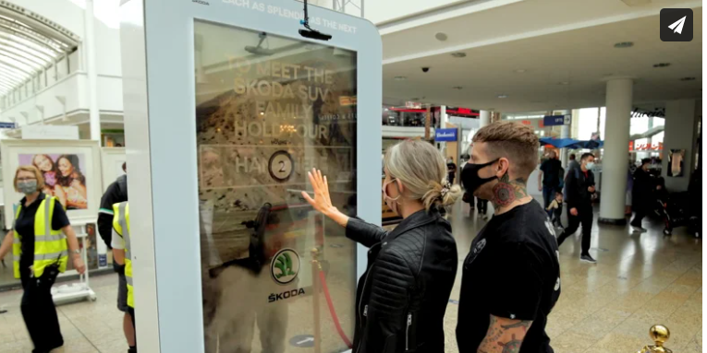

- (Ibboline.comTug.12.2.2021blog.Marketing agency.London) the research study reveals once the pandemic would come under normal picture people would be moving off the street which will be usually observed in the coming times. The OOH Media will be applying strategies of digital campaigns to retarget commuters who are exposed to these outdoor advertising. The post pandemic will also help the OOH media to display on psychology and behavior of consumers. More displays will be seen on roadside billboards rather than on pipes since public would demand transits in cars than travel through any public transport. Out of Home (OOH) will need to chalk out the task by emphasizing on new spirit and winning reinforce.
- (Adgully Bureau@adgully 5.5.2020 Dr.K.Rajeshwari) The research findings reveals OOH Media will move towards innovation strategy for its work in fiction advertisements in post pandemic since health companies will take up decision for messaging and revealing safety on billboards for family health care products. It would be combination of costumers mind and sense in belongings. OOH Media is quite flexible in advertisements taking the scenario into consideration .Taking other countries in the world after post pandemic scenes. There will be winning strategies coming up with new hope when public would move in around since outdoor advertisements senses people perception and emotional being personally. The industry will be adopting different combination method in retaining new practices.

5.(exchange4media.com23.3.2021staff updated) The study finds The Noida Metro Rail Corporation (NMRC) has invited tenders for OOH Media advertisers granting license, spaces, and rights at movable transit across metros. As per choice, design upload and activate their creativity to attract the passerby. This would help the OOH Media put impact in the minds of goers post pandemic.

6.(Increasing Importance of Out of Home Advertising Post-COVID-19: The New Normal by April Koh May 12, 2020) The research study reveals Post pandemic with new winning strategies will find way out to shine up the business in the appearance of OOH Media advertising as community will recognize the importance of being out of home. The OOH Media will activate and relate to online digital campaign and commitment to movers. The media shall show cast positive and comfortable thoughts maintaining sensitivity of people during the later stages
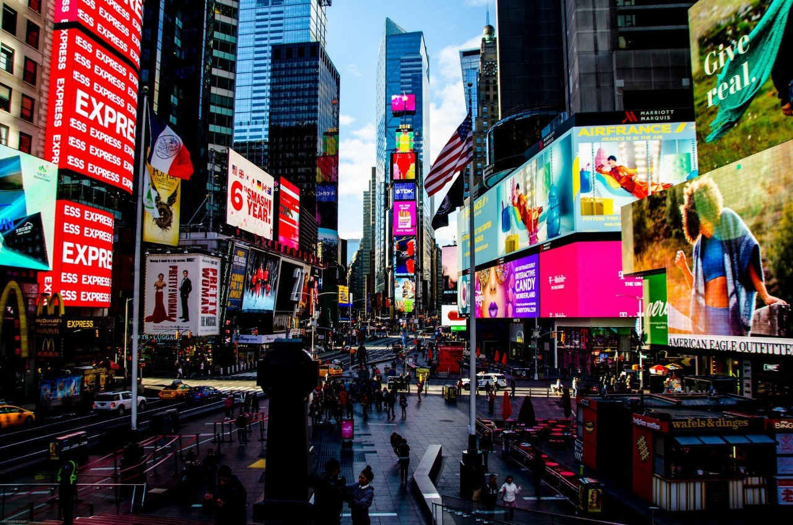
Research Findings:
The information and the findings which the researcher collected have given a brief understanding of the importance of winning new marketing strategies in post pandemic situations with Out of Home (OOH) Media modes. Business is totally depended upon customers it would be unimaginable without them it is only the relationships of all marketing mix which usually provides a blend in strategies adopted in market. Marketing managers usually track out new findings and ways to reach the public along with media. The post pandemic will totally move into new positive new normal again.
CONCLUSIONS:
Review of past literature on winning new marketing strategies in post pandemic with reference to Out of Home (OOH) Media Advertising has helped me in the generation of idea &knowledge of how new strategies are adopted by the firms to adjust according to the changing scenario. There are many information and studies available on post pandemic strategies has brought in new sights and hope. The opinions shared by the experts, comments, helped to understand the gaps and design in research methodology for the study. There are various modes to identify the factors which might influence the consumers buying decisions on there move. The researcher has studied various parameters which would be considered to regain the confidence of consumers in post pandemic situations. The researcher also analyzed the reasons behind foresee industries gearing up with fresh or minimal advertising plans and OOH will play an even bigger role in reaching their audiences.

REFERENCES:
- How OOH media advertising might play out Post-Pandemic May 22.2020 Hub Spot Co-Founder, Dharmesh Shah.
- E.consultancy blog, effective-ooh-advertising- Nikki Gilliland 20.10.2020
- Ibboline.comTug.12.2.2021blog.Marketing agency.London)
- Adgully Bureau@adgully 5.5.2020 Dr.K.Rajeshwari
- exchange4media.com23.3.2021staff updated
- "There's nothing new about the 'new normal' - and here's why". World Economic Forum. Retrieved 26 September 2020
- David Hochman. The New Normal: What Comes After COVID-19? Experts predict how the pandemic will change our lives, AARP, June 8, 2020
- Increasing Importance of Out of Home Advertising Post-COVID-19: The New Normal by April Koh May 12, 2020

