CRIMINALIZATION OF THE SEAFARER

CDT. CDT. ABHISHEK JADAV & CDT. DHRUVESH PANDEY

AUTHOR:
ABHISHEK JADAV & DHRUVESH PANDEY
  - Acknowledgement

  - This thesis would not have been possible without the continuous encouragement, help and support of a number of people and I take this opportunity to express my gratitude to them.

  - First and foremost, I offer my sincerest gratitude to my supervisor, Captain.Srirang Gokhale, Prof. Vrushali Rampure ma'am and Prof. Tejashwini Yadav ma’am, who has supported me throughout my thesis with patient guidance and encouragement.

  - Last, but not least, special thanks to my family and close friends whose love and support has enabled me to complete this thesis.

  - Abstract

  - The purpose of this study was to examine the criminalization of seafarers and the positions, views and perceptions of seafarers and industry organisations
  - Another aim was to investigate the impact of the criminalization of seafarers on the industry and to explore policies and identify difficulties encountered in implementing of these policies for the fair treatment of seafarers.
  - The study thus reviewed the important current phenomenon of the criminalization of seafarers and identified the real problems as perceived by the seafarer and shipping industry bodies.
  - Both qualitative and quantitative methods were applied. The questionnaire surveyed seafarer opinion on unfair treatment and the criminalisation of seafarers.
  - The results revealed that criminalisation is a phenomenon that has significantly affected the maritime community. It showed some surprisingly large numbers of seafarers who intended to retire early due to the fear of criminalisation and those who say that they would not recommend this profession to family and friends.
  - There also appears to be a feeling that little support has been received from companies when seafarers are treated unfairly, and looking to the future, a large number of respondents were unsure or did not think they would receive support from their companies.

  - Introduction

  - This thesis critically examines the phenomenon of criminalization of seafarers and the subsequent effects. It explores policies and identifies difficulties encountered in implementing these policies for the fair treatment of seafarers in law. Seafarers are currently criminalised in situations such as marine pollution and ISPS Code violations. More disturbing are the treatments of acts which were heretofore simple negligence or incompetence as crimes. The paper concentrates on the criminalization of marine pollution and on the innocent seafarer who becomes a victim of fair laws applied unfairly, usually for regulatory offences, and of being presumed guilty until proven otherwise,

  - This study is also intended to encourage future studies on seafarer issues related to criminalization by exposing problems that have heretofore remained hidden due to the absence of previous work in this area

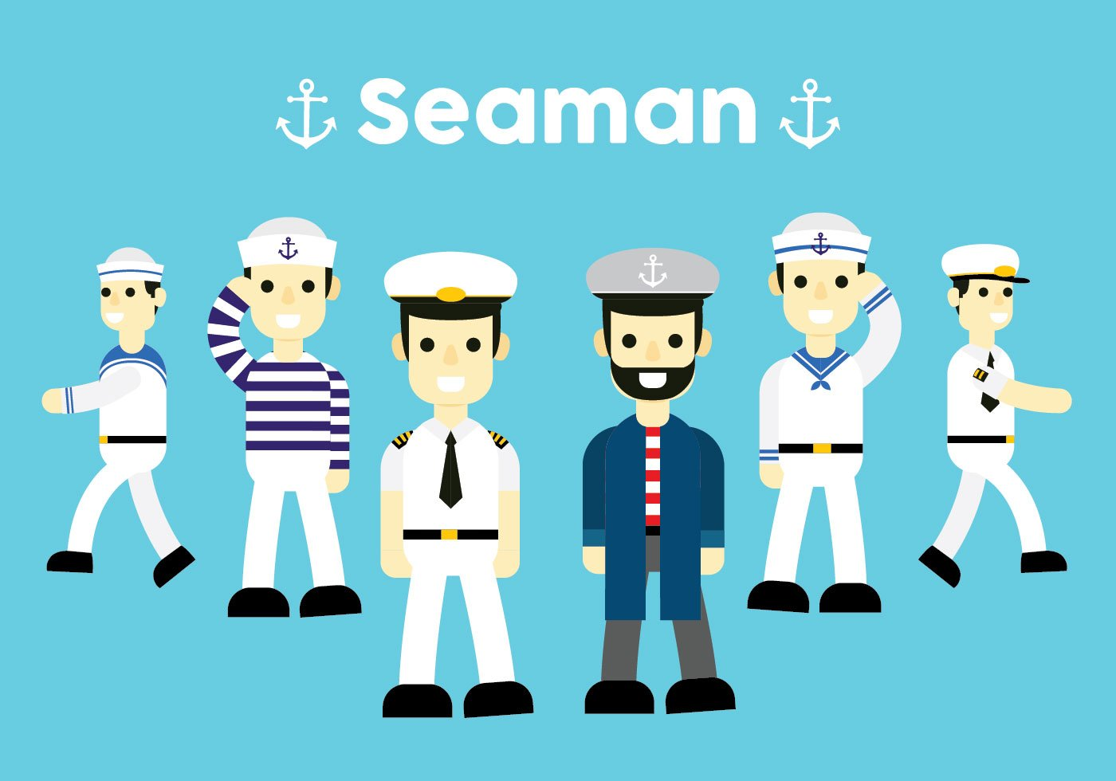
  - Research Aims and Objectives
- Research Aim
The aim of the research is to investigate the impact of the criminalization of seafarers on the industry and to explore policies and identify difficulties encountered in implementing these policies for the fair treatment of seafarers in law.
- Research Objectives
  - The specific objectives of this research are –
  - (1) To discuss the causes of the criminalization of seafarers.
  - (2) To identify and analyse the impacts of criminalization on seafarers.
  - (3) To investigate policies and actions taken by the industry to deal with criminalization.
  - (4) To evaluate critically the effectiveness of the industry initiatives.
  - (5) To identify constraints of policy and practice on the protection of seafarers’ welfare.
  - (6) To provide recommendations on how to deal with criminalization.

Abbreviations
- UDHR: - The Universal Declaration of Human Rights
- BIMCO/ISF: - Baltic and International Maritime Council
- IMO: - International Maritime Organization
- ITF: - International Transport Workers' Federation
- ASEAN: - Association of Southeast Asian Nations
- OECD group: - Organisation for Economic Co-operation and Development
- ISPS code: - International Ship and Port Facility Security

Literature Review

  - What is ‘Criminalization of the seafarer’?
  - Criminalization may be defined in two ways: ‘treating someone as a criminal’ or ‘making something illegal’.
  - Treating a seafarer as a criminal stem from the phenomenon following accidents where seafarers have been incarcerated and in several cases were not charged. Prosecutors seem to assume that spilling oil in an accident makes a seafarer a criminal.
  - The concept of ‘making something illegal’ refers to regulatory or civil offences of seafarers being made criminal offences by legislatures using new laws and by prosecutors combining series of old or obsolete laws or of using laws in ways legislatures did not intend.
  - The differences are important. In common law a criminal offence is a serious offence that requires proof of a ‘guilty mind’. Regulatory or civil offences do not.
  - The Universal Declaration of Human Rights (1948) is applicable everywhere, but is rarely referred to in cases where seafarers are denied their basic human rights because U.N Declarations are not international law. However, as an aspiration, Article 9 of the UDHR states that ‘No one shall be subjected to arbitrary arrest, detention or exile’. Of greater relevance, Article 11 states that ‘No one shall be held guilty of any penal offence on account of any act or omission which did not constitute a penal offence, under national or international law, at the time when it was committed’ (United Nations, 2010). This then deals with ex post facto criminalization.

  - A BIMCO (2009) study on the treatment of seafarers discusses 47 cases from the seafarers’ perspective, which have occurred between 1996 and 2010. Of these cases, 14 involve arrest and incarceration of seafarers before they have been pronounced guilty. A further 33 are on the criminal treatment and incarceration of seafarers after being found guilty on dubious application of the law. These cases are not comprehensive. They grant insight into how seafarers are treated following accidents in different jurisdictions in pollution-related offences or in drug or contraband related offences.
  - To illustrate the scale and the significance of the phenomenon, it is useful to present a sample of the cases that have drawn much debate and attention.

  - List of cases where criminalization has occurred
  - Source: (BIMCO, 2009)
- No | - Vessel Name | - Year of occurrence
- 1 | - M V Million Hope | - 1996
- 2 | - M T Erika | - 1999
- 3 | - Amorgos | - 2001
- 4 | - Celine | - 2005

  - There are some obvious similarities in these cases. In almost all cases, confinement has taken place before charges were made for an offence. Most of the vessels involved were under open registers. Most incidents have occurred in developed nations which are environmentally concerned and at the same time are also champions of human rights. However, it appears reasonable to conclude that when a choice between the two has to be made, human rights of the seafarers have been put aside in order to protect the environment. This is a causative factor in the criminalization phenomenon.

The Consequences of Criminalization
  - If one walked down a high street, anywhere in the world, asking people at random if they could name some famous seafarers, one would get a blank look. Ask the same people about famous ships and they would likely talk about the Titanic (1912) or the Exxon Valdez (1989) or some other vessels that met with disaster. As Grey (2007) succinctly puts it “Notoriety, it seems, invariably registers, where professional excellence tends to pass one by”. Society by and large is relatively uninterested in shipping. Articles on ships sinking and seafarers losing their lives appear in remote corners of newspapers. What energizes society is a picture of an oily dying or dead seagull. Society expects perfect safety from the maritime industry and appears unwilling to accept that mistakes can happen at sea as well as ashore. No other industry is held to such high standards. It is this societal pressure translated to political force that makes governments take harsh action after a marine accident.
  - 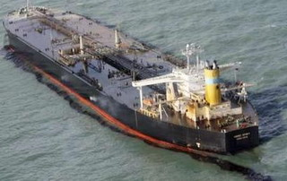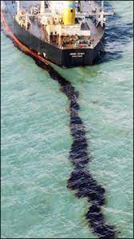
  - The case of MT HEBEI SPIRIT OIL SPIIL came to mind which is truly sad story in which the Master and Chief officer had not committed any crime what so ever yet ended up spending nearly two years in jail.
  - After an 18-month ordeal, two Indian sailors, jailed in South Korea after a crane barge collided with their crude carrier leading to a major oil spill in December 2007, returned here on Saturday following their acquittal by the Supreme Court in Seoul. Capitan Jaspreet Chawla and Chief Officer Shyam Chetan, who were working with the ship Hebei Spirit and were imprisoned for a year in South Korea before being granted conditional bail in January, arrived at Mumbai international airport. A crane barge owned by Samsung Heavy Industries collided with Spirit and led to an oil spill which endangered marine lives and resulted in loss of livelihood for many.
  - Last year, a local court had acquitted Chawla and Chetan and blamed Samsung for the accident. But the ruling was challenged in an upper court which held them guilty on charges of negligence resulting in marine pollution. Chawla was awarded one-and-a-half years in jail and Chetan was sentenced to eight months imprisonment. The ruling by the South Korean court sparked widespread anger in the international shipping community, including Indian seafarer’s unions, which insisted the tanker crew were not guilty. In January 2009, another South Korean court granted the two conditional bail and the matter went to the Supreme Court which acquitted them on June 11.

  - Another major consequence of criminalization is the impact that it has on the global campaign to attract new recruits to the maritime profession. A number of surveys such as the ASEAN Shipowners' Forum survey, various EC-funded studies and research projects and the BIMCO/ISF studies all point to the fact that average seafarer age is increasing worldwide, with very slow recruitment unable to cope with the numbers that leave the industry (Mitropoulos, 2005). Even within the scope of this study, it is interesting to note the opinion of seafarers when asked whether they would recommend friends and family to join the industry.
  - Only 11% of respondents would recommend seafaring as a career to family and friends, 32% saying they would not and 57% saying it would depend on the circumstances. 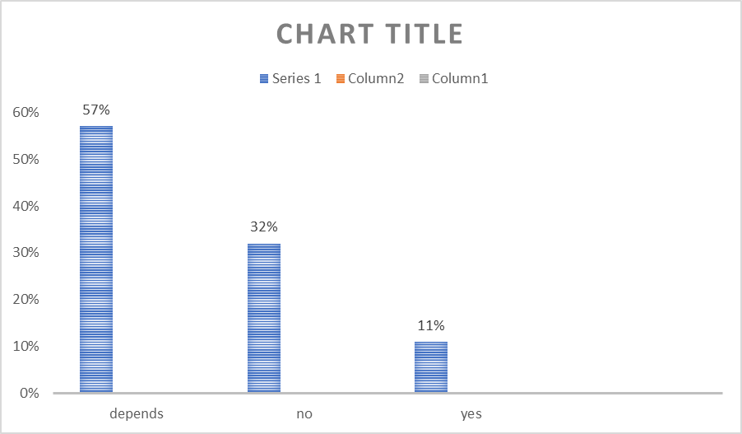

Methodology
This research aims to study the causes of criminalisation of the seafarer, the effects on the seafarer and industry policy. A review of the literature reveals that no academic studies of this nature have been carried out. Thus, a field survey to gather primary data was necessary. Multi-strategy or mixed method research involving both qualitative and quantitative methods were used
- Primary data
Questionnaires
Questionnaires were chosen for this aspect of the study as they are generally used for descriptive or explanatory research which examines the attitudes and opinions of respondents Some questions were given to the seafarers about their background, personal experience of the criminalization, effect of criminalization, support received by the company, their views on this and prevention of criminalization.
- Secondary data
The secondary data were documentary in nature, and obtained from the Fair Treatment of Seafarers (BIMCO, 2009), as well as various shipping publications such as Lloyd’s List, Fair play and Tradewinds. The websites of major shipping industry stakeholders such as BIMCO, ITF, INTERTANKO and INTERMANAGER were also used to secure secondary data
The renowned case of MV Prestige (oil tanker) was one such case of criminalization of seafarer due to oil pollution from the vessel. On 13 November 2002, the MV Prestige was sailing from Ventspils, Latvia to Gibraltar, carrying 77,000 metric tons of two different grades of heavy fuel oil. The weather got changed and it started to take on water from high waves. This caused a 50-foot hole on the starboard side. The crew was evacuated while the ship drifted within four miles of the Spanish coast and leaked oil.
The French, Spanish and Portuguese governments did not allow the vessel to dock to avoid pollution on their coastlines. As a result, after several days of sailing, the vessel split in half on 19 November in Portuguese waters. It sank 250 kilometres from the Spanish coast, releasing over 17 million US gallons (76,000 m3) of oil into the water. Over 20 million US gallons (76,000 m3) of oil were spilt in total.
The court found the captain, insurer and owner of the tanker that broke up off north-western Spain in 2002 liable. The Captain Apostolos Mangouras was sentenced to 2 years of imprisonment by the Spain court founding him to be “reckless in his duty” and “failing to preserve the environment.”

Data Analysis
This chapter contains a detailed analysis of questionnaires. Data from the questionnaires have been interpreted and converted into graphical format for ease of exposition.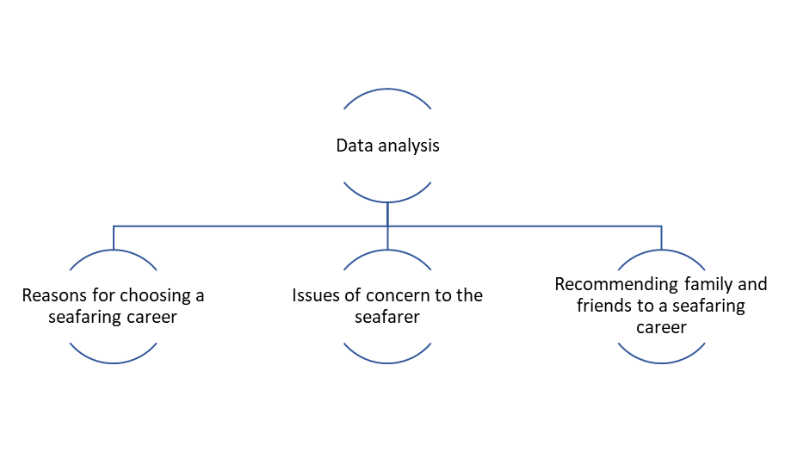
- Reasons for choosing a seafaring career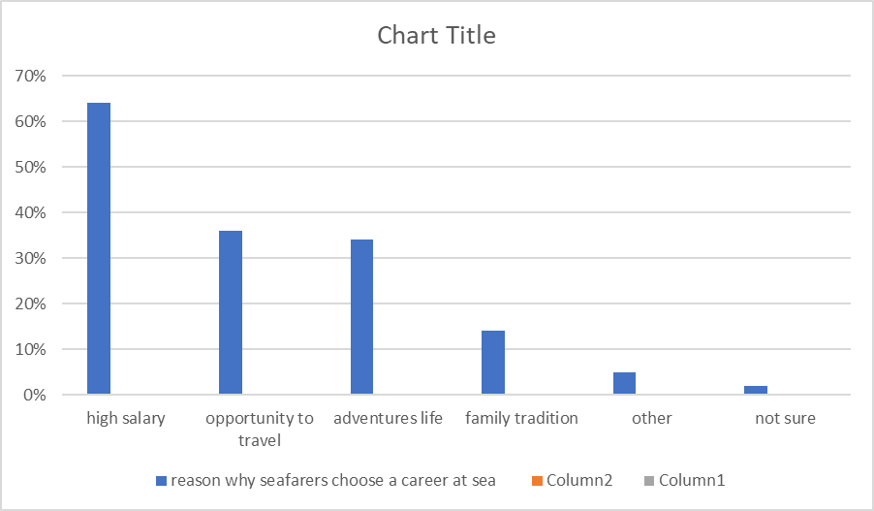
Mostly a high salary, the opportunity to travel and an adventurous life were the top three reasons for choosing a career at sea. Respondents across all age groups chose a high salary as the primary reason for taking up a seafaring career. When looked at from the nationality perspective, it is found that North Americans, Europeans and Australians (OECD group) primarily chose this career for its adventurous nature, with salary taking second place. South Asians and Southeast Asians primary reason to join this career was the high salary, with adventure figuring very low on their priorities. Masters’ responses to this question indicate that they joined primarily for the adventure, while officers and ratings have chosen a high salary as the primary reason why they took up a career at sea
- Issues of concern to the seafarer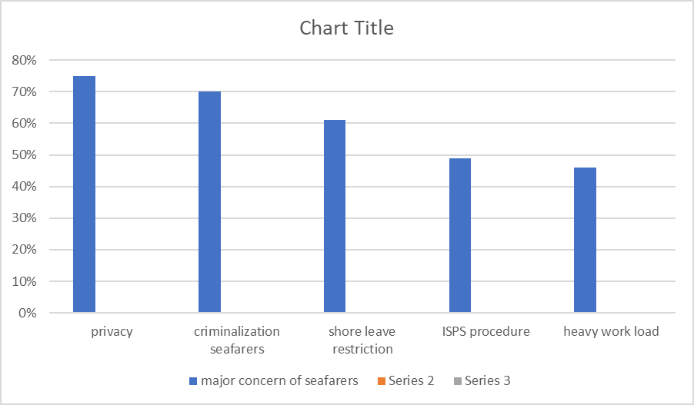 Across the board, the greatest concern is piracy, followed by criminalization and shore leave restrictions. Unsurprisingly, it is apparent from the statistics that the main concern of senior seafarers with greater responsibility and liability is criminalization, while younger seafarers are mainly concerned about piracy. The OECD (The Organization for Economic Co-operation and Development) group was mainly concerned with criminalization, heavy paperwork and the poor image of the shipping industry. Piracy did not appear to be a major concern for these seafarers. South and Southeast Asians were mainly concerned about criminalization, piracy and shore leave restrictions. Another major concern for the Southeast Asians was ISPS procedures. Masters were mainly worried about criminalization, piracy and the poor image of the industry, while officers and ratings main concern was piracy, suggesting liability. 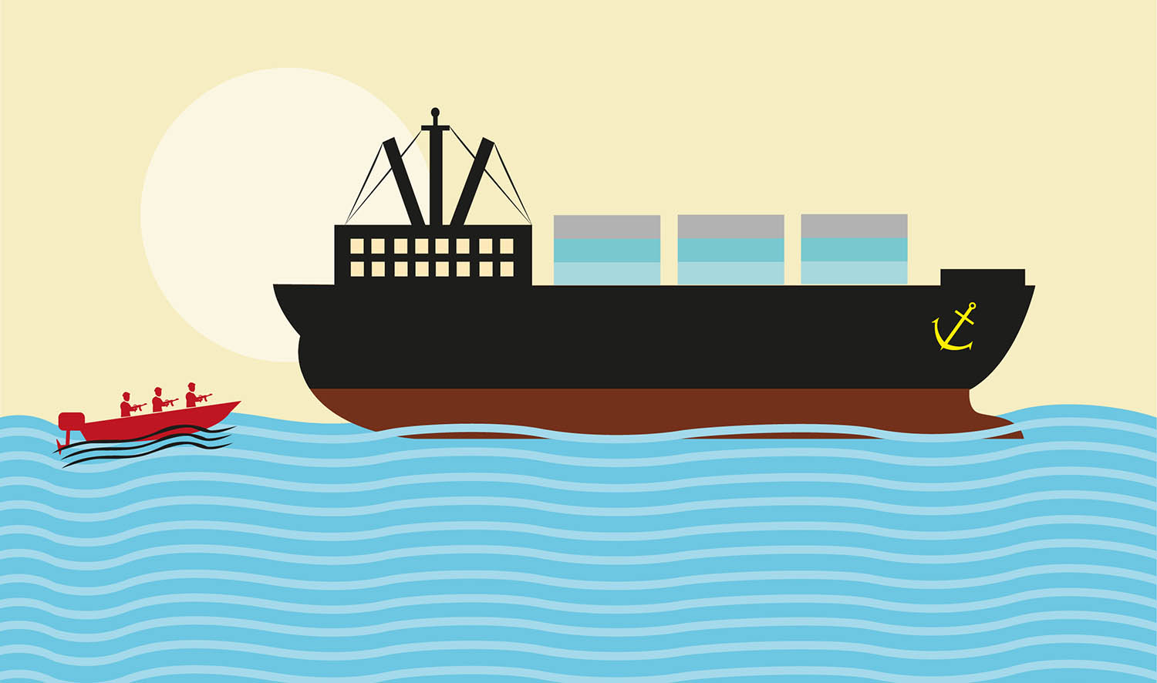
- Recommending family and friends to a seafaring career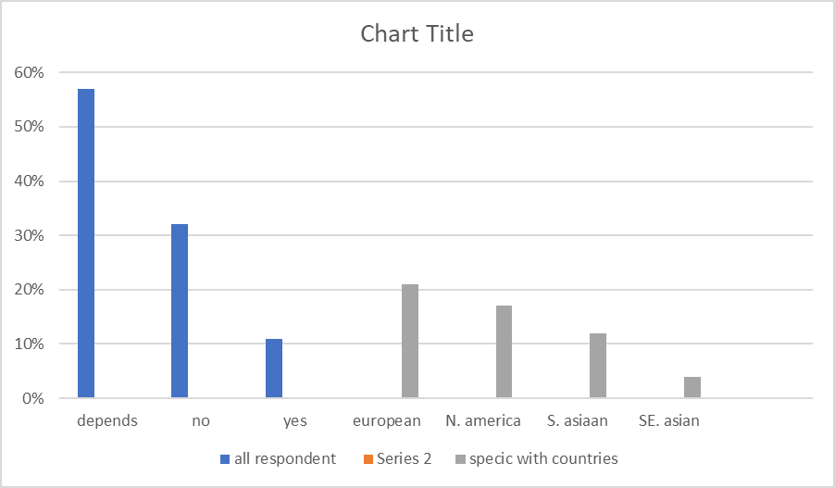 Of the overall populace a total of 89% of respondents were either unsure or would not recommend this career to family and friends. The lower age group were least willing to recommend at 9%, with older respondents being marginally more willing at 11%. Across the nationalities there is a marked reluctance to recommend seafaring as a career with the Europeans the most willing at 21% against the Australians who all answered in the negative. Among the rank’s masters are the most willing to recommend this career at 18% against officers at 9% and ratings at 7%. Immaterial of how the numbers are looked at, there is a marked reluctance on the part of all seafarers across all categories, to recommend this career to family and friends. 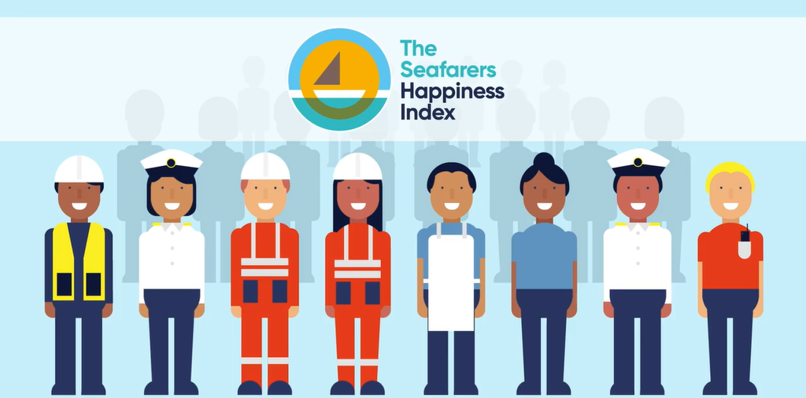

Discussion
Seafarers live a unique life on board ships, with extended periods spent away from family and friends, with at best, rudimentary communication facilities. Thus, it is the seafarers living and work conditions that ultimately determine a significant part of how they live their lives as human beings. Labour and human rights laws therefore, become an intrinsic part of the seafarers’ life.
This study has established that criminalisation is a matter of concern, not just to the senior ranks, but to all seafarers. Undoubtedly, frequent press reports of the incarceration of seafarers, lengthy detentions during investigations and refusal of bail despite security being offered, have struck a chord within the seafaring community and makes them feel threatened. The study also highlights the fact that high wages have been the main reason why most respondents went out to sea. Yet, a hike in salary does not appear to be wholly successful in retaining staff that are faced with the prospect of being criminalised. The consequences can be clearly seen in light of large numbers of seafarers choosing to opt out of this profession earlier than they would have done normally. Almost 61% of seafarer respondents are either unsure or would not choose this career again if asked to choose today, and a significant proportion refuse to endorse seafaring as a career, to family and friends. Clearly there is a great deal of discontent within the industry. Of great concern is the fact that many seafarers intend to start leaving the profession in the next five years.
Despite all these problems, not much initiative is being taken by companies to enlighten seafarers on the problem with over 80% of seafarers stating that they have never been spoken to about criminalisation. Quite a few seafarers seem to be discussing the matter with colleagues and friends on their own initiative. Just 10% of respondents felt that they had company support when they had been unfairly treated or criminalised. There is a perception by almost half of the respondent population that they will not receive any support from their companies in these circumstances. While there are a number of excellent companies that seem to back their seafarers
In summary, these analyses show an industry in trouble with its labour and headed for deeper trouble unless something is done to mitigate the problem. In the event that criminalisation continues, owners may look forward to demands of half again as much pay as now afforded. It will be difficult to get younger persons to go to sea in all cases and this suggests that training institutions will also be hurt. It makes little difference as to the state from whence a seafarer originates, they are for the most part troubled and concerned about criminalisation.

Conclusion and Recommendations

There is a long way to go before seafarers will be treated with the respect that they are due. Recognition that this must happen, is the first step towards making it happen. This study concludes that criminalisation is a phenomenon that has significantly affected the maritime community. The causes of criminalisation were identified within the literature review. These include the ISPS code, treating of gross negligence as a crime, criminal sanctions being applied to seafarers for regulatory breaches, misuse of legal instruments, and misguided public prejudice towards seafarers, to name a few. The impact of criminalisation on seafarers was measured through the questionnaire analysis. It has demonstrated that a majority of seafarers would not choose this career again if given a chance. A significant number of seafarers also state that they would not recommend this career to family and friends
Industry policy to deal with criminalisation has this far been restricted to the IMO-ILO Guidelines on the fair treatment of seafarers. How effective these guidelines are depending on who is asked the question. In reality, it appears that these guidelines, more than having anything to do with preventing criminalisation, have provided the starting point from which stronger legislation will have to be built up over the next few years. A number of NGOs such as the Nautical Institute, ITF, BIMCO, IFSMA, ICS/ISF, HCMM, INTERTANKO and INTERMANAGER have been actively involved and instrumental in the fight against this phenomenon.

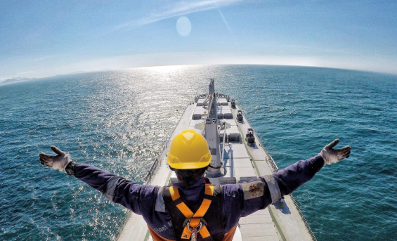

A few recommendations are made from the findings of this study:
- Shipowners and ship managers need to recognise that a seafarer who is well aware of the criminalisation phenomenon is better equipped to deal with it. The matter must be brought up and discussed at pre-joining meetings, at least for senior seafarers. Masters must be made aware of the differing laws that they face as they move through various jurisdictions
- In cases of accidents, courts should be encouraged to allow piercing of the veil of corporate secrecy. In conjunction with sub-standard flag states, the veil is misused by owners to hide their identity. While this is not a matter of concern under normal circumstances, when accidents take place, owners must not be allowed to evade their liabilities using this facet of the law
- The public image of the industry needs to be changed. This is something that needs further investigation. No studies have been carried out on why seafarers and the maritime industry are considered socially irresponsible and are constantly vilified.
- The IMO needs a separate department that only overlooks ‘fair treatment of seafarer’ issues. 2010 being the year of the seafarer and with IMO Secretary General, Mitropoulos, being a great proponent of fair treatment, the creation of a separate department must be examined
It is hoped that this study will provide the basis for future studies on related issues of concern to seafarers and thus contribute to improving the seafarer’s lot

References
https://www.marineinsight.com/maritime-law/criminalisation-of-seafarer/

https://www.itopf.org/in-action/case-studies/case-study/hebei-spirit-republic-of-korea-2007/

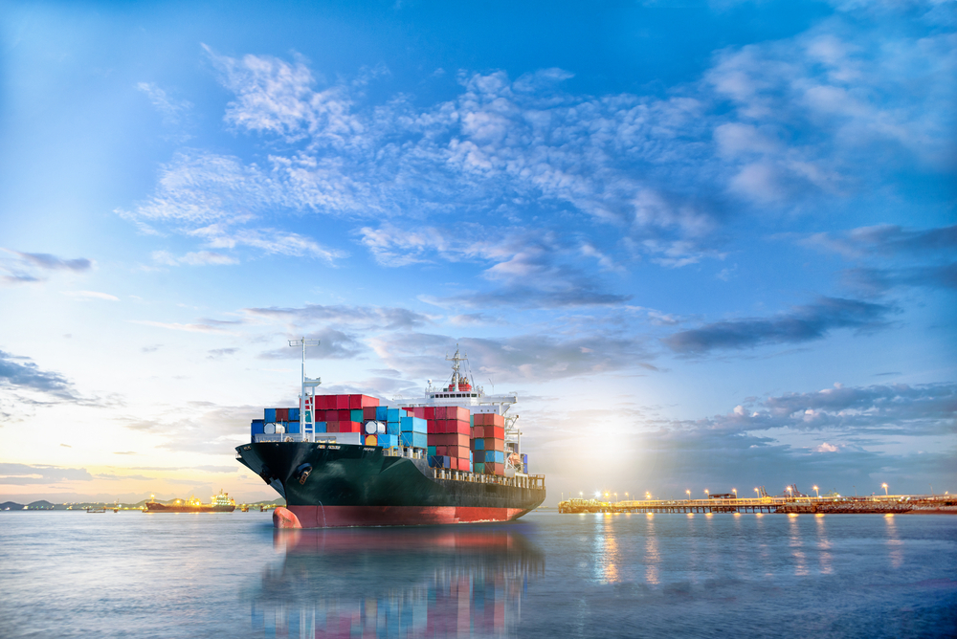
THANK YOU!

