Hybrid power and propulsion systems for ships: Current status and future challenges: a Review
Arnab Chakraverty
Student, Department of B. Tech Marine Engineering, MANET, MIT-ADT University, Pune - 412201, India
arnab.7chakraverty@gmail.com

ABSTRACT
As environmental concerns grow, the shipping industry is being forced to take more stringent steps to reduce greenhouse gas emissions. The International Maritime Organization (IMO) encourages the maritime industry to develop more energy-efficient and environmentally friendly power systems. Research into maritime alternative fuels, operational enhancements such as slow steaming or predictive maintenance, and further emission abatement technology are not enough to reduce hazardous emissions. One technique to improve the efficiency of the maritime propulsion system is to employ electricity as the primary energy vector. Power production technologies, energy storage components, energy management systems, and hybrid propulsion topologies are all discussed in this study. As power generation units, diesel engines, fuel cells, solar, and wind power as renewable energy sources are examined. Batteries, supercapacitors , and flywheels are among the energy storage options.
Keywords: Electric ship, emission reduction, hybrid propulsion architecture, energy management system, hybrid propulsion selection, hybrid propulsion optimization methods

INTRODUCTION
International legislation is forcing the maritime industry to gradually lower its emissions as it becomes more aware of the worldwide environmental impact of ships. International Maritime Organization treaties and energy efficiency standards place a burden on the shipping industry, ship owners, and ship designers to develop propulsion systems that efficiently decrease or eliminate emissions while increasing energy efficiency at a reasonable cost and time. In terms of adjustment time, implementation cost, and energy storage system capacity, each approach has advantages and downsides.
The International Maritime Organization (IMO), the United Nations agency in charge of ensuring the safety of lives at sea, efficient shipping, and the prevention of pollution caused by international shipping, has drafted strict environmental regulations to reduce the global impact of maritime shipping emissions. In April 2018, the IMO adopted an initial strategy to reduce greenhouse gas (GHG) emissions from international maritime shipping by at least 50% by 2050 as compared to 2008 levels. This strategy additionally targets reducing CO₂ emissions from shipping by at least 40% and 70% by 2030 and 2050, respectively, as compared to 2008 levels. [1] This will minimize CO2 emissions from maritime shipping, lowering its environmental impact. As a result, some countries have already begun to implement the new IMO requirements.
New concepts discussed in this study include the use of environmentally acceptable fuels in existing propulsion design, hybrid propulsion, and all-electric propulsion with the use of renewable energy sources.

1. HYBRID POWER
In power engineering, the term 'hybrid' describes a combined power and energy storage system.[2] Hybrid systems, as the name implies, combine two or more modes of electricity generation together, usually using renewable technologies such as solar photovoltaic (PV) and wind turbines. Hybrid systems provide a high level of energy security through the mix of generation methods, and often will incorporate a storage system (battery, fuel cell) or small fossil fueled generator to ensure maximum supply reliability and security.[3]
Most of us are familiar with how solar, wind, and biomass power generation systems function, but each of these methods has its own set of disadvantages. Solar panels, for example, are costly to install and do not produce their maximum output at night or on overcast days. Wind turbines, on the other hand, cannot operate safely in high wind speeds and provide little power in low wind speeds. Low temperatures cause biomass plants to fail.
So, depending on the control units, the downsides can be partially or totally avoided if all three are merged into one hybrid power generating system. Because one or more disadvantages can be overcome by the other, as in the northern hemisphere, solar power is limited on windy days and vice versa, and the biomass plant can operate at full capacity during the summer and rainy season, the power generation can be maintained in the above stated condition. Solar panels can be made cheaper by employing glass lenses and mirrors to heat a fluid that can rotate a standard turbine used by wind and other sources.
Now comes the topic of how to deal with cold winter nights or gloomy winter days with low wind speeds. Here comes the Hydrogen's action. Electrolysis, as we know, produces hydrogen by breaking water into hydrogen and oxygen, which may be stored; hydrogen is also a good fuel that burns with oxygen to make water. In the winter, hydrogen can be utilized to keep the biomass reservoir warm enough to create the maximum quantity of biogas for power generation. As previously indicated, biogas is a good source in the summer; the available solar energy is also at its height during this time, so if demand and supply are properly evaluated and estimated, the excess energy may be used to produce hydrogen and stored. On a sunny, windy, and hot day, the turbine runs at full speed since the supply is at its peak, and the excess power may be used in the hydrogen production process. Because power consumption is lower in the winter, the supply limit is also lower, and may be achieved with less use.

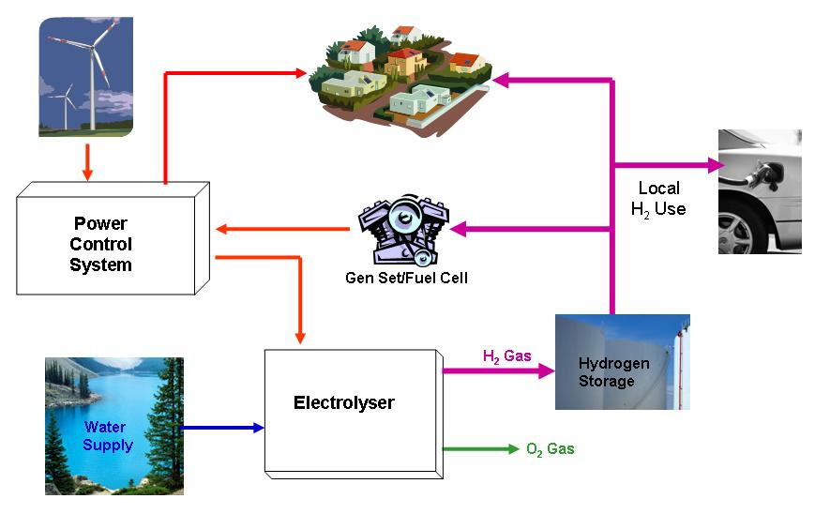

2. HYBRID PROPULSION
While the pressure to reduce fuel consumption and emissions has increased, the operating profile of ships has become increasingly diverse: offshore vessels perform numerous tasks, such as transit and critical dynamic positioning (DP) operations [5], [6]; heavy crane vessels, such as the Pioneering Spirit, exhibit an increased capacity and complexity for diverse offshore operations; naval ships perform traditional patrol operations in open sea, but are also deployed in littoral operations; and tugs require full bollard pull when towing and require limited power during transit or standby [7]. Due to these diverse operating profiles, the power and propulsion plant has to perform well on many performance criteria, such as:
1. Fuel consumption;
2. Emissions;
3. Radiated noise;
4. Propulsion availability;
5. Maneuverability;
6. Comfort due to minimal noise, vibrations and smell;
7. Maintenance cost due to engine thermal and mechanical loading; and
8. Purchase cost.
Furthermore, the diverse operational profile makes it hard to optimize the power and propulsion plant for a specific operating point at a vessel’s design stage, as was conventionally done. Thus, since the 1990s, the power and propulsion configuration has been adapted to a varied operating profile with electric propulsion for various ship types. However, although electrical propulsion is more efficient at low speed, it introduces additional conversion losses of 5–15% of the propulsive power in electrical components such as generators, power converters, transformers and electric motors.
2.a ELECTRICAL PROPULSION
Electrical propulsion has been around since the early 1900s. In the 1990s, electric propulsion received an enormous boost in the cruise ship industry and in capital naval ships. A typical architecture of an electric propulsion system is depicted in Fig.1. Multiple diesel generator sets (1) feed a fixed frequency high voltage electrical bus (2). This bus feeds the electrical propulsion motor drive (5) and the hotel load (6), in most cases through a transformer (3). The electric propulsion motor drive consists of a power electronic converter (4) used to control shaft line speed and thus ship speed.
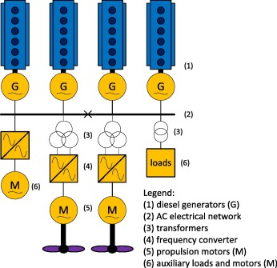

Electrical propulsion's advantages and disadvantages
The NO_{x} emissions of electric propulsion are likely to be less than those of mechanical propulsion, because the propulsion power at full ship speed is, in most cases, split over more engines, which due to their lower individual power run at a higher speed. For example, a cruise ship with an electrical propulsion power of 20 MW per shaft typically has 5 diesel generators installed, running at 720 rpm, and a cruise ship with a mechanical propulsion plant of 20 MW per shaft typically has two main engines of 20 MW, each running at a maximum speed of 500 rpm with four-stroke diesel engines or 80 rpm with two-stroke engines. For Tier II, this would mean a cycle-averaged NO_{x} production of 9.7 g/kWh for the diesel generators used in electrical propulsion and of 10.5 or 14.4 g/kWh for the four-stroke or two-stroke diesel engines used in mechanical propulsion. Moreover, due to the power station concept of electrical propulsion, the diesel generators run closer to their design point, at which they typically produce less NO_{x} emissions or need less fuel-consumption-increasing NO_{x} abatement measures. Furthermore, they always run at rated speed, as opposed to mechanical propulsion engines, which run at reduced speed in part load, producing more NO_{x} due to the longer NO_{x} formation time.Advantage of electrical propulsion is the reduced maintenance load, as engines are shared between propulsion and auxiliary load and are switched off when they are not required.
Electric propulsion can achieve reduced radiated noise due to the absence of a mechanical transmission path from the engine to the propeller. To this aim, the design of motor and power converter has to be optimised for minimal torque fluctuation. The impact of dynamic (operational) conditions on noise performance of electrical propulsion appears not to have been studied yet.
Electrical propulsion, on the other hand, has the following challenges:
Electrical propulsion incurs greater losses due to the additional conversion stages in power converters and electric motors. These losses result in an increase in SFC, especially near the ship's top speed.
Most ships with electric propulsion use FPP, because electric motors with variable speed drives can provide maximum torque at every speed and run in reverse. Vrijdag [8] has shown that radiated noise due to cavitation increases under operational conditions when fixing propeller pitch and using speed control, which is the standard control strategy for electric motors. Therefore, cavitation potentially increases under operational conditions, particularly for electric propulsion with fixed pitch propellers and speed control, as well as for mechanical propulsion with FPP.
SIMULATION RESULT AND DISCUSSION [9]
Firstly, we tested the performance of hybrid propulsion system by running the simulations in various wave conditions. The key performance indexes, such as amplitude of speed and power fluctuation and fuel efficiency, are compared between the conventional propulsion system and the hybrid one. Secondly, we selected a number of cases to run both in all-in-one simulation and in co-simulation. Simulation run time was the main key index for comparison and the accuracy of the co-simulation is checked.
PERFORMANCE OF THE HYBRID PROPULSION SYSTEM
For the first part of the simulation, we set up the simulation cases in order to monitor the performance of the system in various wave conditions. 45 wave conditions are produced as combination of following Wave amplitude (Hwave) : 3, 4, 5m
• Wave encounter angles(χwave) :180°,135°,90°,45°,0°
•wave parameters: Wave length (Lwave) : 192, 352, 512m
• Key performance indexes in this part of the simulations are: Amplitude of fluctuations of shaft speed and• engine power Voltage and frequency deviation
• Energy efficiency
• Analyzing the 45 cases of simulation, the amplitude of the fluctuation of shaft speed has decreased by 55% in average and 50% for engine power. Moreover, we could find only limited correlation between the degrees of reduction and wave conditions where the absolute values of the correlation coefficients of these performance indexes to the wave parameters are less than 0.5. More detailed analysis of the results are shown in the Table 7. Figure 10 is the time series plot for shaft speed variation in the order of increasing sea state. The speed signal shown in the figure is low-pass filtered to remove the high frequency variation due to cyclic torque variation. The first two cases show that the amplitude of the shaft speed decreased by factor of nearly two when the hybrid mode is engaged at 50 seconds. The peak at 50s in the first figure is caused by the transition from one control logic to another.
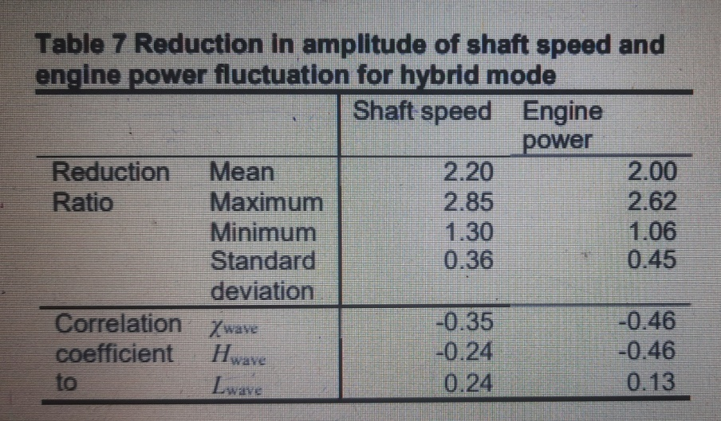
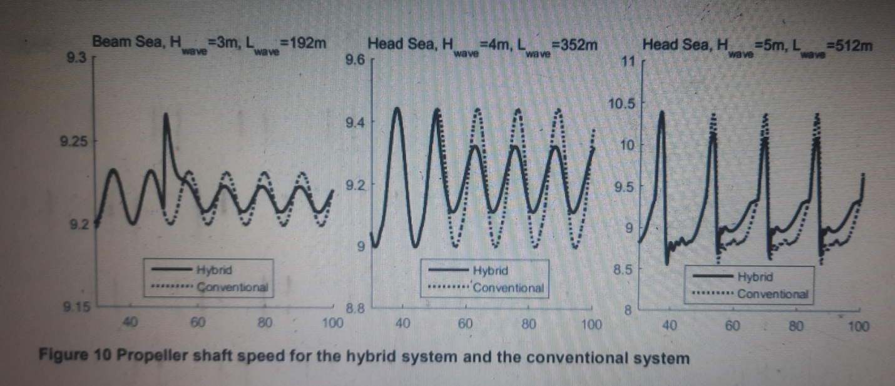

3.a HYBRID GAS PROPULSION
Hydrogen fuel could be used to decarbonize thermal engines if the hydrogen is produced in a carbon-free manner and the engines emit very low levels of NOx. Furthermore, hydrogen eliminates undesirable pollutants such as unburned hydrocarbons, aromatic compounds, sulphur oxides, soot, and smoke. Hydrogen is a technology that can help the maritime environment be more sustainable. Unlike fossil fuels, however, hydrogen gas cannot be collected directly from the earth and must be generated from a variety of sources. In general, hydrogen can be produced from several sources, including water, biomass, and fossil fuels, using electrolysis, steam methane reforming, and gasification [10, 11]. However, technologies that can produce hydrogen in cleaner ways are emerging. For instance,
an electrolysis process that is a zero-CO2 emissions technology has been developed to produce hydrogen by splitting water into hydrogen and oxygen directly without natural gas or CO2 emissions by using solar energy [12].
In the future, hydrogen will be transported using a large-scale LH2 carrier ship. However, saving weight and cargo space is a concerning issue in the maritime sector, especially for LH2 tankers, because the density of hydrogen is extremely less as a voluminous substance. Thus, a combined-cycle gas turbine is a potential alternative for achieving compact engine size benefits with acceptable thermal efficiency targets [13].
Hydrogen gas turbine design[14]
The gas turbine engine design fuelled by hydrogen was inspired by an LM2500þ industrial gas turbine engine fuelled by natural gas [28] as conventional fuel to achieve the ships power requirement. The design difference arises during the slightly different properties in the hot section of the gas turbine fuelled by hydrogen due to the same reason related to the combustion products containing no CO2. Table 2 shows the changes in the gas turbine hot section areas with the velocity variation for each stage. The gas turbine fuelled by hydrogen simulation results shows that the combustor outlet and turbine inlet section's area increased around 3.1% compared with conventional fuel in the combustor. On the other hand, in the case of turbine outlet and power turbine inlet using hydrogen fuel, the section's area decreased around 0.002 m2 compared with conventional fuel. In the case of a power turbine outlet using hydrogen fuel, the section's area increased around 1.6% compared with conventional fuel. Those changes are due to variability in each section's total inlet and outlet temperatures.
Based on the preliminary design of the LH2 tanker ship hull and the stability analysis conducted in a previous study [3], a suitable propulsion system design is required for this unique ship. The authors of this paper determined that the initial design concept of the LH2-tanker ship-propulsion system depends on several factors based on the ship propulsion power requirements, such as ship dimensions, weights, resistance, speed, and hull design coefficients, considering the decarbonisation target and high thermal efficiency achievement. The primary stage of the ship propulsion system design includes the ship-module calculation of the brake power required from the propulsion system, prediction of ship hull resistance, and estimation of propulsion factors using a statistical method [14,15]. In particular, the total hull resistance was preliminarily calculated as a function of viscous hull resistance, appendage resistance, wave resistance, and model-ship correlation resistance, including the additional pressure resistance of bulbous bow near the water surface, which was assumed as zero owing to the ship hull form design. Moreover, the additional pressure resistance of the immersed transom stern was assumed as zero owing to the ship design. The calculation of propulsion factors involved the Table 1; Gas turbine engine characteristics by applying conventional and hydrogen fuel.

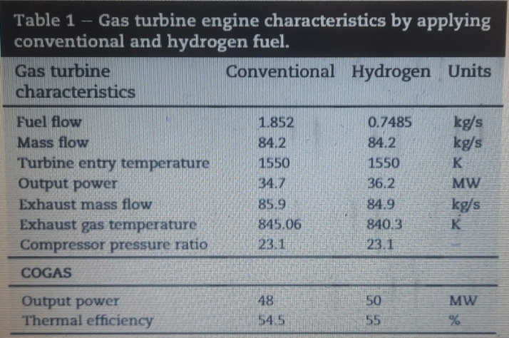
The prediction of the effective wake fraction, thrust deduction factor, and the relative rotational efficiency of the propulsion system established on the LH2 carrier ship . In addition, the resistance estimation and the power required during loading and unloading conditions at various speeds were validated using the MAXSURF software. Furthermore, the collaboration between the hull and propeller was represented via the power required by the combined-cycle gas turbined known as the brake power from the effective power for the ship hull, which is a product of the total resistance and the LH2 carrier ship speed. The authors used the Wageningen B-series propellers method to estimate the twin-screw attached to the pods of the open-water propeller design and specify its characteristics [16]. However, the lightweight of hydrogen requires a distinct ship design, especially a small hull draft in the unloading condition, which eventually causes operation challenges in shallow water as compared to alternative tanker ships. Based on this distinct condition, the authors of this paper selected a turboelectric
system including two azimuthal podded propellers with a maximum power output of 15.5 MW each as a component of the LH2 carrier ship propulsion system. This selection supported the reliability and controllability of the LH2 carrier ship in shallow waters. After the power requirements were determined, the power plant was required to be modelled for generating the power required for the vessel. Thus, the authors selected a hydrogen-fuelled combined-cycle gas turbine as the prime mover to generate power for the LH2 propulsion system owing to its more compact size and dimensions, which is a vital consideration for the large volume of LH2cargo, lightweight, high thermal efficiency, and low emissions in comparison to two-stroke diesel engines [17]. The combined-cycle gas turbine, including a simple-cycle gas turbine and a single-pressure heat-recovery steam generator, was simulated with the capabilities of design and off-design point calculations based on the TURBOMATCH gas-turbine performance code [18] and MATLAB software. The following sections will describe the power requirements, power generated, and engine efficiency for LH2 carrier ships in various conditions. The results of the preliminary design evaluation are listed in Table 3 [3].
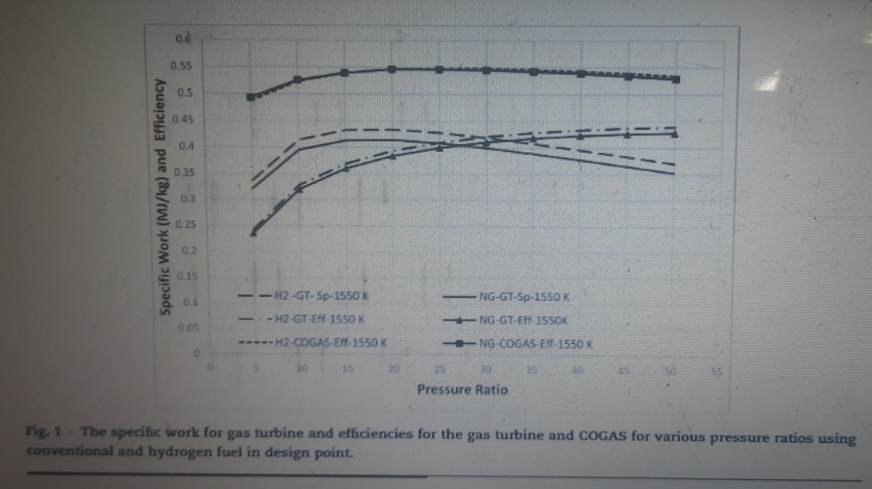
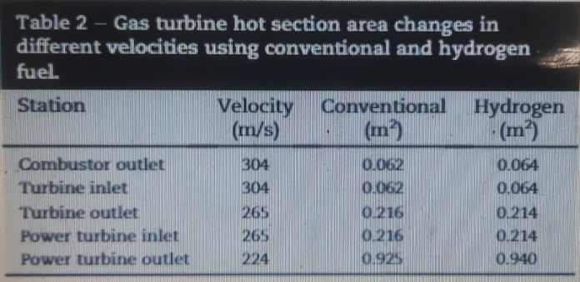
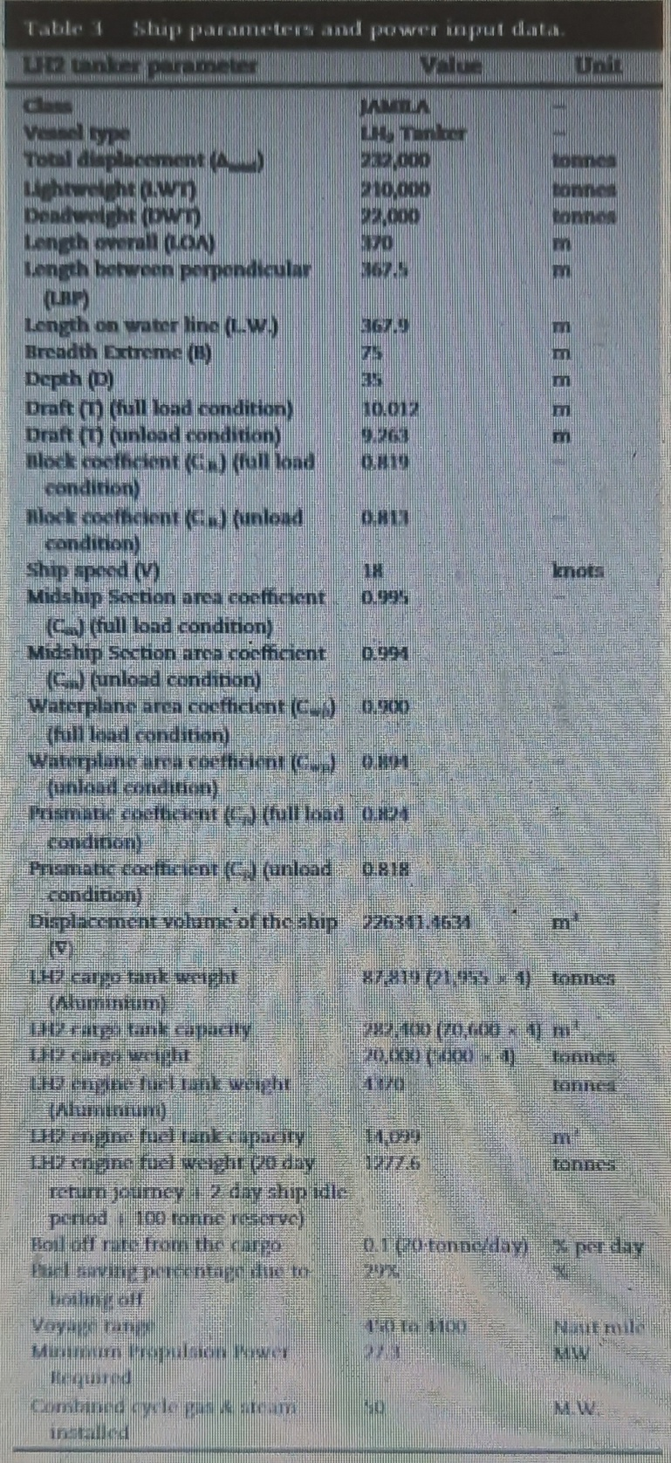
Technical feasibility of a hydrogen propulsion system
- In comparison to 54.5 percent using conventional fuel, a combined cycle gas turbine powered by hydrogen achieved 55 percent thermal efficiency with zero CO2 emissions.
- In 6 percent of degradation under varied weather conditions, the combined cycle gas turbine powered by hydrogen has an acceptable thermal efficiency and power output performance to be a successful propulsion system.
3 . CONCLUSION
1. The simulation revealed that having an energy storage device allows for active use of the shaft generator as a propulsion aid, especially in waves. It has the ability to lessen speed fluctuations and enhance propeller loads, giving it more maneuvering capabilities in bad weather. It has also been demonstrated that the system is equal in terms of efficiency in such operations even when the plant is not optimized.
Furthermore, a more efficient technique for a complex system simulation was demonstrated, as well as its validity, by comparing the results to an all-in-one simulation method. An economic appraisal is an essential step toward putting such a system into practice.

2. From an industrial standpoint, the proposed hydrogen-fueled maritime propulsion system is feasible and can be executed using cutting-edge techniques and technologies. Even under conditions of degradation and increased ambient temperature, the modeling results revealed that this consideration was satisfied in the majority of operating scenarios. The proposed system nevertheless delivered 31 M.W. at a thermal efficiency more than 50% in the worst-case scenario of high deterioration and ambient temperature, permitting a ship speed of 16 knots. Although a somewhat more efficient power plant and propeller arrangement may be accomplished with more comprehensive optimization, the proposed system gave a competitive performance and met the goal of visualizing a prospective LH2 tanker ship propulsion system.

We've shown that, despite huge reductions in emissions, the feasibility of a hybrid power system is still a long way off, and a much more optimal plant needs to be designed. Here we conclude the review on hybrid power and propulsion system.

ACKNOWLEDGMENT

I would like to express my deep and sincere gratitude to my research supervisors Mrs.Archana Bhange and Mr. Govind Ghule and Mr. Subhodh Devgaonkar , Principal , Manet , Pune for giving me the opportunity to do research and providing invaluable guidance throughout this research. I am extremely grateful to my parents for their love, prayers, caring and sacrifices for educating and preparing me for my future. I would like to thank the administration of MANET, Pune and MIT-ADT University. Finally, my thanks go to all the people who have supported me to complete the research work directly or indirectly.

REFRENCES

[1]. IMO. Report of the marine environment protection committee on its 72nd session (2018)
MEPC 72/WP.7

[2]. Ginn, Claire (8 September 2016). "Energy pick n' mix: are hybrid systems the next big thing?"

[3]. Kamal, Mohasinina Binte; Mendis, Gihan J.; Wei, Jin (2018). "Intelligent Soft Computing-Based Security Control for Energy Management Architecture of Hybrid Emergency Power System for More-Electric Aircrafts [sic]". IEEE Journal of Selected Topics in Signal Processing. 12 (4): 806
[4]. By Longershanks at English Wikipedia - Transferred from en.wikipedia to Commons by Teratornis using CommonsHelper., Public Domain, https://commons.wikimedia.org/w/index.php?curid=7276101
[5]. Barcellos R. The hybrid propulsion system as an alternative for offshore vessels servicing and supporting remote oil field operations. In: Proceedings of the annual offshore technology conference, vol. 3; 2013. p. 1622–31
[6]. MER. Offshore propulsion: powering the offshore industry. Marine Engineers Review; March 2008. p. 18–22.
[7]. Volker T. Hybrid propulsion concepts on ships. In: Zeszyty Naukowe Akademii Morskiej w Gdyni, vol. 79; 2013. p. 66–76.
[8].Vrijdag A. Control of propeller cavitation in operational conditions. PhD thesis, Faculty Mechanical, Maritime and Materials Engineering, Delft University of Technology, The Netherlands; 2009.
[9]. Simulation of a Hybrid Marine Propulsion System in Waves 09 System Integration & Optimization Kevin Koosup Yum, Norwegian University of Science and Technology Stian Skjong, Norwegian University of Science and Technology Bhushan Taskar, Norwegian University of Science and Technology Eilif Pedersen, Norwegian University of Science and Technology Sverre Steen, Norwegian University of Science and Technology. 28th CIMAC World Congress 2016 in Helsinki.
[10]. The future of fuel: the future of hydrogen
S. Bourne
Fuel Cell Bull, 1 (2012), pp. 12-15, 10.1016/S1464-2859(12)70027-5

[11]. Hydrogen the future transportation fuel: from production to applications

[12]. Low carbon energy and feedstock for the European chemical industry
A.M. Bazzanella and F. Ausfelder
DECHEMA Gesellschaft für Chemische Technik und Biotechnologie (2017)
(In German)
[13]. Evaluation of gas turbines as alternative energy production systems for a large cruise ships to meet new maritime regulations Armellini,+2 ,M. Reini Appl Energy, 211 (2018), pp. 306-317
[14]. Alkhaledi ANFNR et al., Propulsion of a hydrogen-fuelled LH2 tanker ship, International Journal of Hydrogen Energy, https://doi.org/10.1016/j.ijhydene.2022.03.224

