BLUE ECONOMY- “BLUE IS THE NEW GREEN”
Cdt. Kanishka Roy, B.Tech Marine Engg., MANET Pune (India), mynameiskroy@gmail.com
Abstract
This paper is a brief documentation of the progress of the well-proposed topic of Blue Economy in lieu of the emergence of an industry of academic proposals, new standards and accreditations, non-governmental organizations and policy institutes devoted to full amplification of the concept in the form of environmental management, financial analyses, planning processes, and the inclusion of poverty alleviation, social justice, human rights, and cultural traditions. This paper also explores the different sectors of the concept and the eventual modifications and sophistications that have emerged ever since its advent. The status of its progress in India is also heavily discussed amidst global context. A brief introduction to the concept has been inculcated with main emphasis on its implications and future prospects.
Keywords —Blue Economy, Sectors, MIS 2021, Sustainability

Introduction
The use of oceans has diversified from a classic medium of transport to being a wellspring for resources. The economic richness of the oceans is represented by the variety of living resources (fish and marine vegetation which provide human protein and feed for other species), material goods (hydrocarbons, minerals, and sand and gravel), services (shipping, ports, shipbuilding, fishing, tourism), and renewable energy (wind, wave, tidal, thermal and biomass). They have acted as a catalyst for the development of a number of industries, both on land and at sea. Or simply put it can be said that a massive economy has been established around the oceans. When the sustainable use of these resources for economic growth is prioritized alongside improved livelihoods and ocean ecosystem health, the concept of ‘blue economy’ arises. It advocates the greening of ocean development strategies for higher productivity and conservation of ocean's health.

Need Of Blue Economy
With land-based resources depleting fast, there would be renewed attempts to further expand economic exploitation of the world’s oceans. However, if not managed sustainably, growing economic engagement with the oceans could risk further aggravation of their already strained health with serious impact on their natural role as the single most important CO₂ sink and recharger of oxygen. This, in turn, could accelerate global warming with catastrophic effects on fish stocks, climatic stabilisation, water cycle and essential biodiversity.
In India, as IORA (Indian Ocean Rim Association) points out this would , “contribute to food security; poverty alleviation; the mitigation of and resilience to the impacts of climate change; enhanced trade and investment; enhanced maritime connectivity; enhanced diversification; job creation and socio-economic growth.” India’s population is estimated to rise to 1.7 billion in 2050. The Blue Economy may offer a partial path towards food security. Also, At least 3-5% of global GDP is derived from oceans.
It may be underlined that the theatre of the development of Blue Economy, from India’s prism, will be the waters surrounding it i.e. the Indian Ocean. Hence the countries situated in our immediate and extended neighbourhood would receive our focal attention.

DEFINITION
Although Blue Economy has entered the arena of regular international debate and discourse for the past several years, no commonly accepted definition has emerged so far. Diversity of views is, therefore, noteworthy. The idea of Blue Economy gained prominence with the publication of Gunter Pauli’s book “The Blue Economy: 10 Years, 100 Innovations, 100 Million Jobs” in 2010.
According to the World Bank the blue economy is the "sustainable use of ocean resources for economic growth, improved livelihoods, and jobs while preserving the health of ocean ecosystem."
European Commission defines it as "All economic activities related to oceans, seas and coasts. It covers a wide range of interlinked established and emerging sectors."
The Commonwealth of Nations considers it "an emerging concept which encourages better stewardship of our ocean or 'blue' resources."
Conservation International adds that "blue economy also includes economic benefits that may not be marketed, such as carbon storage, coastal protection, cultural values and biodiversity."
The Centre for Blue Economy says "it is now a widely used term around the world with three related but distinct meanings- the overall contribution of the oceans to economies, the need to address the environmental and ecological sustainability of the oceans, and the ocean economy as a growth opportunity for both developed and developing countries."
A United Nations representative defined the Blue Economy as an economy that "comprises a range of economic sectors and related policies that together determine whether the use of ocean resources is sustainable. An important challenge of the blue economy is to understand and better manage the many aspects of oceanic sustainability, ranging from sustainable fisheries to ecosystem health to preventing pollution. Secondly, the blue economy challenges us to realize that the sustainable management of ocean resources will require collaboration across borders and sectors through a variety of partnerships, and on a scale that has not been previously achieved. This is a tall order, particularly for Small Island Developing States (SIDS) and Least Developed Countries (LDCs) who face significant limitations." The UN notes that the Blue Economy will aid in achieving the UN Sustainable Development Goals, of which one goal is "life below water".

Exclusivity of Blue Economy
Ocean economy
A related term of blue economy is ocean economy and we see some organizations using the two terms interchangeably. However, these two terms represent different concepts. Ocean economy simply deals with the use of ocean resources and is strictly aimed at empowering the economic system of ocean. Blue economy goes beyond viewing the ocean economy solely as a mechanism for economic growth. It focuses on the sustainability of ocean for economic growth. Therefore, blue economy encompasses ecological aspects of the ocean along with economic aspects.

Green economy
The green economy is defined as an economy that aims at reducing environmental risks, and that aims for sustainable development without degrading the environment. It is closely related with ecological economics. Therefore, blue economy is a part of green economy. During Rio+20 Summit in June 2012, Pacific small island developing states stated that, for them, "a green economy was in fact a blue economy"

Blue growth
A related term is blue growth, which means "support to the growth of the maritime sector in a sustainable way." The term is adopted by the European Union as an integrated maritime policy to achieve the goals of the Europe 2020 strategy.

development of blue economy
Given the economic potential of the oceans and the seas, a number of countries are investing enormous financial, technological and human capital to develop maritime economies and are striving to leverage their unique strengths.
Several countries have announced initiatives and action plans to promote the Blue Economy. Among the island states, Seychelles and Mauritius have been spearheading the discourse, while the European Union has developed a sophisticated framework for harnessing the oceans. Similarly, multilateral Association for Regional Cooperation (SAARC) and Indian Ocean Rim Association (IORA) have highlighted institutions such as Asia-Pacific Economic Cooperation (APEC), East Asia Summit (EAS), South Asian the potential and prospects of the Blue Economy in their statements and communiqués.

- India
India has planned to focus on emerging economic and strategic axis spreads from the East Coast of Africa to the Western Pacific Ocean - called the Seychelles-Singapore-Samoa (SSS) axis - as part of its long-term strategy to utilise oceanic resources under the country’s proposed Blue Economy policy.This in addition to another policy on the Arctic region is expected to put India at the forefront in exploring resources of strategic importance through maritime cooperation.
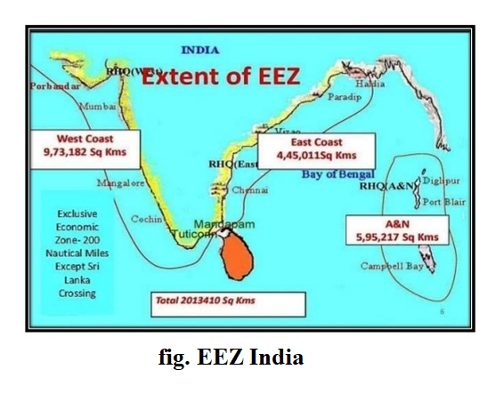
The maiden Maritime India Summit 2016 in Mumbai witnessed investment commitments of nearly INR 83,000 crore (US$ 13 billion) in the shipping, ports and allied sectors. The government plans to invest INR 12 lakh crore over the next ten years to develop 27 industrial clusters and to improve connectivity with ports through new rail and road projects. These are expected to create “immense employment opportunities” in the ports, roads and shipping sectors over and above the 10 million potential jobs (four million direct and six million indirect jobs) over the next ten years under the Sagarmala Project. The priority sectors for India’s maritime ecosystem include shipping, ports, Container Freight Stations (CFS)/Inland Container Depots (ICD) and Coastal Economic Zones (CEZ), road, rail and coastal connectivity, shipbuilding, investments, advisory, technology, training and leisure Including cruise and lighthouse tourism. India has an umbrella scheme by the name of O-SMART which aims at regulated use of oceans, marine resources for sustainable development.
The MIS 2021 has brought forth many significant updates-
Other Initiatives for Port Development:
- The Sagar-Manthan: Mercantile Marine Domain Awareness Centre has also been launched. It is an information system for enhancing maritime safety, search and rescue capabilities, security and marine environment protection.
- Ship repair clusters will be developed along both coasts by 2022. Domestic ship recycling industry will also be promoted to create 'Wealth from Waste'. India has enacted Recycling of Ships Act, 2019 and agreed to the Hong Kong International Convention.
- India aims to increase usage of renewable energy to more than 60% of total energy by 2030 across Indian ports. Terminal infrastructure and ecosystem development at 4 theme based coastal destination circuits to activate cruise demand.
- Increase usage of renewable energy to >60% of total energy by 2030 across Indian ports with primary focus on solar and wind.
- Holistic development for island infrastructure and ecosystem across Andaman and Lakshadweep to make them an attractive cruise destination.
- Evaluate and pilot advanced energy solutions (e.g. wave, tidal) at select Indian Ports by conducting a detailed feasibility study (e.g. tidal at Deendayal port, wave energy at Cochin port).
- Drive adoption of multi-clean fuels (Electric, CNG, LNG) for vehicles in port ecosystem.
- Develop green belt (including mangrove, mudflats) cover at ports with participation of corporates under CSR program.
These are few of the initiatives proposed in 2021 which if implemented will massively help India in becoming a world leader in blue economy.

- Others
The People’s Republic of China has a Five-Year Development Plan for National Marine Economy which monitors progress of various marine sectors. The State Oceanic Administration (SOA) is the nodal agency. During 2011-2015, China’s ocean economy grew at an annual average growth of 8.1 per cent. In 2015, the marine economy was estimated to be 6.47 trillion Yuan (US$ 989.3 billion or INR 6.7 lakh crore), which is 7 per cent higher than in 2014. This corresponds to about 9.6 per cent of the national GDP for 2015.The marine industry employs an estimated 35.9 million people. The Chinese leadership is conscious of the importance of the marine economy and has noted: “A developed marine economy is an important part of building maritime power.” In March 2016, the Chinese government announced the 13th Five-Year Plan (2016-2020) which aims to achieve nearly 100 targets in the five-year period. China plans to develop smart ports, construct more ice-breaking vessels, transform the ship equipment industry and engage in deep-sea activities. These initiatives will help China to promote the growth of Blue Economy.
Bangladesh is perhaps the most vocal country in South Asia about Blue Economy. In 2014, it proposed the “Bay of Bengal Partnership for Blue Economy”21 for an “inclusive and people centric,” sustainable development of sea-based resources. The Blue Economy is high on its national economic agenda as nearly 30 million people in Bangladesh are “dependent on the sea for livelihood, and are engaged in fishing and commercial transportation.” Bangladesh is in the early stages of embracing the Blue Economy and confronts a number of technological and financial constraints to make the dream come true. It has instituted several measures, including setting up a research institute for study of marine science, oceanography and training personnel to develop skills for the sustainable development of resources. It has also established scientific collaboration with other countries to develop expertise on Blue Economy.
Seychelles and Mauritius are Small Island Developing States (SIDS) and highly dependent on the seas for economic well-being. Their economies are closely linked to the African economies which have endorsed Blue Economy. Further, they have established partnership for development of Blue Economy with Australia and India and are seeking support for technical, fiscal and security- related capacity building. Likewise, Maldives is highly dependent on the seas for its economic vitality and is a strong supporter of Blue Economy.

sectors of blue economy
- Fishing
This sector supports livelihood of about 11 per cent of the world’s population, thus providing a myriad of economic opportunities. This sector provides lucrative avenues for small and medium enterprises which should seize existing domestic opportunities. For many people, it is even the only available source of protein. In 2016 the total catch was 90.9 million tonnes (2011: 92.2 million tonnes). 79.3 million tonnes in the marine environment and 11.6 million tonnes inland. Unfortunately, the negative effects of the fishing industry have hardly changed. The figures for overfished or overexploited fish populations are still depressingly high. And fishing quotas have not truly contributed to the improvement. The development of the last decade has confirmed their largely ineffective impact on sustainable fishing. 58 %of the fish population is fully fished, and a third is overfished. To sum it up: 90 % of the fish population is over- or ‘out fished’. The lesson which we have learnt in recent years is as simple as easy. Give the fish time to recover. The experience of decades of discussions showed that Marine Protected Areas (MPA) is more efficient than fishing quotas. The goals should be to achieve more sustainable catches with low energy consumption and lower costs; to improve food security and livelihoods by restoring over-exploited or collapsed fish stocks, applying the precautionary principle and scientifically based fisheries management.
India has developed expertise in satellite launching, fabrication and application of such systems. This facility can be effectively used in the IORA region for identifying and locating fish clusters in the sea for facilitating capture fishing. Such satellite facilities may be used alternatively in other areas of economic activities such as search and rescue operations, meteorology and other applications in the region.
India is a trade-surplus country in the fisheries sector. India’s fisheries exports were more than 31.5 times higher than its imports in 2013. While the country’s exports stood at US$ 2.4 billion, its imports were US$ 76 million, registering a trade surplus of US$ 2.32 billion in the corresponding year. India is also an important exporter of aquatic plants and aquatic products, having the 17th and 23rd positions respectively in world ranking.

- Marine Bio-Technology
One of the fastest emerging high-technology sectors in Blue Economy is marine biotechnology. It has wide-ranging applications in industrial sectors including pharmaceuticals, cosmetics, nutritional supplements, molecular probes, enzymes, fine chemicals and agrichemicals. In the global economy, the size of biotechnology market is estimated at US$ 2.4 billion which is expected to register an annual growth of 10 per cent. The relevance of white biotechnology is becoming important due to growing dependence on agriculture, particularly on sectors like fisheries and food additives. Polyculture is becoming important in fishing technology to replace conventional method of aquaculture production in mariculture. Since capture fishing is declining persistently in the face of growing demand for fisheries products, increasing supply of fish production in an environmentally sustainable manner is becoming important. Agricultural biotechnology has the advantage of improving supply of high quality food on a sustained basis. This technology focuses on optimum food and feeding, health of cultural organisms, diseases and resistance.
There are certain drugs available in the market for specific critical diseases and these drugs are manufactured using marine bio-resources as shown in Table 3 below. Moreover, bio-resources and compounds are used for preparation of various cosmetic products, which are traded widely across the globe.
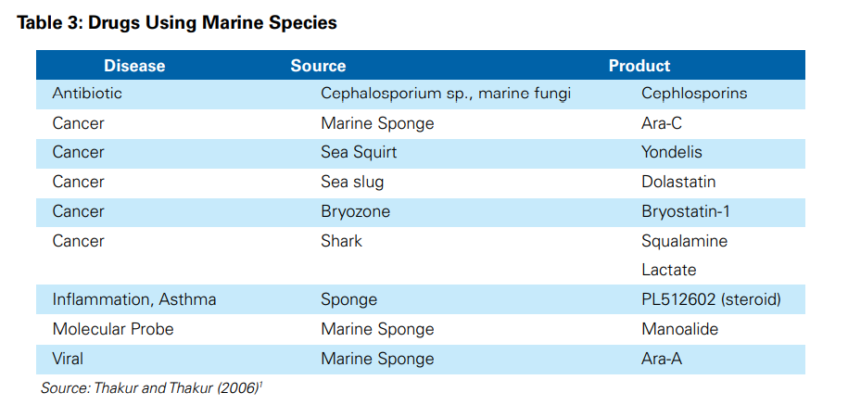
- Exploration of coastal and offshore mining
It is viewed as an important sector of Blue Economy globally. The EU estimated that the largest chunk of its ocean economy is sourced from offshore mining. Similarly, several other countries such as Australia, South Africa, Namibia, and Papua New Guinea are intensely endowed with marine minerals. Marine mining focuses on aggregates including sand, gravels, salt, sulphur, magnesium, oil and gas, tin etc. In addition, deposits of diamond, gold and other heavy metals are also found in the offshore.
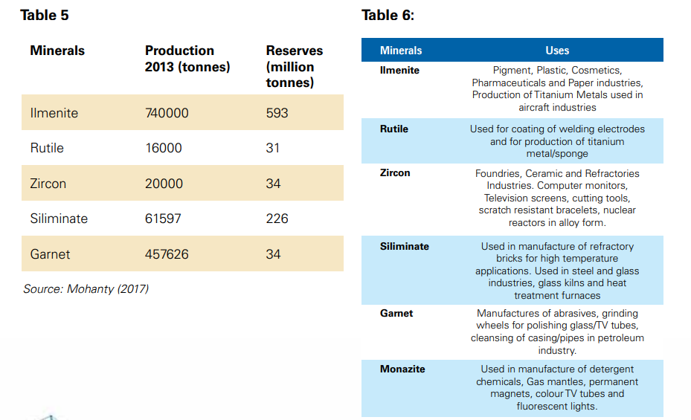

In India at present, placers are mined by state agencies, but exploration of deep-sea mining on a commercial basis is yet to happen. Because of a pressing demand for large investment in production, extraction and processing of aggregates and placers, state-run agencies are unable to augment domestic production to meet the current required targets. In this regard, private sector may be allowed to enter the sector in a PPP model in order to expedite the pace of exploration of aggregates and placers in India.

- Marine Tourism and Leisure Marine space
It provides numerous opportunities for tourism and recreation such as swimming, sun-bathing, pleasure boating, snorkeling, surfing, reef walking, whale and dolphin watching, and SCUBA diving among others. Besides conventional tourism, coastal (or marine) tourism assumes considerable importance in the context of the Blue Economy. Several initiatives have been taken by coastal nations to promote marine tourism in different national and regional locations. Cruise shipping and lighthouse tourism are given exclusive emphasis in these initiatives. In order to attract more foreign tourists, marinas may be developed along the Indian coast. The range of employment opportunities include hotels, restaurants, housing and residential activities, vending, beach hawking, agriculture and fishing activities. The growth of tourism sector in the country has a lasting impact on coastal environment in terms of urban sprawl, urbanisation, production of waste and social environment.

- Shipping, Port and Maritime Logistics
As a fast-growing emerging country, development of port infrastructure plays an important role in promoting various developmental activities, including trade. The Ministry of Shipping reports that much of India’s international trade (about 90 per cent by volume and 70 per cent by value) is carried through maritime transport. The sector covers a wide range of services which are broadly divided into two categories: shipping industry and maritime logistics.
Despite India being a major player in the global trade, it has been lagging behind several other countries in terms of containerisation measured byTEUs (Twenty-Foot Equivalent Units). In several major shipyards, private sector participation is not permitted. For a more effective and efficient PPP type model, both Micro, Small and Medium Enterprises (MSMEs) and large enterprises may be allowed to operate in all Indian shipyards. For improving efficiency of the major ports, minor ports could be roped. The relative performance of major and minor projects is presented inTable 7.There are about 27 ongoing projects undertaken for Indian water transportation and coastal shipping with a total investment of INR 7,414.14 crore. These initiatives may strengthen India’s port and shipping sector.

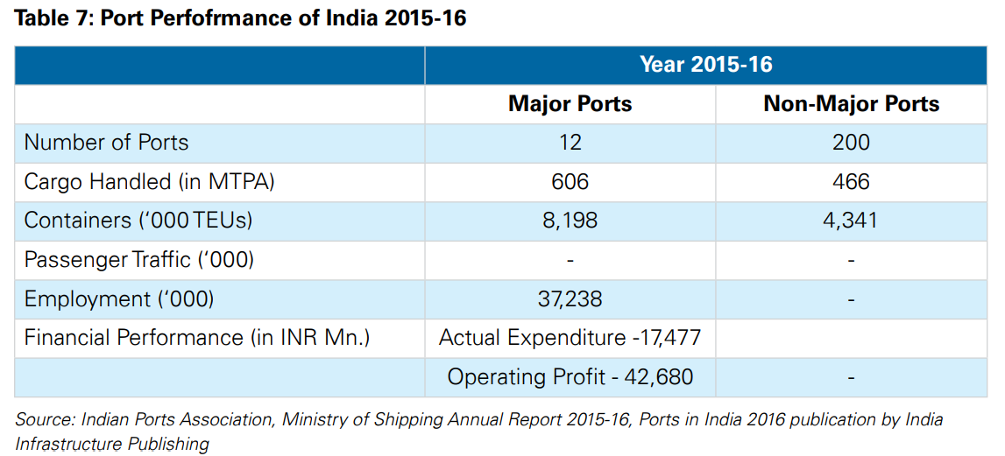

- Marine Construction
Construction in the marine and offshore environment offers great opportunities for innovation. It is emerging as one of most exciting fields of engineering practice. Marine construction typically involves dealing with construction, diving and dredging activities, hydraulic engineering, underwater works including cabling, construction and development of ports and offshore bridges.
The Sagarmala Project is a major initiative of the Indian Government to impart dynamism to the port sector. It is expected to tackle the challenge of under-utilised ports by focussing on port modernisation, efficient evacuation and coastal economic development.
The marine construction sector offers large opportunities to private sectors in India. Some of the key opportunities in India are: -
- About 36 ongoing projects undertaken for Port Development with total investment of about INR 70,178.2 crore.
- Around 32 ongoing projects undertaken for Port modernization with total investment of about INR 9982.8 crore
- 33 ongoing projects aimed at Port-led Development with a total investment of INR 1,50,657 crore
- 4 ongoing projects related to green port initiatives with total investment of INR 419 crore.

- Marine Renewable Energy (MRE)
Renewable energy enjoys almost 22 per cent share of the global energy mix. Considering the fact that MRE has potential to have sizeable returns to capital, more inflow of investment into the sector could provide a solution to the “Energy Trilemma” that includes energy security, energy equity and environmental sustainability.
Offshore wind energy is the most mature energy in comparison to other forms of marine energy with respect to their technology development. The world’s exploitable offshore wind resource is around 30 times higher than global estimation of average electricity generation. Wave energy is emerging as a viable source of energy providing substantial energy with minimum environmental impact. Even though tidal energy has immense potential, the full-scale development of this industry is not achieved yet due to environmental concerns.
As enabling environment for investment is building up, India is among the top five countries which have invested in renewable energy (UNEP, 2016)39. India’s cumulative investment in the sector is adding up to US$ 10.2 billion as against US$ 102.9 billion in China in 2015. However, financing continues to be a major constraint for the development of the renewable energy sector in India.
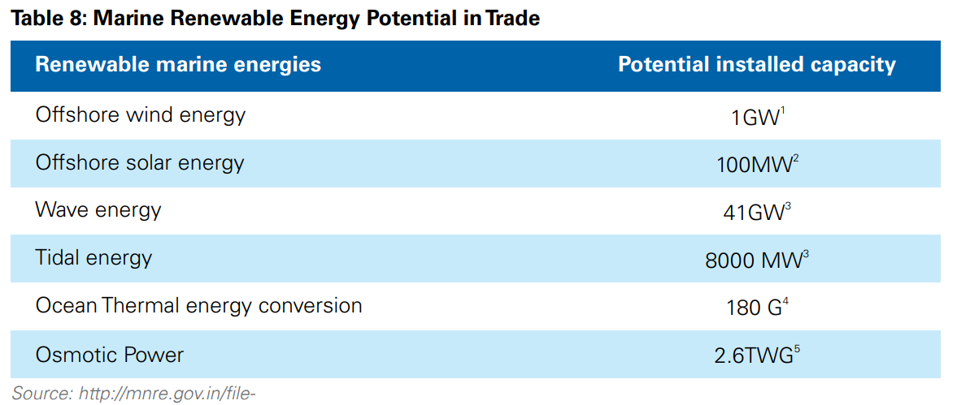

Since India has set the target of achieving a five-fold rise in renewable energy capacity from 30 GW to 175 GW by 2022, exploring marine renewable energy sources would be the best way to enhance India’s energy mix. India has a long coastline of 7,500 km (including island territories), which provides ample opportunities for generating multiple sources of marine renewable energy, but the country has a long way to go for achieving this goal.

- Marine manufacturing
It is a globally dynamic sector and an important segment of the Blue Economy. Korea, Japan and China are emerging as key market players replacing the US and the EU. India has the potentiality to emerge as a new global leader in ship manufacturing. Its meteoric rise in the global market has been perceptible during the last decade.
India has a large ship building base, but it needs to be modernized. At present, India has 23 shipyards, of which 7 are under administrative control of the Central Government, 2 with state governments, and the rest are in the private sector. The Indian shipping industry, with a marginal share of 0.1 per cent of global shipbuilding market in 2002, has expanded manifold during the last decade, accounting for 1 per cent of world shipbuilding industry.
However, there remain several challenges that hold back the shipping industry from reaching its full potential. At the same time, there are several opportunities that need to be tapped to see the linear growth of the industry in the next decade (Table 9)
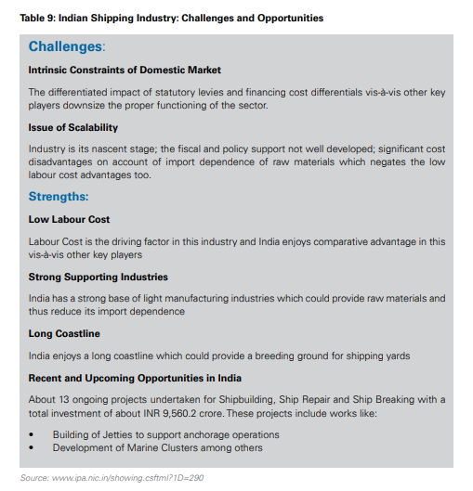

other important & regional conventions
The following could apply to the development of Blue Economy:
a) Ramsar Convention on wetlands of international importance;
b) Convention on Biological Diversity (CBD) for protecting ocean biotechnology;
c) Nairobi Convention for protection and conservation of coastal environment of East African coast;
d) MARPOL for prevention of pollution by ships;
e) African Maritime Transport Charter on promoting regional cooperation and best practices in maritime transport;
f) World Heritage Convention which also seeks to protect sites of human heritage on high seas; and
g) International Whaling Commission (IWC) for controlling all kinds of whaling activities.

Decoupling environmental degradation from the developmental process is at the very heart of the Blue Economy. This fits well with India’s own initiatives and priorities such as renewables and energy efficiency, Swachh Bharat, cleaning of rivers and promoting cleaner production and delivery mechanisms, which would eventually also guide various flag-ship programmes including Sagarmala, Smart Cities, Skill India and Make in India, with sustainability as an integral component. The essence of decoupling environmental degradation from development has also the potential to create employment in projects relating to new systems of waste treatment and recycling which will ensure that no pollutants find their way into our rivers and oceans.

CONCLUSION

The Earth’s resources are limited, while the needs of humankind – and the world population itself – are on the rise. It is, therefore, imperative to plan on maximising the utilisation and harnessing of oceanic resources. However, this should be done in a thoughtful, essentially Gandhian manner, ensuring an optimal focus on sustainable development. In practice, this amounts to distributing equitable priority attention to three key elements, namely Growth, Employment and Protection of Environment. This tripod may be used as a broad yardstick, with each project judged for ensuring sustainability. For this purpose, a high priority may need to be given to ecological protection and economic democracy. Another fundamental consideration should be to balance the requirement of optimisation of business potential with the needs and interests of local, particularly coastal, communities. It is only through a broader inclusion of all stakeholders – big, medium and small – that the long term sustainability and viability of the proposed expansion of Blue Economy opportunities would be ensured.

Acknowledgment

I would like to thank Prof. Tejasvini Yadav to encourage me to go forward with this paper and guiding me throughout.

I would also like to express my ardent gratitude towards Capt. Gajanan Karanjikar for introducing me to and enlightening me with this particular topic.

References
- www.moes.gov.in
- www.ficci.in
- www.maritimeindiasummit.in
- www.frontiers.in.org
- www.wikipedia.org.
- www.oceanfdn.org
- www.worldoceanobservatory.org/content/once-and-future-ocean.

