Cdt.Karan Sahu
MAHARASTRA ACADEMY OF NAVAL EDUCATION AND TRAINING ,PUNE ,INDIA,[ksahu3906@gmail.com]
Cdt. Vedant Sutar
MAHARASTRA ACADEMY OF NAVAL EDUCATION AND TRAINING ,PUNE,INDIA,[vedantsutar57@gmail.com]
Abstract: The oceans are increasingly viewed as a new frontier for economic development. Yet, as companies and governments race to capitalize on marine resources, substantial risks can arise for people and the environment. The dominant discourse that frames blue growth as beneficial for the economy, developing nations, and coastal communities risks downplaying the uneven distribution of benefits and potential harms. Civil society organizations and academics alike have been sounding the alarm about the social justice implications of rapid and unchecked ocean development. Here, we review existing literature to highlight ten social injustices that might be produced by blue growth: 1) dispossession, displacement and ocean grabbing; 2) environmental justice concerns from pollution and waste; 3) environmental degradation and reduction of ecosystem services; 4) livelihood impacts for small-scale fishers; 5) lost access to marine resources needed for food security and well-being; 6) inequitable distribution of economic benefits; 7) social and cultural impacts; 8) marginalization of women; 9) human and Indigenous rights abuses; and, 10) exclusion from governance. Through this critical review, we aim to stimulate a rigorous dialogue on future pathways to achieve a more just and inclusive ocean economy. We contend that a commitment to ‘blue justice’ must be central to the blue growth agenda, which requires greater attention to addressing the 10 risks that we have highlighted, and propose practical actions to incorporate recognitional, procedural, and distributional justice into the future ocean economy. However, achieving a truly just ocean economy may require a complete transformation of the blue growth paradigm.
1.KEYWORDS- Blue Economy; oceans; maritime; marine; definition; sustainability; industrialization; validity; cluster analysis; value chain.
2.INTRODUCTION
The oceans are indeed correctly compared to a cornucopia for humanity, by providing us with food, oxygen and livelihoods, as stated in UNEP’s (United Nations Environment Programme) Synthesis Report titled Green Economy in a Blue World. As the ocean has an inherently fluid nature, the compartmentalisation of ocean, coastal and marine industries from its operating environment of watersheds and ecosystems, to the harmonisation of traditional economic activities with sustainable economic values, becomes a challenging activity
“Eradicating poverty is the greatest global challenge facing the world today and an indispensable requirement for sustainable development. In this regard we are committed to freeing humanity from poverty and hunger as a matter of urgency.”
Rapid and unchecked economic development in the ocean can produce substantial risks for people and the environment. But, what harms or social injustices might be produced by the ocean economy? Isn’t it

3.What is Blue economy?
The word economy has been used in different ways as per world bank blue economy refers to the sustainable and integrated development of economic sectors in healthy oceans, basically blue economy concept seeks to promote economic growth increasing or sustaining the livelihood of people by not destroying the ocean environment. There are diverse components in blue economy like fisheries industry, tourism Maritime transport, offshore renewable energy, aquaculture, seabed, extractive activities and marine biotechnology. Today currently Government of India switching is pitching to promote polar economy and has outlined a multi- prompt plan for coastal area development comprising transforming the blue economy improvement of coastal infrastructure and protecting the marine ecosystem.
“Oceans” is included to define the operating environment and differentiate it from the land where traditional activities take place. These activities are now being transferred to a non-traditional operating environment: the oceans. The motivation for including “benefit” is to balance improvements in equity and wellbeing of both humankind and the environment with a reduction in ecological scarcities, bringing in the elements of resource efficiency and a low-carbon footprint. Benefit, as defined in this context, allows for measurement of all the included elements, which may be interpreted as a measurement of effectiveness. The motivation of “all” is to emphasise that it is a holistic, all-inclusive approach that covers humans, systems and operations, and is endowed with a calculation function, making it a measure of effectiveness.
4.The Blue Economy- a Framework for Sustainable Development
The Blue Economy is a developing world initiative pioneered by SIDS but relevant to all coastal states and countries with an interest in waters beyond national jurisdiction. SIDS have always been highly dependent upon the seas for their well-being but the Blue Economy, whilst encompassing the concept of ocean-based economies, goes far beyond that. The Blue Economy conceptualizes oceans as “Development Spaces” where spatial planning integrates conservation, sustainable use, oil and mineral wealth extraction, bioprospecting, sustainable energy production and marine transport. The Blue Economy breaks the mould of the business as usual “brown” development model where the oceans have been perceived as a means of free resource extraction and waste dumping; with costs externalised from economic calculations. The Blue Economy will incorporate ocean values and services into economic modelling and decision-making processes. The Blue Economy paradigm constitutes a sustainable development framework for developing countries addressing equity in access to, development of and the sharing of benefits from marine resources; offering scope for re-investment in human development and the alleviation of crippling national debt burdens.
5.The Blue Economy – Issues
The natural world made up of the physical environment, its mineral components and biodiversity at all three levels (genetic, species, ecosystem) is intrinsically interconnected and the more diverse and productive the natural system, the greater the degree of interconnectivity. Hence the identification of particular issues is inherently an anthropogenic construct and depending on one’s perspective may appear arbitrary. A case in point is the precursory role that the conservation and sustainable use of biodiversity has in enabling the establishment of a Blue Economy, broader sustainable development and poverty eradication (see fig below). This is particularly true in developing countries where economies are more directly related to environmental exploitation.
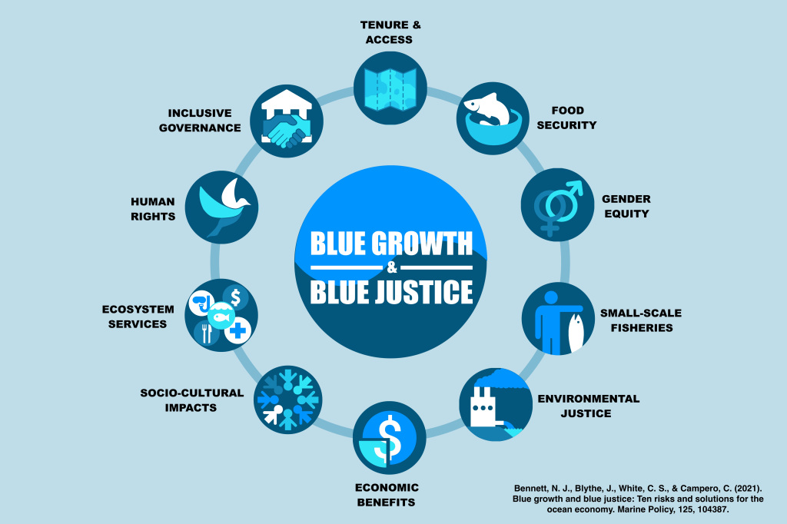
a). Sustainable use of biodiversity- The natural capital of many marine and coastal ecosystems has been degraded, impacting upon the provision of services and livelihoods. Approximately 20% of the world’s coral reefs have been lost and another 20% degraded5 . Mangroves have been reduced to 30-50% of their historical cover and it is estimated that 29% of seagrass habitats have disappeared since the late eighteen hundreds
b) Food security-
In the context of the Blue Economy food security is very closely related to the sustainable use of biodiversity particularly where it pertains to the exploitation of wild fisheries. 1 billion people in developing countries depend on seafood for their primary source of protein
“We are deeply concerned that one in five people on this planet, or over 1 billion people, still live in extreme poverty, and that one in seven — or 14 per cent — is undernourished…”
c). Unsustainable Fisheries- The proportion of marine fish stocks estimated to be underexploited or moderately exploited declined from 40% in the mid-1970s to 15% in 2008, and the proportion of overexploited, depleted or recovering stocks, increased from 10% in 1974 to 32% in 2008-09 . Fishing fleet subsidies are estimated to be between US$ 10-30 billion per year driving the further depletion of fisheries that have otherwise ceased to be economically viable. The benefits lost to fishing nations as a consequence of over fishing are estimated to be in the order of US$ 50 billion per annum.
d). Climate change and managing carbon budgets- Sea level rise and change in ecosystem status due to changing temperatures, from coral bleaching to impacts upon migration patterns, have been discussed at length in diverse international fora and need not be re-stated here. Relatively new issues on the agenda, however, are Ocean Acidification and Blue Carbon.
e). Marine and coastal tourism- Marine and coastal tourism is of key importance to many developing countries. Despite the global economic crisis international tourism has continued to grow. Data indicates that international tourist arrivals increased by 4% to 1.035 billion in 2012, generating US$ 1.3 trillion in export earnings. The UNWTO forecasts further growth of 3-4% in 2013-15 . This does not detract however from the vulnerability of economies so heavily dependent on a single industry. Tourism brings challenges in terms of increased: greenhouse gas emissions, water consumption, sewage, waste generation and loss or degradation of coastal habitat, biodiversity and ecosystem services.
f). Pollution and marine debris- The growing human population, intensification of agriculture and the rapid urbanisation of coastal areas are all key land based factors causing higher levels of pollution in our seas. Documented marine “dead zones” now number more than 400 covering an area of over 240,000 km2 including some of the formerly most productive areas of estuaries and shelf. There has been an approximate threefold increase in the loads of nitrogen and phosphorous enrichment to the oceans since pre-industrial times.
6.The Blue Economy – Opportunities
Issues and problems bring with them challenges and opportunities and the Blue Economy offers a suite of opportunities for sustainable, clean, equitable blue growth in both traditional and emerging sectors.
a). Shipping and Port Facilities- 80 percent of global trade by volume, and over 70 per cent by value, is carried by sea and handled by ports worldwide. For developing countries, on a national basis, these percentages are typically higher. World seaborne trade grew by 4% in 2011, to 8.7 billion tonnes18 despite the global economic crisis and container traffic is projected to triple by 203019. Coastal countries and SIDS need to position themselves in terms of facilities and capacities to cater for this growing trade and optimise their benefits. The IMO has brought in new industry wide measures to increase efficiency, reduce green house gas emissions and pollution.
b). Fisheries- Globally 350 million jobs are linked to marine fisheries, with 90% of fishers living in developing countries. The value of fish traded by developing countries is estimated at US$ 25 billion making it their largest single trade item. Global catch rose from 4 million tonnes in 1900, through 16.7 million tonnes in 1950, 62 million tonnes in 1980 to 86.7 million tonnes in 2000 but has stagnated subsequently 20% . In 2009 marine capture production was 79 million tonnes. Overall catch risks decline with 75% of stocks fully exploited or depleted21. Human activity has directly and markedly reduced ocean productivity; additional deficits may be due to climate change increasing ocean stratification and reducing nutrient mixing in the open seas.
c).Tourism- Tourism is a major global industry; in 2012 international tourist arrivals increased by 4% despite the global economic crisis and constituted 9% of Global GDP.
Tourism developments bring various problems, as iterated in section 5e of this document. The tourism consumer, however, is driving the transformation of the sector with a 20% annual growth rate in ecotourism; about 6 times the rate of growth of the overall industry. A Blue Economy approach where ecosystem services are properly valued and incorporated into development planning will further advance this transition, guiding tourism development and promoting lower impact activities, such as ecotourism and nature-based tourism, where the natural capital is maintained as an integral part of the process.
d). Aquaculture -Aquaculture is the fastest growing global food sector now providing 47% of the fish for human consumption is 26% . Fish used for human consumption grew by more than 90 million tonnes in the period 1960-2009 (from 27 to 118 million tonnes) and aquaculture is projected to soon surpass capture fisheries as the primary provider of such protein. To maintain its viability and growth without undermining wild fisheries the aquaculture industry must actively reduce the proportion of industrial fish in fishmeal.
e). Energy- In 2009 offshore fields accounted for 32% of worldwide crude oil production and this is projected to rise to 34% in 2025-29 and higher subsequently, as almost half the remaining recoverable conventional oil is estimated to be in offshore fields - a quarter of that in deep water 30% . Deep water oil drilling is not new, but market pressures are making the exploration for and tapping of evermore remote reserves cost effective, bringing the most isolated areas under consideration. Methane hydrates, a potentially enormous source of hydrocarbons, are now also being explored and tapped from the seabed.
f). Biotechnology- The global market for marine biotechnology products and processes is currently estimated at US $ 2.8 billion and projected to grow to around US$ 4.6 billion by 2017. Marine biotech has the potential to address a suite of global challenges such as sustainable food supplies, human health, energy security and environmental remediation.
On the energy front algal biofuels offer promising prospects. The European science Foundation postulates a production volume of 20-80 thousand litres of oil per hectare per year can be achieved from microalgal culture, with even the lower part of this range being considerably higher than terrestrial biofuel crops.
g). Submarine mining- The world is gearing up for the exploration and exploitation of mineral deposits on and beneath the sea floor. Industry, due to rising commodity prices, is turning its attention to the potential riches of polymetallic nodules, cobalt crusts and massive sulphide deposits; the latter a source of rare earth elements, such as yttrium, dysprosium and terbium, important in new ICT hardware and renewable energy technologies. Commercial interest is particularly strong in polymetallic nodules and in seafloor massive sulphides.
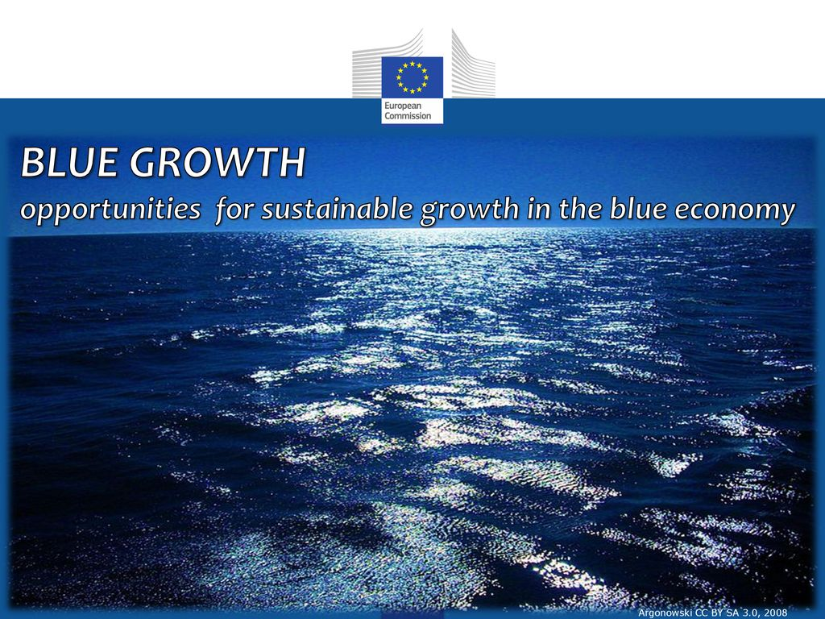
7.Conclusion
The research question of the paper was to find an approach that allowed for a definition of the Blue Economy that is easy to remember, apply, manage and measure. This was addressed first by analysing the background of the Blue Economy in its internationally regulated framework and then by investigating, with the use of qualitative comparative analysis, the various existing definitions. The definition derived from this analysis was then tested against minimum criteria to ensure that it is able to uphold its integrity.
The second part of the paper applied the definition in practical terms on the ocean economy as it is emerges from existing knowledge. This analysis was done with the aid of value chain analysis and cluster analysis. The methodologies were applied first by structuring the oceans according to a value chain, and then clustering it according to its activities, services, and established and emerging industries, as well as shedding some light on what drives the growth in these industries. The approach was built on applying the individual elements of the definitions to the structure of the ocean value chain and then on clustering of the chain. The final assessment was to ensure that the drivers of change or growth factors of the activities are now included as a part of the balance to be obtained and as a measurement of effectiveness. Finally, the paper indicated that by defining the Blue Economy in measurable and calculable terms, standards may be set for it, allowing for a systems approach in how it balances regime-related obligations with socio-economic activities, without ecological degradation of the oceans.

8.Reference:-
1.Bennett, N. J., Blythe, J., White, C. S., & Campero, C. (2021). Blue growth and blue justice: Ten risks and solutions for the ocean economy. Marine Policy, 125, 104387. https://www.sciencedirect.com/science/article/pii/S0308597X20310381
2."What is the Blue Economy?". THE WORLD BANK. 6 June 2017. Retrieved 14 May2018.

3.Nellemann, C. et al (2009). Blue Carbon. A Rapid Response Assessment. UNEP, GRID-Arendal, ISBN: 978-82-7701-060-1 OECD (2012).
4.The Future of the Ocean Economy – exploring the prospects for emerging ocean industries to 2030. PARM (2004).
5.Sustainable Development of the World’s Large Marine Ecosystems during Climate Change. IUCN
6.United Nations Conference on Sustainable Development, 2012. Blue Economy Concept Paper, s.l.: United Nations Conference on Sustainable Development. http://unctad.org/en/ PublicationsLibrary/ditcted2014d5_en.pdf (Accessed 14th April 2016).`
7.Goddard, C., 2015. The Blue Economy: Growth, opportunity and a sustainable ocean economy, s.l.: Economist Intelligence Unit. http://www.greengrowthknowledge.org/resource/blueeconomy-growth-opportunity-and-sustainable-ocean-economy (Accessed 14th April 2016)

