A study of proposed AI-based Interview Process model for Interview and Campus Selection Process

Authors:
- Dr. Pooja Kulkarni, Assistant Professor, Vishwarkarma University
- Mr. Sagar Kulkarni, Research Scholar, MIT World Peace University
- Dr. Jaideep Jadhav, Professor MIT World Peace University
- Dr. Ashish Kulkarni. Associate Professor, MIT World Peace University

Abstract

The recruitment process generally follows criteria of 60% for SSc, HSc, Graduation (till candidate appeared for interview) specifically for campus selection. This criterion may lead to bar the deserving candidate form the selection process in addition there is no guarantee that the student having though out 60% criteria may not be deserving for the required position.

60% criteria or some filtering criteria dose not have any relevance with the selection process its purely for filtering students as there are large number of students for campus selection and organization officials does not have time to test all the aspiring candidates

This problem may resolve if Artificial Intelligence based proctored software used to conduct the primary scrutiny rather than adding some criterial for filtering

This paper will discuss about features required for artificial intelligence-based software to conduct primary scrutiny of aspirants.

Keyword : Artificial Intelligence, Interview, HR Process

Introduction:

When an organization posts a job requirement on their careers page or any other job portals such as LinkedIn, naukri.com, etc. There are many applicants that apply to that posting by fabricating their experiences and skills on their resumes. Also many times there are applications received that are not suitable and relevant for the job requirements. Due to this, a lot of time, money and other resources of the organization gets dissipate.

To reduce this and to utilize the organizations resources more efficiently and effectively we are proposing an “AI-based Interview Process” system.

Literature review:

1. Jin-Young Kim, WanGyu Heo has published article in Information Technology & People, Vol. 35 No. 3, pp. 861-878. Title of article is “Artificial intelligence video interviewing for employment: perspectives from applicants, companies, developer and academicians”
As a result, all of them accepted that an AI-based meet was more proficient than a conventional one in terms of taken a toll and time reserve funds and is likely to be received by more companies within the future. They pointed to the plausibility of information inclination requiring an enhancement in AI responsibility. Candidates seen an AI-based meet to be way better than conventional assessment methods in procedural reasonableness, objectivity and consistency of calculations. In any case, a few candidates were disappointed almost being evaluated by AI. Computerized partition and computerized imbalance were repeating topics in this think about.

2. Theresa Eriksson, Alessandro Bigi, Michelle Bonera has published article in The TQM Journal Vol. 32 No. 4, pp. 795-814. Title of article is “Think with me, or think for me? On the future role of artificial intelligence in marketing strategy formulation”.
As a result (1) Significance of AI in key showcasing choice administration; (2) Nearness of AI in vital choice administration; (3) Part of AI in key choice administration; (4) Significance of commerce culture for the utilize of AI; (5) Effect of AI on the business’ organizational demonstrate. A key thought may be a “creative-possibility perspective,” highlighting long haul potential to utilize AI not as it were for levelheaded but moreover for imaginative considering purposes.

3. Serge-Lopez Wamba-Taguimdje, Samuel Fosso Wamba, Jean Robert Kala Kamdjoug, Chris Emmanuel Tchatchouang Wanko has published article in Business Process Management Journal Vol. 26 No. 7, pp. 1893-1924. Title of article is “Influence of artificial intelligence (AI) on firm performance: the business value of AI-based transformation projects”
As a result AI covers a wide run of innovations, counting machine interpretation, chatbots and self-learning calculations, all of which can permit people to superior get it their environment and act appropriately. Organizations have been embracing AI innovative developments with a see to adjusting to or disturbing their environment whereas creating and optimizing their vital and competitive preferences. AI completely communicates its potential through its capacity to optimize existing forms and move forward mechanization, data and change impacts, but too to identify, anticipate and associated with people. In this way, the comes about of our think about have highlighted such AI benefits in organizations, and more particularly, its capacity to move forward on execution at both the organizational (monetary, promoting and authoritative) and handle levels. By building on these AI properties, organizations can, subsequently, improve the trade esteem of their changed ventures. The same comes about too appeared that organizations accomplish execution through AI capabilities as it were when they utilize their features/technologies to reconfigure their forms.

4. Richard D. Johnson, Dianna L. Stone, Kimberly M. Lukaszewski has published article in Journal of Tourism Futures Vol. 7 No. 1, pp. 40-52. Title of article is “The benefits of eHRM and AI for talent acquisition”
As a result eHRM and AI have the potential to convert how the neighborliness and tourism industry enroll and select representatives. In any case, care must be taken to guarantee that the bits of knowledge picked up and the choices made are well gotten by representatives and lead to superior representative and organizational results.

5. Prachi Bhatt has published article in Foresight, Vol. ahead-of-print No. ahead-of-print. Title of article is “AI adoption in the hiring process – important criteria and extent of AI adoption”.
As a result, the discoveries uncover that data security and return on speculation are considered two exceptionally critical criteria by human assets directors whereas mulling over the selection of AI in contracting prepare. It was found that AI appropriation will be appropriate at the sourcing and introductory screening stages of contracting. And the reasonableness of the enlisting organize where AI can be connected has been found to have changed from some time recently and after the onset of COVID-19 widespread circumstance. The discoveries and its dialog help and improve superior choices around AI selection in contracting forms of firms in the midst of changing situation – outside and inner to a firm.

Rational of Study

Recruitment of workers is a vital part of any company. Principally, recruitment process involves aptitude test, group discussion, interview, etc. An employer oversees the entire recruitment process based upon the conditions of the company and finalizes the selection of campaigners applied. Interviews are also critical in assessing a seeker’s capabilities where the
interviews include, person-to-person interviews, and debate- grounded interviews.

When an organization posts about a vacancy on their careers page or any other job portals, there are a number of campaigners that apply to that job by fabricating their gests
and chops on their resumes. Also, numerous times there are aspirants who aren't suitable or applicable for the job conditions. Due to this, a lot of time, plutocrat and other coffers of the association get dissipated.

In general, interview process aims to retain and elect talented campaigners and assign them to a proper position according to reasonable and just procedures. This procedure comprises
colorful stages similar as shortlisting, aptitude evaluation, canvassing and finalization of the campaigners. Still, conventional reclamation process is tedious and time consuming thereby rendering them ineffective. Conventional reclamation process utilizes AI in order to search for the talented campaigners using machine literacy. Still, the AI is unfit to perform an interview.

Being interview process consume a lot of time, plutocrat and other coffers of the association get dissipated. The conventional reclamation process is tedious and bear a lot of
coffers of the association thereby rendering it ineffective.
Thus, there exists a need of artificial intelligence- grounded interview process that aids an association to retain workers grounded on job conditions within lower time and using Minimum coffers. There's a need to conduct interview for a lesser number of campaigners at the same time directly. There's a need for a system that performs colorful processes of reclamation of a seeker and also monitors the processes continuously. There's a need for a
system that eliminates the involvement of association help until a suitable seeker with needed chops is shortlisted after colorful assessments. There exists a need to determine whether
the operations entered from the campaigners for the interview are genuine or not for the interview process. There's a need to minimize the time, and cost, needed for the interview
process.

Objective:

- To select more suitable candidate for the job profile and to save organizations resources used in interview process
- To give fair chance to all the deserving candidate to grab the opportunity

Significance of the study:

AI-based Interview Process:

- After an organization have posted their requirements on their career page or other job portals, candidate will have to fill the required form along with his/her resume. Once the data is feed into the system, the keyword/string matching algorithm will shortlist the candidate based on the candidate’s skills mentioned in their resume with context to the job requirements. If the candidate gets minimum score set by the organization from the algorithm, AI will send an automated email that the candidate is shortlisted for an aptitude test. Along with the email AI will send a link that will be activate till next 24hrs for candidate to give the test.
- The test will be monitored by AI system which will measure the response time and correctness of the answers. If the candidate achieves pre-defined score set by an organization to clear the aptitude test, AI will send another email to the candidate where he/she will receive a link to AI proctored interview which will be activate till next 24hrs.
- Once the candidate join the link, he/she has to follow AI’s instruction where AI can recognize identity based on live photo upload while filling the form, and the current face in the video. If both matches, AI will start the interview, else will flag that candidate and send the uploaded photo and live photo while starting the proctor interview to HR department of organization for confirmation whether to proceed further with that candidate for the interview process. If AI receives a positive feedback from HR department, then candidate’s interview will continue on another link sent by AI.
- Once interview starts, audio and video will be recorded by AI till the interview is over for analyzing and report generation purpose. In the interview AI will ask questions to the candidate where the candidate will be given questions based on the skills of the candidates and job requirement posted by organization. Organization will set number of questions that AI has to conduct for the interview, also the questions will have 4 difficulty levels – Easy, Medium, Hard, and Expert.
- AI will randomly ask question from any difficulty depending on the experience level of the candidate. For example - If the candidate has more experience, then he/she will receive more questions from hard and expert difficulty and vice versa, so that it will be fair to a candidate to get select based on his/her skills and experience.
- AI will ask questions 1 by 1 where every question will have limited time to answer. After question has been mentioned to the candidate, AI will display a timer on the screen for candidate to give the answer. If the candidate finishes giving the answer before time ends or wants to skip that question, then he/she can proceed to next question; else once the timer has ended, AI will proceed to next question. Once all the questions are over or candidate click on submit button, AI will send the recorded audio and video of an organization’s server for report generation.
- Once the video and audio is stored on server, initially AI will start working on video where AI will measure the body movements, body gesture, eye blinking’s, eye gesture, based on these AI will generate a report for the self confidence level, attentiveness, understanding, method of thinking and responsiveness of the candidate.
- Once video processing is done AI will start processing on audio recording where AI will analyze the frequency change in candidate’s voice to check their nervousness, confidence, truthfulness, etc. and will generate the report for that.
- For AI to generate these reports we will consult with multiple psychiatrists with good experience in human behavior in respective fields. Data that has been gathered from psychiatrists will be feed to the AI system, with the help of Machine learning and Deep learning AI system will use that data to generate those reports.
- Along with these reports AI will generate another report from the recorded audio to check the knowledge of candidate by converting audio to text using speech-to-text transformation and check the answers given by the candidate for respective questions by keyword/string matching algorithm.
- HR department will receive separate and consolidated reports of the candidates that have scored 70% and above in the AI proctored interview along with all the audio and video recording of the candidate for review purpose.
- HR department can now directly proceed further for one to one interview with selected candidates to get them know personally, also for salary negotiation, joining dates and other official formalities.

Materials and methods:

Flowcharts

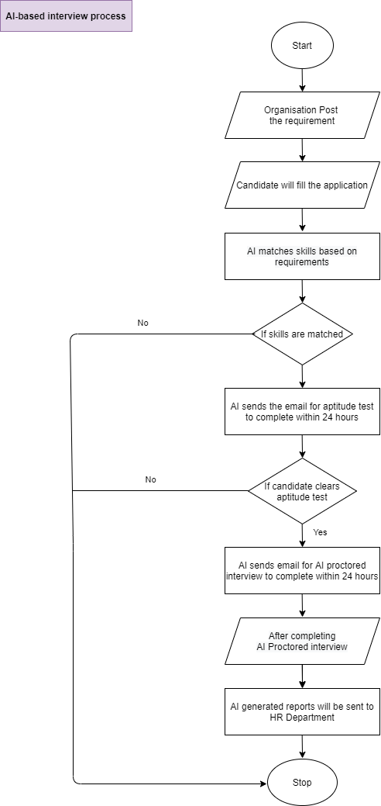

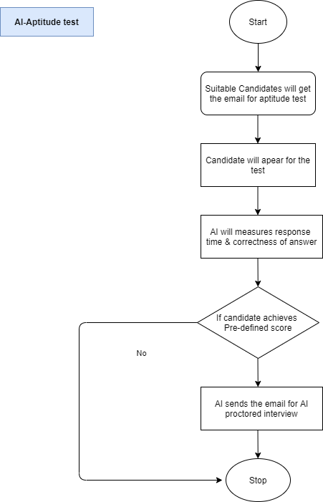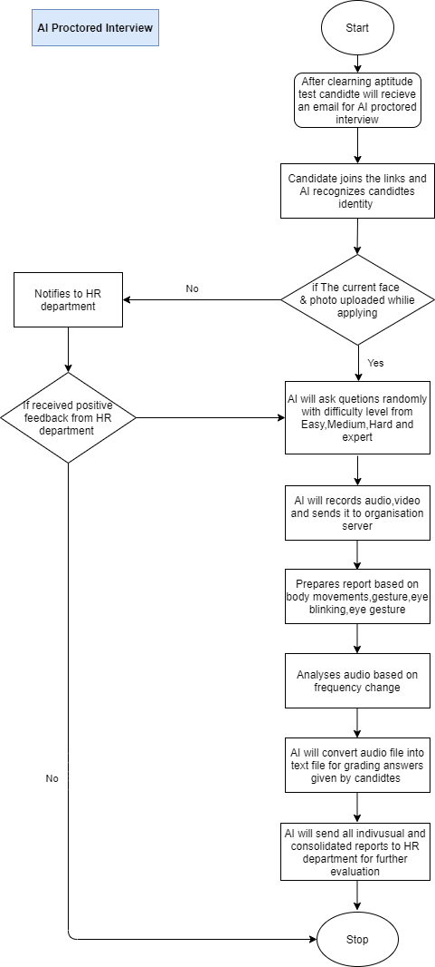

Proposed System

The system comprises an input module, a shortlisting module, a test monitoring module, an identity verification module, an interview module, and an analysis module. The artificial intelligence- grounded system for automated interview of campaigners aids the recruiting associations to retain suitable campaigners for a part within lower time and using lower coffers of the recruiting association.

The input module is configured to admit operation data of a seeker for a specific job part. The shortlisting module is configured to shortlist the seeker grounded on chops mentioned by the seeker in the operation data and transmit a preconfigured test link to the seeker. In specific, the shortlisting module shortlists the seeker grounded upon parameters set by the HR department of the recruiting association.
The test monitoring module is configured to cover response time and correctness of answers handed by the seeker in a test given by the seeker using the preconfigured test link and transmit an interview link to the seeker upon scoring a certain score in the test. In specific, the test monitoring module monitors the test given to the seeker which include either an aptitude test or a specialized test to assess the seeker

The test monitoring module is configured to cover response time and correctness of answers handed by the seeker in a test given by the seeker using the preconfigured test link and transmit an interview link to the seeker upon scoring a certain score in the test. In specific, the test monitoring module monitors the test given to the seeker which include either an aptitude test or a specialized test to assess the seeker.
The interview module is configured to give questions to the seeker aimlessly at regular time intervals grounded on the chops and experience mentioned by the seeker in the operation data. In specific, the questions asked by the interview module depends upon the chops and experience of the seeker with colorful difficulty situations similar as easy, medium hard and
expert situations.

The analysis module is configured to assay change in facial and fleshly movements along with change in voice of said seeker in order to check seeker’s unease, confidence and probity of responses to the questions and generates a report of the seeker if the seeker is shortlisted and transmits the report to the recruiting association. In specific, the analysis module generates reports grounded upon data attained from colorful psychiatrists with good experience in mortal geste in different fields

The invention provides a system for artificial intelligence grounded automated interview of campaigners. The system includes the way comprising of posting a vacancy for a specific job part on career runner of the recruiting association or other job doors and operation data of the applied campaigners is input into the system. Also, plurality of campaigners is shortlisted grounded on the operation data using a matching algorithm. Also, an automated andpre-configured link for a test is transferred to the shortlisted campaigners. Latterly, the test
is covered using a test monitoring module to measure response time and correctness of the answers given by the campaigners and scores are perfected upon completion of the test. Also, AI proctored interview link is transmitted to the campaigners who achieved apre-determined score in the test. Also, the identity of the seeker is vindicated using live print and factual face in the AI proctored interview.

Conclusion:

This way using “AI-based Interview Process” organization can save a lot of time, money and other resources. Also as it is an AI based system we can conduct interview for more number of candidates as compared to traditional interview process, which will give the organization more suitable employee who is keen in knowledge, confident, and the one who is more suitable for the posted job requirements.

References:

1. Kim, J.-Y. and Heo, W. (2022), "Artificial intelligence video interviewing for employment: perspectives from applicants, companies, developer and academicians", Information Technology & People, Vol. 35 No. 3, pp. 861-878.
2. Eriksson, T., Bigi, A. and Bonera, M. (2020), "Think with me, or think for me? On the future role of artificial intelligence in marketing strategy formulation", The TQM Journal, Vol. 32 No. 4, pp. 795-814.
3. Wamba-Taguimdje, S.-L., Fosso Wamba, S., Kala Kamdjoug, J.R. and Tchatchouang Wanko, C.E. (2020), "Influence of artificial intelligence (AI) on firm performance: the business value of AI-based transformation projects", Business Process Management Journal, Vol. 26 No. 7, pp. 1893-1924.
4. Johnson, R.D., Stone, D.L. and Lukaszewski, K.M. (2021), "The benefits of eHRM and AI for talent acquisition", Journal of Tourism Futures, Vol. 7 No. 1, pp. 40-52
5. Bhatt, P. (2022), "AI adoption in the hiring process – important criteria and extent of AI adoption", Foresight, Vol. ahead-of-print No. ahead-of-print.

