To Recommend The Best Hospital In An Area Using Machine Learning: Medic Aid Analysis
Siddhant Navele¹, Rucha Ambale², Varun Kapse³ ,Suyash Ghadge⁴
Information Technology, MIT ADT University,Pune
MIT ADT University, Rajbaug,Loni Kalbhor,India.

Abstract
In the health-care industry, there is a huge demand for the finest Medicare for patients. Weighted average Method approach is used to predict the best hospital for the patient on the basis of various attributes used in the dataset.
Health care in India is not easily available, according to various polls conducted over the last decade.. Health-care apps now accessible do not enable one-stop access to surrounding hospitals and testing centres. This app's goal is to improve one's health and, as a result, one's quality of life. If people have improved access to healthcare, many chronic diseases can be diagnosed earlier. The goal of this project is to demonstrate how a weighted average technique with content-based filtering may be used in a hospital recommender system and to compare performance.
The results reveal that the weighted hybrid technique used in this study does not significantly improve performance, but it does help to provide a prediction score for unrated hospitals that cannot be recommended using simply content-based filtering.

Keywords: Weighted average method, K-nearest neighbour(KNN), Collaborative filtering,Sentiment Analysis

INTRODUCTION

In Today’s world, data is everything and everywhere. The advent of electronic health record has opened doors for healthcare organization who wants to use this data to improve process. This helps to compare costs and outcomes, and facilitate research.
When you add smartphones, wearable fitness trackers and symptom-checker apps, the amount of information that can be examined for patterns and trends is massive.
This new wave of easily gathered and accessible health information is a boon for data analysis looking to apply their skills in healthcare.
Our aim is to get the users access the right hospital at right time so prevention of mass disease is opted.
Benefits of this Medicaid is reducing medical errors by recommending the best suited hospital to the user within

click, this will not only recommend hospital but the availability of beds with infra details for better decision making. According to multiple polls performed over the last decade, health care in India is difficult to come by. MedicAid Analysis aspires to change that.
Currently available health-care apps do not offer one-stop access to local hospitals and testing centres.
The goal of health care is to improve a person's health and, as a result, their quality of life. If people have improved access to healthcare, many chronic diseases can be diagnosed sooner.
As a result, we created our own dataset using the following criteria: hospital name, coordinates, disease specialty columns, review mean score, Google sentiment score, pincode, address, and so on. We polled 1671 participants for the hospital evaluation and used the data to establish a mean score to use in the algorithm.

Literature survey
After the research in this field findings are discussed and used to develop a model of patient satisfaction. The measurement of patient satisfaction and the findings of empirical studies are then reviewed, including summaries of effect sizes.

Patient satisfaction in primary health care: a literature review and analysis.

1]This paper reviews the literature on patient satisfaction in primary health care settings. Definitions and models of satisfaction are considered first. Attention is given to the conceptualization of satisfaction by investigators concerned about consumers in general as well as by researchers focusing on consumers of medical services. Research findings are discussed and used to develop a model of patient satisfaction.
2]The measurement of patient satisfaction and the findings of empirical studies are then reviewed, including summaries of effect sizes. It is concluded that patient satisfaction information can provide a dependent measure of service quality and serves as a predictor of health-related behaviour. Issues deserving further investigation and recommendations regarding research strategies are presented.

Literature survey on machine learning based techniques in Medical Data Analysis

1]This literature survey deals with various machine learning based techniques by applying machine learning techniques for disease diagnosis using intelligent algorithms has been a hot research area of computer science. This paper throws a light on the comprehensive survey on the machine learning applications in the medical disease prognosis during the past decades

2]Machine Learning plays a significant role among the areas of Artificial Intelligence (AI). During recent years, Machine Learning (ML) has been attracting many researchers, and it has been successfully applied in many fields such as medical, education, forecasting etc.Right now, the diagnosis of diseases is mostly from an expert's decision. Diagnosis is a major task in clinical science as it is crucial in determining if a patient is having the disease or not. This in turn decides the suitable path of treatment for disease diagnosis. Applying machine learning techniques for disease diagnosis using intelligent algorithms has been a hot research area of computer science. This paper throws a light on the comprehensive survey on the machine learning applications in the medical disease prognosis during the past decades.

Hence, a comprehensive survey has been carried out on previous works covered on the usage of automated and semi-automated medical diagnosis used in the application of speciﬁc diseases like cancer, brain tumor, Entailment, coronary heart disease, thyroid, liver disorders etc .

Methods
Hospital suggestion applications work best when implemented with algorithms and surveys from users knowing their actual sentiment about the hospitals.
Sentiment of users play an important role in classifying hospitals. They tell us how they are treated along with all the care and responsibility taken by the hospitals towards the patient
The main aim of our project is recommending different hospitals to the users, which will be a lot easier using algorithms specially designed for this job. Collaborative Filtering is one such algorithm which will help in forming a good recommendation system. This algorithm is most commonly used when implementing a recommendation system.

Collaborative filtering: Collaborative filtering (CF) is a technique used by recommender systems. Collaborative filtering has two senses, a narrow one and a more general one. In the newer, narrower sense, collaborative filtering is a method of making automatic predictions (filtering) about the interests of a user by collecting preferences or taste information from many users (collaborating). The underlying assumption of the collaborative filtering approach is that if person A has the same opinion as person B on an issue, A is more likely to have B's opinion on a different issue than that of a randomly chosen person.

Weighted average Method: Weighted average is a calculation that takes into account the varying degrees of importance of the numbers in a data set. In calculating a weighted average, each number in the data set is multiplied by a predetermined weight before the final calculation is made. A weighted average can be more accurate than a simple average in which all numbers in a data set are assigned an identical weight. We have implemented Weighted average formula to suggest hospitals specifically for heart patients for testing based on: Reviews from the users and sentiment score extracted for google reviews. We first focused on recommending hospitals that can treat heart disease. The file will read details along with its average rating and no. of reviews encountered of each hospital. By using the formula 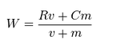.
Based on the above formula we have defined variables with related Columns like v=ReviewCount, R=Review_Mean_Score,C=Reviw_Mean_Score.mean(),m=Review_Count.
Later we sorted based on weighted average in the descending order.
The hospitals were selected based on a weighted average, Google-sentiment-score, and the number of beds available. We have assigned no-of-beds a low value of 10%, whereas weighted average and google-sentiment-score each have a 45 percent priority.
The result we got provides a list of hospitals where the user can go if they have a heart problem.

Sentiment Analysis: Sentiment Analysis is a technique that detects the underlying sentiment in a piece of text.
It is the process of classifying text as either positive, negative, or neutral. We use this technique to evaluate a piece of text and determine the sentiment behind it. In our dataset we have calculated sentiment score on the basis of this by taking reviews from the patients.

KNN method: KNN is used for classifying the hospitals as per the user preferences. It classifies a data point based on its neighbours’ classifications. It stores all available cases and classifies new cases based on similar features. K in KNN is a parameter that refers to the number of nearest neighbours in the majority voting process. Since the KNN algorithm requires no training before making predictions, new data can be added seamlessly, which will not impact the accuracy of the algorithm. There are only two parameters required to implement KNN: the value of K and the distance function.
Using the Cosine function & K-Nearest Neighbour algorithm, we can determine how similar or different two sets of items are and use it to determine the classification. The Cosine function is used to calculate the Similarity or the Distance of the observations in high dimensional space.
As all the data related to healthcare is confidential we have created our own data which contains hospital name, location coordinates, disease specialty columns, review mean score, Google sentiment score, pincode, address, and so on.For the hospital evaluation, we surveyed 1671 people and generated a mean score to utilise in the algorithm based on the results.
With the help of Weighted Average Method and KNN method we are suggesting the best Hospitals to the patient according to his/her requirement.

D. System Architecture
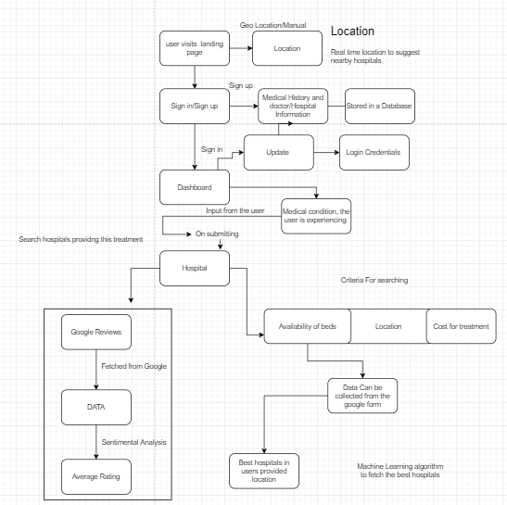

Conclusion
A conclusion section is not required. Although a conclusion may review the main points of the paper, do not replicate the abstract as the conclusion. A conclusion might elaborate on the importance of the work or suggest applications and extensions.

Acknowledgment

I'd want to express my gratitude to our project guide, for her direction and patience throughout the process of seminar preparation. I'd want to express my gratitude to the Head of the Information Technology Department. I'd also like to express our gratitude to the teaching and non-teaching staff who have supported us with their own experiences from time to time, and I'd like to thank principle Sir from the bottom of our hearts for being supporting and always encouraging.

Results

We can get a number of ideas from the application after searching for a hospital based on specialization. These suggestions are based on geo location, number of beds available, and the cost of a given therapy. The website can recommend a hospital depending on a person's preferencence.

References

Patient satisfaction in primary health care: a literature review and analysis :https://pubmed.ncbi.nlm.nih.gov/10299618/

Using Quality Information for Health Care Decisions and Quality Improvement

Mathematica Policy Research, Inc. 955 Massachusetts Ave., Suite 801, May 6, 2005.

Linear and nonlinear models of patient satisfaction with medical care.

National Medical Commission Website-Digital India

