A REVIEW PAPER ON INTEROPERABLE DIGITAL WORKFLOW FOR STRUCTURAL DESIGN, ENGINEERING AND DRAWING DEVELOPMENT PROCESS
Ms. Krupa Savalia¹, Prof. Nikhil Landage²
¹PG student, civil engineering department, MIT – ADT School of engineering, Pune, Maharashtra, India
²Asst. Professor, MIT – ADT School of engineering, Pune, Maharashtra, India
Abstract: BIM is a set of interactive policies, processes and technologies generating a methodology to manage the essential building design and project data in digital format throughout the building’s life cycle. Robust digital workflows are essential for generating and modifying the information held in BIM models. The information modelling aspects of BIM are essential in taking the information produced by computational design and disseminating it amongst the design team, site operatives and future owners of the building. The aim of this project is to map the outcome-based digital workflow of structural engineering from concept to as-built drawings.
1. Introduction
The idea of a ‘digital workflow’ often feels like, it unnecessarily complicates a simple task. Workflows are a normal part of all engineering work. Digital workflows are seen as something novel or new. This is not the case. The idea of a digital workflow is simply the process of mapping tasks and outcomes to the software available to the designer and filling in gaps or developing strategies to better handle those gaps.
With experience, the designer will be better suited to modify and augment processes within the design office, increasing efficiency, reducing duplication of work, and revealing data often hidden within the software for other processes.
A workflow maps a set of outcomes, defines processes required to get to those outcomes, and links or ‘pipes’ outputs of a certain process into inputs of other processes. The design process is inherently a workflow. In fact, the engineering design process of anything from a beam, to a frame to a connection can be defined loosely as the workflow described below:
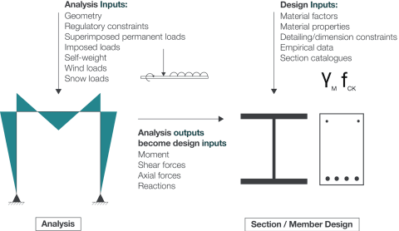
Figure 1.1 Traditional Structural Design workflow
As can be seen in figure 1.1 the design of the structural element starts with analysis. This analysis takes in information from loads derived from architectural finishes, plants, wind loads and other imposed loads. Once complete, the analysis outputs information regarding the forces on a particular element. The design of this element takes in the analysis data, material factors and code-based coefficients and empirical data to design the element.
While simple to understand and easy to implement this linear workflow is incomplete. A somewhat more refined process is shown below:
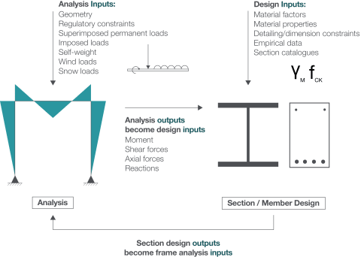
Figure 1.2 Iterative Structural Design workflow
This illustrates that following element design; the proposed section size is put back into the original model to determine the effects of the change in stiffness on the overall frame action of the structure. This process is familiar to most engineers and may seem somewhat trivial, but it provides the basis on which we can begin to understand the process of digital workflows and the use of software in mapping these processes.
In reality, an even more complex workflow operates in building design. There are often more than standalone structural elements in a building, and these processes need to be undertaken for each and every element in a structure.
With relatively small structures (e.g., simple frame analysis) this may not seem particularly onerous – however as the complexity increases, or as the number of frames to be analyzed increases so does the amount of work to be undertaken.
The problem scales linearly. If the goal was to reinitialize analysis with the new member sizes and run checks on the stiffness of the frames the problem would scale with the number of possible interactions between elements.
For a small frame, such as the one pictured, the problem would be relatively easy to solve with limited possible combinations of different stiffnesses.
With larger frames, more complex structures or more elements to consider, the complexity of the problem doubles with each additional member.
Without consideration of the process by which analysis and design take place, there is a risk of duplication of work, errors and a considerable investment of time to undertake design checks manually.
2. Literature Review
Traditional Workflow
Many of the faults in the construction industry occur owing to the poor exchange of information, subsequently leading to incompatible design solutions during the design stage of the project.
Civil Engineering projects traditionally move through a set of sequences from preliminary design, to detailed design and then to construction documentation. In this case, if alterations and design changes are required, the system becomes inadequate leading to works running over budget as explained in the following figure 2.1.
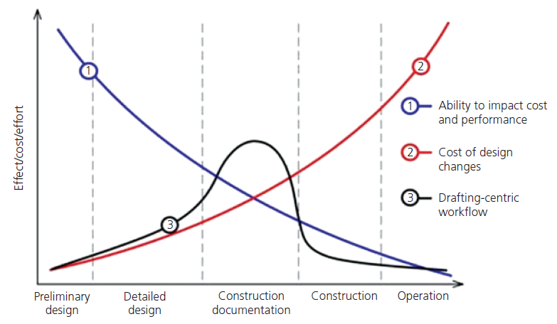
Figure 2.1 Traditional Civil Engineering workflow
In the case of Digital transformed workflow [BIM], when design alterations take place all such elements are updated automatically and communicated electronically to all responsible parties on the project using both documents and projected simulation as shown in the following diagram.
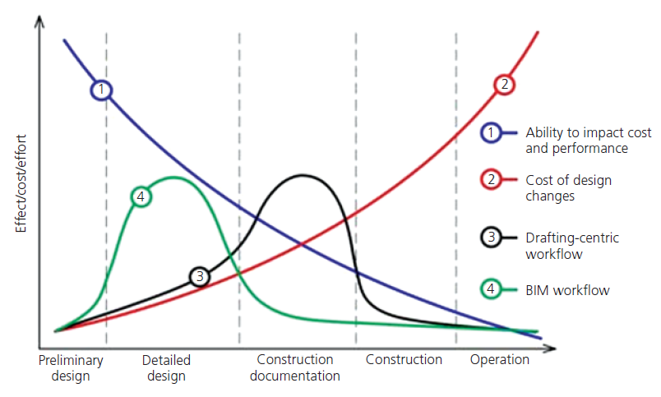
Figure 2.2 digitally transformed Civil Engineering workflow
There is no accepted method for information transfer at the structural design stage and so it continues to be the weak link in BIM model workflow.
Digital Workflow
Digital transformation is defined as transformation concerned with the changes that digital technologies can bring about in a company’s business model, products or organizational structure. Digital transformation is not just the adoption of a set of technologies, rather it is a fundamental shift in culture, supported and facilitated by technology AEC is often regarded as lagging behind other industries when it comes to the digital transformation of their business process. Digital transformation allows us to create what could not be created before, to design new kinds of buildings, to transform towns and cities to meet the challenges of urbanization and sustainability. Now is the time for design teams to bust out a traditional workflow to be better positioned for competitive advantage using digital transformation. In addition, to improve collaboration and a better client experience, productivity and efficiency have gained by 79% Digital transformation will save time and money, minimizing on-site changes and post-construction remedial work. Four keys to digital transformation are
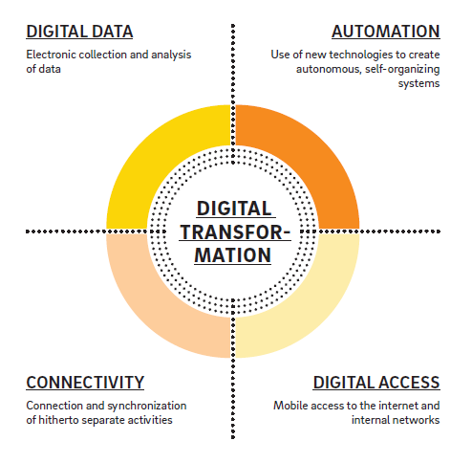
Figure 2.3 Key aspects of Digital Transformation

3. References
[1] Swen Nadkarni, Reinhard Prugl. “Digital transformation: a review, synthesis and opportunities for future research”, Management Review Quarterly, Springer, April 2020.

[2] Tabinda Chowdhury et al. “Review of digital technologies to improve productivity of New Zealand construction industry”, Journal of Information technology in construction, ISSN 1874-4753, Vol. 24, pp. 569-587, 2019.
[3] Tatjana Vilutiene et al. “Building information modelling (BIM) for structural engineering – A bibliometric analysis of the literature”, Advances in Civil Engineering, Hindwi, Volume 2019, ID 5290690,2019.
[4] Felipe Munoz-La Rivera et al. “Methodology for Building information modelling (BIM) implementation in Structural Engineering Companies (SEC)”, Advances in Civil Engineering, Hindwi, Volume 2019, ID 8452461,2019.
[5] Helle Stam Faugstad, Oyvind Sunnvoll Rognes. “Digital workflow in conceptual structural design”, Civil & Environmental Engineering, Norwegian University of science & technology, 2018.
[6] Microsoft & RIBA, “Digital Transformation in Architecture”, NBS Research, 2018.
[7] Strafaci A. “What does BIM mean for Civil Engineers”, CE News magazine, pp. 27-36, October 2018.
[8] N.F.Azmi et al. “Building information modelling (BIM) in architecture, engineering and construction (AEC) industry: A case study in Malaysia”, Proceedings of the 21st International Symposium on Advancement of Construction Management and Real Estate, pp. 401-412, December 2017.
[9] Tae-Song shin. “Building information modelling (BIM) collaboration from the structural engineering perspective”, International Journal of Steel Structures, Vol. 17, Issue 1, pp. 205-214, 2017.
[10] Dr. Kai-Stefan Schober, Dr. Philipp Hoff. “Digitization in the construction industry-Building Europe’s Road to construction 4.0”, Roland Berger GMBH, Civil economics, energy & infrastructure competence, 2016.
[11] Thomas Hess et al. “Options for formulating a Digital Transformation Strategy”, MIS Quarterly executive, Vol. 15, Issue 2, pp. 103-119, June 2016.
[12] Bilal Succar, Mohamad Kaseem. “Building Information Modelling: Point of Adoption”, CIB World congress, Tampere Finland, May 30 - June 3, 2016.
[13] Zhao Qiu Liu et al. “Building Information Modelling and its use for data transformation in structural design stage”, Journal of applied science and engineering, Vol 19, No 3, pp. 273-284, 2016
[14] Norman Gilkinson et al. “Building information modelling: the tide is turning”, Structures & Buildings, The Institute of Civil engineers, Vol. 168, Issue SB2, pp. 81-93, September 2014.
[15] Gilkinson N.R. “How can facilities managers benefit from BIM”, SCRI Forum workshop, Salford centre from research and innovation in the built & Human environment, University of salford, UK, 2011.

