Analysis and Risk Assessment of Structures on Hilly Areas: Case of Pune, India
- Gautami Prabhakar Bura, Final year B.Arch. Student, B.K.P.S College of Architecture, Pune, India, buragautami@gmail.com
B. Dr. Parag Govardhan Narkhede, Professor, B.K.P.S College of Architecture, Pune, India, parag@bkps.edu
Abstract Hilly areas have certain risk factors that are neglected. It may happen due to uneven development and improper construction. Risk assessment of an area helps to analyze events that impact on environment, people and property to judge risk analysis and factors influencing it. These areas are usually occupied when flat land is not available or rates of land on flat ground are high. Due to this, there is a chance of unplanned growth of settlements. Hilly areas have steep slopes and the site has more number of weaknesses and threats like rock falling, landslides, soil erosion and many more. By doing this study, we can become aware of the risks which are not much taken into consideration but do make a major difference, secondly we can try to develop better construction methods which could overcome these risks and provide safety for these structures. Also long life of the structures is ignored because no one is able to consider the future state of the area. To carry out this analysis, a case study of Pune is taken; the hilly areas of Ambegaon are recently developing drastically. The research is done after the damage caused in the vicinity by heavy rainfalls during the monsoon season 2019.
Keywords —Construction, Hilly areas, Landslides, Poor structures, Risk Assessment, Safety, Structures

Introduction

Nowadays, land is getting scarce near cities, migration and increase in population lead to the increase of development in metro cities. As land is not available, development is forced on hilly areas. Poor development vanish the beautiful green covers on the hills. This affects the natural biodiversity and ecosystem of the area. High altitude, dense forest coverage and low population density are basic ingredients in balancing ecosystem. (Meshram, 2007) Due to poor construction, excessive cutting, steeper slopes and improper drainage and water supply systems, the buildings come under risk factors. It is necessary to identify the risks affecting human as well as the ecosystem and their causes and provide solutions to overcome the problem. Due to steep slope of land, the land is cheaper and poor settlements develop in such areas with structure which are not safe. Contour study helps in understanding the safe sites on the area or and steeper sites should adopt adequate construction to prevent risk.
The research focuses on poor structures present on the terrain which lie on landslide prone zones marked according to analysis of the contours and area. The area of research is the hilly terrains of Ambegaon, Pune city. This area is developing drastically and the terrains lie near the Katraj Ghat. Jambhulwadi Lake is located near the area.
Aim: To study structures in terms of construction and identify Risk prone buildings on hilly areas with a case study of Katraj Hills.
Objectives:
- Understanding risk factors in hilly areas that cause damage to life and property.
- Risk mapping of structures which are damaged due to poor construction, heavy rainfall and landslides.
- Studying the construction on hilly areas which can overcome the issues.
Research Gap:
- What are the hazards associated with structures on Hilly areas?
- The existing structures on Hilly areas are safe or not, this analysis is essential.
- How important is the need to highlight safe construction on hilly areas?

Risk assessment
The Monsoon floods 2019 had affected this area of study where the roads are seen damaged till now and landslides have occurred. There was loss of property at that time, currently the people have reconstructed temporary shelters for living and some are using the same damaged structure. The major risk factors are construction that are weak and not suitable to resist steep slopes, over development and deforestation, no provision of sufficient open spaces, steep contour profile, soil erosion, heavy rainfall, landslides and other calamities.
The risk factors of a hilly site are broadly classified and factors of construction and natural calamities are taken as a focus. Considering the area, the disasters occurred and relation with architecture research, we are focusing on landslides. Firstly, the method is identifying the location and slope with contour maps, analyzing the risk prone areas through rough assumptions of the form and nature of contours. (Figure 1 and 2) After identifying the risk prone areas of landslides, any one area is selected and studied by sampling method of individual structures. It is observed that in the risk areas, slums and poor structures are present.
The research questions are which are the risk prone areas, what is the current situation of the structures, which type of construction is done, what is the age of the structures, why they are under risk, what are the solutions to overcome this issue?

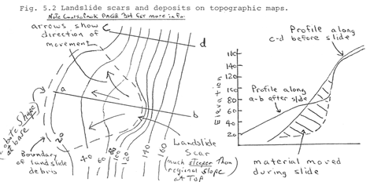
Figure 1: Landslides and mass movements contour study
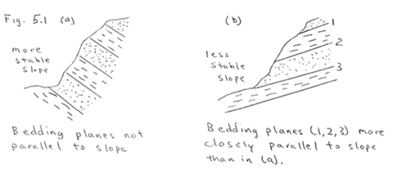Figure 2: Bedding planes cannot be identified by outer observations, but this is a cause of landslide.
Source: bostoncollege.instructure.com
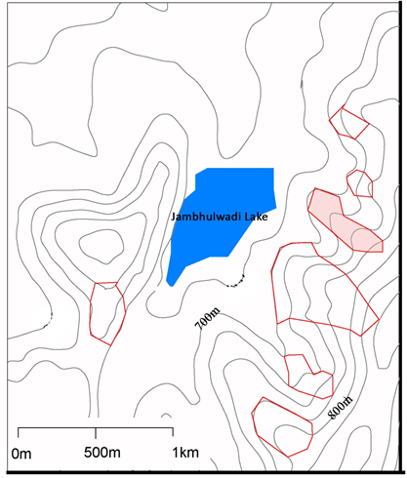

Figure 3: Contour Map showing area of study (Ambegaon, Pune.) Source: Author

The map (Figure 3) shows location of the area study done and the zone highlighted in red is the area of study. According to HBRC journal, Hilly areas have altitude of more than 600m from the mean sea level. Also an average slope of 30 degrees is classified as hilly area. The three categories are Foot hill regions (below 1200m) mid hill regions (1200-3500) and high hill regions (above 3500). This area of study is under foot hill regions. The other areas are demarked showing that they may have landslide disasters in the future according to contour profile study. The contour profile shows that the area is a hilly region with steep slopes. Jambhulwadi Lake is surrounded by hills thus the run off direction is towards the lake from all directions. Heavy rainfalls caused huge runoff that pushed the soil and other elements towards the lake causing damage to the temporary and weaker structures. The concrete roads were also completely damaged. Thus out of all risky zones identified, the selected zone was most affected according to field observations, hence it was necessary to study this area. Preventive measures can be done to overcome this problem during construction. The most affected area is considered to obtain better findings.

Methodology

By sampling observation, a data analysis obtained and 100 samples was done of existing buildings on random basis and considering the site with steep slope and structures affected by landslides. The present state and various characters of the building were sampled as below. Photographs and Site observations was also done to understand the characteristics of the existing structures.

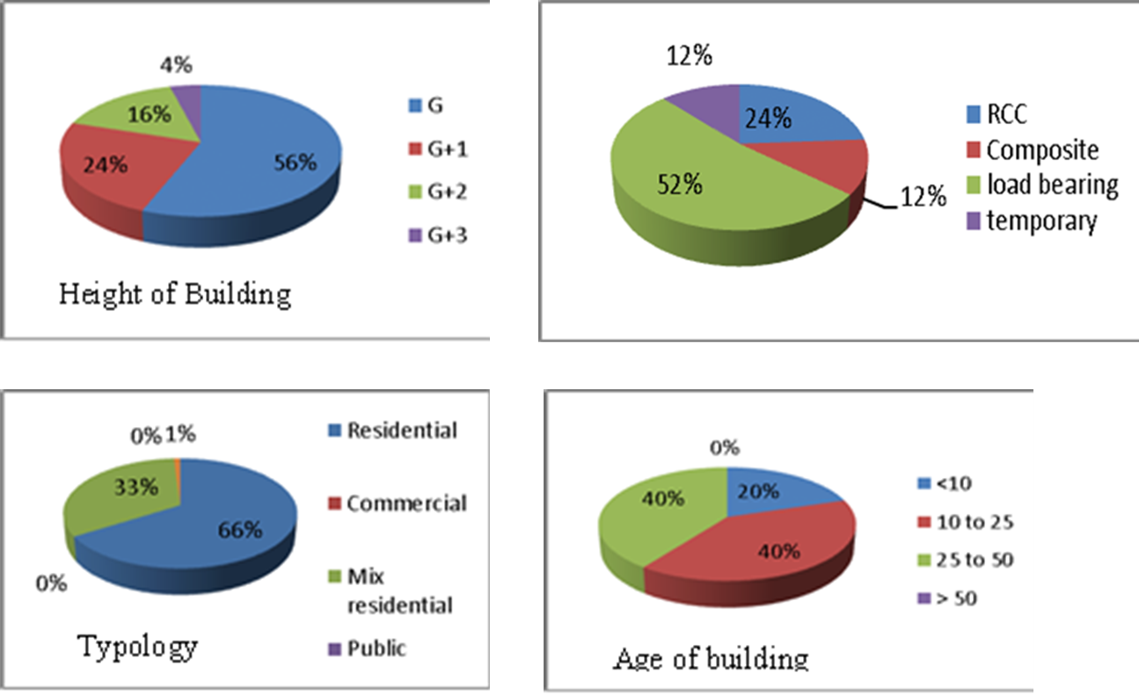

Figure 4: Sampling Data. Source: Author

Data Analysis

After sampling randomly 100 affected structures, it was found that 52% structures were load bearing construction being the highest. This indicates that the structures have weak foundations and may not sustain longer. 12% structures are temporary which are incapable to withstand heavy winds and rain. 12% structures are composite which means they might have strong foundations but the walls are weak and may damage easily. 24% structures are RCC; we can assume that RCC structures are safer and capable to withstand winds and rain. By ground observations, RCC structures had no damage at all. 56% of the samples are ground floor structures, thus the height is within limits and human loss is less. The maximum height of the structures is G+3 storeys which are RCC construction (statement by observation).
40% of the total sampling consists of older construction i.e. 25-50 years. This indicates that these 40% structures are weaker and need to reconstruct soon with RCC structures. Another 40% structures are ranging between 10 to 25 years. Out of these RCC structures may withstand another 20-30 years approximately, while poor structures must be replaced with RCC construction.
The typology of building is important to keep balance, not much open spaces or recreational spaces were identified by observation. 66% of samples are only residential structures and 33% are mix residential. This states that almost all of them are residential typology. Public buildings were not identified nearby and only commercial was very few. This is a drawback for development of the area. More commercialization may increase the urge to develop the hill slopes and road conditions.

Findings and Site Observations

By the above methodology and analysis, it is observed that the existing development on the hilly areas of Ambegaon is at risk prone to landslides and disasters. The percentage of existing structures which are not capable to withstand natural calamities is greater. Thus, it can cause property and human loss in the neighborhood. The heavy rainfall occurred in 2019 destroyed the temporary structures completely and the load bearing structures were damaged and cannot be occupied. The concrete roads were damaged and soil erosion occurred on the roads due to absence of retaining walls. If there will be continuous heavy rainfall in the future, landslides will occur and cause more destruction of these structures which are especially temporary and load bearing. RCC structures may have strong foundation which can protect until safe evacuation. As this region is recently developing the age of the structures not much older, so we have an opportunity to prevent serious damage.

According to DCPR Pune, 0.5 % construction is allowed of temporary material. There should be enough setbacks i.e. minimum three meters between two structures. Studying the slums atlas of Pune, Pune is considered as having a large number of slum pockets which is around 477 slum settlements with 1.1 million populations. Comparatively this area is much smaller, so the population is not declared by Maharashtra Social Housing and action League (MASHAL). But this slum settlement is not purely a slum but a poor developed area as many more new construction is happening nearby, the problem is related to landslide risks and poor structures, so slums is not a focus to be studied.
Hilly areas are not suitable for complete residential living. Other spaces like recreational spaces, biodiversity parks or land should be left open.(Kumar, 2014) It is not advisable to have poor construction and if there is need to construct, RCC construction is preferable with providing bylaws regarding ratio of space to be left open or inter building spaces on hilly regions. By providing retaining walls to hold the earth on slopes, Compacting weak soil at not only individual plots but the whole area helps reducing landslides. The safety on Hilly areas is depended on individual durable construction as well as proper site development.
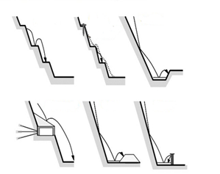

Figure 5: Road side cutting development and landslide patterns. Source: Technicas Construcivas
The foundation of the structure is an important part to consider while mitigating risks. RCC foundations are proven stronger to resist. Stability of RCC foundations last longer if proper concrete mix design and site development is done. By the observations done on site by the author, it is found that there was landslide which did not cause major destruction but soil erosion, trees and temporary structures were affected. Some structures have developed cracks, some structures appear weaker, the roads and drainage system is poorly maintained, some structures have gone partially under the ground as layer of soil has displaced. Despite there were concrete roads in this area, they failed to perform during heavy rains as all the soil and rocks fell all over the road. The roads made by massive cutting on one side should be treated accordingly so that minimum rock falling and landslide happens. (Figure 5) Proper runoff water storage or flow should be designed along with the drainage system. This reduces the collapse of roads and building exterior damage. Landslide Preparedness Guidelines for Safety of Buildings on Slopes is given by NIBM they should be followed. (NIDM, 2019) The observations are road damage, soil erosion into houses and no provision of retaining walls and lack of site development. (Figure 6)
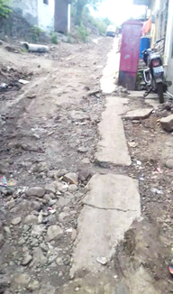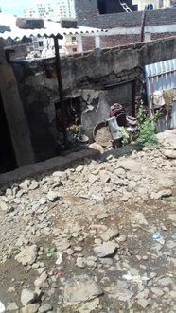
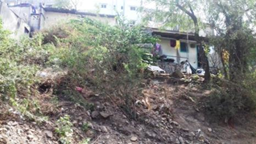
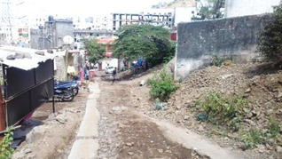
Figure 6: Site Photographs. Source: Author

Recommendations:
It is the need of the hour to highlight construction guidelines of buildings on hilly areas. Guidelines must be made mandatory by the local governments to prevent disasters. Some of the recommendations are highlighted referring to Guidelines given by National Institute of Disaster Management, India as follows:
- Provision of retaining walls wherever soil is loose and likely to slide – earth wall, dry stone wall, steel bin wall, precast concrete wall, sand bags wall and sheet piles can be used.
- Material behind the wall should be well drained.
- Type of construction of structures should be preferable RCC with strong foundation.
- Multi-storey building is not recommended instead split level floors according to the slope should be designed.
- Wherever hill cutting is done, the rocks are exposed to moisture and weathering thus they fall .Rock anchors, wire mesh or jute netting prevent rock falling
- Prevent soil erosion by vegetative covers like seeding, turfing, mulching etc. these methods are sustainable and economical
- Planting more trees and plants in the area will reduce soil erosion as the roots hold the soil in place.
- Proper planning of drainage system is important.
- Storm water management and provision of percolation for run off.
- Moisture level check of the soil is necessary, if the soil has excess moisture it should be replaced or soil should be compacted.
- Slope alteration reduces the slope angle by removing some material from top of the slope and fills the toe of slope to give support to it.
- Rock Buttress with under drain at steep slopes also prevents disaster and drains the surface water.

The outcome of this research study is that the existing hill area development is inappropriate and not safe to withstand natural disasters in terms of construction. Site development will help reduce immediate disasters, eventually the structures should be replaced with reinforced concrete construction. This will reduce the risk factors of the structures. Detailed guidelines are provided in the guidelines given by the National Institute of Disaster Management (NIDM, 2019). The roads should be well designed and maintained and awareness programs will help people understand the vulnerability.

Literature Review:
The paper by T. Mia, N. Sultana and A. Paul 1990 of topic ‘Studies on the Causes, Impacts and Mitigation Strategies of Landslide in Chittagong city, Bangladesh’ demonstrates the landslides occurred on the area. The study area is selected and data collection is done by primary and secondary data. Various causes and socio economic condition of the respondents was analyzed. They have mentioned that weak soil structure, de-vegetation and hill cutting are the major causes of landslide in this area. Landslide study is an important issue that has to be developed.

The paper by Prof. D.S Meshram, Ph.D., March 2007, of topic ‘Development of Hill Areas: Emerging Issues and Imperative’ demonstrates the various aspects of development in hilly areas. Due to development on hilly areas many issues happen such as depletion of natural land and ecosystem, depletion of the natural green covers and risk of life of structures. The paper focuses on hilly areas discussing the various parameters of developing residents on steep slopes, risk of land sliding and negative impacts that environment has to face.

Conclusion
This study was important as the conditions of the structures are worse and there is scope of future damage causing great loss. Hilly areas have natural resources and they are being cut down due to development. This not only affects the environment but also humans are not safe to live on such places with poor development. Land is scarce and thus development is forced to happen on land which is not suitable for safe living of the building. But following appropriate guidelines and providing strict rules may reduce the risk factors and also maintain the ecosystem of hills. Use of stronger construction (preferably RCC) and proper site development by using retaining walls, equal cutting and filling, provide way for runoff or storage, slope analysis are some solutions that reduce risk factors. Thus we can conclude that these structures which are temporary and load bearing above 25 years old are under risk and are likely to face damage in the future due to heavy rainfall and landslides.
References
- Anil Kumar, Poonam, Ashok Gupta, “Some Aspects of Sustainable Buildings for Hilly Regions”, IJSER, Vol. 5, Issue 5, May 2014.
- Ashwani Kumar, “Building Regulations for hill towns in India.” HBRC Journal, 18 June 2014.
- Arbooz Gaurav, Khakhar Mona, “Sustainable Development Imperatives for new Towns in Hilly Areas: A Case of India”, IJETSR, Volume 4, Issue 12, December 2017.
- Darius migilinskas; Leonasustinovicity, et.al(2008) “Methodology of Risk and Uncertainty Management in Constructions Technologies and Economical Problems”ISARC-2008.
- F Ahmad, AS Yahaya, “Environmental Risk Assessment on Hill site Development in Penang, Malaysia: Recommendations on Management Systems.” European Journal of Scientific Research.
- Highland, L. M. and Bobrowsky, P. “The Landslide Handbook- A Guide to Understanding Landslides”, 2008, (Vol. Circular 1325, pp. 129p.)
- Jivanya Tiwari, Anuj Bansal, “Study of Building Structures & Construction Techniques in Hilly Regions: Hotel Dalhousie”, IJESC, research article, Vol.7, Issue 4, April 2017
- Mahmood, A. B. and Khan, M. H. “Landslide vulnerability of Bangladesh Hills and sustainable Management options”, 2008.
- NIDM, “Landslide preparedness Guidelines for Safety of Buildings on Slopes” 2019.
- Nikhil Ghuge, Neha Shahare, Mohini Tupsunder, Shivram Totewadi, “Analysis and Design od Multistoried Building in Hilly Areas using STADD PRO”, IRJET, Vol. 7, Issue 4, April 2020
- Prof. D.S Meshram, Ph.D., “Development of Hill Areas: Emerging Issues and Imperative”, March 2007, ITPI Journal.
- Rahman, T. “Understanding the issues involved in urban landslide vulnerability in Chittagong metropolitan area, Bangladesh.” 2012.
- T. Mia*, N. Sultana and A. Paul, “Studies on the Causes, Impacts and Mitigation Strategies of Landslide in Chittagong city, Bangladesh M”, 1990.
- Techi Takar, Jitendra Kumar, “Road Construction in Hilly Region and their Problem and Solution”, IJSRET, Volume 5, Issue 6, Nov-Dec 2019.
- Vrushali Chawhan, Mohannad Arif Kamal, “A Study of Planning, Design and Construction of Building in Hilly Regions of India”, American Journal of Civil Engineering & Architecture, Vol. 9, Issue 1, February 2021.

