Recent Trends in Aviation Management and Safety
Ruta Nalavade⁽¹⁾, Vidhanshu Jadhav^{(2),} Hursh Kshirsagar⁽³⁾, Krishna B. Jadhav⁽⁴⁾
1, 2, 3: Students of First Year B. Tech Aerospace Engineering at MIT-ADT University, Pune.
4: Assistant Professor of Aerospace Engineering at MIT-ADT University, Pune.

Abstract:
The management and safety regulations are of paramount importance in todays aviation, from all the stake holders point of view. The Ethiopian Airlines Boing 737 Max collapsed and crashed immediately after takeoff from Addis Ababa for Nairobi. It was second 737 Max tragedy in six months after a Lion Airplane in Indonesia in October 2019, resulting in death of 190 people, operating the same plane. After this incident, Boeing faced a Huge Loss in its shares, bringing them down to 35%, whereas Airbus had a 65%. Share of single-aisle. Hence, Airbus takes a lead in deliveries and Ranking top amongst all-other vehicles. The two biggest Airplane manufacturers in the world are Airbus and Boeing hence entering into a fierce rivalry. Boeing was behind far more wide body flights 103,244 Flights in comparison with 6, 45,220 with Airbus aircrafts.
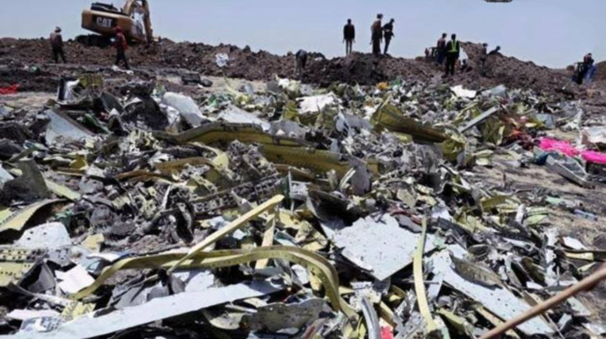
Regulations and Safety things Boeing can do are noted as follows:
As Boeing has had a lot of experience dealing with crisis situation over past several years and needs to focus on Safety and other issues too, and regain its customer service and trust by keeping in point the following points:

1. High damage tolerance.
2 Active controls
3. High Stiffness (since airline structures are sized for stability)
4. Low-cost raw materials fabrication methods with proper aircraft design and aerodynamics and low density.
5. Modularity
6. Resistance to Lightning strike.
7. Resolve the faults in Airframe, reportedly affecting parts made from Carbon fiber composites as well as titanium.
8. Airplane makes worry more about how quickly they can. Ramp up production at both their factories and their supplies.

Therefore, MAX's return service in most countries made 2021 a year of "stabilizing”, which will involve further. Recovery in 2022. Hence, Boeing stock Shares mild increase and can reach a good milestone by some following points.

1) Safer landing, fewer costly excursion’s: →Reduces chances of costly runway excursions of other runway related issues.

2) Cost saving and operational savings: Inaccurate payload and performance decrement on decision.

3) Better passenger experience and avoid cash: Passengers make sure that all the decisions are factual and knowledge based Safety of the Customer is most important. Boeing Should record proper care and safety.

4) Upgrade with emergency sensors in case of unusual flight conditions: Such sensors only work in emergency Situations and Others

International regulators and airlines around the world have worked together to allow the aircraft to return to work safely. This required software function only works in rare aircraft conditions and now relies on two sensors, operates only once and never exceeds the pilot's control over the aircraft.

Safety, Security management in Aviation Services:-

Airport security and co-workers ensure airport security, flight, and passenger safety. Airport management and flight safety, using the following steps:
Flight attendants and airports are trained in safety and security issues, as well as problem-solving procedures. Emergency airports have passenger evacuation procedures and airport campus is monitored by Closed Circuit TV camera systems. A dedicated team of trained security officers are safely deployed at the airport. Security guards take the help of sniffing dogs for any unwanted object is lying near or in the airport premises.

Recently, the airports are facilitated with:-
1. Transition of Airport Ownership
Airports view a change in ownership and management scenario from a public-private partnership, to contracted operators on behalf of the boss, and resulting to full-fledged private airports. This creates chances for greater investment in airport progress and allows providers to catch the market with conventional and new products.

2. Airport Cities (Aerotropolis)
Airports are changing into a public place where passengers can meet, relax, and enjoy a wide range of aviation facilities. Providers who build relationships with service providers or those who have diverted to the aviation industry are able to show new facilities that can merge with other sectors and provide more seamless, beneficial and connected services.

3. Services based on Locations
Marketing based on specific targets, which includes store site information and airport discounts, as well as new shopping models such as online platforms and delivery of products locally, will result in revenue for airline flights at airports. Non-Service Providers have given passenger and flow tracking systems and integrated personalized applications that use Bluetooth and WiFi that identify customer location with respect to the store and give data.

4. Consolidation
Due to the expansion of the airport and the even increasing competition among suppliers, they are trying to consolidate their position in the industry by pressing their products in current markets in order to get greater market share. In this, Providers build by venturing into new market regions and making and branding new products in current regions.

5. Security based on Digital Technology
Modern technology has been applied to promote new concepts such as "walking or safety" to deduce passenger waiting time, while biometrics can be used to digitalize the processes to verify and reduce staff. Security has quickly become the mandatory at airports. Providers are moving quickly to install IT services and solutions. Providers are pressing hard on advance security suits.

6. Self Operation
The emergence of passenger performance will result in passengers availing all services from entry to boarding flights on their own. This will help to increase resources, reduce operating costs, and improve non-aviation revenue. The providers have developed new high-quality products that allow such services including self-help platforms and e-boarding.

7. Digital Transformation
The level of digital deployment at airports is growing rapidly and supports trends such as increased automation and passenger-oriented services. This will lead to a connected airport where the control center is visible at all functions and can better monitor and manage performance compared to performance indicators, ways to provide seamless connectivity over the entire airport.

Conclusion:
Many advanced measures are taken by Aviation giants Boeing and Airbus for management and safety of aviation and world is there to follow them. However, with digitalization’s and non-human interference will pave way to more advanced and modern ways to bring and impose measures. Safety and management will go on improving in future.

References:
- https://www.hindustantimes.com/world-news/ethiopian-plane-smoked-and-shuddered-before-deadly-plunge/story-p1UFSdBWIqcXMBml83o7iL.html
- https://www.faa.gov/about/initiatives/sms
- https://www.cranfield.ac.uk/courses/short/transport-systems/aviation-safety-management

