ION Thrusters for nuclear propulsion – An Overview

***Nishant Yadwadkar, UG student, MITWPU, Pune, India.*** [***Email: yadwadkarnishant@gmail.com***](mailto:Email:%20yadwadkarnishant@gmail.com)

***V.S. Kanthale, Associate Professor, MITWPU, Pune, India. Email:*** [***vilas.kanthale@mitwpu.edu.in***](mailto:vilas.kanthale@mitwpu.edu.in)

***N.T. Dhokane, Assistant Professor, MITWPU, Pune, India. Email*** [***nilesh.dhokane@mitwpu.edu.in***](mailto:nilesh.dhokane@mitwpu.edu.in)

***S.B. Barve, Professor, MITWPU, Pune, India. Email:*** [***shivprakash.barve@mitwpu.edu.in***](mailto:shivprakash.barve@mitwpu.edu.in)

**Abstract- Man was born on earth but he was never meant to die here. Thus it is the need of the hour to explore our universe beyond our planet. We have to start preparing for intrastellar as well as interstellar travel. In order to undertake such great endeavors we have to develop our space technology as the current space technology in existence is not enough for our great ambitions. Space is the final frontier, science is our spaceship and curiosity is our fuel. But metaphors aside, the technology that we need to take on such great As advanced the space sector is there are still a lot of advanced designs that are only in theoretical form. We have to find out which technologies are best suitable for our needs and which are not suitable. An ION thruster is a technology that has not been used much, but through experimentation and calculations it has been proven that this is one of the best technology for future space travel and long distance voyages.**

***Keywords- thruster, ION thruster, Helium, Xenon, nuclear, chemical, LOX, propulsion***

INTRODUCTION-

On July 16th 1969 astronauts Neil Armstrong , Buzz Aldrin and Michael Collins lifted off from earth in the Saturn-5 rocket which was the most powerful rocket produced till date. Thus began the age of space travel and Russia soon followed with its own mission.

There has been a lot of research on space technologies and many have been actually developed. In this literature review we will see the technologies that have been developed so far and also the technologies that we might be developing in the future. Development of these future technologies will one day help us to become a space faring species.

LITERATURE REVIEW-

In this literature review we will focus on technologies of propulsion. There are different types of propulsion used in space technologies.

1. **Mechanisms**

There are three main types of propulsion technologies nuclear , chemical and electronic.

First we will focus on the nuclear technologies of propulsion. In the paper [1] written by Rahul Mungala, he explains about the working and advantages of nuclear propulsion.

In the work of Mungala et al[1] the engine works mainly on hydrogen as its propellant and the power source is the nuclear fusion reaction that is present in the core of the engine.

The working of this engine is similar to that of a nuclear reactor. The radioactive core that is present on the engine, super heats the compresswed hydrogen. As a result the hydrogen expands rapidly and is then propelled out of the engine at about 5% the speed of light. The reason hydrogen is used as a fuel source is due to its nature of being very light and thus we can achieve very high exhaust velocities .

The exhaust velocities achieved through this engine are about 5% the speed of light and as a result the launch vehicle can go upto 10 Machs .

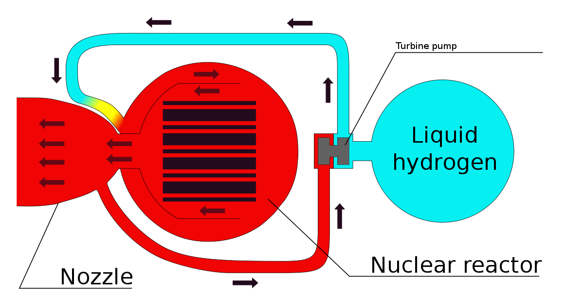

**Fig (1) diagram of nuclear propulsion system [1]**

In the work of Ulrich Walter et al[2] he has focused on the chemical propulsion systems that go into launch vehicles.

Currently chemical propulsion systems are the only systems that can launch any payload from the surface of the earth to its orbit. The thrust in the chemical propulsion system comes from the propellant that burns in the thrust chamber.

A chemical combustion engine mainly consists of 2 propellants , one is called the fuel which is highly volatile and the other is called the oxidizer which supports the burning of the fuel. The fuel is injected into the thrust chamber with the help of injector plates where it mixes with the oxidizer. This mixture is then ignited with the help of an igniter that is also situated in the thrust chamber. There are many fuel and oxidizer combinations available.

Some examples are as follows.

1. Fuels – Methane, Kerosene, R.P.-1
2. Oxidizers – LOX, Liquid Hydrogen, Methyl Hydrazine.

Thus the author concludes in the paper that chemical propulsion systems are currently best suited for launch vehicles

**Fig (2) thrust chamber of chemical propulsion engine [2]**

In the work done by Dr.Ugur Guven et al [3] the capabilities and the limitations of ION thrusters have been discussed.

An ION propulsion system is much more efficient and longer lasting than normal chemical or nuclear propulsion systems

An ION propulsion engine works by propelling ionized plasma out of the engine as compared to the mixture of LOX and Methane used by chemical propulsion systems.

The author has also explained that the Ion propulsion system also has its own drawbacks. It cannot be used inside earth’s atmosphere due very low chamber pressures. The thrust produced by an ION thruster is very small as compared to the thrust produced by chemical and nuclear propulsion systems. The reason for this is the low mass flow rate of the engine. The maximum thrust produced by an ION thruster to date is about 16 milliNewtons.

There are however other advantages to use an ION thruster. Its very long lasting and can keep accelerating for decades after which very high speeds are achievable.

Thus it was concluded from this paper that an ION thruster is the most suited method of propulsion for long distance space flights due to its efficiency and durability.

**Fig (3) comparison molar mass of different fuels [3]**

in the work done by Nithin N et al [4] the discussion on scramjet engines comes into view.

Scramjet stands for supersonic ramjet engine. This is the ,most developed air breathing engine that has ever been used for propulsion.

The inlet of scramjet engine is used for increasing the pressure and temperature of the combustion process. In the combustion chamber the fuel is injected through an inlet which super heats the air that enters the engine. Thus scramjet engines use air itself as their propellant. This gives it a major edge over all the other engines as the weight of the propellant is absent from the rest of the system.

However the drawbacks of the scramjet engines are that it can only be used inside earth’s atmosphere and at a relatively low altitude. One major drawback is that all the combustion processes taking place in the engine are at hypersonic speeds.

In the end the author concludes that scramjet engines are very fast and can be used in low earth atmosphere for speeds upto 10 Machs.

**Fig (4) diagram of scramjet engine [4]**

1. **Properties of various engines**

In the works of Jaisal Chauhan et al. [5] the different ways to power an ION thruster are given.

In an ION thruster most of the energy is spent in the ionization of plasma and its acceleration. Thus we need durable energy sources in order to power the ION thruster for decades if necessary.

Solar cells have been mentioned as a viable source of energy for an ION thruster. It is mostly used as a power source in satellites. Its efficiency is about 10-15% . but the drawback is that the power it generates is simply not enough for a full scale spacecraft.

Another drawback is that as it moves away from the sun it will generate lesser and lesser power.

Solar generators have also been mentioned as a possible source of energy. They have an efficiency of about 30-40% which is twice the efficiency of solar cells. In this system sun rays are made to fall on a working fluid that expands on contact with the rays. This working fluid gets super heated and is then used to drive a thermal generator that creates a potential difference in the acceleration chamber.

Radioactive thermal generators can be used as a power source. One advantage of this system is that it does not depend on any external phenomenon for its power, its completely internally powered. Plutonium 238 is used as the radioactive material in this system. The heat generated by the core finds its way to a thermo-electric generator which creates a potential difference in the acceleration chamber.

Thus it was concluded from this paper that the ideal power source for a ION thruster will depend on the mission requirements

**Fig (5) diagram of ION thruster [5]**

In the work of Hannu Kartunnen et al.[6] the criteria for propellant selection has been discussed. The basic requirements of the propellant are that it should have a high energy density and a high specific impulse. As for ION thrusters the charge to mass ratio is of paramount importance as the exhaust velocity is directly proportional to the square root of charge and inversely proportional to the square root of mass.

The basic 2 propellants used by an ION thruster are hydrogen and xenon.

Hydrogen does have the highest charge to mass ratio but it is unfavorable as it reduces the mass flow rate of the engine.

Xenon is inert and is much easier to store . it is easy to ionize and it gives a decent mass flow rate .



**Fig 6 comparison of specific impulse and voltage [6]**

Gaps

All of these papers have been written extremely well some research is still has not been done.

1. A nuclear propulsion system will emit high amounts of radiation that will be harmful for the humans on the craft.
2. Another drawback of nuclear propulsion is its very hard to cool in space.
3. A chemical propulsion system is very inefficient and is very heavy due to high propellant mass
4. Another drawback of chemical propulsion is that it does not have a very high range.
5. A scramjet engine cannot be used outside of earth’s atmosphere .
6. An ON thruster cannot be used inside earth’s atmosphere due to low chamber pressure.
7. Although there are several ways to power an ION thruster one single power source that is both long lasting and efficient is yet to be found.
8. The main problem of an ION thruster is its low mass flow rate , which in the end leads to low thrust.

CONCLUSION

There has been a lot of research and development in the field of space technology yet we face many obstacles.

Still a lot of research is to be done in this field of we are to ever become an interstellar species. A lot of scope is there for improvement , new ideas and new concepts. As you can see from the above review lots of gaps and places for improvement are present in this field.

REFERENCES

[1] Aspects of nuclear propulsion, Rahul Mungala

[2] Astrodynamics the physics of space flight, Ulrich Walter.

[3] Developments in ION propulsion systems and a study of other systems, Dr.Ugur Guven.

[4] Numerical analysis of supersonic scramjet engines, Nithin N.

[5] Ways to power an ION thruster, Jaisal Chauhan.

[6] Propellant selection for ION thrusters, Hannu Kartunen.

[7] Aircraft design – a conceptual approach, Daniel .P .Raymer