Flying Wing: The Aerodynamic concept that needs help of latest technological advances

Atharved Deshmukh ⁽¹⁾, Atharva Parab ⁽²⁾, Sarthak Kulkarni ⁽³⁾, Chinmay Kulkarni ⁽⁴⁾, Aditya Palande ⁽⁵⁾, Krishna B. Jadhav ⁽⁶⁾
1, 2, 3, 4, 5: Students of First Year B.Tech Aerospace Engineering at MIT-ADT University, Pune.
6: Assistant Professor of Aerospace Engineering at MIT-ADT University, Pune.

Abstract:
In this rapidly changing world, few concepts that were evolved in early stages of aviation just remained in literature and not in application. One such concept is The flying Wing. It needs help of latest technological advances to see the light of practical applications. This paper tries to discuss about this aspect.

Introductory Background:
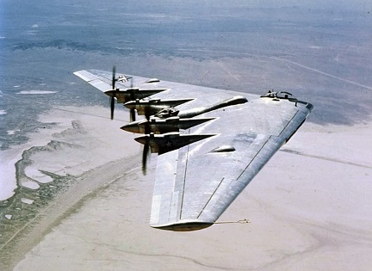

A flying wing is an airplanee that has no fuselage or tail, aircraft with its team, payload, gas and gadget housed within wing. A flying wing can have protuberances , pods, booms vertical stabilizers, nacelles, blisters etc.
A flying wing is every so often presented as theoretically the most aerodynamically efficient (lowest drag) layout configuration. It additionally could provide excessive structural performance for a given wing intensity, main to light weight and excessive gasoline performance. Because it doesn’t have traditional surfaces and the related manipulate surfaces, in its purest shape the flying wing is unstable and tough to manipulate. these compromises are tough to reconcile, and efforts to accomplish that can lessen or even negate the expected advantages of the flying wing design, less weight and drag. Answers might also produce a very last design that is nonetheless too risky for sure makes use of, including industrial aviation.
Further problems are fitting the pilot, engines, flight equipment, and payload all within the depth of the wing segment and issues with pitch and yaw.

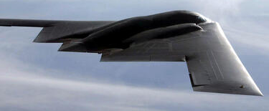
Design

A wing that is made deep to comprise the pilot, engines, gas, undercarriage and different necessary gadget could have an multiplied frontal region, while as compared with a conventional wing and long-skinny fuselage. This brings about higher drag and as a result decrease performance than a conventional design. Solution followed was to keep it thin.
The problem turns into more acute at supersonic speeds, wherein the drag of a thick wing rises sharply and it's far vital for the wing to be made skinny. Supersonic flying wing was never possible.
Stealth
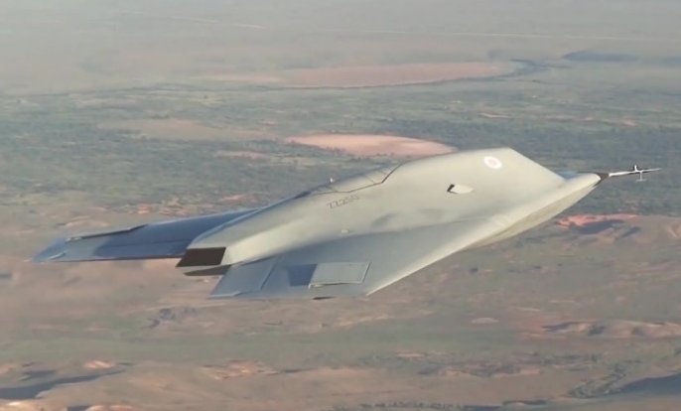

Good Stealth characteristics are very much required from defence and attack point of view, Flying wings lacks these characteristics.
This flying wing layout is a lot greater green than a conventional plane. as opposed to separate wings helping all the weight of the fuselage, the complete craft works to generate raise. removing the tail and fuselage additionally reduces drag -- the full pressure of air resistance acting on the plane.
Greater performance enables the B-2 tour lengthy distances in a quick time frame. it is no longer the fastest craft around -- the navy says it's excessive subsonic, meaning its top pace is just below the rate of sound (around 1,000 feet/sec or 305 m/s) -- however it is able to pass 6,900 miles (11,000 km) without refuelling and eleven,500 miles (18,500 km) with one in-flight refuelling. it may get anywhere on the planet on brief notice.

Directional Stability
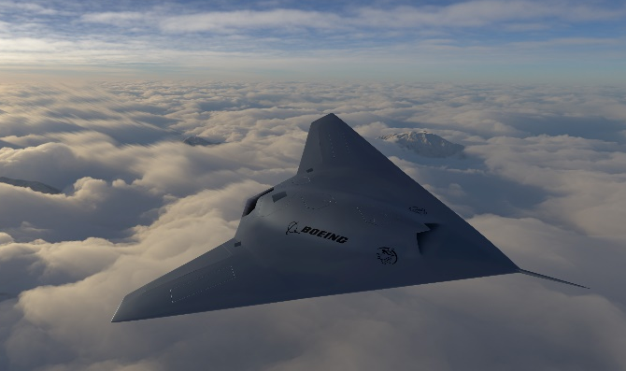

Directional stability in yaw is must. Flying wings lack this.
What does fin area mean?
Fin stabilizer, fin or small wings mounted on a ship or an aircraft in such a way as to oppose unwanted rolling motion of the vehicle and thus contributes to its stability. Fin is nothing but a vertical stabilizer. Normally they are mounted on the top rear of the fuselage and form part of the empennage.
Fuselage: - It is an aircraft’s main body section. It holds crew, passengers or cargo.
In normal planes, the work of stabilizer job is to provide stability for the aircraft to keep its flying straight.
Fin is an important part of the fuselage and wing body from stability point of view and flying wing becomes tedious case of this.
Another solution is to crank the wing tip sections downward with massive anhedral, growing the vicinity at the rear of the plane when regarded from the facet.
The control Surfaces of flying wings are designed to catch up on the steadiness furnished by a tail. Yaw balance is finished with the aid of a method known as differential drag, wherein the drag on one side of the wing is multiplied greater than on the opposite side causing a directional trade of the plane in that path.

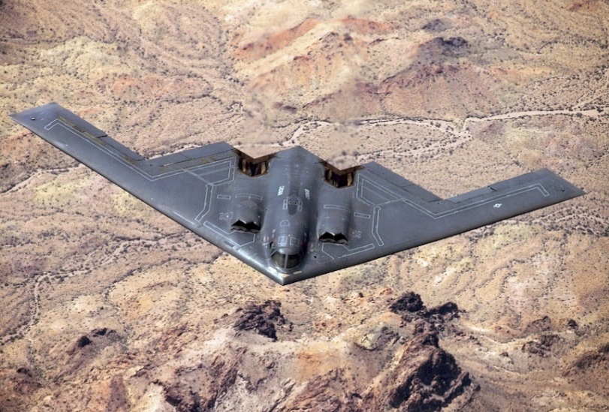
Control

Due to very thin aerodynamic shape without control surfaces, flying wing is not stable from control point of view. Lot of research is required if one wants to design it perfectly for all stability and control characteristics.
Yaw
Due to lack and proper stability and control and control surfaces, yaw charactertistics are very weird. We can think stable yaw of flying wing only at last stages of design.

Advantages
Potentially clean aerodynamics (usually no obtrusive tail surfaces & fuselage components).
All (or nearly all) of the structure provides lift.
The advantages of flying wing aircraft are light weight and drag, higher top speeds and lower fuel consumption.

Disadvantages
Dynamically unstable in pitch, unless sharply swept with resulting transverse flow & effectively reduced aspect ratio (loss of lift efficiency)
Dynamically unstable in yaw, partially ameliorated by sharply swept wing &/or includes wing-tip vertical stabilizers, with accompanying drag &/or reduced aspect ratio.
Necessity of having thrust in close proximity to centreline, which impedes efficient use of cargo space.
High probability of requirement for software-driven flight controls.
Small cargo capacity that can only be offset by transverse load distribution — increasing polar moment in yaw and resistance to yaw/spin recovery. Very high probability of unrecoverable spin behaviour.
It has become impossible to design a flying wing that can transport hundreds of people in comfort.

Conclusion
- Such is the beautiful concept of flying wing which was put forth by former aero dynamists and if it is given help of latest technologies, we may come up with new generation concepts in aviation.
- We can add swept back control surfaces to the outer portion of wings. It will counter the nose-up altitude by reducing the downward force on the tail. It will level out its stable. Swept wings are used to reduce the wake drag. They are longer than straight wings. Hence, air moves slowly and creates more drag.
- We can add movable thrusters that are similar to a spaceship to change the direction across yaw motion. It will increase the weight by a small margin but it will significantly increase directional stability while turning.

References
- John D. Andreson Jr., Introduction to flight, 6th edition p.251-573 principles of stability and control.
- https://en.wikipedia.org/wiki/Flying_wing
- https://science.howstuffworks.com/stealth-bomber1.htm
- https://www.quora.com/What-are-the-advantages-disadvantages-of-flying-wing-aircraft
- https://en.wikipedia.org/wiki/Yaw_(rotation)
- https://en.wikipedia.org/wiki/List_of_tailless_aircraft
- https://ieeexplore.ieee.org/document/5456588
- https://www.globalsecurity.org/military/systems/aircraft/phantom-ray.htm
- https://oa.upm.es/4475/1/INVE_MEM_2008_60902.pdf

