Electric Propulsion: The Future of Aerospace Technology
Vaishnavi S. Panhale^{[1]}, Saloni^{[2]}, Pranay L. Jamjare^{[3]}, Ridham B. Lalani^{[4]} , Lokesh N. Sapra^{[5]}, Krishna B. Jadhav^{[6]}
1,2,3,4,5: Students of First Year B.Tech Aerospace Engineering at MIT ADT University, Pune.
6: Assistant Professor of Aerospace Engineering at MIT ADT University, Pune.

ABSTRACT
Electric propulsion system (EPS) Research is presented here to provide an introduction to specialized technical papers. This study contains spacecraft that use an electric propulsion system to change the speed of space vehicles. Firstly, here is a description of what is the value of a propulsion system, a brief history of establishment and transformation due to EPS. Principles of performance and a few types of active or advanced thruster are discussed. Incentives for the development of power transmission systems are no more fundamental than Newton's dynamics laws. Its use in recent projects and presentations is also discussed in detail. The necessary improvements in its structure and the future scope of the spacecraft are also provided. We conclude with a detailed summary and the latest technologies that have used EPS to achieve their goals using EPS technology.

INTRODUCTION
This study is intended to provide a general review of electric propulsion (EP) system and its applications, as well as to provide one with the best documentation to understand the principle of Electric Propulsion system. Spacecraft propulsion is used to change the speed of spacecraft and satellites made, or in short, to give delta-v. There are different methods. Each method has its pros and cons, and spacecraft is an progrssive research area. Many spacecraft today are operated by heat reaction and allow it to flow out of the back of a spacecraft. This type of engine is called a rocket engine. The spacecraft system should be able to operate in a vacant and stable environment. The main functions of spacecraft operations are to speed it up, change its speed and change direction, while sitting and launching. Propulsion systems can work on chemical fuels using reaction engines and rocket engines (Hydrogen and liquid oxygen or ammonia). Non-chemical propulsion systems, on the other hand, include the Electric Propulsion System.
In the Electric Propulsion system (EPS), the reaction weight is a series of ions. Here, the engine uses electrical energy, first to make the atom ionize, and then to create a voltage gradient to accelerate ions to higher exhaust velocities. Different spacecraft are intended for different purposes and thus require different types of EPS. For example, in GEO satellites, high-powered dynamic power systems have been used in many popular satellite platforms recently to reduce satellite weight, increase payload, increase satellite lifespan and improve control accuracy. There are various types of power generation systems some of which are advanced Gridded Ion Engine (GIE), High Efficiency Multistage Plasma Thruster (HEMPT), Hall Effect Thruster (HET) etc.

EPS - WORKING AND CONSTRUCTION
Electric Propulsion System is just a group of devices that work in sync to convert electrical energy into kinetic energy in propellants. The EP is a space-oriented class that uses electric current to propel a propeller through various possible electrical and / or magnetic fields. Electric power consumption improves performance of EP thrusters compared to conventional thrusters. Unlike chemical systems, electric motors require very little weight to accelerate the spacecraft. The propellant is released twenty times faster than the old chemical thruster so the whole system works very well in bulk. Figure 1 shows the typical EPS system in its basic category.
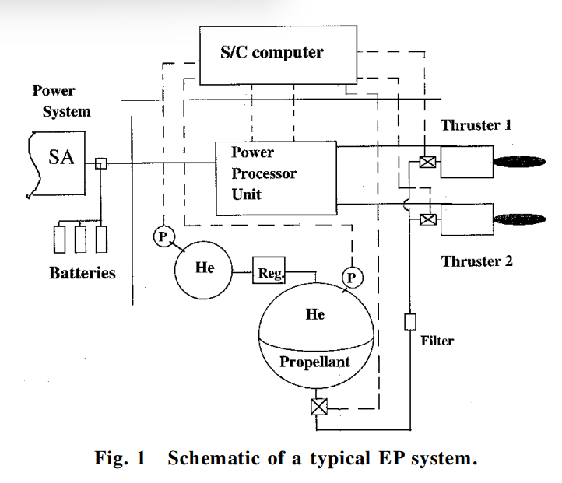

An EPS consists of mainly four different main building blocks mentioned below:
- The thruster components,
- The propellant components (or fluidic management system),
- The power components (including PPU),
- The pointing mechanisms.
generally, the power system supplies dc bus power controlled to the power processing unit (PPU), as well as to other auxiliary components, such as valves, heaters, etc. PPU converts this green energy into a specific form required by thrusters and is often one of the most complex EP components. The main of the system is the thruster itself, and this paper will focus on the thrusters.
The performance of the EP thruster and electric motor is the same. In an electric car, the power required by the engine to rotate the wheels is taken from larger batteries, which are then charged. Although spacecraft have batteries, they use the best source of energy — the sun. Solar panels collect solar energy, and the electrical energy of this energy is amplified and sent to the EP thruster. The complex process of electromagnetism takes place inside the truster with gasoline on board (usually Xenon in current systems) to form ions, which accelerate the electric field to form an exhaust plume. As in the case of chemical systems, this air purifier is the one that propels the spacecraft to its destination.
However, it should be noted that a large proportion of the propulsion engineer's effort should be devoted to the balance of the EP system, which in turn is often heavier, larger, and more expensive than thruster.
TYPES OF EPS
In particular there are three basic types of electrical transmission systems, classified according to the method used to accelerate propellant such as electrothermal, electrostatic, and electromagnetic.
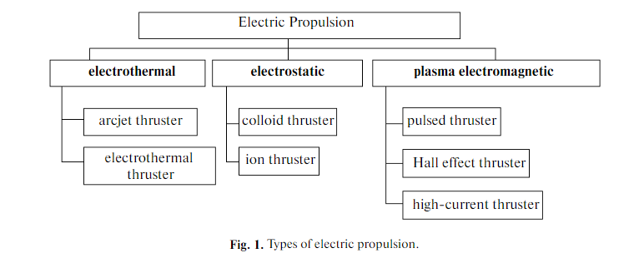

ELECTROTHERMAL:
Simply put, it is the use of electric heaters to power the propellent electronically and extend it thermodynamically to produce thrust. Usually, when the propellent is heated electrically, it increases the pressure and expands the gas, forcing a powerful weight out of the tube and providing the atmosphere. There are two basic types used today: -
- Resist jets-
It depends on the proposed concept of electro-thermal thrusters; as shown in figure. In advanced, double-stage reactions increase efficiency, in which hydrazine after a chemical degradation, is heated by electricity and released which increases concentration. Its main advantage is that it can achieve maximum thrust efficiency up to 90%. But it does have two features that limit the heat resistance of ohmic materials and the thermal conductivity of the system.

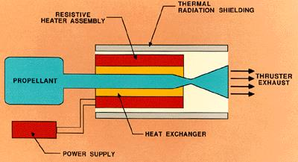

- Arc jets-
It depends on the central cathode surrounding the anode. When a propellent is injected between the anode and the cathode a high-strength electric field is produced and the anode acts as a hot-gas exhaust pipe.
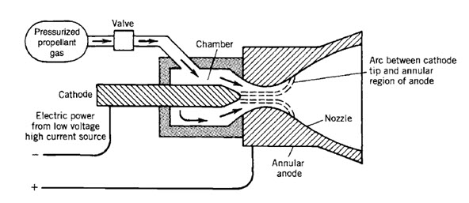

ELECTROSTATIC:
These rely on Coulomb's ability to accelerate the propellent composition of neutral charged particles and operate only in a vacuum. Electricity depends only on the chart in the same direction. Heavy particles such as fine ions or liquid droplets are highly sought after for use. These are divided into categories related to the source of the charged particles: -
• Electron Bombardment Thrusters-
Fine ions are produced by the explosion of monoatomic gas by electrons emanating from the hot cathode.
• ion Contact Thrusters-
Fine ions are produced by evaporation.
• Field Emission or Colloid Thrusters-
Small propellent drops are charged positively or poorly but their stability is still a challenge.

ELECTROMAGNETIC:
These devices accelerate the combustible gas emitted in the plasma state. Plasma is a mixture of electrons, direct ions, and neutrals that transmit electricity easily at temperatures often above 5000 K or 9000 R. Accordingly, when the conductor holds a perpendicular current to the magnetic field, physical force is applied to the conductor in such a manner that it makes right angles to both the current and magnetic field which provide a central exhaust. The concept Lorentz energy is used in electromagnetic device.
a. Hall Effect Thruster:
In Hall thruster, propellant is speeded by the electric field, in space uses. Hall thrusters catch electrons in the magnetic field and use electrons to ionize the propellant, effectively accelerate ions to produce pus, and reduce ions to plume. Hall thrusters work on a variety of propellants, most commonly xenon.⁽²⁾
b. Magneto-plasma-dynamic (MPD) thruster:
In the MPD thruster, the electric current near the steering bar creates an azimuthal magnetic field that crosses with the arc flow from the bar surface to the holding wall. ⁽²⁾
c. Pulsed Plasma Thruster:
The Pulsed Plasma Thruster (PPT), the plasma jet engine, is electric space shuttle. PPTs are the simplest type of electric spacecraft and were the first means of electricity to fly into space, in 1964. They generally take solar energy. ⁽²⁾

APPLICATIONS OF EPS
In order to reach its operational path and maintain its position in space, the satellite must be able to move around, using its thrusts. Traditionally, this has been done using chemical delivery systems. However, things are changing. Although chemical propulsion does a good job of producing much needed for a satellite to orbit, it is rarely carried out when the satellite is in space.
In addition, chemical propellants and the final structure used in chemical propulsion systems are complex and expensive. Another possible alternative is the electric propulsion system (EPS). By detecting the thrust at high airflow speeds, EPS reduces the amount of propellant required in a given system. Any reduction in propellant weight can greatly reduce the launch of a spacecraft or satellite. This also results in the ability to use small launch vehicles to deliver the desired bulk to a particular route or in the direction of deep terrain - all of which reduce the cost of the whole goal. Apart from this possibility, the EPS does not have the operational or maturity levels required for the use of a broad scale.
The exception is Hall-effect propulsion technology, which is the focus of the EU-funded CHEOPS (Consortium for Hall Effect Orbital Propulsion System) project. “When it comes to high thrust density, Hall-effect propulsion technology is at the forefront,” says IdrisHabbassi, CHEOPS project coordinator and head of R&T programmes on space EPSs at Safran. “From the thruster to the cathode, Power Process Unit and Flow Management System, this project focused on providing the incremental technology changes needed to advance the state of the art in EPSs.”
Development in robots, microelectronics and nano-electronics make it possible to explore Earth, air and deep space conventional ways of exploring space. Smaller spacecraft have reduced the initial cost of using orbit energy. While small satellites enjoyed early success, the public sector needed sophisticated spacecraft to create a distant Earth sensor, accurate plowing, monitoring of erosion, pollution, accurate weather forecasts, navigation, global satellite-based communications systems, and many other services caused significant improvements in the efficiency. Intelligent orbiters and landers can explore other planets, Venus and Mars etc. Two stages of use of satellites and Cubesats (i) exploring our solar system and beyond, and (ii) using space near Earth. All these operations, machines and technologies are likely to involve electric propulsion.
RECENT APPLICATIONS
Many companies are becoming increasingly sophisticated with the use of EP satellites to extend their service life of satellites and reduce operating and launching costs.This produces savings that can be passed on to consumers. NASA's main use of ion propulsion will be to facilitate long-distance missions that are difficult or impossible to maneuver using other types of push-ups.In May 2006, the Dawn spacecraft was scheduled for launch, will use three ion thruster in which NSTAR thrustwas the main force. The campaign will study Ceres and Vesta, two protoplanet-based protocols located between Mars and Jupiter.
The widespread use of nanoapproach in space technology could be a possible way to find a clever, nanoscale-made spacecraft. According to NASA's 2015 Nanotechnology Roadmap Initiative, nano-materials and related techniques should form the basis of a new generation of spacecraft10. Clearly, EP systems are the main candidates for the development of these novel spacecraft — see Boxes and learn more about the design and amazing benefits of EP platforms and the two most advanced EP thrusters, namely Hall-type thruster and grilled ion thrusters.
Gridded ion thrusters and Hall-type thrusters are among the most advanced, mature EP technologies proven in space, the legacy of a relatively long aircraft. They work on electric phenomenon called closed electron drift, Hall current,
Hall thrusters are used to create low thrust levels (up to 250 mN). These devices have reduced to less than 100 W at μN-thrust levels. Hall thrusters can produce a very large number (> 104) of thrust pulses without part adjustment and replacement, with very high ventilation speeds (up to 40 to 50 × 103 m / s).
CONCLUSION:
This paper has provided a condensed overview of the electric propulsion field. Many concepts of future technology are in the early stages and are still being explored worldwide. Electric propulsion is currently considered by all space players to be the key and evolving technology in the new age of commercial and scientific space satellites. Efforts in this field around the world are aimed at developing new competitive EPS generations.
REFRENCES
- Applications of Electric Propulsion in Scientific Space Projects: Benefits, Features, and Implementation Examples, M. B. Martynov and V. G. Petukhov [December 2012]
- A Study and Brief Research On Electric propulsion Of Spacecraft and Rockets, A.Hemant Kumar Yadav1 ,V.V.S.Nikhil Bharadwaj ,KundanamSaikiran , D.Rahul Rao, P. Naga Sudeepthi , SirsinahalAmulya , A.VenkatSai , KalyanDagamoori [December 2014]
- Spacecraft Electric Propulsion—An Overview M. Martinez-Sanchez[Sept-Oct.1998]

Defining the future of electric propulsion for in-space operation and transportation – European commission: cordiseuropa EU research results[Article-27 Feb-2020]

https://www.epic-src.eu

