Conceptual Design of an Electric Lift + Cruise Roadable Aircraft
¹Sarthak Sudhir, ²Prof. Vijaykumar Gorfad
¹UG Student, ²Asst. Professor, Aerospace Engg. Dept., MIT School of Engineering, Pune, Maharashtra, India
¹sarthaksudhir99@gmail.com, ²vijaykumar.gorfad@mituniversity.edu.in
Abstract: This paper presents a conceptual design for electric roadable aircraft called as Hindustan Electric Akash Vahan Yantra (H.E.A.V.Y.), which is an all-electric aircraft producing zero emission and is capable of cruise in air as well as on land. It also possesses lift + cruise VTOL (Vertical Take-Off and Landing) capabilities which are a benchmark for futuristic aerial vehicles. This paper investigates the aircraft design aspect of the conceptual design phase. With a set of design requirements, the conceptual phase was carried out based on the empirical aircraft design approach. Design processes such as initial sizing, airfoil selection, constraint analysis and component sizing were carried out, which provided aircraft’s performance parameters. It was observed that these were interdependent and parameters were iterated to fall within the constraint limitations. Here, sensitivity analysis was carried out to obtain a safe design region in the constraints matching diagram for H.E.A.V.Y., providing a feasible design for it. A computational model was generated based on the obtained parameters. A compact safe design region was observed in the matching diagram which narrowed down design change possibilities for prototyping and testing phases which would be carried out with further work such as preliminary and detailed design phases.
Keywords —eVTOL, roadable aircraft, vertical take-off and landing, lift + cruise, UAM, aircraft design

Introduction
Since the previous decade, humanity has contemplated about the future of urban transportation. Futuristic urban vehicles are said to airborne, flying in a 3-dimensional airspace and eliminating possibilities of traffic congestion. Majority of such foresight have been synonymous with terms such as flying cars or aerial hovercrafts. These foresights have begun turning into reality in recent years with the rise of Urban Air Mobility (UAM) concepts such as Personal Aerial Vehicle and Air Taxi. These aircrafts possess VTOL (Vertical Take-Off and Landing) capabilities and are classified into intercity or intracity UAM. With the tremendous advancements in the battery technology, the aviation industry has begun electrification of aircrafts [1], [2]. The UAM sector has emerged as a frontrunner in aircraft electrification as it is viable to have all electric propulsion systems for such smaller aircrafts rather than large passenger aircrafts. eVTOL (electric Vertical Take-Off and Landing) aircrafts have rendered as the future of urban aviation because they produce lower noise pollution and have zero carbon emission in comparison to the obsolete fossil fuel-based aircrafts.
Roadable aircraft is the terminology used to refer to aircrafts that have the capability to cruise on land as well as in the air, hereby making them also known as flying cars in modern literature. In the previous decade, there have been numerous experimental UAM vehicles being fabricate and tested. Companies such as Airbus, Boeing, Bell, Pipistrel, Uber, Lilium and Joby Aviation have been in the lead of this race for UAM transportation [1]. Companies such as Terrafugia, Aeromobil and Klein Vision [1] have fabricated prototype roadable aircrafts with either fossil fuel or hybrid propulsion systems. Historical trade-off [3], [4], [7] between these experimental aircrafts have shown that every design is unique and none of the designs for these aircraft have any similarity with another such aircraft. A notable observation is that the eVTOL concepts have been limited to intracity transportations due to the limitations of battery pack technology [2], [3]. The major considerations for eVTOL battery packs are the Lithium based battery packs such as the Li-Ion ones. The battery energy density for eVTOL batteries is limited to about 200-250 Wh/kg [2] and are expected to drastically increase in the near future.
This paper throws light on aircraft design aspect of the conceptual design phase of an electric Lift + Cruise roadable aircraft called as Hindustan Electric Akash Vahan Yantra (H.E.A.V.Y.). Lift + Cruise is a category of eVTOL aircrafts which include lift generating surfaces such as wing and empennage along with singular or multiple rotors for vertical take-off and landing. Empirical aircraft design techniques [2], [3], [4], [9] have been implemented to conceptualize the aerial cruise capabilities of H.E.A.V.Y. With a set of design requirements, sensitivity analysis was carried out and parameters such as range, endurance, power, MTOW (Maximum Take-Off Weight), empty weight fraction, battery mass fraction, etc. were obtained for H.E.A.V.Y. Aircraft loadings such as wing loading, disk loading and power loading are observed. With the constraints of the design requirements, a matching diagram is generated where the aircraft loadings are interpolated to obtain a safe design region, which is an aera under the graph in the matching diagram. This safe design region determines the feasibility of the design and aerial cruise capabilities. With a computational model for visualization, a viable design is generated for H.E.A.V.Y., making it a zero-carbon emitting, lower noise generating, eVTOL (electric Vertical Take-Off and Landing) roadable aircraft with cruise capabilities on land as well as in the air. This design renders a potential for solving urban mobility problems such as traffic congestion and rapid transportation for an economically and environmentally sustainable modern urban transportation.

Design Requirements
The conceptual design phase generally beings with a set of design requirements [2]. These requirements can be client based or design optimization based. On the basis of these design requirements, performance parameters such as endurance, MTOW, L/D, Power, etc. are obtained to generate a viable design. Design requirements were generated for H.E.A.V.Y. which helped in conceptualizing the design (see Table 1). The set of design requirements are listed as follows;
Table 1: Design Requirements
Design Requirement | Dimension
Passenger +Baggage Weight | 200 kg
Absolute Ceiling | 1000 m
Minimum Range | 250 km
Cruise Speed (in kmph) | 200 kmph
Maximum Speed (in kmph) | 250 kmph

Range and Endurance

Range
In aircraft design phase, range is the distance an aerial vehicle can cover during its flight. Range is limited for eVTOL aircrafts due to the low battery energy density. Currently, battery energy density of about 250 Wh/kg in Li-Ion batteries have been achieved by battery packs of eVs (electric vehicle) such as Tesla Model S. This has been taken into consideration for the battery pack of H.E.A.V.Y. Historically, Lift + Cruise eVTOL have the L/D ratio variation from about 9-14 [1], [2]. This historical trend has been taken into consideration for H.E.A.V.Y. With the acceleration due to gravity taken as 9.81 m/s² and the total efficiency as 81%, the design requirement of minimum range has been achieved for H.E.A.V.Y. Historically, the battery mass fraction (BMF) has observed to vary from 0.15-0.5 for Lift + Cruise eVTOLs and for H.E.A.V.Y., BMF of 0.2, 0.3 and 0.4 have been taken into consideration. With these parameters, a sensitivity analysis was carried out to meet the minimum 250 km range design requirement (see Table 2). The formula for range [2], [3], [10] is as follows;
$R=3.6\frac{L}{D}\frac{E_{sb}η_{Total}}{g}\frac{m_{b}}{m}$ (1)
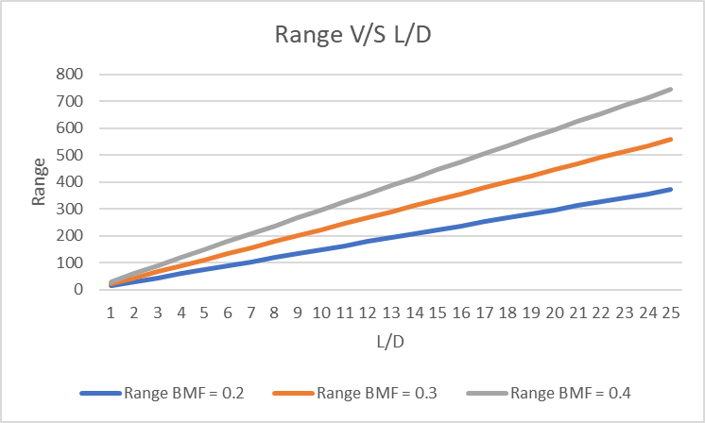
Fig. 1 Range V/S L/D
A graph was plotted to observe the variation of Range with respect to L/D ratio. The variation was seen to be proportional in nature and an L/D ratio of was required to achieve the design requirement of minimum 250 km range (see fig. 1). For redundancy and emergency, an additional distance of about 17 km was included in the range apart from the minimum range of 250 km (see Table 2).
Table 2: Range Parameters
Input Parameters | Dimension
$$η_{Total}$$ | 0.81
L/D | 12
BMF | 0.3
Battery Specific Energy (E_{sb}) | 250 Wh/kg
Output Parameters | Dimension
Range | 267.5229358 km

Endurance
The endurance for an aerial vehicle is the flight time required to cover the range at a particular speed. Endurance is obtained for the cruise speed and the maximum speed of 200 kmph and 250 kmph respectively. Endurance is generally measured in terms of hours [3]. A graph for Endurance variation with respect to the L/D ratio is plotted. This graph shows similar variation as the Range variation graph (see fig. 1, fig. 2). The formula for endurance [3], [4] is as follows;
$E=3.6\frac{L}{D}\frac{E_{sb}η_{Total}}{g V}\frac{m_{b}}{m}$ (2)
Table 3: Endurance Parameters
Input Parameters | Dimension
Cruise Speed | 200 kmph
Maximum Speed | 250 kmph
Output Parameters | Dimension
Cruise Speed Endurance | 1.337614679
Maximum Speed Endurance | 1.070091743
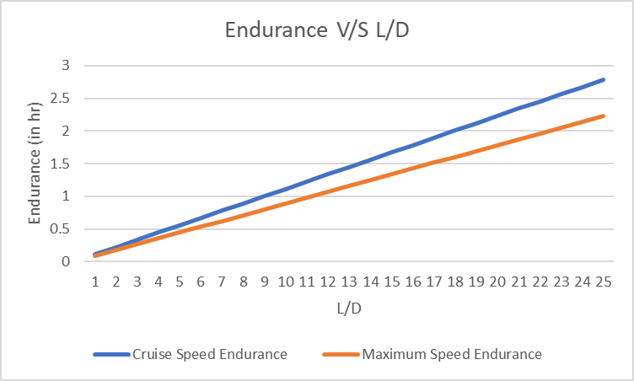

Fig. 2 Endurance V/S L/D

Maximum Take-Off Weight (MTOW)
The Maximum Take-Off Weight (MTOW) is the gross weight of the aircraft during the take-off phase. As H.E.A.V.Y. is an AEA (all electric aircraft), the MTOW remains constant throughout the entirety of the flight of H.E.A.V.Y. MTOW depends on the battery mass fraction and empty weight fraction along with the payload weight fraction for H.E.A.V.Y. [3]. The empty weight fraction (EWF) varies from 0.3-0.6 according to historical analysis of previous eVTOL aircrafts. The battery weight is excluded from the empty weight and the battery mass fraction is 0.3 (see Table 2). As H.E.A.V.Y. is a roadable aircraft, the empty weight was considered to be at a higher value in the EWF variation to accommodate for the aerial and land cruise empty weight components. Sensitivity analysis has been carried out and the MTOW is obtained (see Table 4). A graph was plotted for MTOW variation with respect to the EWF (see fig. 3). The graph showed exponential increase in MTOW when the EWF was increased. The formula for MTOW [3] is as follows;
$W_{o}=\frac{ W_{payload}}{1-\frac{W_{b }}{W_{o}}-\frac{W_{e }}{W_{o}}}$ (3)
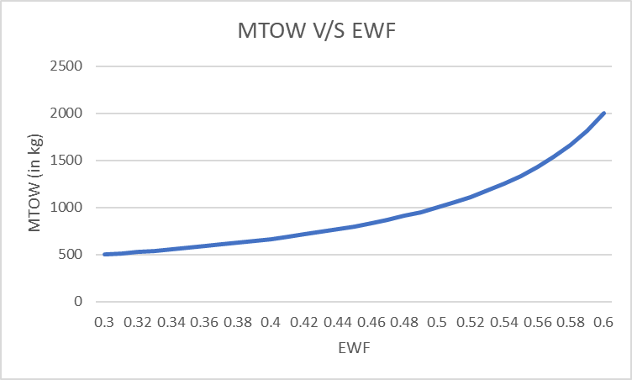
Fig. 3 MTOW V/S L/D
Table 4: MTOW Parameters
Input Parameters | Dimension
BMF | 0.3
EWF | 0.55
Output Parameters | Dimension
MTOW | 1333.333333

Power
Power in aircraft design is the amount of energy required per unit flight time. It basically is the energy transferred by the battery system of H.E.A.V.Y. to the electric thrust generating systems such as rotors. Power is obtained with the design requirements of speed and range. Power used is obtained for the cruise speed of 200 kmph and 250 kmph (see Table 5). The battery power is obtained as ideal power of H.E.A.V.Y. A graph was plotted to observe the variation of Power with respect to the L/D (see fig. 4). The power formulae [3], [4] were as follows;
P_{used} = $\frac{V m g}{3.6 \frac{L}{ D} η_{p} 1000}$ (4)
P_{Battery =} $\frac{P_{Max used}}{η_{Total}}$ (5)
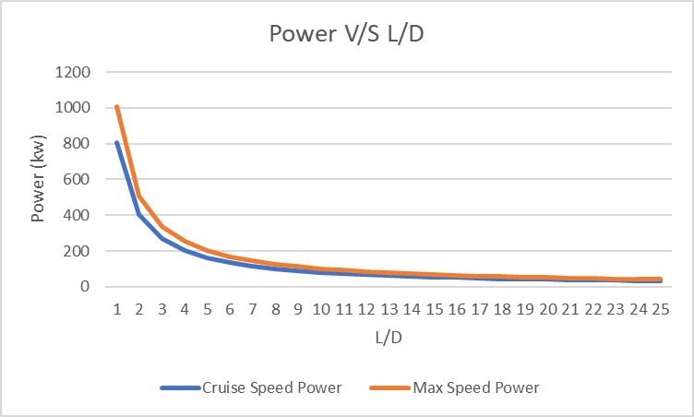
Fig. 4 Power V/S L/D
Table 5: Power Parameters
Input Parameters | Dimension
Cruise Speed | 200 kmph
Maximum Speed | 250 kmph
Output Parameters | Dimension
Cruise Speed Power | 67.28393447
Maximum Speed Power | 84.10491808

Wing Loading, Power Loading and Disk Loading

Wing Loading
Wing loading is the amount of load in terms of the aircraft’s gross weight acting upon the wing surface area. Basically, it is the ratio of MTOW of H.E.A.V.Y. to the wing surface area. Through the airfoil selection process [3], [5], NACA 4412 [6] has been considered as viable airfoil for the wing of H.E.A.V.Y. The wing loading is proportional to the stall speed and maximum coefficient of lift at the service ceiling [3], [8].
The FAA (Federal Aviation Administration) has put a constraint limit on the maximum stall speed of an aircraft, which is 61 knots (31.3811m/s). With the constraint of stall speed and maximum speed of 112.972 kmph and 250 kmph, the wing loading characteristic graph is plotted (see fig. 5). This graph shows the variation of the wing loading and the stall speed where an area is obtained between the constraints for the possible wing loading of H.E.A.V.Y. The formula for wing loading [8] is as follows;
$\frac{W}{S}=0.5ρ{ S C_{L max} V}_{stall}2$ (6)
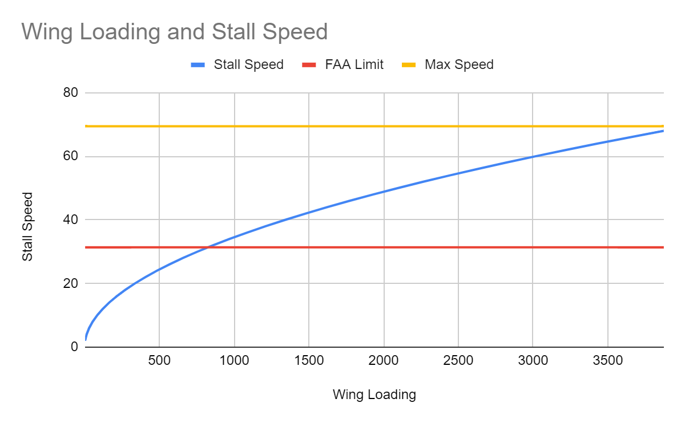
Fig. 5 Wing Loading Characteristic

Table 6: Wing Loading Parameters
Input Parameters | Dimension
FAA Stall Speed | 31.3811 m/s
C_{L max} | 1.507
Output Parameters | Dimension
Wing Loading | 825.1338 N/m²

Power Loading
Power loading is the ratio of the power output to the MTOW (P/W). Power loading indicated the amount of load the electrical propulsion system is undergoing for the gross weight/MTOW to cruise in the 3-dimensional airspace. A graph is plotted for the power loading against the wing loading with the constraints of the stall speed and maximum speed (see fig. 6). This graph helps in conceptual designing to observe a safe design region for the aircraft [8].
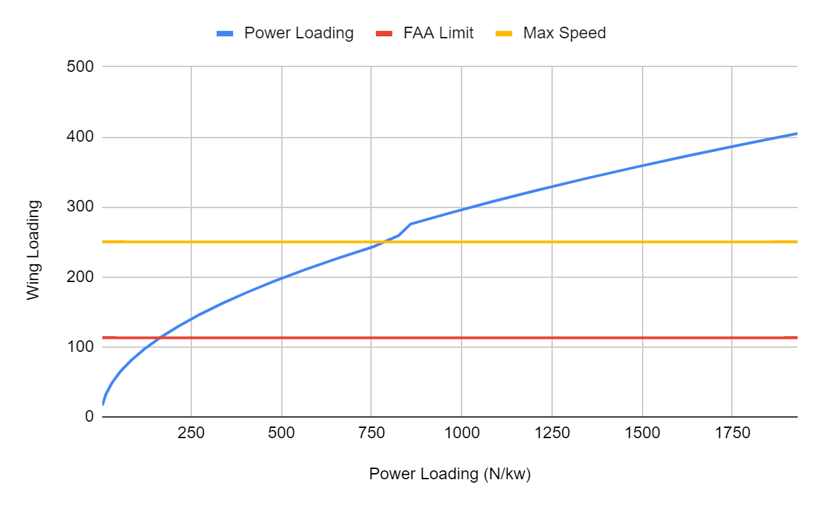
Fig. 6 Wing Loading V/S Power Loading
Table 7: Power Loading Parameters
Input Parameters | Dimension
Cruise Speed Power | 67.28393447
Maximum Speed Power | 84.10491808
Output Parameters | Dimension
Cruise Power Loading | 194.3996 N/kw
Minimum Power Loading | 155.5196485 N/kw

Disk Loading
Disk loading is a crucial parameter of VTOL aircrafts. It is the pressure change over the actuator disk. Disk loading is weight upon the rotor thrust area for an aircraft [8]. In VTOL, thrust equals the weight is a minimum requirement for vertical take-off [2]. Actuator disk area is obtained through this consideration. The formula for actuator disk area [7] is as follows;
A = $\frac{T^{3}}{2 ρ P^{2}}$ (7)
Disk loading variation is observed with respect to the power loading (see fig. 7). This graph indicated the limitations of the electrical propulsion system with constraints of stall speed and maximum speed taken into consideration.
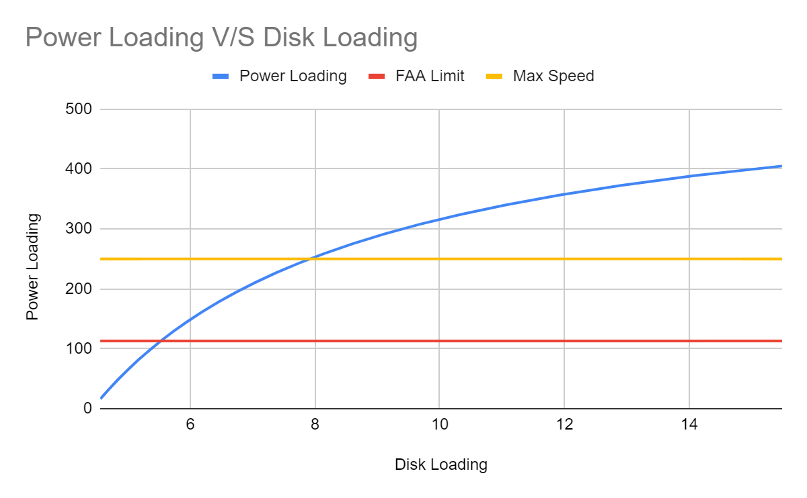
Fig. 7 Power Loading V/S Disk Loading

Table 8: Disk Loading Parameters
Input Parameters | Dimension
Actuator Disk Area | 129.1280485 m²
Output Parameters | Dimension
Disk Loading | 9.680317205 kg/m²

Matching Diagram
Once various aircraft loadings are obtained, a matching diagram is plotted. A safe design region (an area under the matching diagram) is obtained for the design (see fig. 8). This safe design verifies the feasibility of the design generated and serves as a boundary condition for design considerations in further design processes (see fig. 8). The safe design region is obtained as the area between the max speed, disk loading and power loading. With this boundary region, a feasible design for H.E.A.V.Y. is attainable. For the achieved values of wing loading, power loading and disk loading, a feasible design for H.E.A.V.Y. has been achieved (see fig. 8).
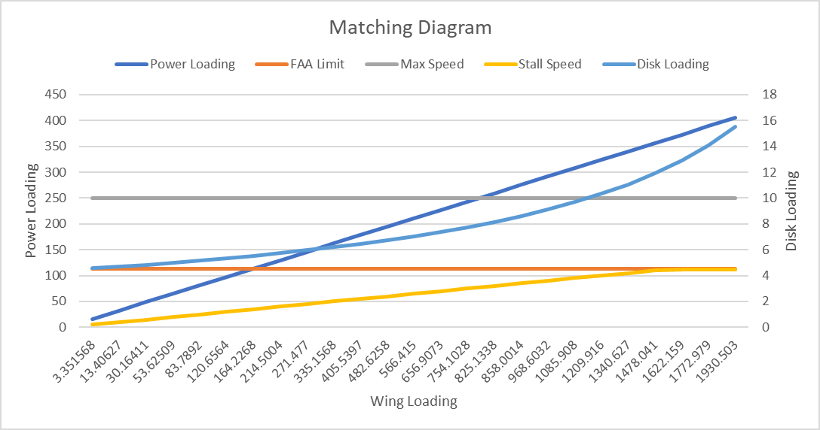
Fig. 8 Matching Diagram

Computational Model Renders
A computational design was made using the OpenVSP and Autodesk Fusion 360 software packages (see fig. 9, fig. 10, fig. 11, fig. 12). This model helped in visualizing the design that has been generated for H.E.A.V.Y.
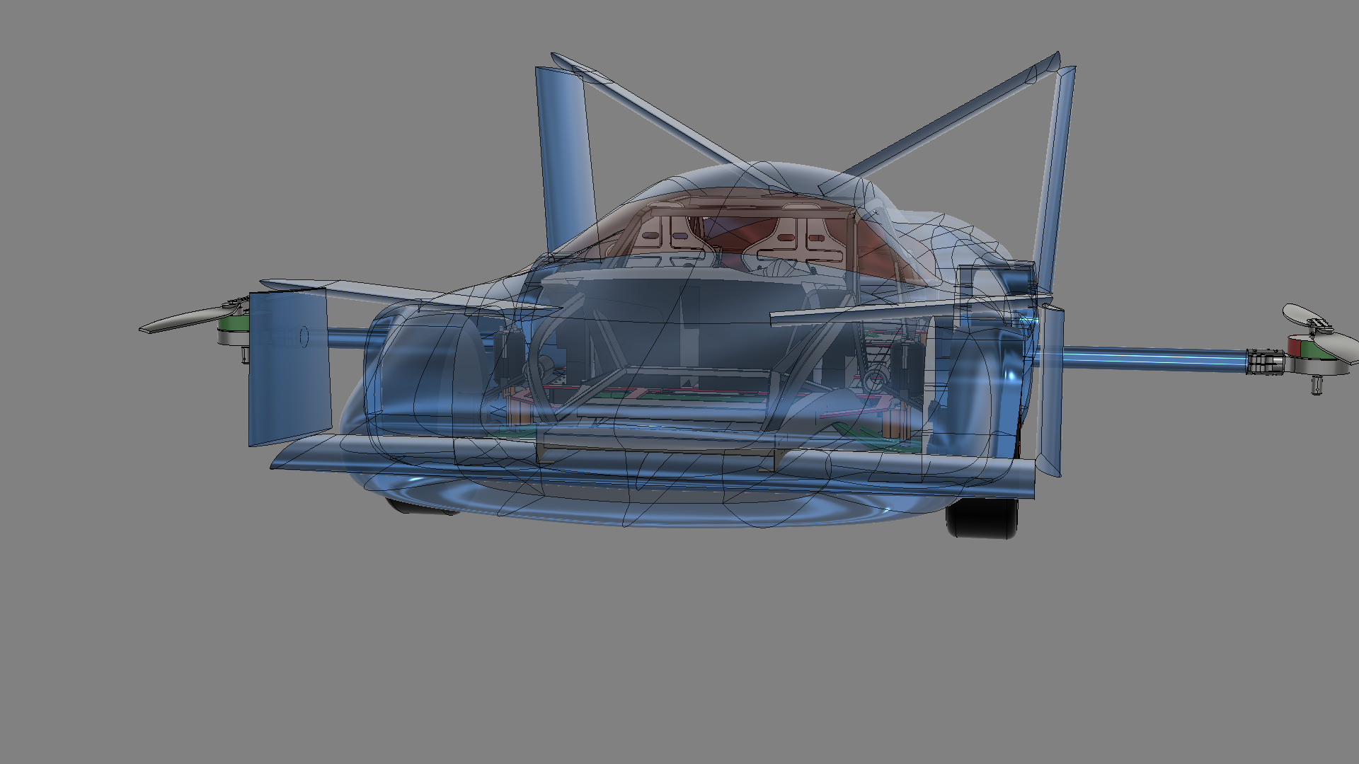
Fig. 9 CAD View 1 Fig. 10 CAD View 1

Fig. 11 CAD View 3 Fig. 10 CAD View 4

Conclusion
H.E.A.V.Y. has been designed to be an electric Lift + Cruise roadable aircraft. The aircraft has VTOL (vertical take-off and landing) capabilities in the air as well as cruise capabilities on land. Being an eVTOL, it produces zero carbon emission and lower noise pollution. The aircraft poses as a potential for solving urban mobility problems such as traffic congestion and rapid transportation for an economically and environmentally sustainable modern urban transportation. Design requirements were taken into consideration and the design for the aircraft was conceptualized. With a set of design requirements, performance parameters such as range, endurance, power are obtained. With these parameters, wing loading, power loading and disk loading are observed. These loadings provided a safe design region in the matching diagram. Within the limitations of the safe design region, a feasible design for H.E.A.V.Y. has been achieved. A computational model was generated to visualize the attained design. A scaled down proof of concept of H.E.A.V.Y. would be fabricated during the prototyping and testing phases along with the detailed design of land and aerial cruise capabilities.
References
- https://transportup.com/the-hangar/
- A. Bacchini, E. Cestino, Electric VTOL configurations comparison, Aerospace. 6 (2019)
- D. Raymer, Aircraft Design: A Conceptual Approach, Sixth Edition 2019
- A. Bacchini, E. Cestino, Key aspects of electric vertical take-off and landing conceptual design, Proceedings of the Institution of Mechanical Engineers, Part G: Journal of Aerospace Engineering
- Airfoil Tool, (2019). http://airfoiltools.com/
- Hossain, Dr Md Alamgir & Hasan, F & Seraz, A. (2011). Development of Design and Manufacturing of a Fixed Wing Radio Controlled Micro Air Vehicle (MAV). MIST Journal: GALAXY (DHAKA)
- Filipp Byström-Troyan and Ola Isaksson, eVTOL Concept for Urban Transport
- A.R. Serrano, A.M. Kamal, Design methodology for hybrid (VTOL + Fixed Wing) unmanned aerial vehicles, Aeronautics and Aerospace Open Access Journal. 2 (2018) 165–176
- D.F. Finger, C. Bil, C. Braun, Initial sizing methodology for hybrid-electric general aviation aircraft, Journal of Aircraft. 57 (2020) 245–255
- R.W. Hascaryo, J.M. Merret, Configuration-independent initial sizing method for uam/evtol vehicles, Aiaa Aviation 2020 Forum (2020)

