Computational Study on Base Drag Reduction for a Boat-tailed Axisymmetric Jet Nozzle through Base Geometry Modifications
Tanmay B. Gholap, Student, Aeronautical Engineering Department, Annasaheb Dange College of Engineering and Technology, Ashta, Sangli, Maharashtra, India, tanmaygholap@gmail.com
Ruturaj V. Salokhe, Student, Aeronautical Engineering Department, Annasaheb Dange College of Engineering and Technology, Ashta, Sangli, Maharashtra, India, ruturajsalokhe123@gmail.com
Ganesh V. Ghadage, Student, Aeronautical Engineering Department, Annasaheb Dange College of Engineering and Technology, Ashta, Sangli, Maharashtra, India, ganeshvg22@gmail.com
Shankar V. Mane, Student, Aeronautical Engineering Department, Annasaheb Dange College of Engineering and Technology, Ashta, Sangli, Maharashtra, India, shankar7916@gmail.com
Devabrata Sahoo, Assistant Professor, Aerospace Engineering Department, MIT School of Engineering, MIT ADT University, Pune, Maharashtra, India, devabrata.sahoo@mituniversity.edu.in
Abstract: A Computational Fluid Dynamics (CFD) analysis was conducted on an axisymmetric boat-tailed afterbody operating at zero angle of incidence. The boat-tail drag can significantly affect the overall propulsion system performance in rockets and missiles. These computations show a very difficult regime with shock induced separations and strong adverse pressure gradients in the flow field. Computations have been carried out at Mach number 2 with nozzle pressure ratios (NPR) of 4 and 6. The SST turbulence model has been used in calculations to study the flow difference in pressure and velocity contours. Nevertheless, the boat tail surface pressure coefficient for a straight cylinder and a tapered cylinder (or boat tail) has been plotted. The boat tail configuration model demonstrated a better overall computational data.
Keywords — Axisymmetric afterbody, Base drag reduction, Base geometry modifications, NPR, Sharp base, Straight cylinder

Introduction
Boundary layer separation occurring on missile straight afterbody rear end at moderate or high Mach numbers leads to the formation of well-organized vortices/recirculation region, especially at supersonic Mach numbers. The pressure acting behind the base in the recirculation region is generally lower than atmospheric which can result in considerable drag. By considering this problem it is very important to redesign the missile afterbody and select proper geometric parameters. In this paper, we discussed/carried out a comparative study on flow over a straight cylinder and afterbody with a boat tail. By the application of the boat tail, it is observed that flow leaves the afterbody smoothly and attached shocks. So, in the base flow region, it can seem to be strongly influenced by the drag reduction and stability.

In the early 1970s, William B. Compton [1] reported that a Jet effect on afterbodies at 10° boat tail is better than 3° and 5°. Wind Tunnel Test was done. Fred et al. [2] summarized that Boat tail drag can be strongly affected by Reynold's Number, drag depends on the Boattail nozzle exhaust shape. They observed that when Reynolds number increased boat tail drag first increased then decreased. They performed wind tunnel and flight tests. For subsonic flow, the separation point moves forward as freestream Mach number and jet total pressure ratio increases revealed by William K [3]. In the 1980s, Kentfield [4] reported that controlled separated flows can be effective to reduce drag. For simple axisymmetric body equipped with a vortex entrapping stepped after body obtained a drag reduction of approximately 55%. Teryn et al. [5] showed a Computational study on Axisymmetric Off Design Boat tail nozzle in variable timestep using the RANS technique. In the same year, Lee et al. [6] found that an increase in the freestream Mach number introduced a strong plume-induced shock and a reduced extend of shock interactions as the shock move downstream. They concluded that the control methods with a rounded tail or groove on the surface of the body near the tail produced positive effects. Analysis of unsteadiness in after body transonic flows reported by the Reijasse et al. [7]. The wall pressure fluctuations are affected by the formation of large-scale vortices in the wake. Verma et al. [8] stated the Base geometry modification in controlling the mean and unsteady base pressure development under jet-off and jet-on conditions. Wind Tunnel Test was conducted on three models i.e., base cavity, round base, and sharp base. Base cavity performs better than round and sharp base models. Pathan Khizar et al. [9] reported that the flow field in an enlarged duct is strongly influenced by Nozzle Pressure, Area Ratio, Mach Number, and L/D Ratio. Flow becomes highly under-expanded when NPR is very high. Mohammed et al. [10] stated that in overexpanded nozzle flow NPR from 2 to 6 resulted in an increase in base pressure from 3% to 17%. They found that at NPR 7, base drag is 50% of the total drag at lower supersonic Mach number. Zakir and Khan [11] investigated that the NPR influences base pressure very strongly. They reported the increasing Mach number leads to an increase in Base Pressure. L/D less than 3 proved to be insufficient for flow to be reattached. In recent years, Nonomura et al. [12] summarized the effect of boat tail angle on pressure distribution and drag of axisymmetric afterbody. They reported that as compared to boat tail of 10°, it is observed that boat tail at 14° gives reduced drag of 5% and at boat tail at 20° result in increasing drag up to 7%. A very high drag was recorded at 30° boat tail angle. Wind Tunnel Tests were conducted in low-speed conditions.
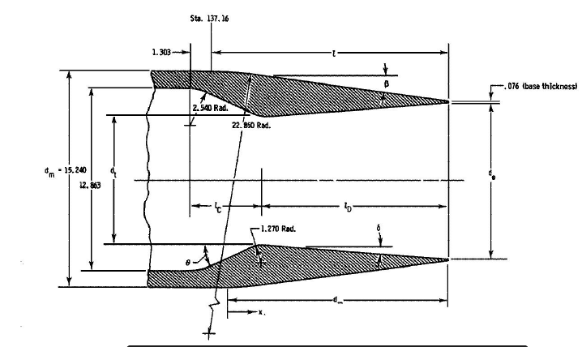
Figure 1: Schematic of nozzle geometry (units of centimeters) [5]

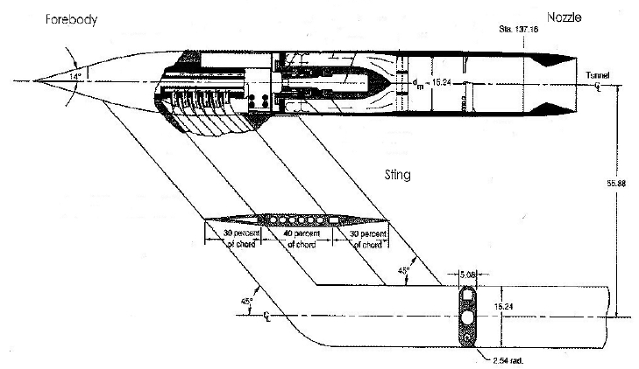
Figure 2: Schematic of NASA Langley experimental rig [5]

Methodology
An axisymmetric, structured, steady, two-dimensional model was taken for Computational Fluid Dynamics (CFD) to solve the Reynolds-Averaged Navier-Stokes (RANS) equation. The Shear Stress Transport (SST) k-ω two-equation model was considered to solve the turbulence model. The material type was fluid: air and the property of density were set to ideal gas and Sutherland for viscosity. Explicit formulation with Roe-FDX flux type has been chosen in Solution methods. For spatial discretization, Green-Gauss cell-based is used along with Second-order upwind condition for Turbulent kinetic energy and specific dissipation rate. The Courant number is 0.8 for the simulation.

Modeling
The straight cylinder model has a diameter of 15.24cm. The nozzle is convergent-divergent. The domain is extended up to 100 points axially and 75 points vertically from the central axis of the missile. Afterbody of 43.15 points has been considered for simulation purposes. The nozzle inside ranges 28.54 points axially and it has a diameter of 12.86 cm. For the boat-tail model, the nozzle dimension and the domain extended to the same number of points. A taper of angle 8.28° was given 15.24 cm before the afterbody ended for the boat tail configuration. The modeling and meshing were carried out on the Ansys Gambit® software.

Meshing
A coarse grid consisting of 35,400 cells (figure 3) was taken for the tapered model domain whereas 32,900 cells (figure 4) for the straight cylinder domain. The density of cells is much more on the boat tail surface and the base region to study the occurrence of the shock wave. The coarse grid is sufficient to capture the pressure distributions in the flow field [5]. More cells at the region to examine provided smooth results in the coefficient of pressure over the afterbody plot.
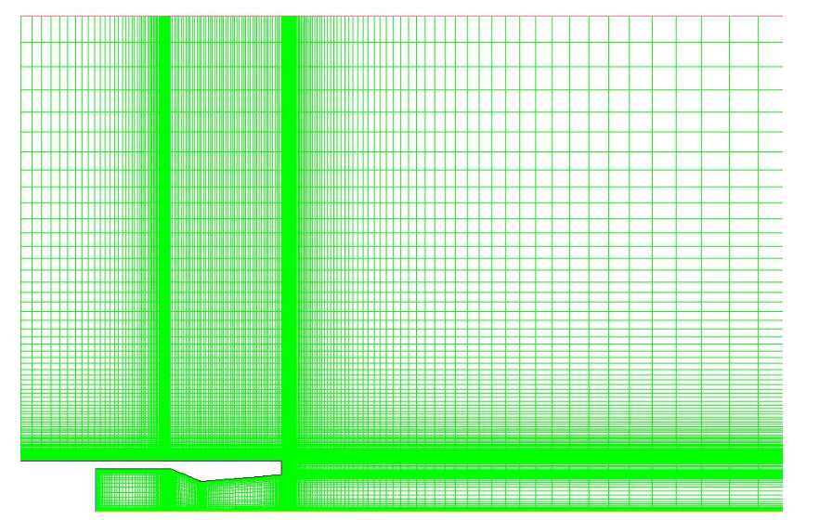
Figure 3: Computational Domain for a straight cylinder 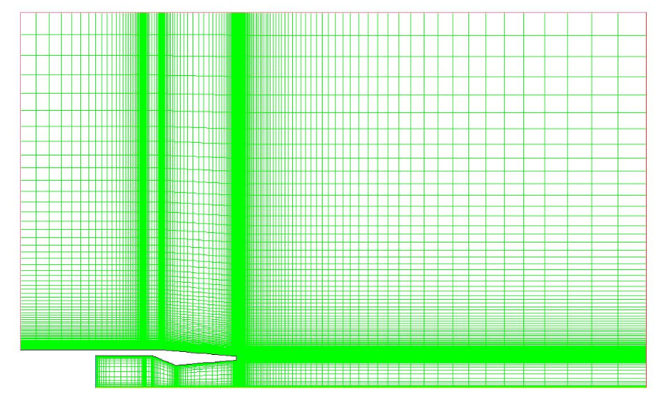
Figure 4: Computational Domain for a Boattail afterbody

Boundary Conditions
The boundary condition allotted to the domain consists of a pressure far field at the top and upstream of the missile. A pressure outlet at the downstream and a pressure inlet at the inlet of the nozzle. The afterbody and the edges of the nozzle were set to wall boundary conditions. Freestream of Mach number 0.9 with Nozzle Pressure Ratio of 4. The flow condition was set to a total temperature of 230.33 K and a total pressure of 101325.9 Pa for the freestream. The nozzle inflow total temperature was 300 K along with a total pressure of 239730.31 Pa and a static pressure of 22349.68 Pa.

  - Validation of computational data
The figure (5) is the validation plot. The Computational domain in figure (4) is used to procure the result for the pressure coefficient on the afterbody of the boat tail at Mach 0.9 and NPR 4. The results obtained in the Ansys-Fluent® software resembles the data in the reference paper [5].

Figure 5: Mean Cp profile of experimental data vs CFD analysis data on external surface for NPR = 4, Mach = 0.9

Results and Discussions
In the Mach contour for a straight cylinder, the shock was induced downstream; at the end of the afterbody and the nozzle. The external pressure disturbance caused in this case is highly unsteady. The Cp values after 0.6 suddenly dropped till x/D 1. Due to this the freestream velocity of the fluid on the body reduced. Therefore, a higher base drag is reported for this case.
The Mach contour in figure (8) for the boat tail afterbody induced a separation shock just where the tapered region started. Reduced fluctuations of pressure were seen at the jet exhaust. The Cp dropped only at the start of the boat tail for 0 to 0.2 x/D. It bounced back to the normal level. The shear layer at the aft portion for the turbulent flow reduced comparatively which reduced the base drag to a certain extent. A positive pressure coefficient from x/D 0.5 to 0.8 proves that the afterbody base drag reduces. As the shock was induced a certain length upstream, this caused less load distribution on the base region.
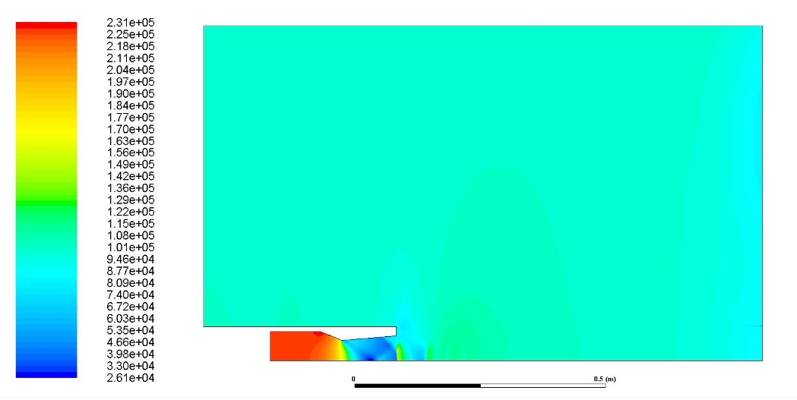
Figure 6: Pressure Contour for straight cylinder
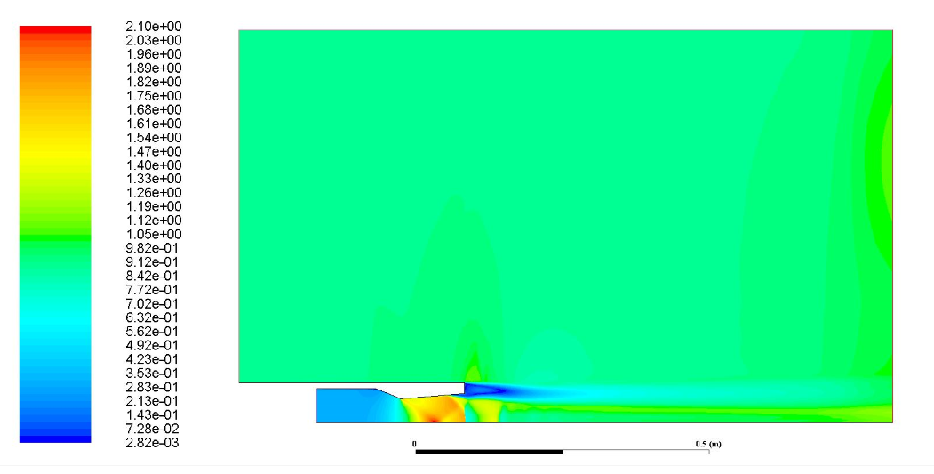
Figure 7: Mach Contour for a straight cylinder
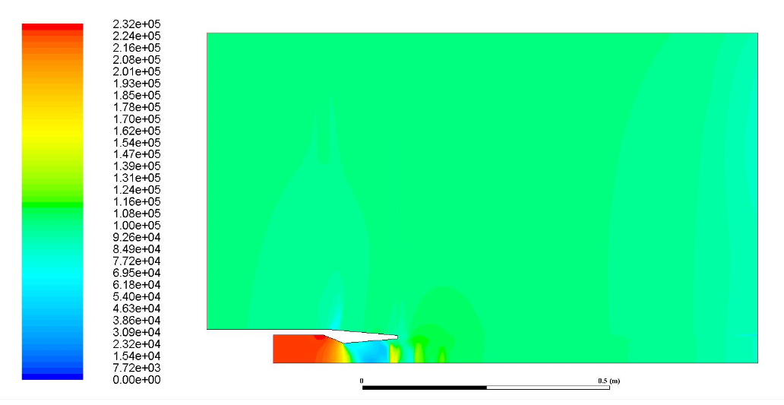
Figure 8: Pressure Contour for a boat tail afterbody
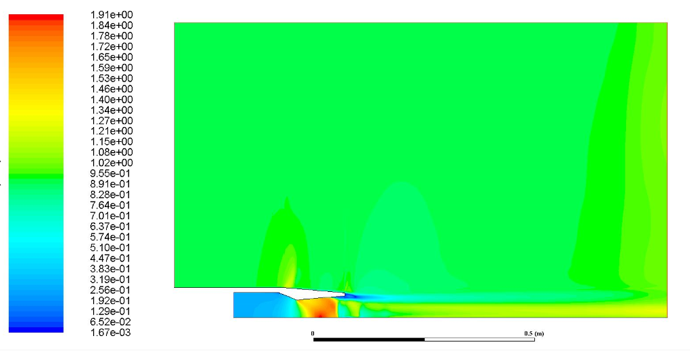
Figure 9: Velocity contour for a boat tail afterbody.
Figure 10: Mean Cp profile on external surface for NPR = 4, Mach = 0.9

Conclusions
From the results and discussions of the computational study at Mach 0.9 NPR 4 for two models the following conclusions can be drawn:
- The Nozzle Pressure Ratio (NPR) has a strong proportion on the amount of base pressure formed.
- The boat tail after body performs significantly better than the straight cylinder afterbody.
- The shock is induced upstream in the boat tail model, causing less base pressure drag at the jet exhaust.
The base geometry plays an important role in the amount of drag generated at the base and changes in the freestream velocity. Certain base geometry modifications can be carried out in the aft portion of the afterbody for lowering the amount of drag generated.
- Acknowledgment
The authors would like to extend their gratitude to the help provided by Dr. D. Sahoo who made this work possible in a global pandemic.
References
- William B. Compton, “Drag on conical afterbody at supersonic speed” Langley Research Center Hampton, Va. 23365, NASA- Washington, D.C. July 1972.
- Fred A, Wilcox, and Roger Chamberlin, “Reynolds number effects on Boattail of exhaust nozzles from wind tunnel and flight tests,” NASA Technical Memorandum, Lewis Research Center Cleveland, Ohio 44135, September 3-6, 1974
- William Kelly, “Boundary Layer Separation on Isolated Boattail Nozzles,” North Carolina State University, May 8, 1977.
- J.A.C. Kentfield, “Drag Reduction by Means of controlled Separated Flows,” University of Calgary, Alberta Canada, 1985.
- Teryn DalBEllo, Nicholas Georgiadis and Dennis A. Yoder, “Computational Study of Axisymmetric Off-Design Nozzle Flows,” NASA Glenn Research Center, Cleveland, OH 44135, 42nd AIAA Aerospace Science Meeting and Exhibit, Jan.5-8 2004.
- Lee s. Raghunathan and E. Benard, “Control of Plume Interference Effect on Axisymmetric Afterbodies,” The Aeronautical Journal, April 2004
- D. Depres and P. Reijasse, “Analysis of Unsteadiness in afterbody Transonic Flows,” AIAA Journal Vol 42, No. 12 December 2004.
- S.B. Verma, Akriti Tripathi, and C. Manisankar, “Control of Base Pressure for a Boat-tail Axisymmetric Afterbody via Base Geometry Modifications,” Article in Aerospace Science and Technology, June 2015
- Pathan Khizar Ahmed, P.S. Dabeer, and S.A Khan, “CFD Analysis of The Supersonic Nozzle Flow with Sudden Expansion,” IOSR Journal of Mechanical and Civil Engineering (IOSR-JMCE) PP 05-07, 2016
- Mohammed Asadullah, and Sher Afghan Khan, “Low-cost Base Drag Reduction Technique,” Internal Journal of Mechanical Engineering and Robotics Research Vol. 7 No.4, July 2018
- Zakir Chaudhary, Vilas Shinde, and S.A. Khan, “Investigation of Base Flow for An Axisymmetric Suddenly Expanded Nozzle with Micro Jet,” Article in International Journal of Engineering and Technology, August 2018.
- Tran Hung, Taku Nonomura, and Keisuke Asai, “Effect of Boattail Angle on Pressure Distribution and Drag of Axisymmetric Afterbodies Under Low-Speed Conditions,” Article in Transactions of the Japan Society for Aeronautical and Space Science, January 2019

